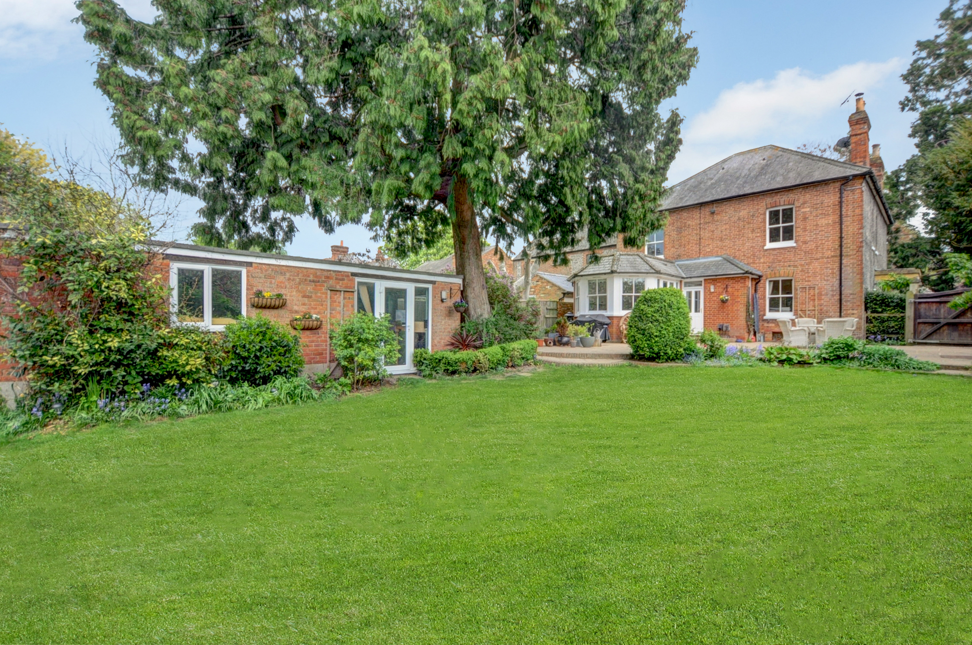
Oakley Road
Chinnor
www.bb-estateagents.co.uk
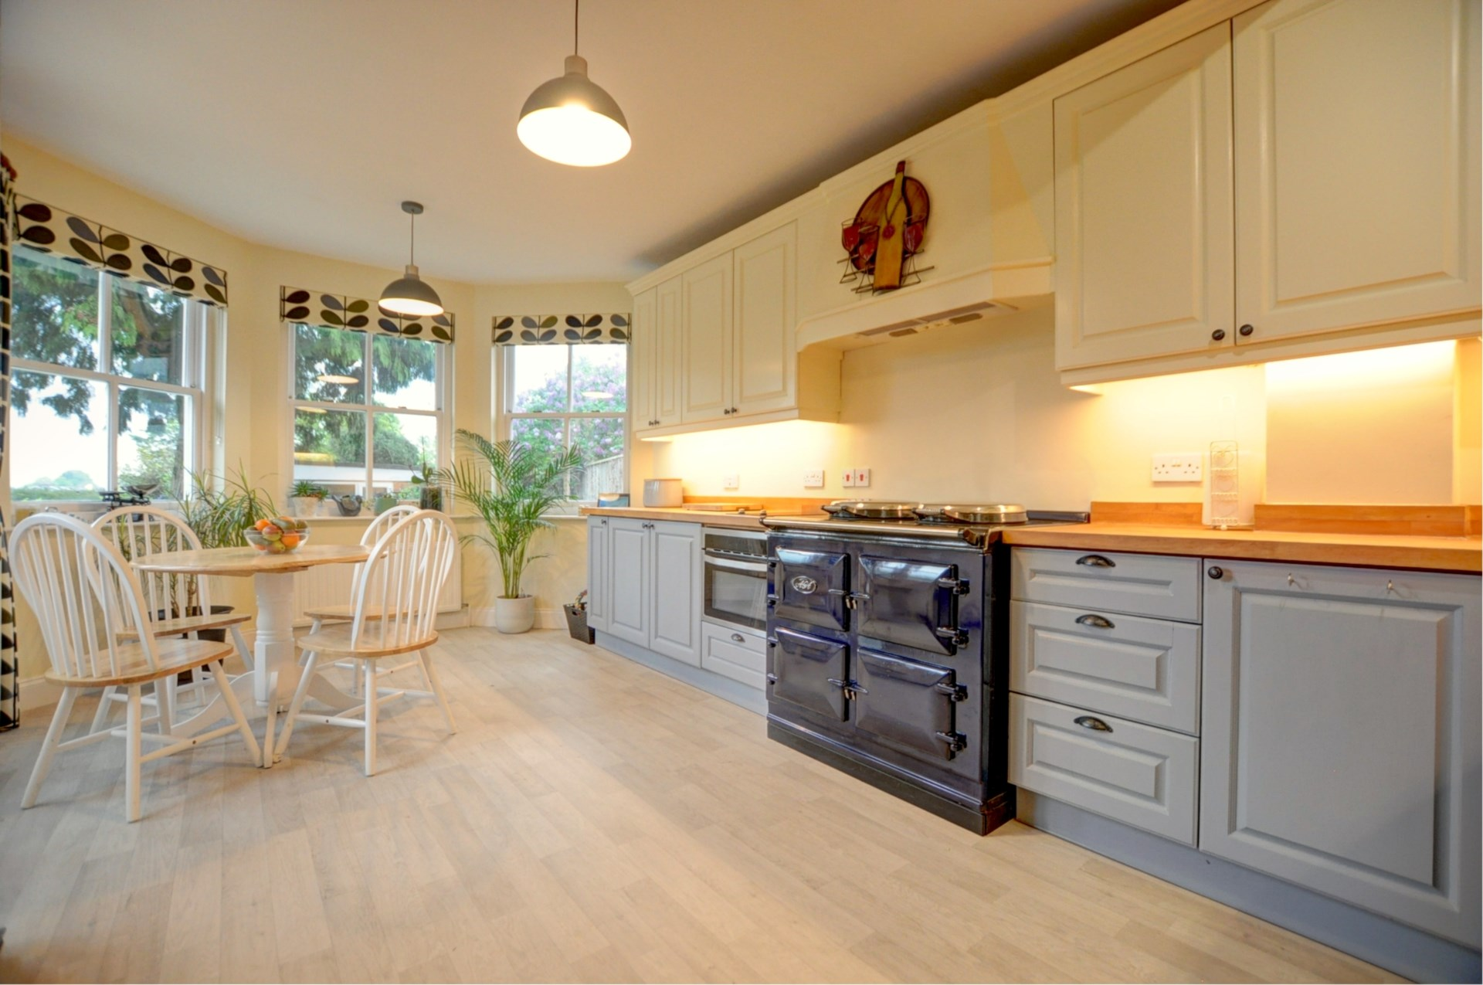
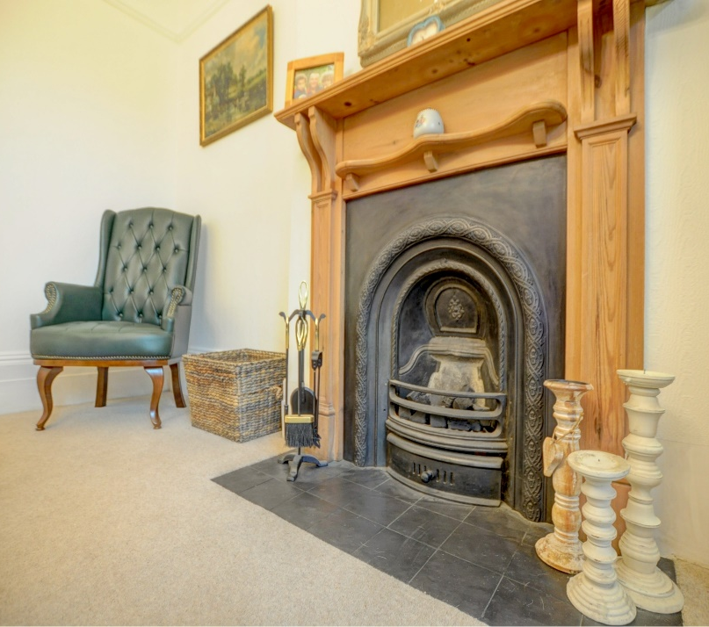
Bonners & Babingtons are delighted to offer this elegant and immaculately presented Victorian period property, that bursts with original character and charm, offering four double bedrooms, three reception rooms, a fabulous kitchen/diner, beautifully secluded garden with swimming pool. Situated close to local shops and amenities, `Outstanding` rated school and excellent transport links.

6 Oakley Road, Chinnor, Oxfordshire, OX39 4HZ

Guide Price £1,000,000

- Victorian Period Property
- Four Double Bedrooms
- Three Reception Rooms
- Full of Charm & Original Character
- Family Kitchen/Diner
- Downstairs Shower Room
- Separate Utility Room
- Secluded Garden Extending to 0.26 of an Acre
- Heated Swimming Pool
- Close to Local Amenities and Excellent Transport Links

Robert House, 19 Station Road, Chinnor, Oxfordshire, OX39 4PU

01844 354554
www.bb-estateagents.co.uk

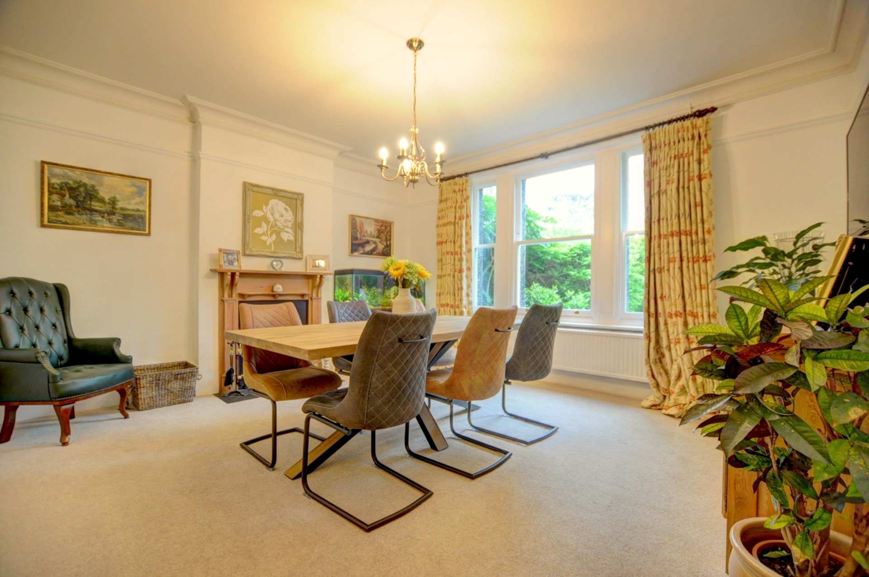
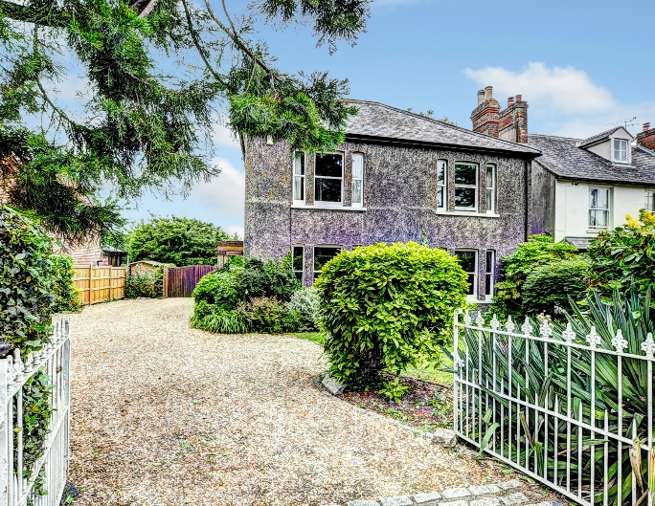
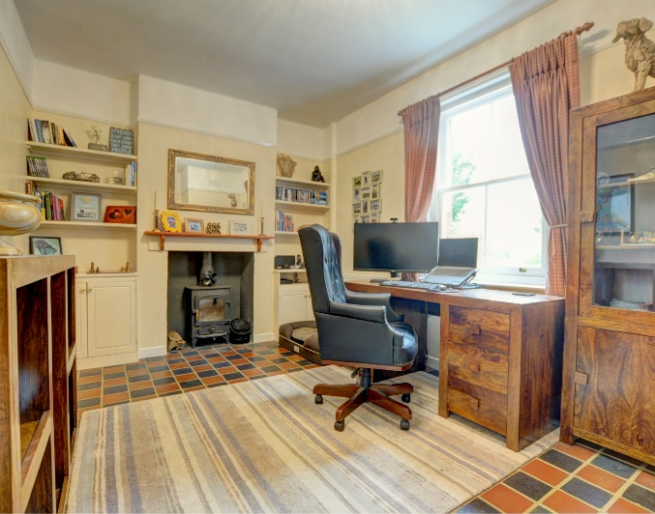
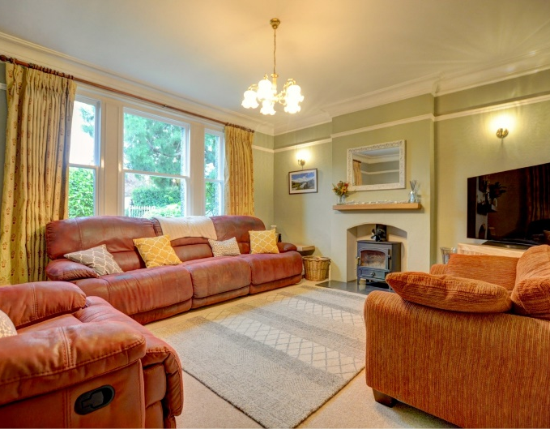
Location

Situated at the foot of the Chiltern Hills, Chinnor is a popular village conveniently situated on the Oxfordshire/Buckinghamshire borders. Within the village there are good local facilities including a variety of shops, churches, pubs and restaurants, post office, doctor's surgery, a nursery and two combined schools. Chinnor lies within catchment for the highly regarded Lord Williams's secondary school in Thame.

M40(Junction 6) is within 3 miles giving access to Oxford(20 miles), High Wycombe(13 miles) and London(48 miles). Princes Risborough mainline station is within 5 miles (Marylebone 35 minutes).

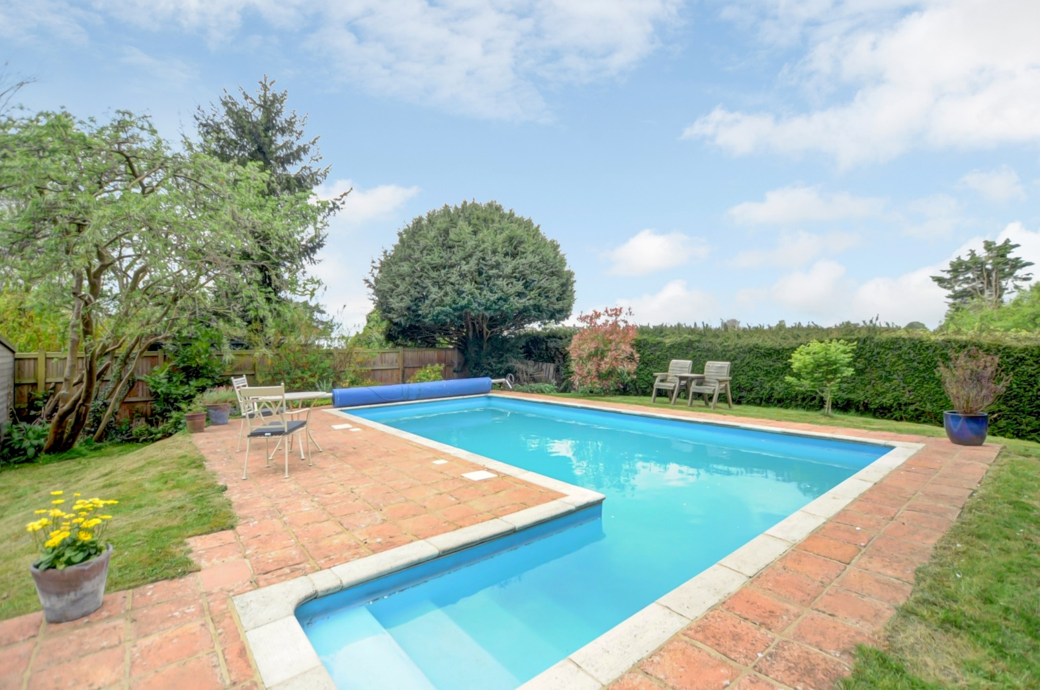
Description

The property is set back from the road and can be accessed through it own private driveway, The grand stone pillared entrance porch leads you into the main hallway, with original tiled flooring where all rooms lead from.
The downstairs accommodation consists of; Classic Victorian high ceilings and picture rails throughout the property. The formal reception room is inviting and cosy with bespoke double glazed sash windows and a wood burning stove, ideal for those winter evenings in. The second reception/snug room also has a wood burner and overlooks the beautiful garden. The elegant dining room also with sash windows and open fireplace, is the perfect setting for entertaining in style.
The modern two tone kitchen/diner is a light and sunny room with French doors opening onto the garden, Oak work tops, modern electric dual control, 3 oven Aga, separate induction hob, fitted microwave , and ample storage with waist and eye level units. There is also a separate utility room with plumbing for white goods and a sink, a wine cellar and downstairs cloakroom with shower.

Upstairs from the spacious landing there are four double bedrooms and a luxury family bathroom with slipper bath, separate walk in shower and built in storage. An ensuite can easily be created in the master bedroom if desired.

Outside
The beautifully landscaped garden which backs onto the village allotment, extends to 0.26 of an acre, with mature trees, shrubs, rose beds and hedging creating peace and privacy. There are various seating areas to capture the sun or shade, a summer house, workshop and potting shed. The inviting crystal clear heated swimming pool is discreetly positioned at the end of the garden and cheaper to run than you would think!

Other notable features include; Double glazing sash windows throughout, modern boiler, gas central heating and ample off road parking.

General Remarks and Stipulations

Tenure
Freehold

EPC Rating
D with B Potential

Local Authority
South Oxfordshire District Council

Viewing
Strictly by appointment with Bonners & Babingtons

Important Notice
Bonners & Babingtons, their clients and any joint agents give notice that:

1. They are not authorised to make or give any representations or warranties in relation to the property either here or elsewhere, either on their own behalf or on behalf of their client or otherwise. They assume no responsibility for any statement that may be made in these particulars. These particulars do not form part of any offer or contract and must not be relied upon as statements or representations of fact.

2. Any areas, measurements or distances are approximate. The text, photographs and plans are for guidance only and are not necessarily comprehensive. It should not be assumed that the property has all necessary planning, building regulation or other consents and Bonners & Bonners & Babingtons have not tested any services, Babingtons have not tested any services, equipment or facilities. Purchasers must satisfy themselves by inspection or otherwise.

