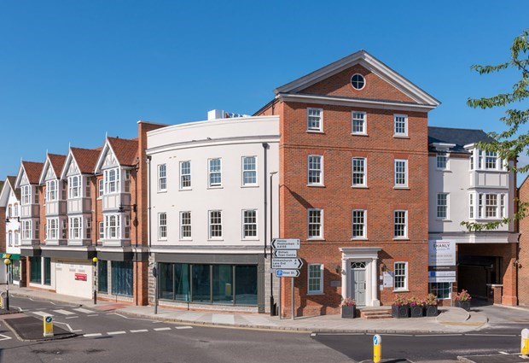

Windsor House, Dean Street, Marlow, Buckinghamshire, SL7 3AA

Price £1,995 pcm | Unfurnished

A stunning two bedroom, two bathroom spacious second floor apartment situated in the town centre and close to all of the amenities Marlow has to offer.EPC B. B&B LETTINGS 01628 333800.

- TOP FLOOR  - FINISHED TO A HIGH SPECIFICATION  - TWO LARGE DOUBLE BEDROOMS  - TWO BATHROOMS  - TOWN CENTRE LOCATION | - GAS CENTRAL HEATING  - UNDERGROUND PARKING FOR TWO CARS  - SECURE VIDEO ENTRY SYSTEM  - COMMUNAL ROOF TERRACE

Description
A stunning two bedroom, two bathroom spacious apartment situated in the town centre and close all of the amenities Marlow has to offer. UNFURNISHED. EPC band B. CONTACT B&B LETTINGS 01628 333800

The apartment comprises;

Lift or stairs to second floor
Secure video entry system
Entrance hallway with plentiful storage
Large and light living area with grey wood effect flooring
Contemporary kitchen with integrated Siemens appliances
Double bedroom with built in storage
Ensuite shower room
Further double bedroom with built in storage
Bathroom with shower over bath
Gas central heating and underfloor heating

The property also benefits from a shared use of roof terrace an secure basement parking for 2 cars

Outgoings:
Utility accounts, including council tax and telephone, are the responsibility of the tenants, who must provide their own contents insurance.

Council Tax:
To be advised

Terms
12-month tenancy agreement
Unfurnished
No smokers please
White goods included

Restrictions:
No pets preferred

(If pet permitted the landlord reserves the right to increase the rent)

Holding Deposit:
Equivalent to one weeks rent. £

Security Deposit required:
5 weeks rent payable before moving in.

Directions
Viewings strictly via the agents:
Bonners and Babingtons Marlow
01628 333800

