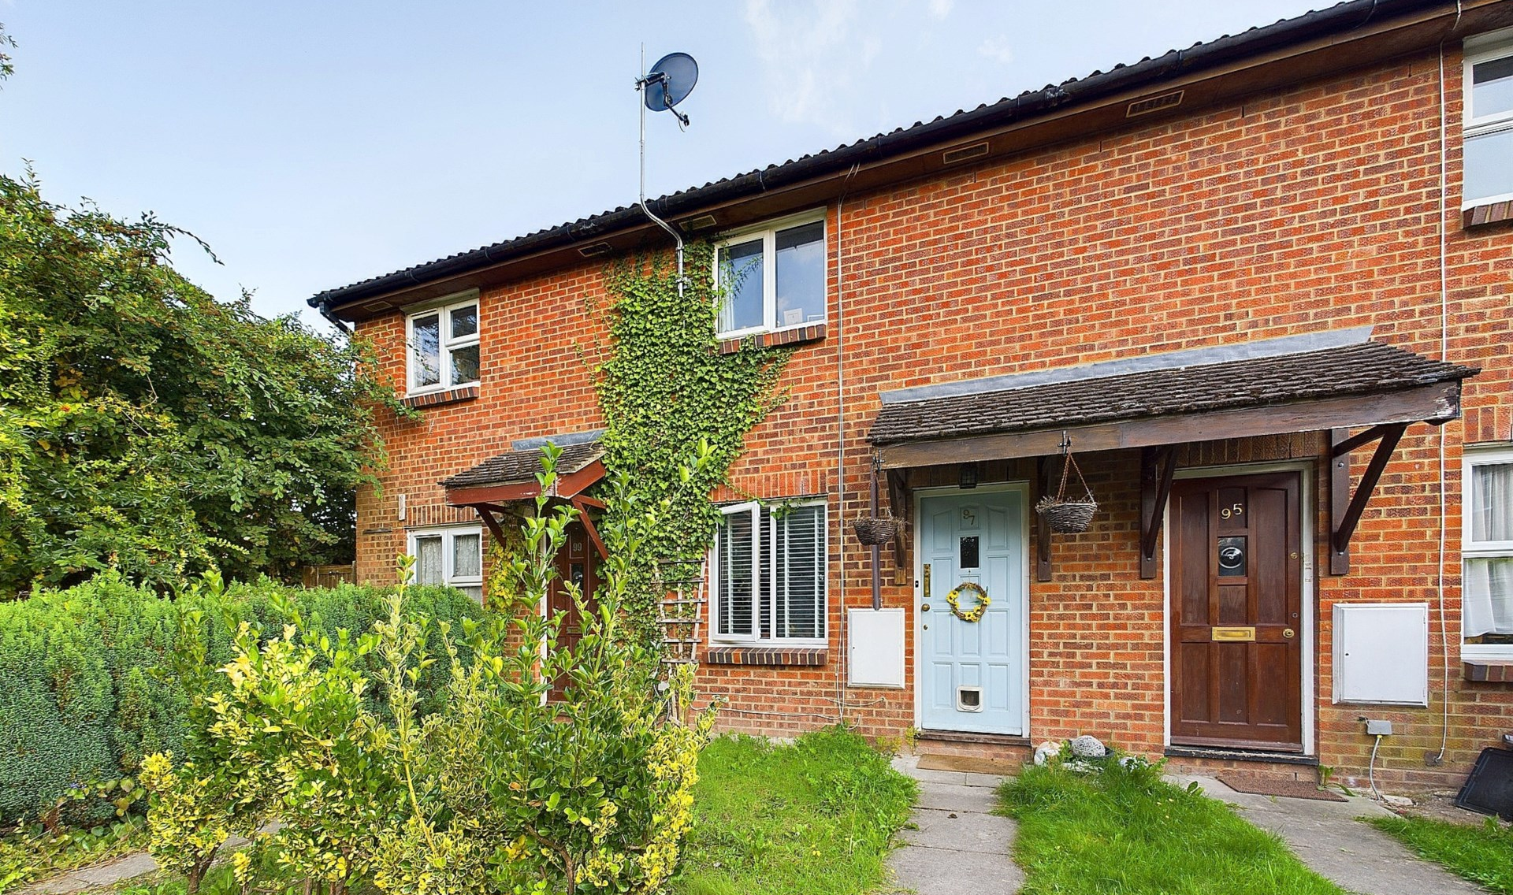
Bridgestone Drive
Bourne End
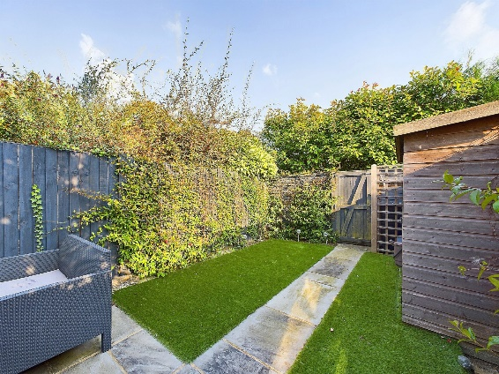
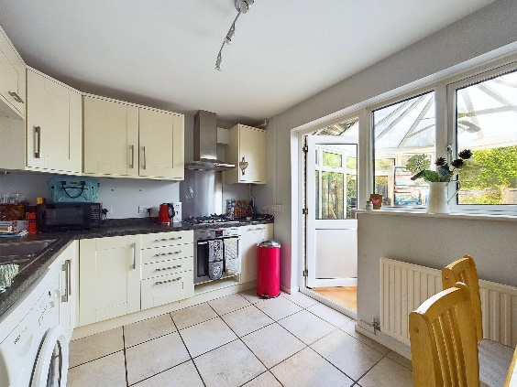
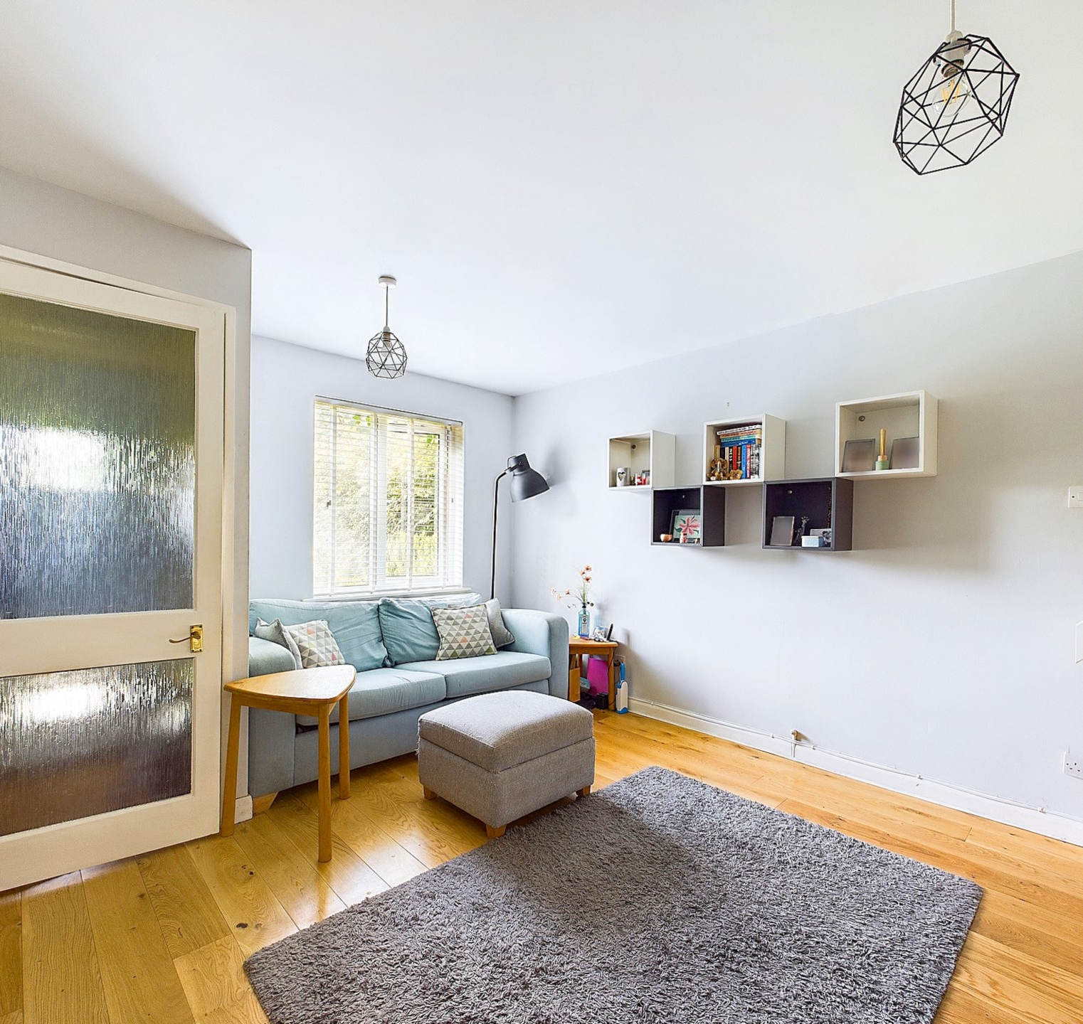
- Tenure:- Freehold
- £400,000
- -124
£0
£0
Band D

Bridgestone Drive
Bourne End
Buckinghamshire
SL8 5XQ

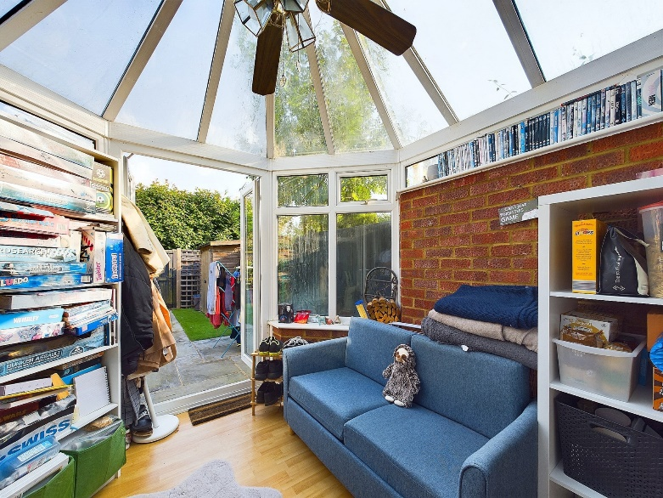
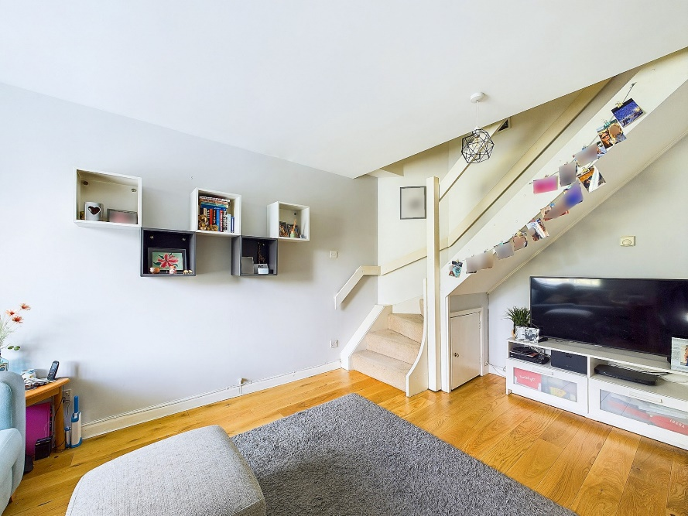
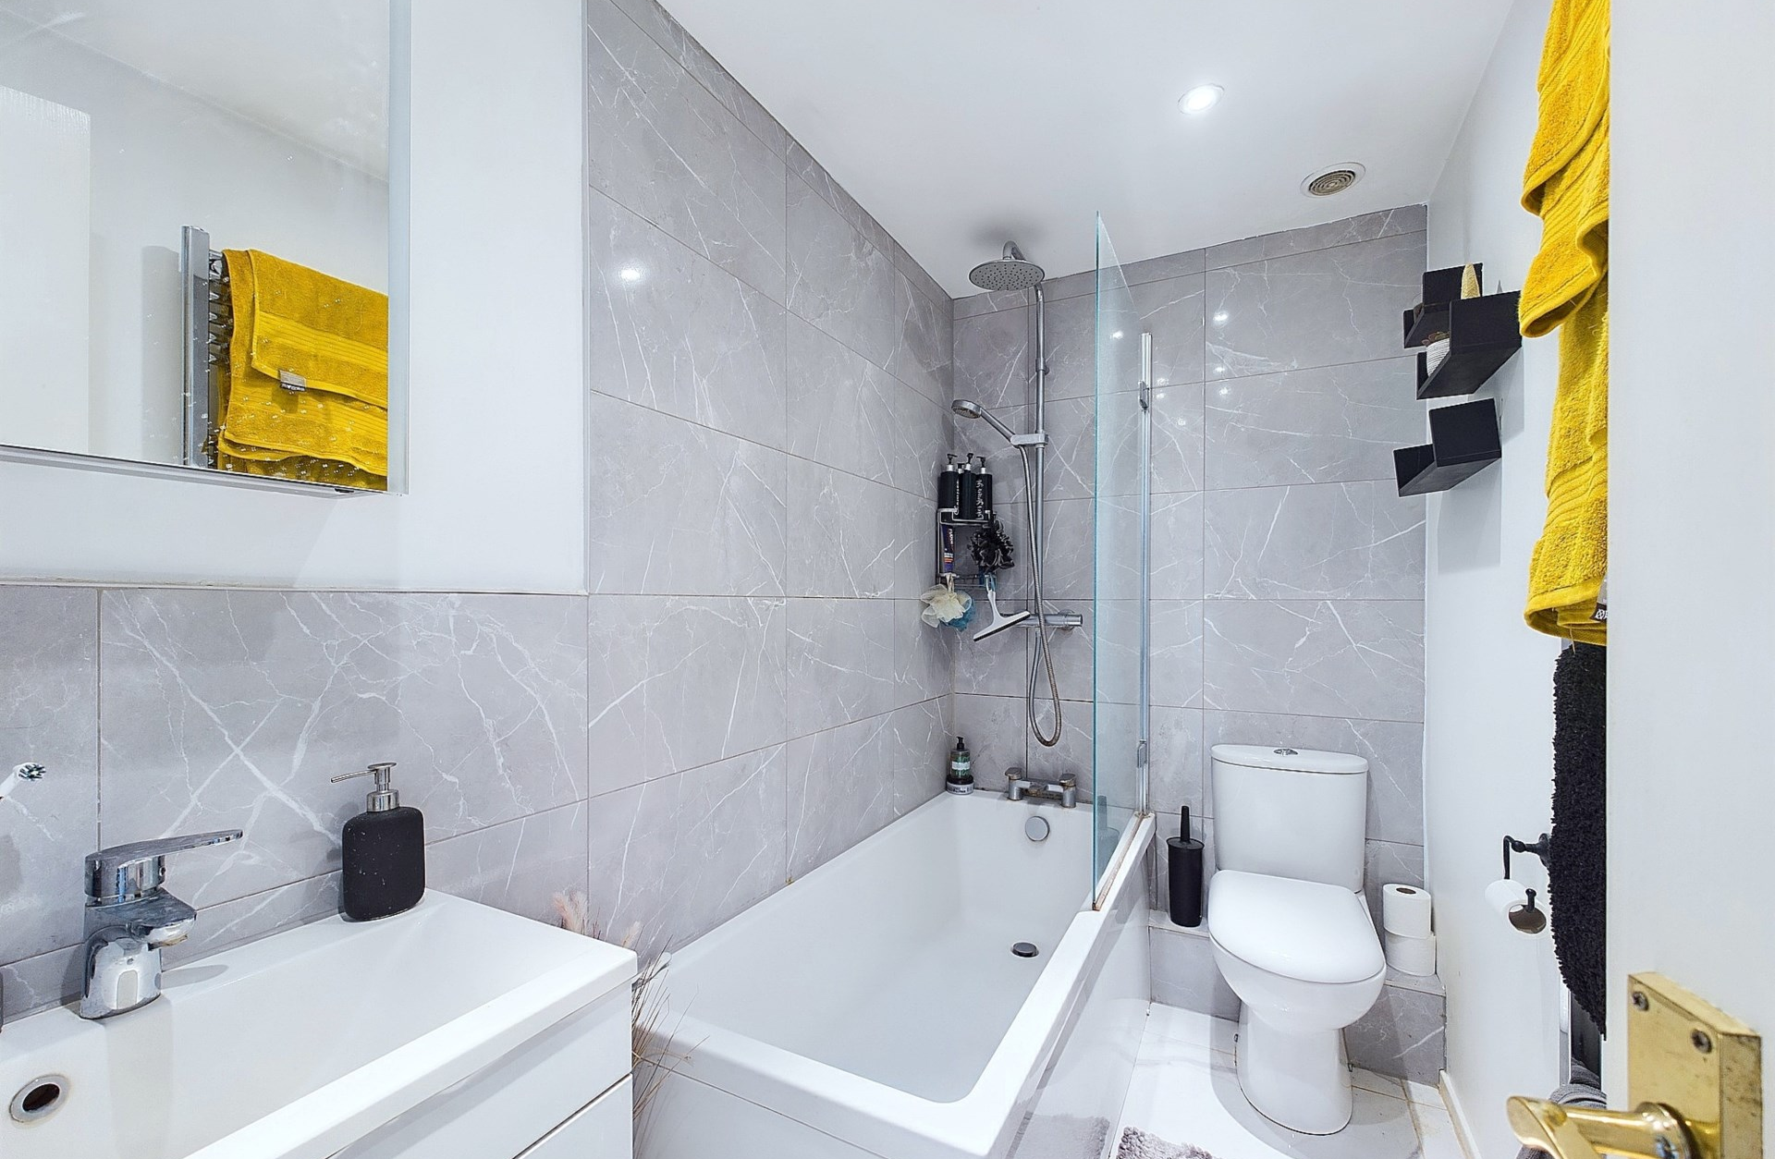
ATTENTION FIRST TIME BUYERS! This delightful two double bedroom house is now available and we highly recommend an internal inspection. On entering the property you are greeted by a light and airy living room with stairs to the first floor and door through to the kitchen / diner. The kitchen diner is also light and airy with a range of wall and base units with work surfaces over, integral hob and oven, plumbing and space for washing machine and door through to the conservatory. The conservatory is a lovely space to sit and unwind after and long day and has double doors leading out to the garden. On the first floor there are two good sized double rooms and a family bathroom plus loft access via the landing. The rear garden is low maintenance with lawned area, patio and shed plus gated access to the rear.

Bourne End sits on the River Thames on the Bucks/Berkshire border. The village boasts a vibrant Parade of shops, coffee shops and restaurants, a sizeable Marina, two sports grounds and a long established Sailing Club. For schooling Bourne End is served by its own primary school and the Bourne End Academy.
Transport links are excellent with its own railway station connecting to Maidenhead station with regular services to Paddington London and the M4 (J8/9) and M40 (J4) motorways within easy reach.

BONNERS & BABINGTONS offer - Situated in a secluded and tucked away location this two double bedroom house is the ideal first time purchase! Benefitting from additional conservatory, private gardens and parking this property is highly recommended.
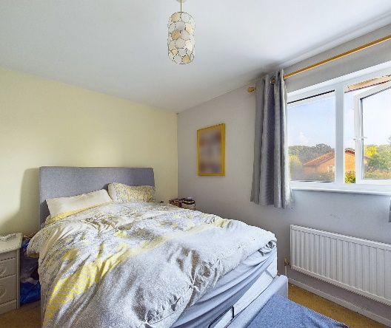
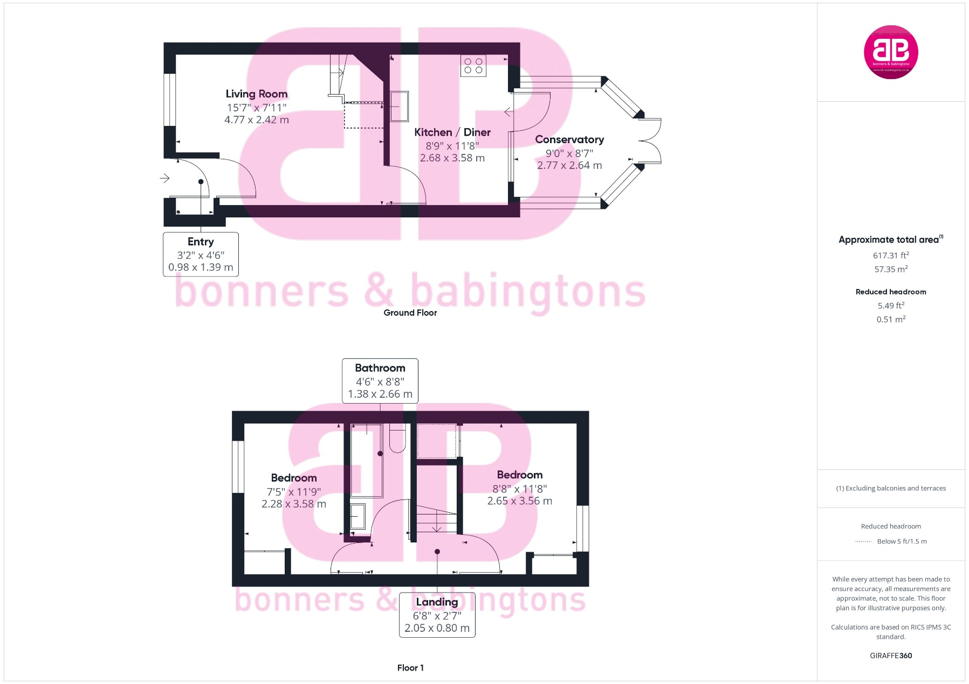

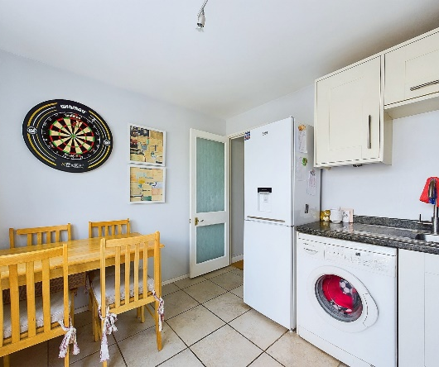

3 Anglers Court, Spittal Street, Marlow, Bucks, SL7 3HJ

01628 333800
www.bb-estateagents.co.uk



