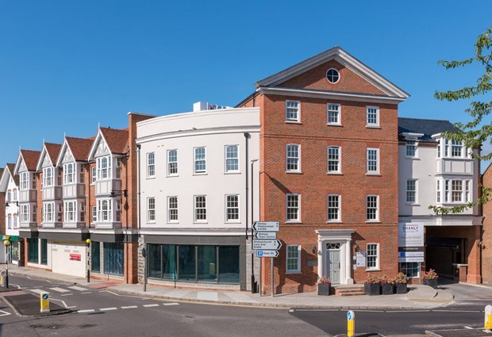

**Windsor House, Dean Street, Marlow, Buckinghamshire, SL7 3AA**

|  |  |
| --- | --- |
| Price £1,995 pcm | Unfurnished |

A stunning two bedroom, two bathroom spacious second floor apartment situated in the town centre and close to all of the amenities Marlow has to offer.EPC B. B&B LETTINGS 01628 333800.

|  |  |
| --- | --- |
| * TOP FLOOR * FINISHED TO A HIGH SPECIFICATION * TWO LARGE DOUBLE BEDROOMS * TWO BATHROOMS * TOWN CENTRE LOCATION | * GAS CENTRAL HEATING * UNDERGROUND PARKING FOR TWO CARS * SECURE VIDEO ENTRY SYSTEM * COMMUNAL ROOF TERRACE |

Description

A stunning two bedroom, two bathroom spacious apartment situated in the town centre and close all of the amenities Marlow has to offer. UNFURNISHED. EPC band B. CONTACT B&B LETTINGS 01628 333800

The apartment comprises;

Lift or stairs to second floor

Secure video entry system

Entrance hallway with plentiful storage

Large and light living area with grey wood effect flooring

Contemporary kitchen with integrated Siemens appliances

Double bedroom with built in storage

Ensuite shower room

Further double bedroom with built in storage

Bathroom with shower over bath

Gas central heating and underfloor heating

The property also benefits from a shared use of roof terrace an secure basement parking for 2 cars

Outgoings:

Utility accounts, including council tax and telephone, are the responsibility of the tenants, who must provide their own contents insurance.

Council Tax:

To be advised

Terms

12-month tenancy agreement

Unfurnished

No smokers please

White goods included

Restrictions:

No pets preferred

(If pet permitted the landlord reserves the right to increase the rent)

**Holding Deposit:**

Equivalent to one weeks rent. £

Security Deposit required:

5 weeks rent payable before moving in.

Directions

Viewings strictly via the agents:

Bonners and Babingtons Marlow

01628 333800

