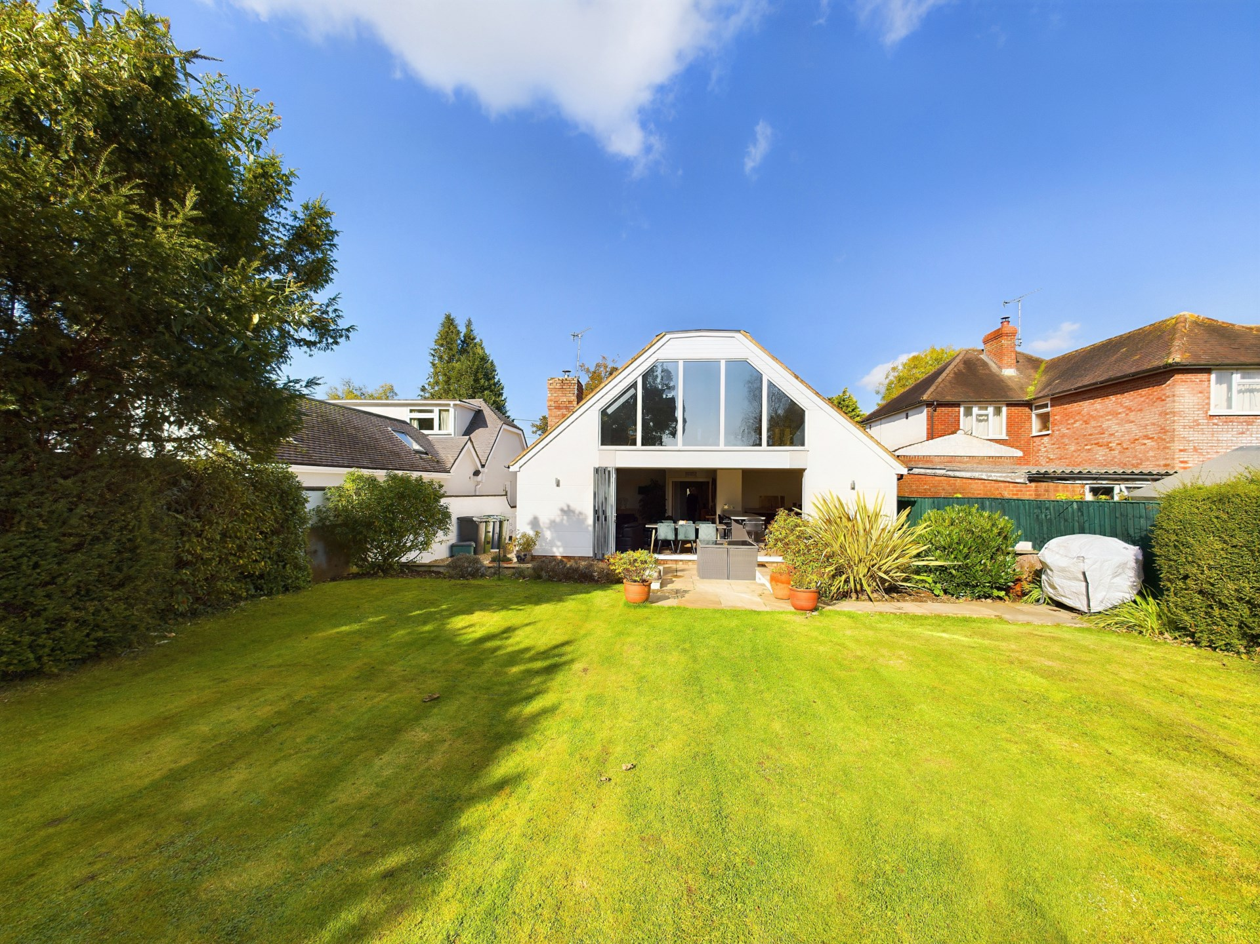bb-logo-final

**Radnage Common Road**

Radnage

www.bb-estateagents.co.uk

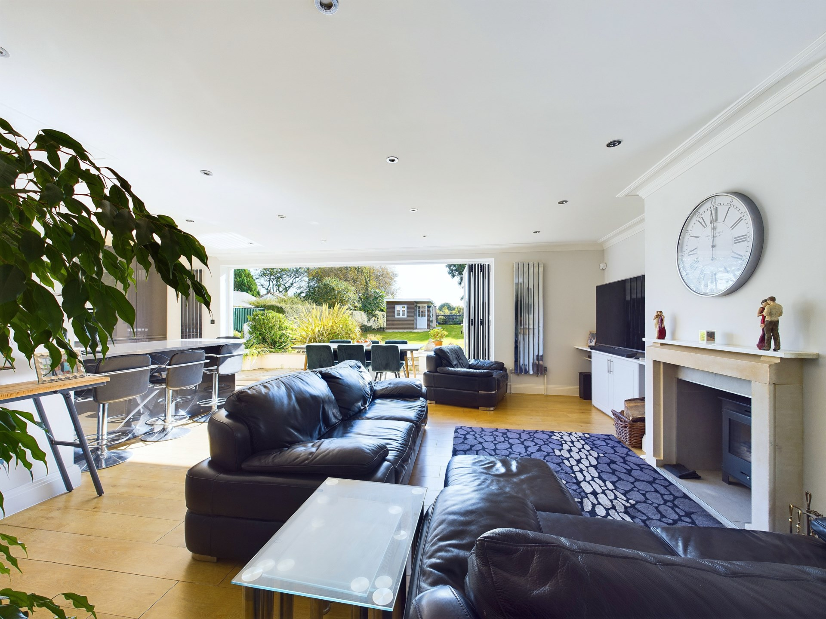

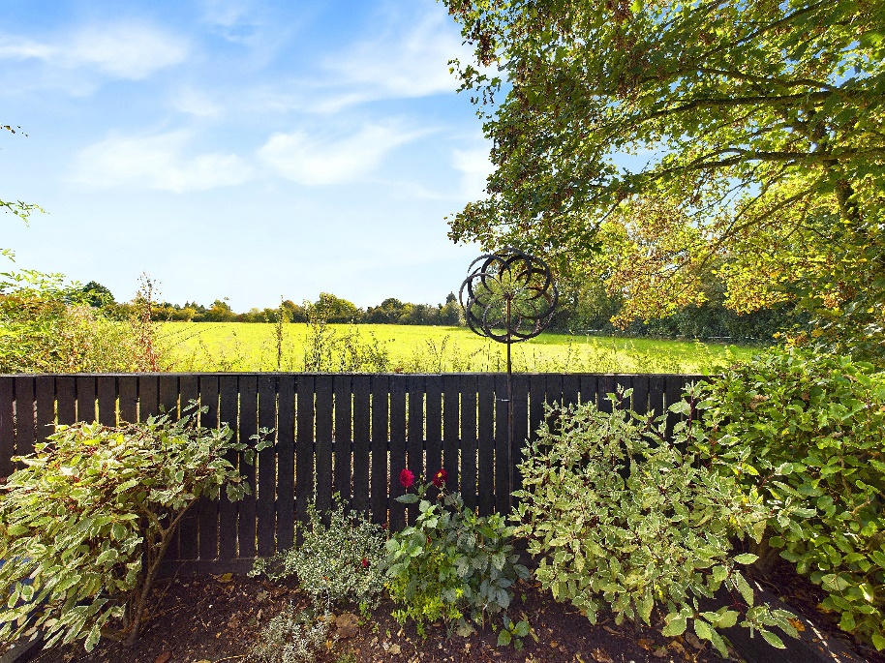

A successfully extended detached contemporary property, that has been finished to a very standard, with a spectacular garden backing on to open paddock land. Situated on one of the best no through roads in this beautiful village, with fabulous countryside walks on your doorstep.

Robert House, 19 Station Road, Chinnor, Oxfordshire, OX39 4PU

01844 354554

www.bb-estateagents.co.uk

Last Pitch, Radnage Common Road, Radnage, HP14 4DD

Guide Price of £800,000

* Stunning Contemporary Detached Property
* 3 Double Bedrooms
* Fabulous Open Plan Reception/Family Room
* Separate Utility Room
* Upstairs Master Bedroom with Picture Gallery Window
* Modern Luxury Bathroom with Separate Shower
* Downstairs Cloakroom
* Spectacular Garden Backing onto Open Paddock Land
* Situated on a Quiet No Through Road
* Ample Off Road Parking
* Out Building Providing a Home Office & Workshop

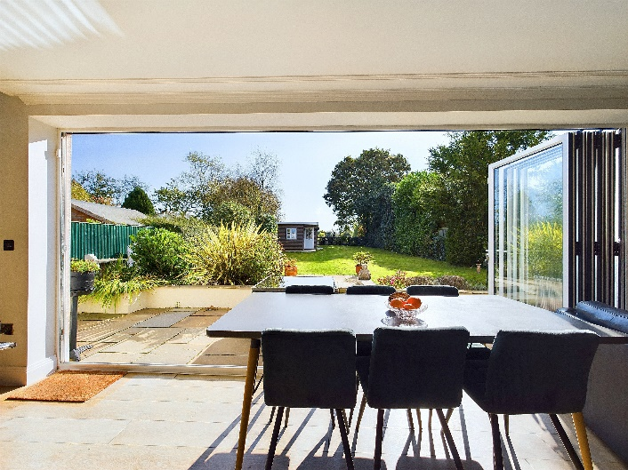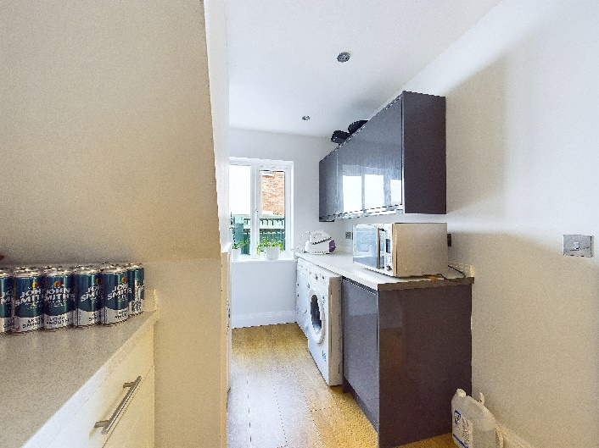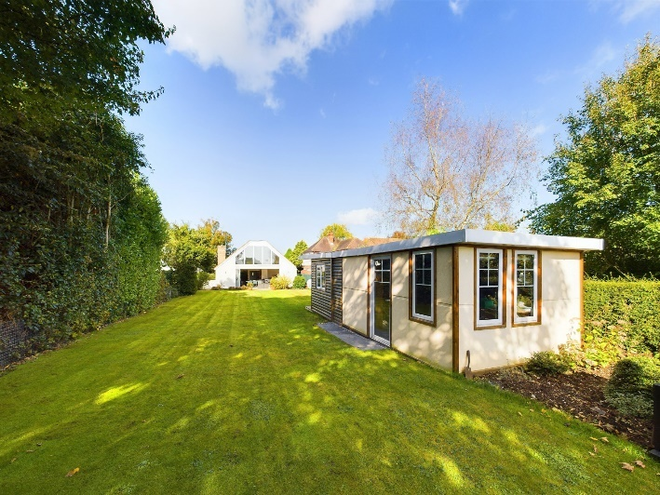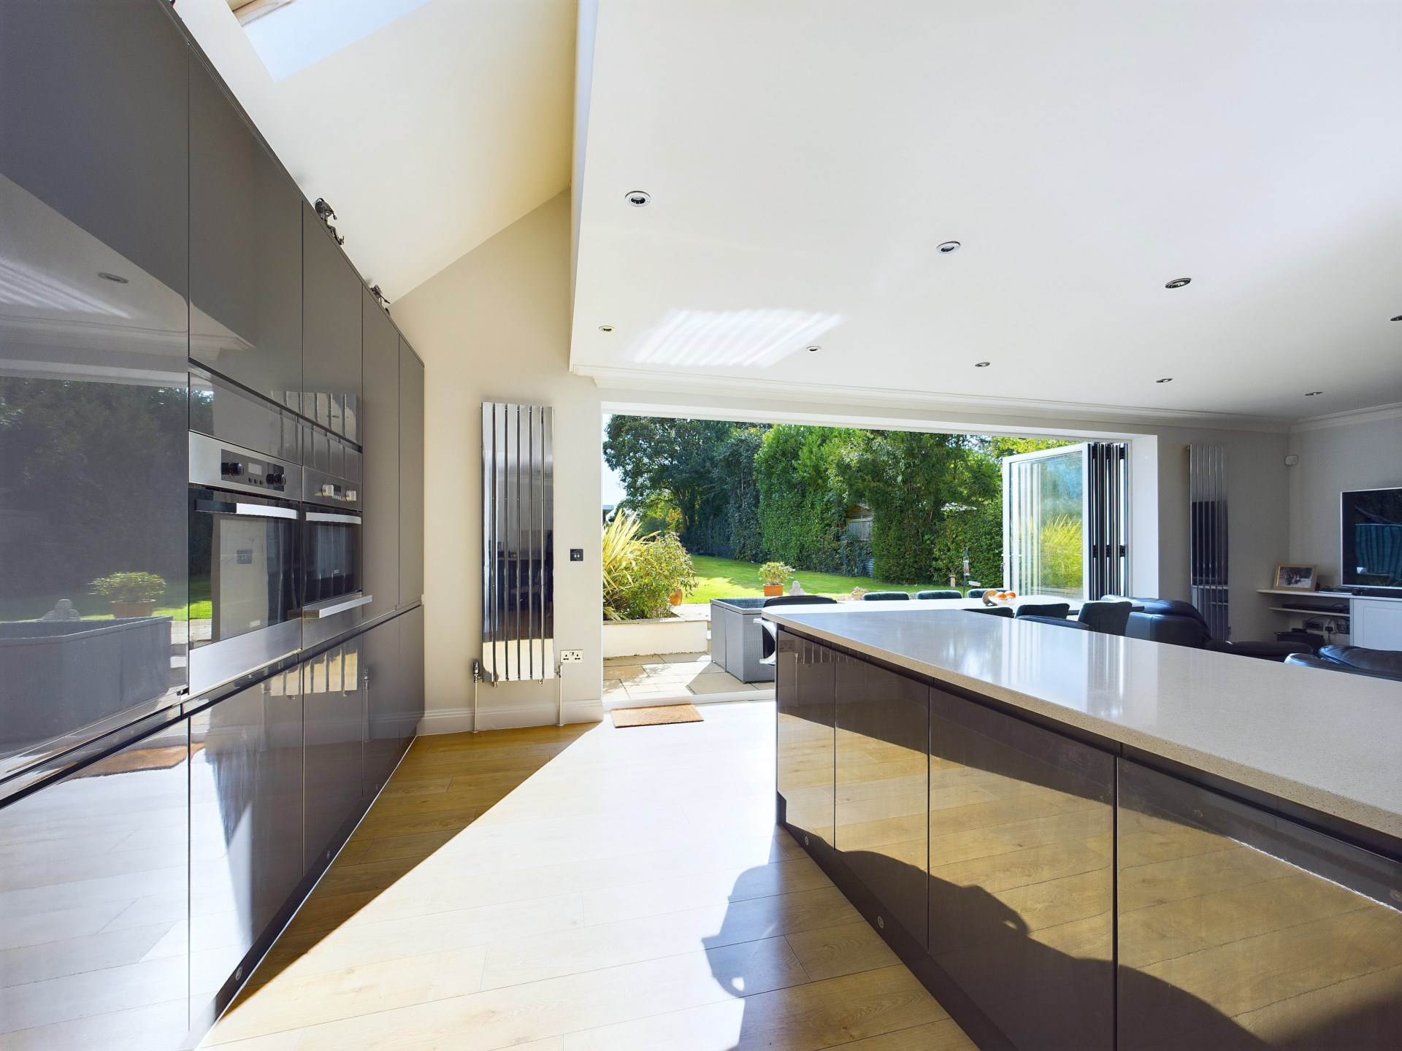

Location

Radnage is a small village located in the Chiltern Hills and occupies some of the most beautiful countryside in the county with quiet country lanes and an assortment of traditional farmhouses, cottages and detached homes. The village has a 12th century church. There are lots of footpaths and bridleways in the immediate vicinity and some link up to the Ridgeway. Despite its rural atmosphere, the village is close to Stokenchurch, Chinnor, Princes Risborough and High Wycombe.

In terms of schooling, the village has a well-regarded combined school, as well as nationally recognised senior schools such as the Royal Grammar School, Wycombe High School, and John Hampden Grammar School within catchment.

For the commuter there is easy access to the M40 motorway at Junction 5, providing links to Oxford, Birmingham and London. The nearest railway station is Princes Risborough just 5 miles away, with links to London Marylebone (35 minutes) and Birmingham.

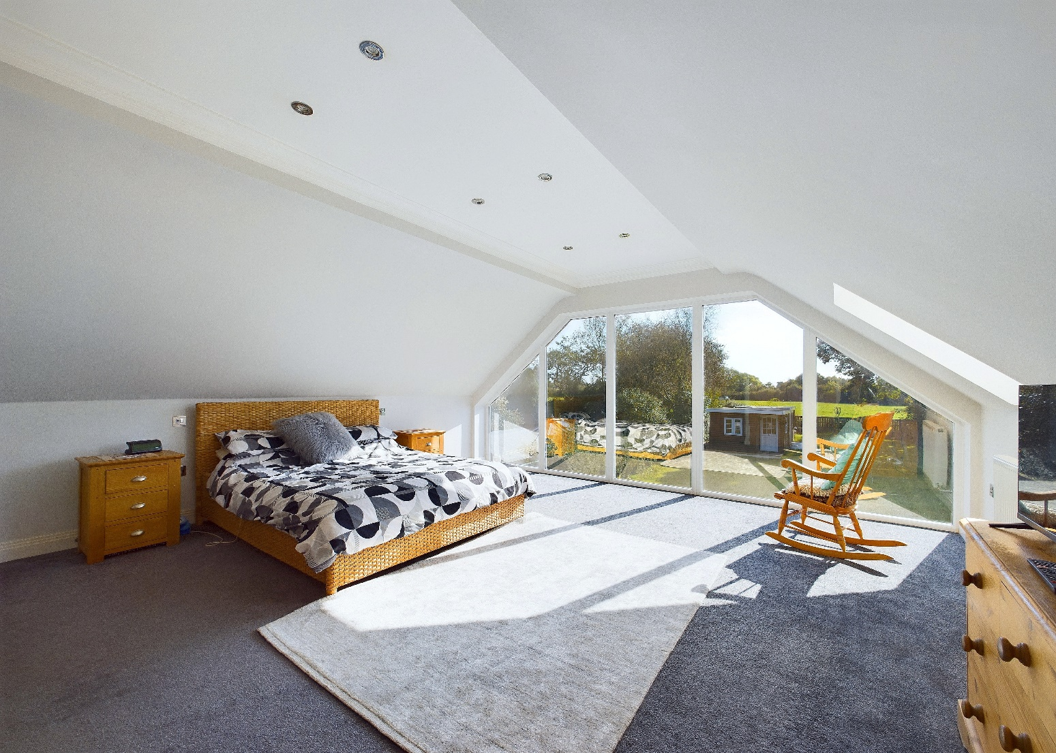

Description

The property consists of: main entrance hallway where all rooms lead from. To the front of the property there are two spacious double bedrooms, both with generous built in wardrobes and a modern downstairs cloakroom.

The reception/family room really is the heart of the home, warm and cosy in the winter with a wood burning stove, and bright and sunny in the summer with bi-fold revealing the pretty garden and paddocks beyond, making this the perfect place to entertain family and friends in true style and comfort. The well appointed kitchen has ample eye and waist level units, granite work tops, middle island with seating , double ovens, double fridge and freezer and wood flooring throughout.

From the kitchen there is a separate utility room, with plumbing for white goods and further storage.

The upstairs master bedroom boasts private elevated views through the picture gallery window, no curtains required!! and a double walk in wardrobe.

There is also another double wardrobe in the hallway and a fabulous family bathroom, with bath and a separate double shower and rain fall shower head, heated towel rail and vanity unit.

**Outside**

To the front of the property there is a small garden and ample parking for numerous vehicles.

The rear garden is laid mainly to lawn with a sociable patio area and mature hedging and trees providing privacy and backing onto pony paddocks. You might be lucky enough to see the resident Kite.

The out building provides a comfortable home office with double glazing, heating, power and lights and a workshop.

Other notable features include: double glazing throughout, LPG central heating, cavity wall insulation and a modern boiler.

**Please note the house has been completely renovated since the EPC was produced**.

General Remarks and Stipulations

Services

LPG gas central heating, mains drains and water.

EPC Rating

F

Local Authority

South Oxfordshire District Council

Viewing

Strictly by appointment with Bonners & Babingtons

Important Notice

Bonners & Babingtons, their clients and any joint agents give notice that:

1. They are not authorised to make or give any representations or warranties in relation to the property either here or elsewhere, either on their own behalf or on behalf of their client or otherwise. They assume no responsibility for any statement that may be made in these particulars. These particulars do not form part of any offer or contract and must not be relied upon as statements or representations of fact.

2. Any areas, measurements or distances are approximate. The text, photographs and plans are for guidance only and are not necessarily comprehensive. It should not be assumed that the property has all necessary planning, building regulation or other consents and Bonners & Babingtons have not tested any services, equipment or facilities. Purchasers must satisfy themselves by inspection or otherwise.

