bb-logo-final

New Road

Bolter End

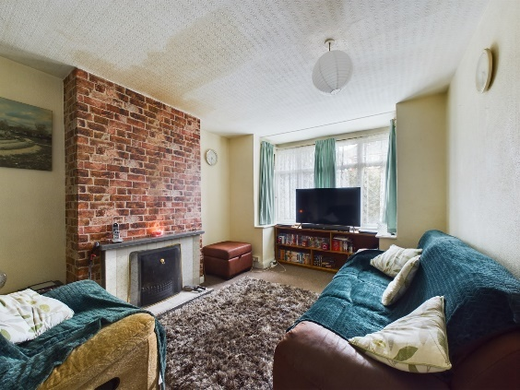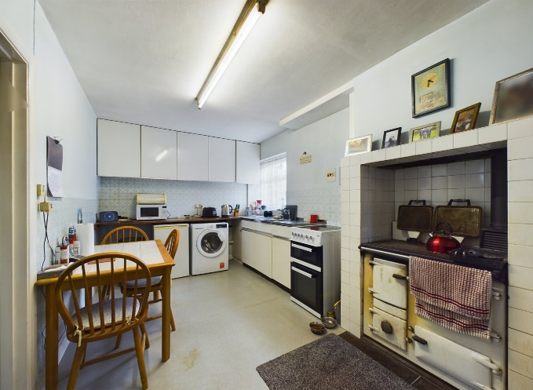

**- Tenure:- Freehold**

**- Guide Price:- £475,000**

**- Council Tax Band: E**

**- Local Authority: WDC**

**- EPC Rating: G**

New Road

Bolter End

Buckinghamshire

HP14 3NA

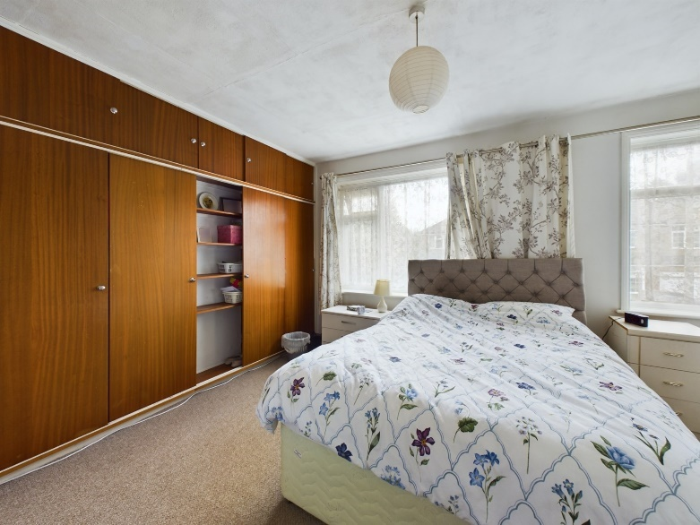

Positioned on a large plot (0.25 acre) this detached family home is offered to the market for the very first time. Comprising three bedrooms, two reception rooms, kitchen and family bathroom this property offers a wealth of potential. The house has been in the same family since construction in the early 1900`s and is only being offered to the market now. With a large rear garden extending to approximately 180 feet this property is a prime opportunity to create the perfect family home. Situated on a private road and only a short drive to Lane End this property requires modernisation throughout but also has room to extend (STPP).

Bolter End is a hamlet approximately 5 miles to the west of High Wycombe, and 5 miles to the North of Marlow. There is an abundance of walks and bridleways in the vicinity, and local hostelries and amenities are a short drive away in the village of Lane End. There are excellent rail links into London Marylebone from High Wycombe, and the M40 junction 4 and 5 are a 10 minute drive away.

Coming to the market for the first time ever is this delightful three bedroom detached home situated on a private road in the rural hamlet of Bolter End. Offered with a quarter of an acre plot this property is an ideal project opportunity.

