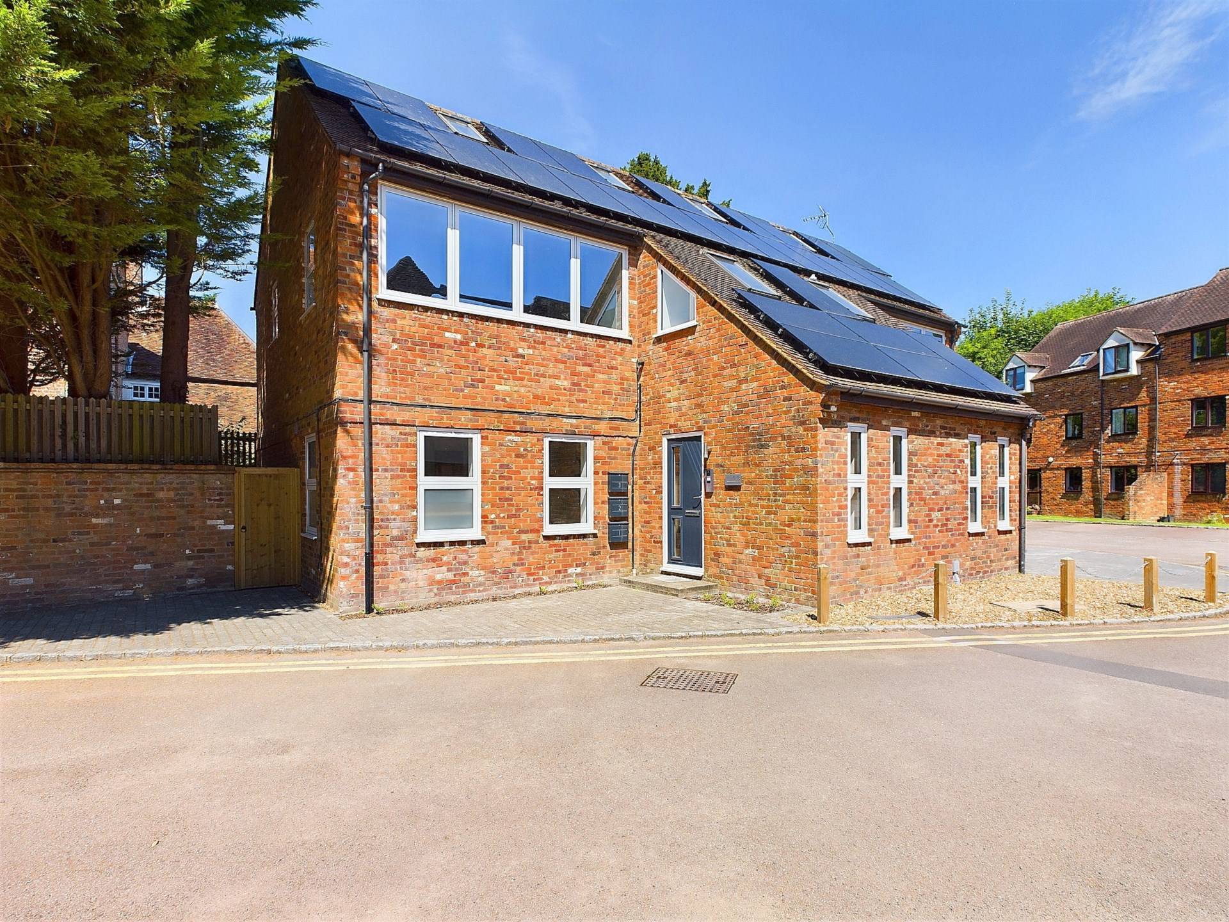bb-logo-final

**Buchanan House**

**Princes Risborough**

- Tenure:- Share of Freehold

- Guide Price £410,000

- Lease 99 years

- Service Charge & Ground Rent TBC

- Tenure – Share of Freehold

- Council Tax Band

- EPC Rating C

Buchanan House

Princes Risborough

Buckinghamshire

HP27 9AJ

A fabulous and superbly spacious luxury apartment situated in the heart of this popular market town within easy walking distance of amenities and the mainline train station. The property forms part of the luxury development of four apartments finished to the highest specification and offered for sale with the share of freehold. Prices start from £300,000.

The accommodation briefly comprises security entry system leading to a communal reception hall with study area, a superb `open plan` kitchen/living room, the kitchen has ample storage and a range of integrated appliances, internal hallway with storage, double bedroom with built-in wardrobes and lovely modern shower room. Outside there is off-road parking for one car.

The property also benefits from UPVC double glazing, modern electric heating system and solar panels. The apartments have a modern contemporary feel throughout with great attention to detail ,offering light and spacious accommodation with the latest in technology making these apartments super energy efficient.

The attractive market town of Princes Risborough offers a post office, a leisure centre and a good range of local shops including a Tesco, Marks & Spencer Simply Food and Costa Coffee. Further, more comprehensive leisure and shopping facilities can be found in High Wycombe, Aylesbury and Oxford all within easy reach.

There is access to the M40 motorway for London and the Midlands just 6 miles away (J6) and Princes Risborough station offers an excellent main line rail service to London (Marylebone - 35 minutes) and the Midlands.

A stunning development of luxury apartments finished to the highest specification sold with the benefit of the Share of Freehold and situated in the heart of the town centre within easy walking distance of amenities

78 High Street, Princes Risborough, Buckinghamshire, HP27 0AX

01844 343661

www.bb-estateagents.co.uk

