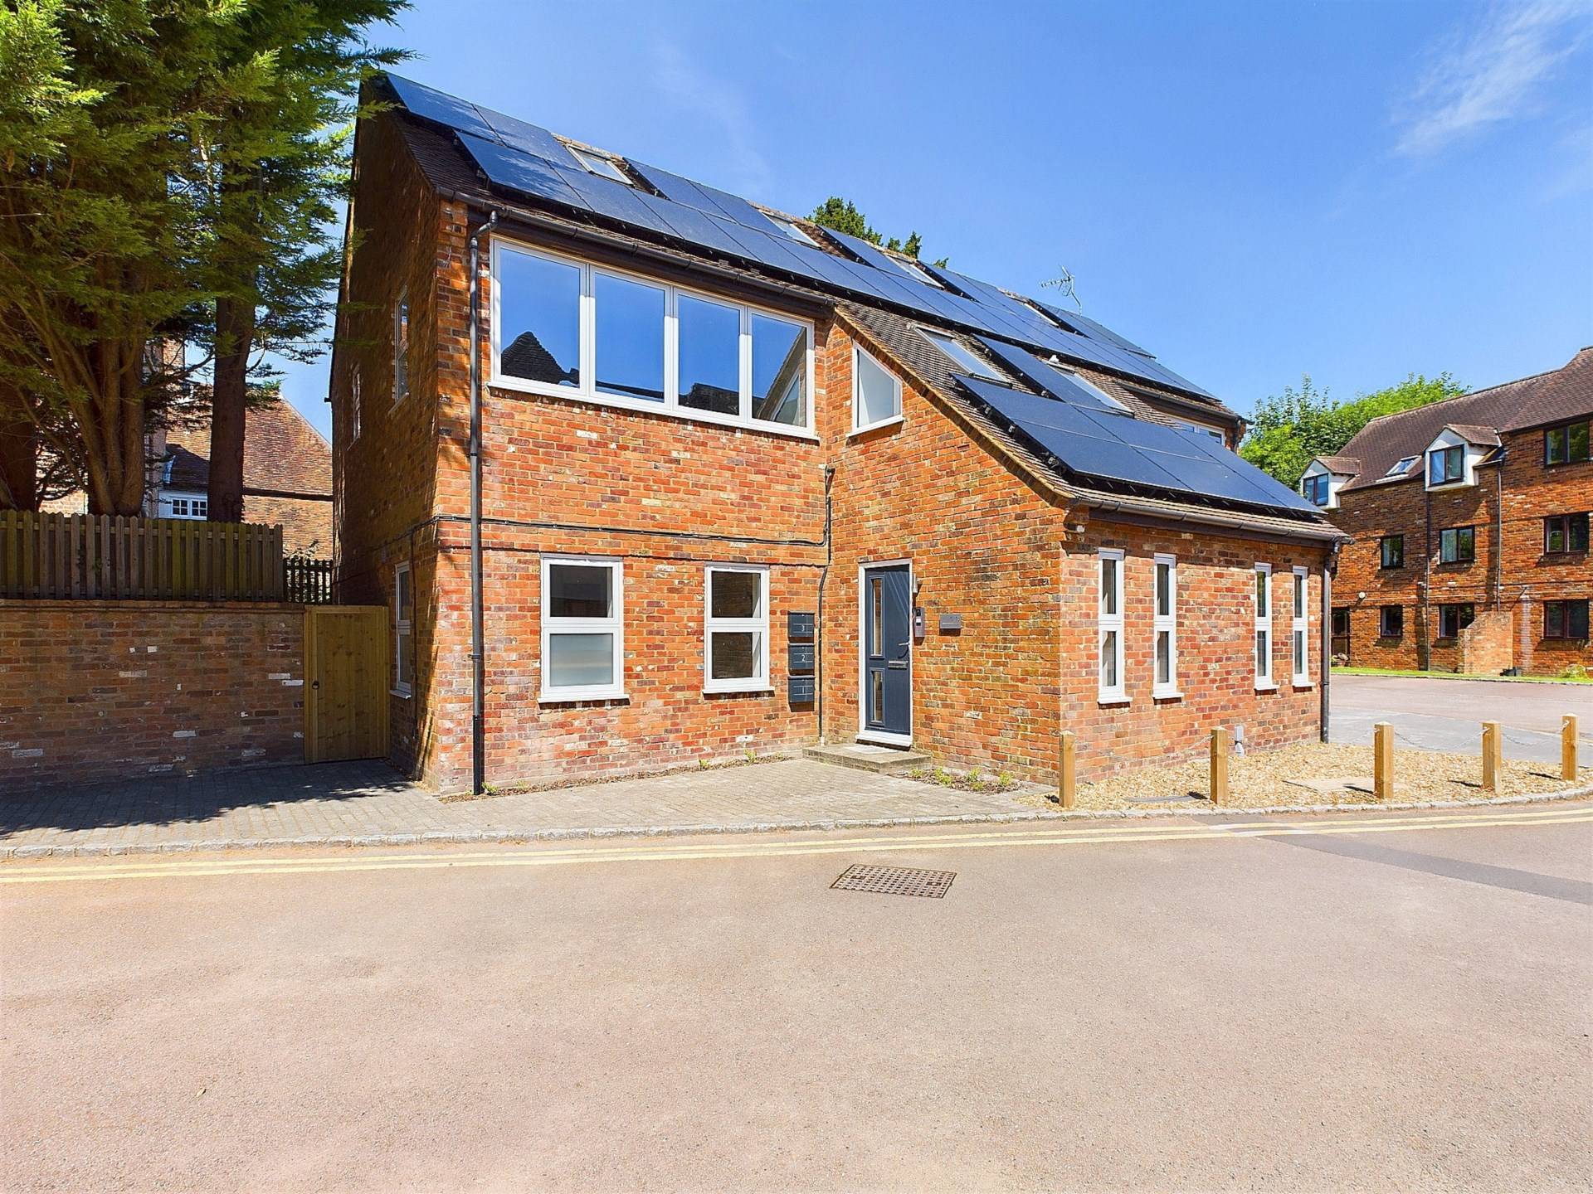bb-logo-final

**Buchanan House**

**Princes Risborough**

- Tenure:- Share of Freehold

- Guide Price £385,000

- Lease 99 years

- Service Charge & Ground Rent TBC

- Tenure – Share of Freehold

- Council Tax Band

- EPC Rating C

Buchanan House

Princes Risborough

Buckinghamshire

HP27 9AJ

A fabulous and superbly spacious luxury duplex apartment situated in the heart of this popular market town within easy walking distance of amenities and the mainline train station. The property forms part of the luxury development of four apartments finished to the highest specification and offered for sale with the Share of Freehold. Prices start from £300,000.

The accommodation briefly comprises security entry system leading to a communal reception hall and stairs to the first floor, a private entrance hall with utility/storage cupboard, a superb 'open plan' kitchen/living room with double aspect, the kitchen has ample storage and a range of integrated appliances. On the second floor there is a double bedroom with vaulted ceiling and built-in wardrobes and en suite cloakroom.

The property also benefits from UPVC double glazing, modern electric heating system and solar panels. The apartments have a modern contemporary feel throughout with great attention to detail ,offering light and spacious accommodation with the latest in technology making these apartments super energy efficient.

The contemporary kitchens have been extremely well designed and laid out providing excellent storage, with a range integrated appliances including a built in oven , built in combination oven/microwave, integrated fridge and freezer, built in dishwasher, induction hob and extractor. The kitchens are open plan with the living rooms where there is ample space for both relaxing and dining.

These apartments all have individual parking spaces for one vehicle which is a rarity in the centre of Princes Risborough.

A stunning development of luxury apartments finished to the highest specification sold with the benefit of the Share of Freehold and situated in the heart of the town centre within easy walking distance of amenities

78 High Street, Princes Risborough, Buckinghamshire, HP27 0AX

01844 343661

www.bb-estateagents.co.uk

