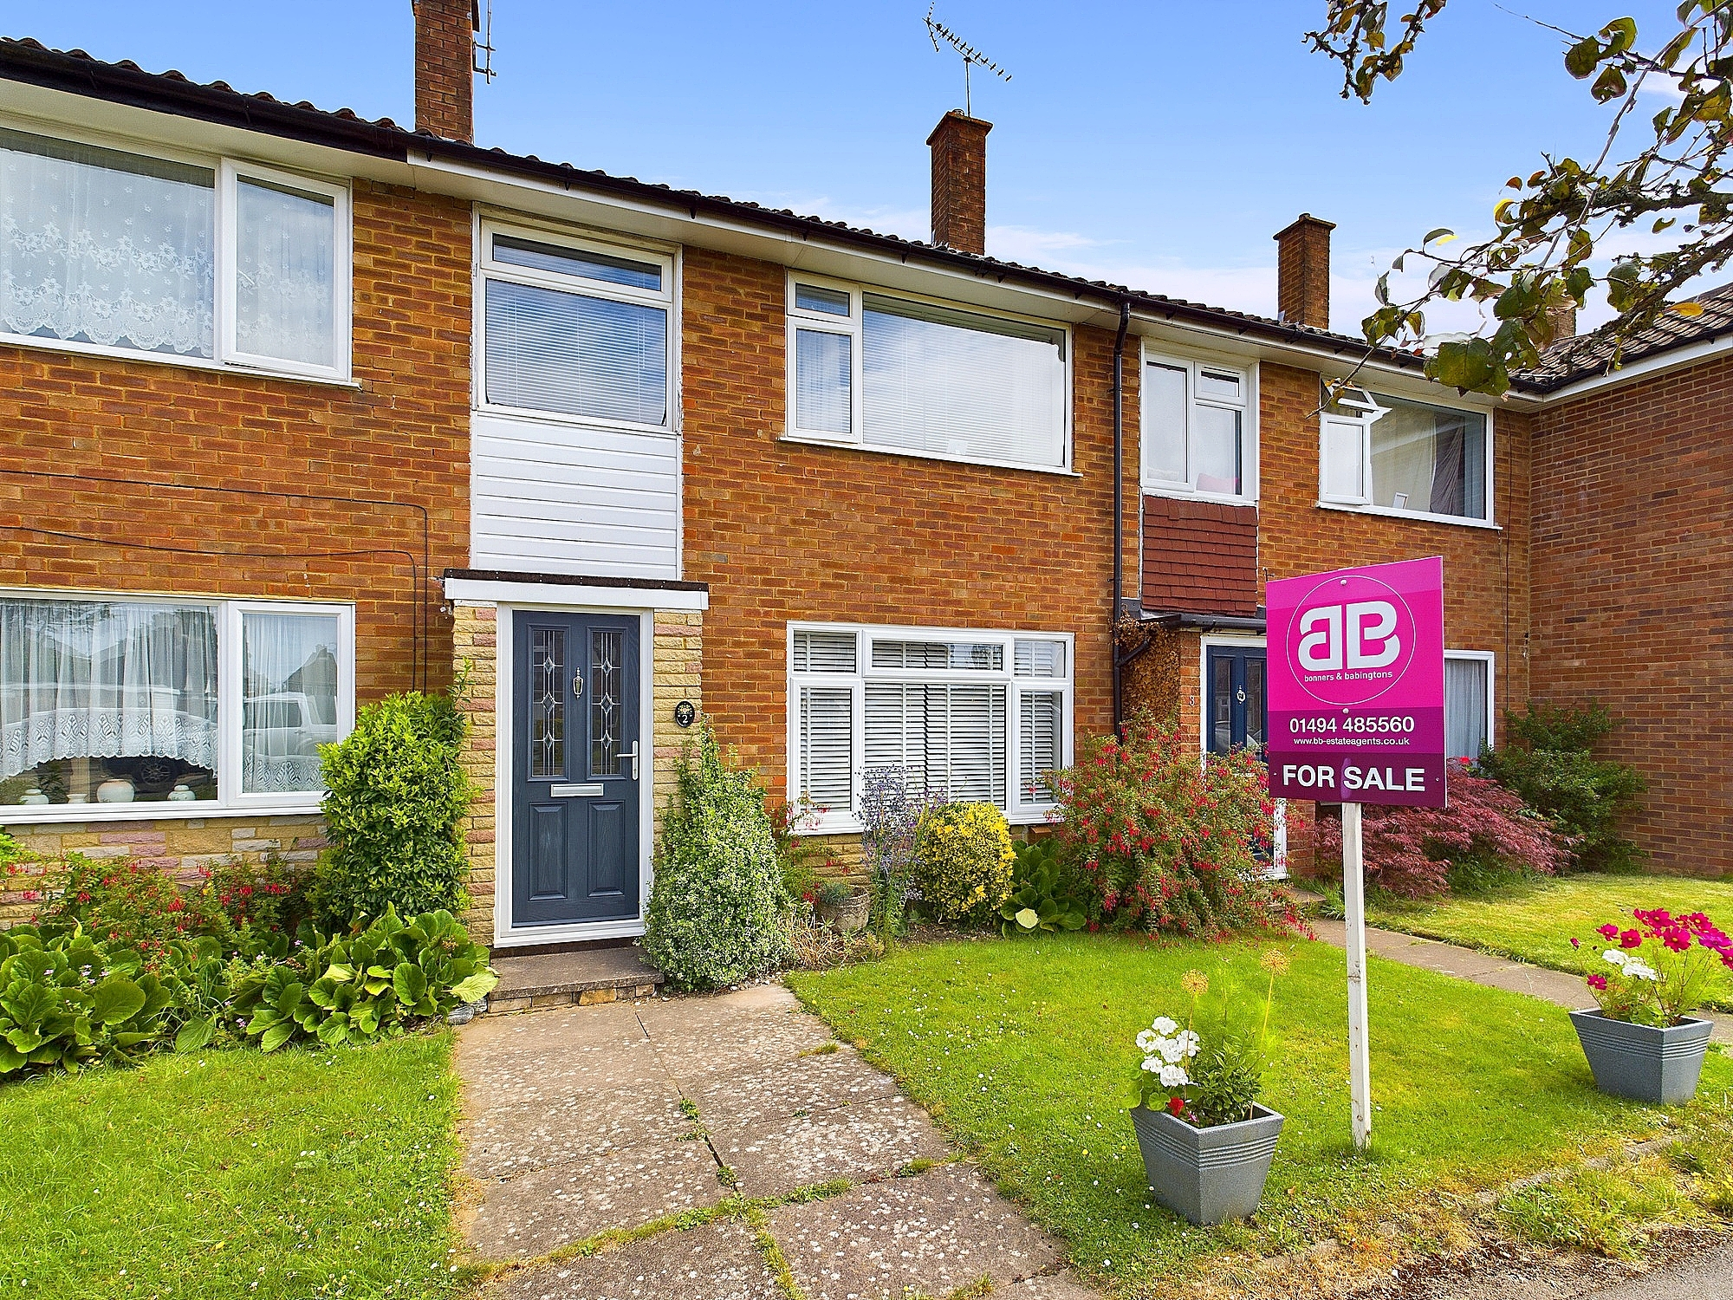bb-logo-final

Old Farm Road

Downley

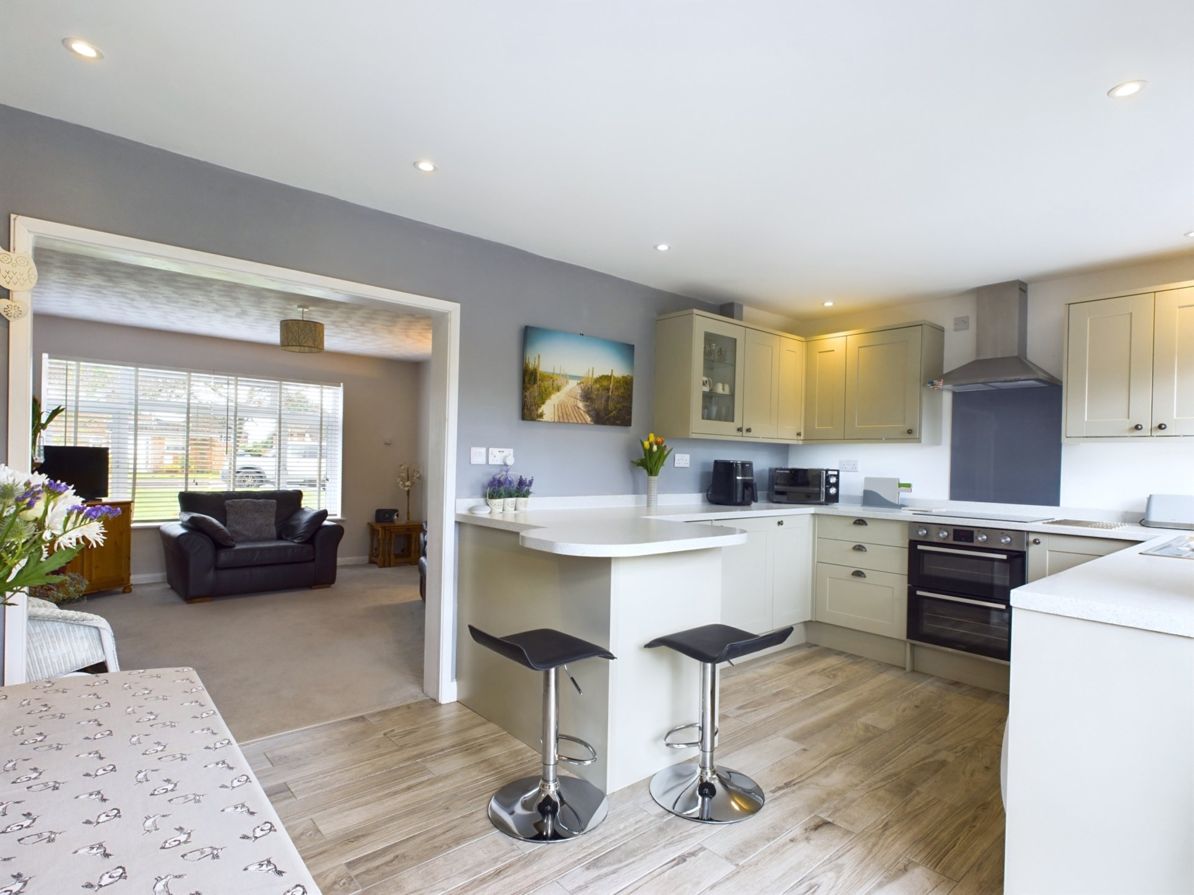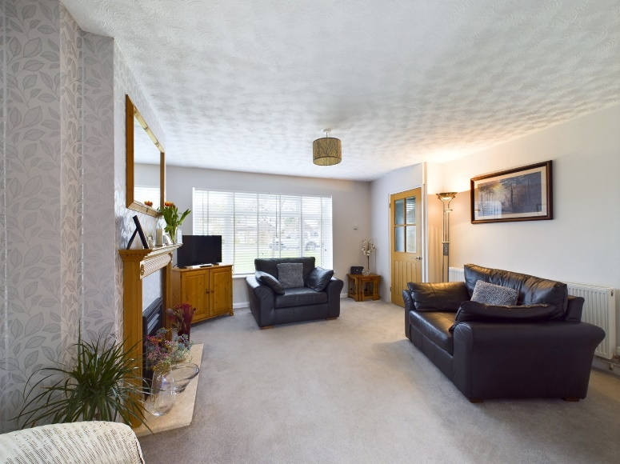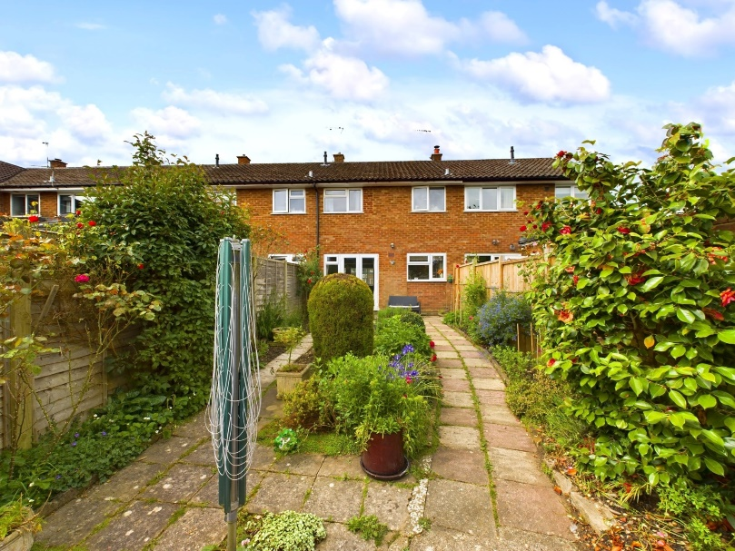

Old Farm Road

Downley

High Wycombe

Buckinghamshire

HP13 5LP

Offers Over- £410,000

A beautifully presented and modern three bedroom terraced house which is positioned within a quiet cul-de-sac. The property is located within the highly regarded village of Downley with excellent schools, amenities and transport links all within walking distance and a short drive of the property.

The property accommodation comprises of the following. entrance hallway leading through to a good sized living room with fireplace and storage cupboard, a recently renovated, open plan kitchen / diner benefiting from waist height & eye level cupboards, built in appliances, breakfast bar and French doors opening to the rear garden.

Upstairs you will find two good sized double bedrooms, a further single bedroom and a newly fitted family bathroom with bath and overhead power shower.

To the rear, French doors from the kitchen / diner lead you out to a sunny, low maintenance garden with access into the single garage which can store a car and one allocated parking space.

To the front, there is a small but pretty front garden and communal green and ample on street parking if required.

Other notable features include, mains gas central heating system, double glazed windows and loft storage space.

Downley Village

Downley is a picturesque village to the north west of High Wycombe providing excellent schooling, with a highly sought after primary school within walking distance and within catchment of The Royal Grammar School and John Hampden Grammar School for boys along with the Wycombe High School for girls. Locally the prestigious National Trust Downley Common allows miles of countryside walks. High Wycombe offers links to London which include a mainline railway station with direct service to London Marylebone and junctions 3 and 4 of the M40 motorway.

Council Tax Band – D

EPC RATING - D

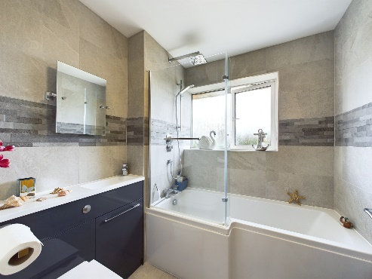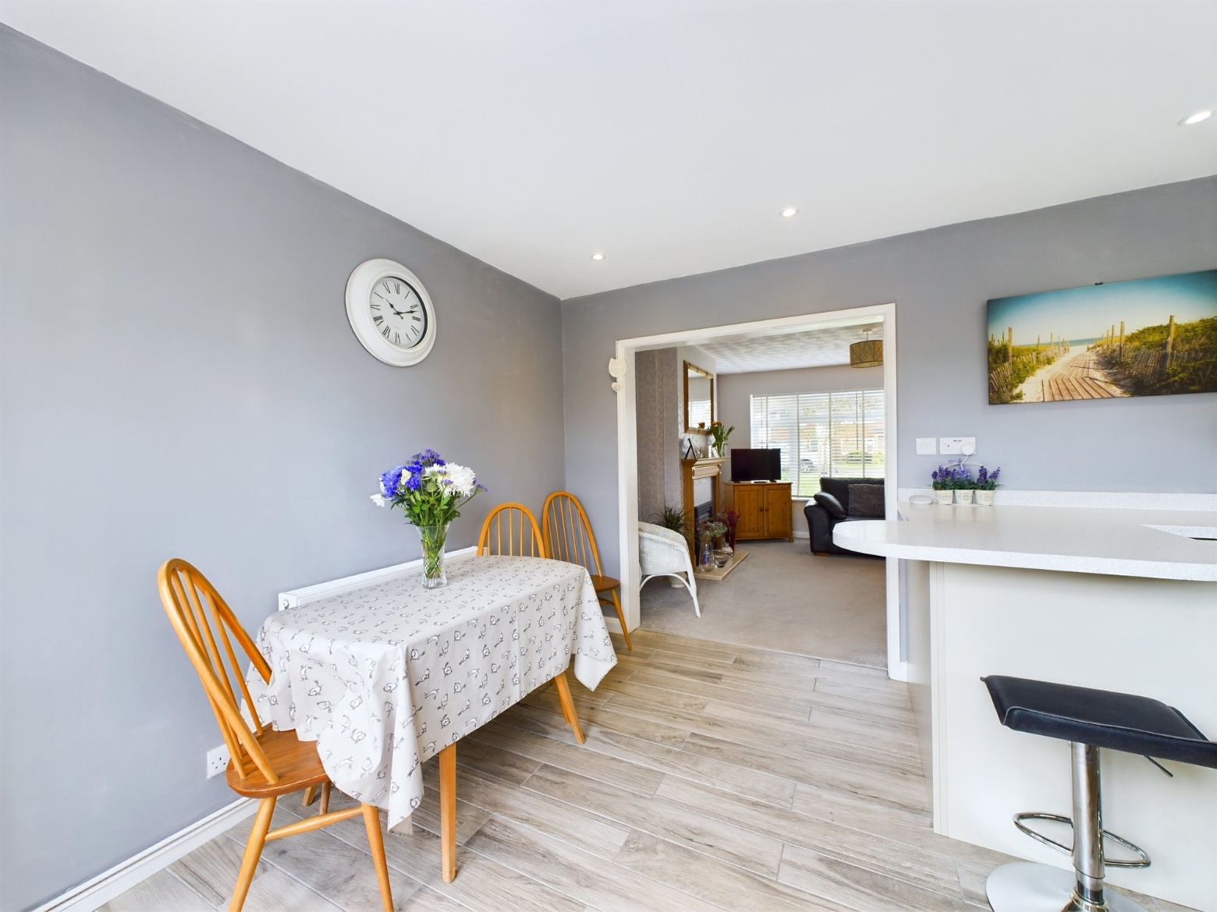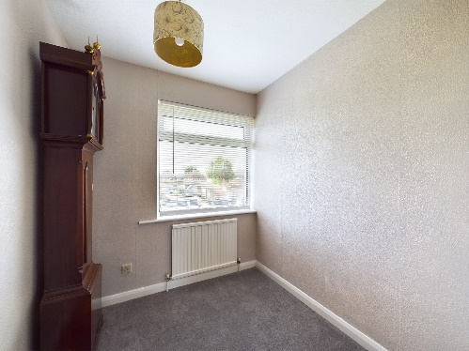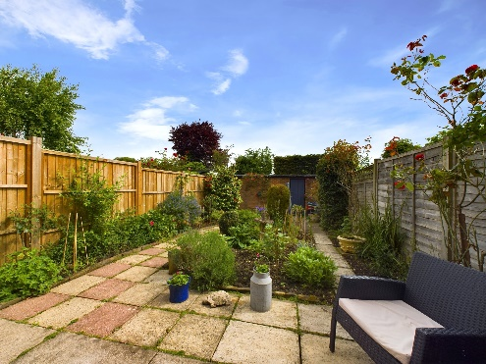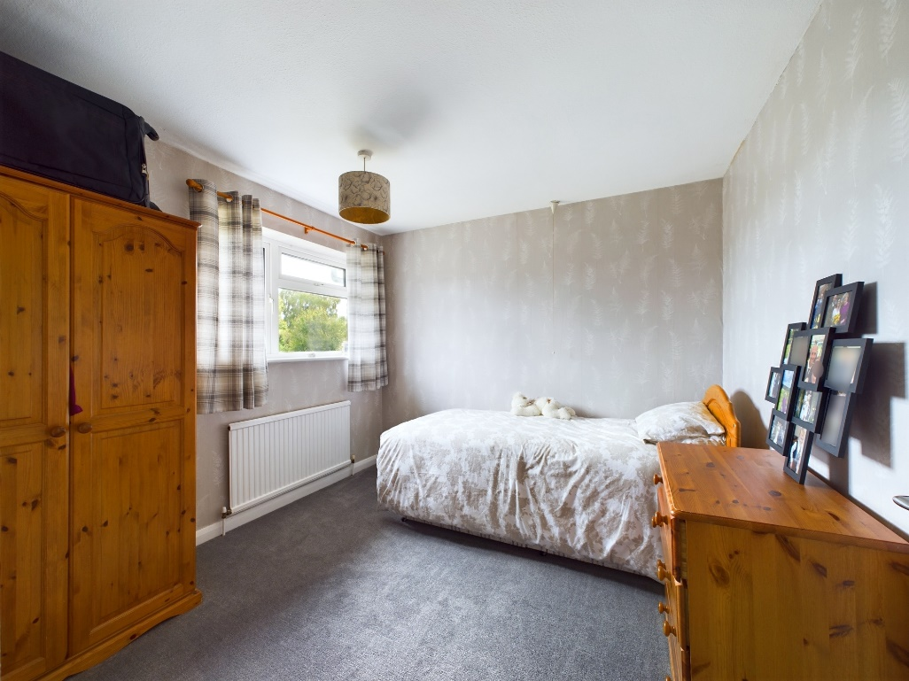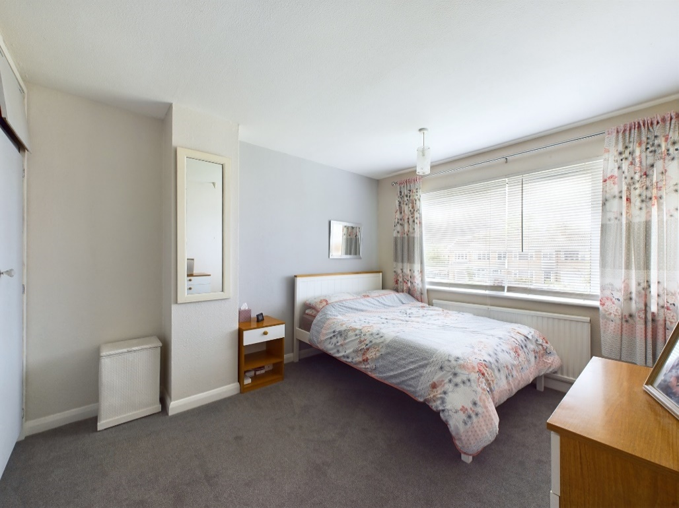

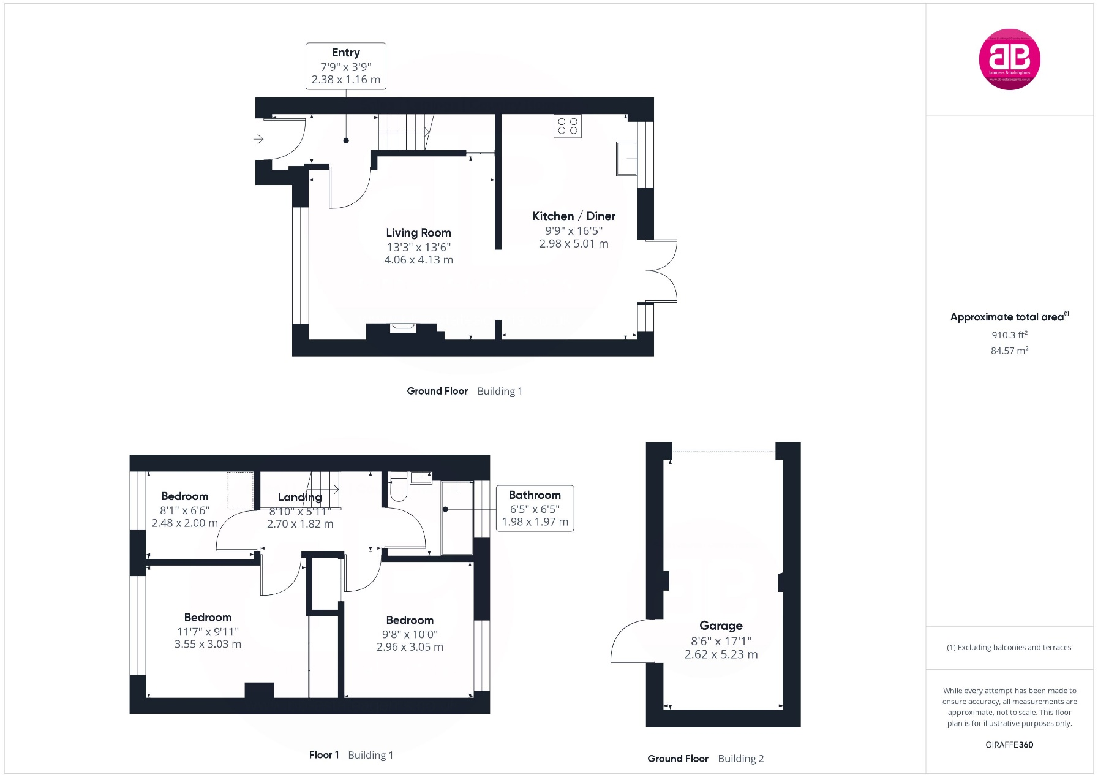

Zoopla LogoNAEA Propertymark Protected CMYKRM_Logo_NoStrap_Colourfacebook logoPrimelocation lscape

**Disclaimer**

We endeavour to make our particulars accurate and reliable. They are for guidance only and are intended to give a fair overall summary of the property. They do not form part of any contract or offer, and should not be relied upon as a statement or representation of fact. Measurements, areas and distances are approximate and photographs provided for guidance only. No undertaking is given as to the structural condition of the property, or any necessary consents, or the operating ability or efficiency of any service, system or appliance. Prospective purchasers must satisfy themselves with regard to each of these points. If there is any particular aspect of the property about which you would like further information, please contact us, especially, before you travel to the property. B2170

1 Karenza, Stokenchurch, High Wycombe, Buckinghamshire, HP14 3DA

01494 485560

www.bb-estateagents.co.uk