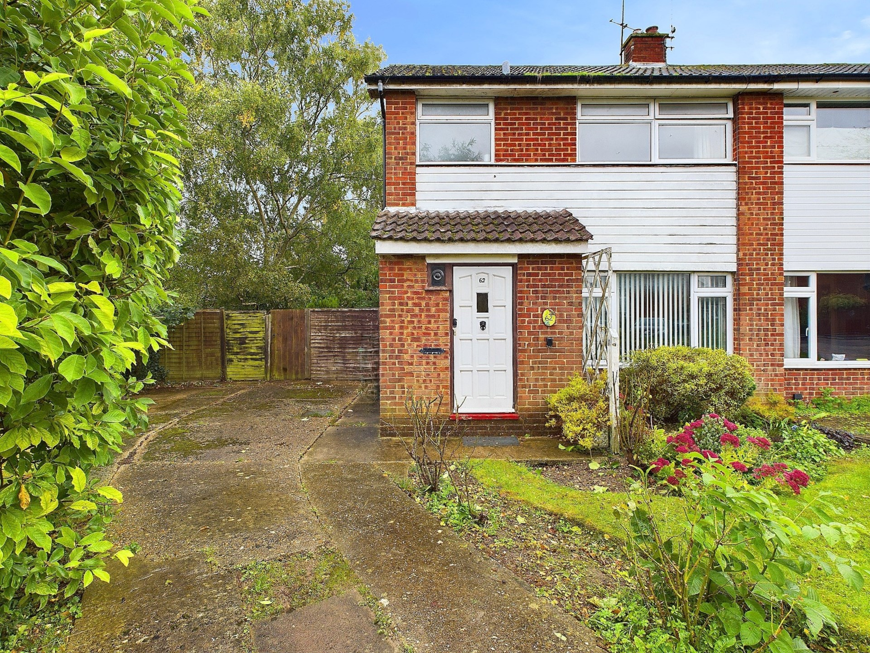



Beech Road

Chinnor

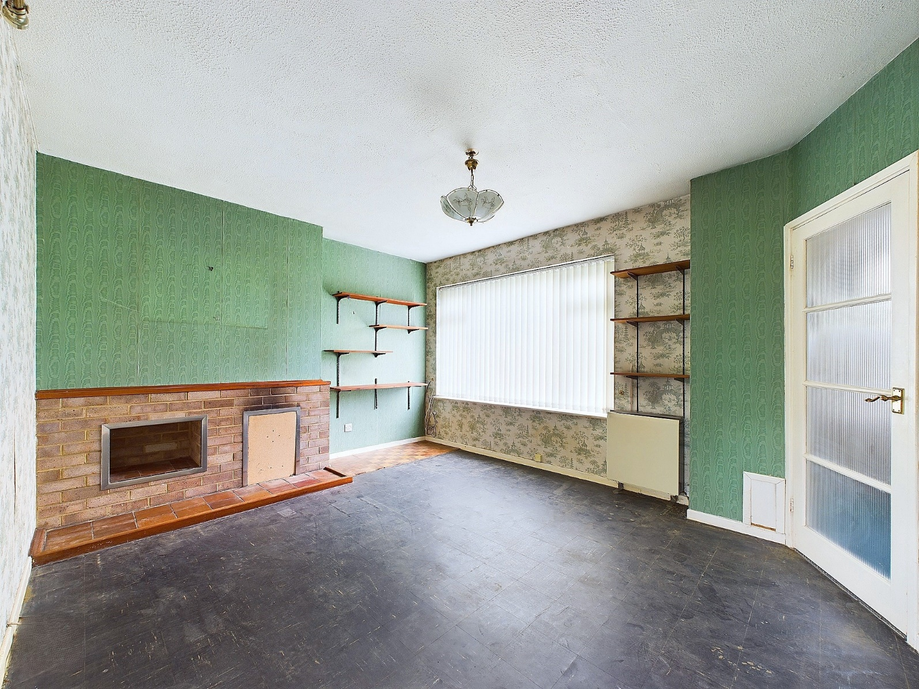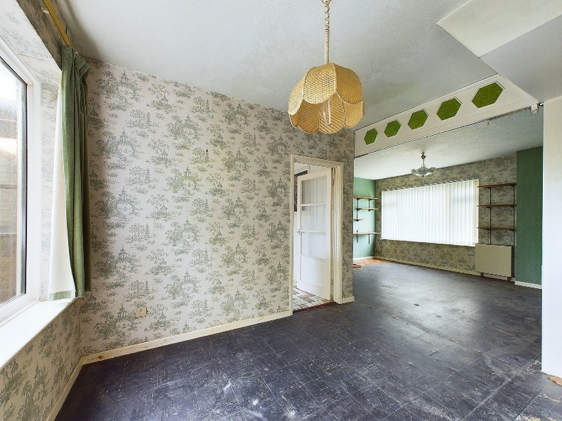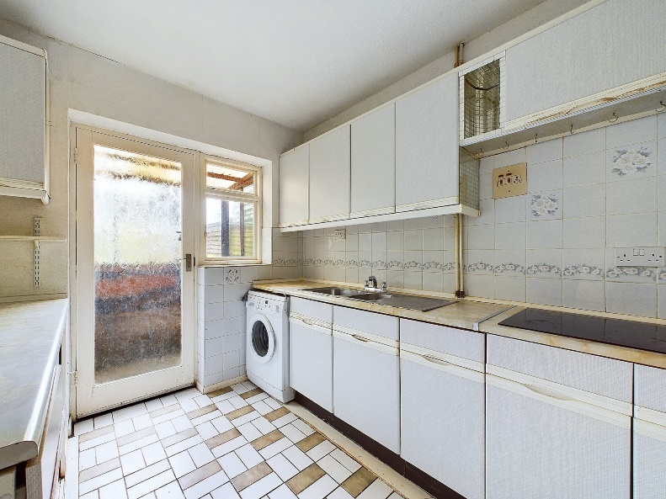

Beech Road

Chinnor

OX39 4RB

Guide Price: £425,000

A 3 bedroom semi-detached property occupying a larger than average corner plot, with huge potential to extend. Currently vacant and in need of complete renovation throughout, situated on a quiet road, close to local schools and amenities and excellent transport links.

This house is in need of a new lease of life and has the possibility of becoming a wonderful, modern family home. It consists of; entrance hallway with cupboard for shoes and coats, spacious, dual aspect, open plan living/dining room with fire place, understairs cupboard and access to the kitchen. In the kitchen, there is ample eye and waist level units, an electric hob and cooker, space for washing machine and fridge and back door to the small porch and further door to the rear garden.

Upstairs are three bedrooms, with two being good sized doubles and the third a single. There is a family bathroom, with bath and overhead electric shower and airing cupboard.

Outside: At the front of the property is a large drive and neat front lawn that leads you to the additional space at the side of the property, lending itself perfectly to an extension or garage. There is access to the rear garden, which is deceptively large, comprising a shed and small patio area, the remaining garden is laid to lawn with mature trees that offer seclusion and privacy.

Other notable features: The property is on main drains and has night storage heating

Location

Situated at the foot of the Chiltern Hills, Chinnor is a popular village conveniently situated on the Oxfordshire/Buckinghamshire borders. Within the village there are good local facilities including a variety of shops, churches, pubs and restaurants, post office, doctor`s surgery, a nursery and two combined schools. Chinnor lies within catchment for the highly regarded Lord Williams`s secondary school in Thame.

M40(Junction 6) is within 3 miles giving access to Oxford(20 miles), High Wycombe(13 miles) and London(48 miles). Princes Risborough mainline station is within 5 miles (Marylebone 35 minutes).

Council Tax:

Band D

EPC PENDING

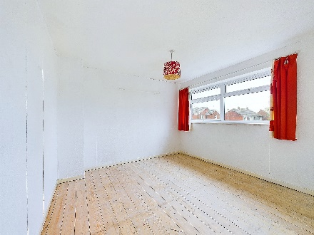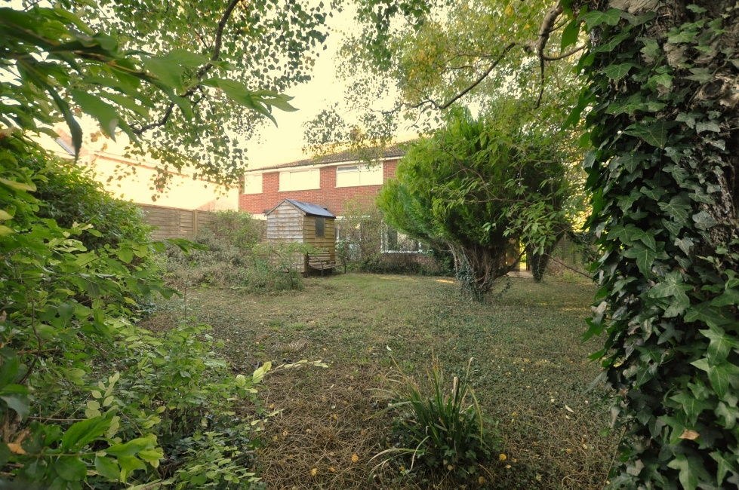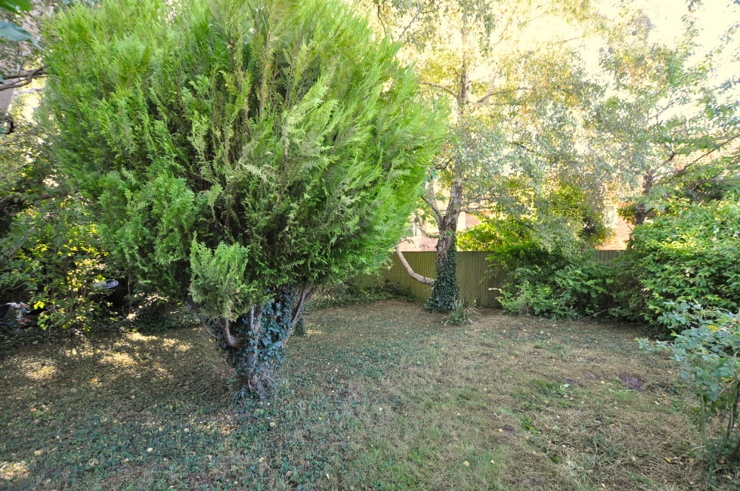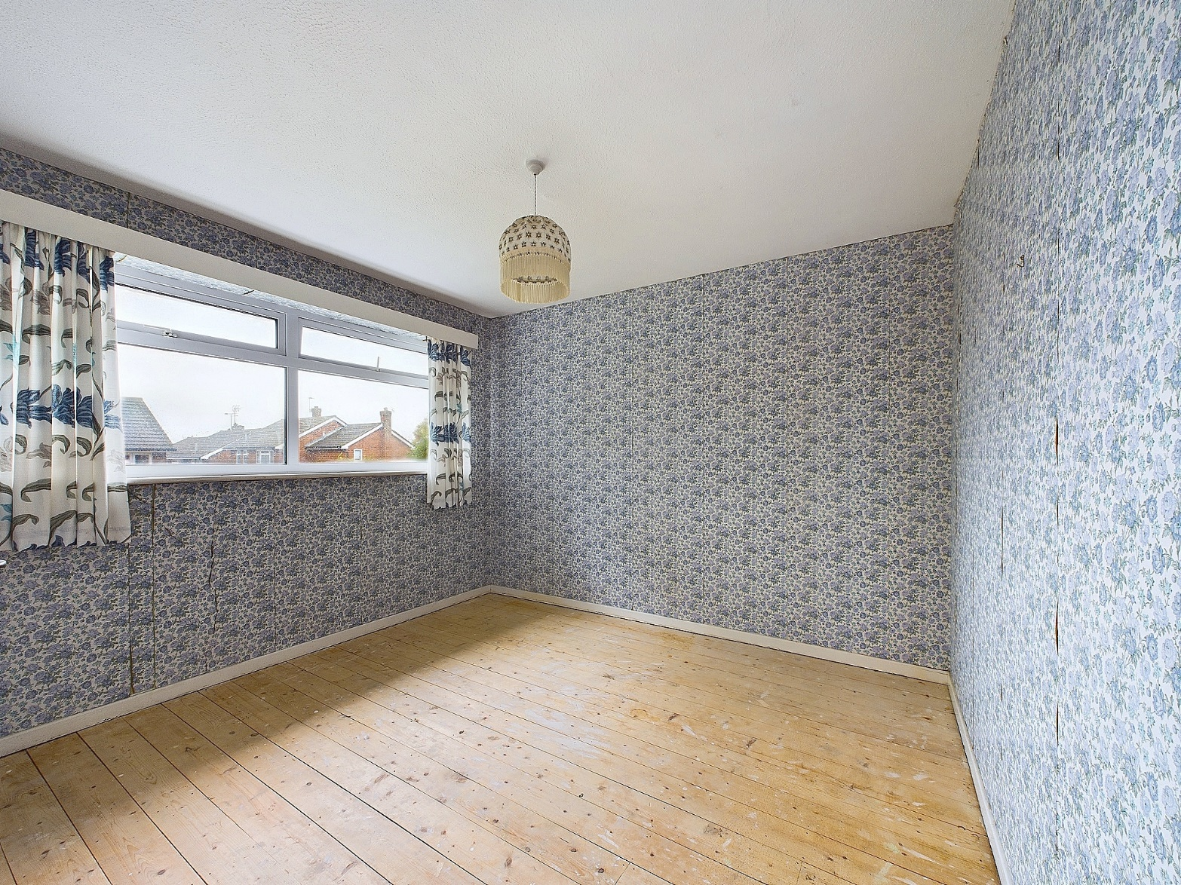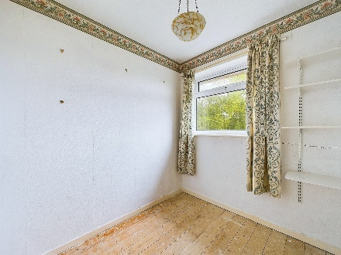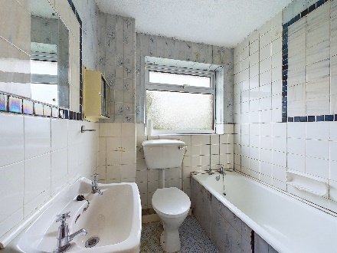

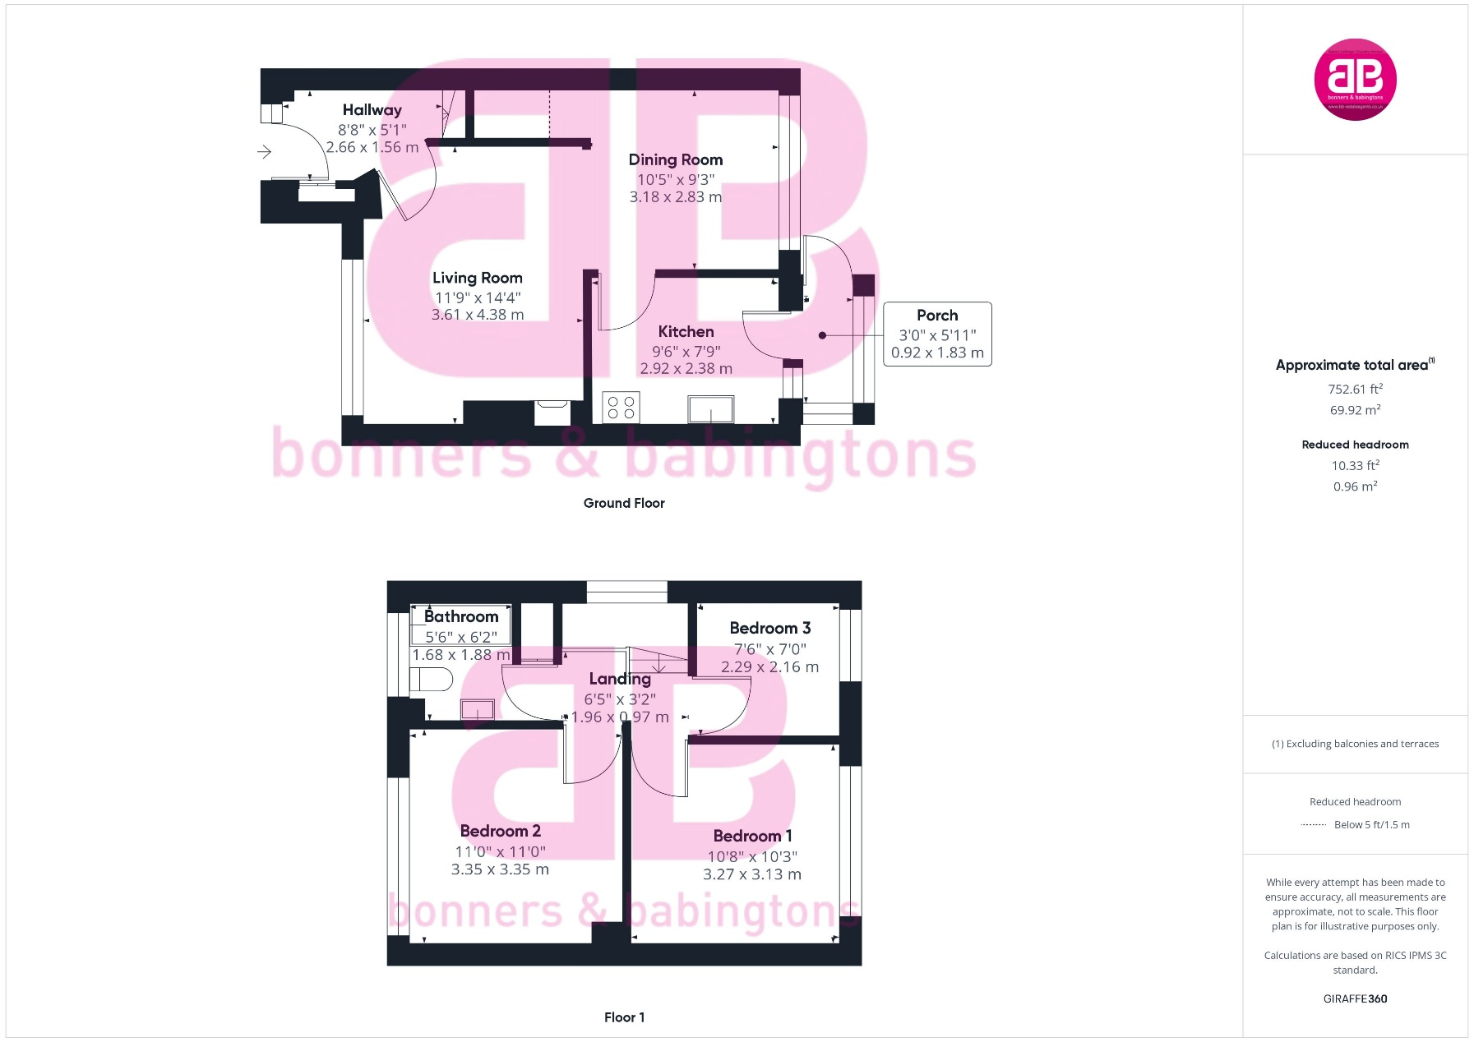Zoopla LogoNAEA Propertymark Protected CMYKRM_Logo_NoStrap_Colourfacebook logo

**Disclaimer**

We endeavour to make our particulars accurate and reliable. They are for guidance only and are intended to give a fair overall summary of the property. They do not form part of any contract or offer, and should not be relied upon as a statement or representation of fact. Measurements, areas and distances are approximate and photographs provided for guidance only. No undertaking is given as to the structural condition of the property, or any necessary consents, or the operating ability or efficiency of any service, system or appliance. Prospective purchasers must satisfy themselves with regard to each of these points. If there is any particular aspect of the property about which you would like further information, please contact us, especially, before you travel to the property. B2170

Robert House, 19 Station Road, Chinnor, Oxfordshire, OX39 4PU

01844 354554

www.bb-estateagents.co.uk