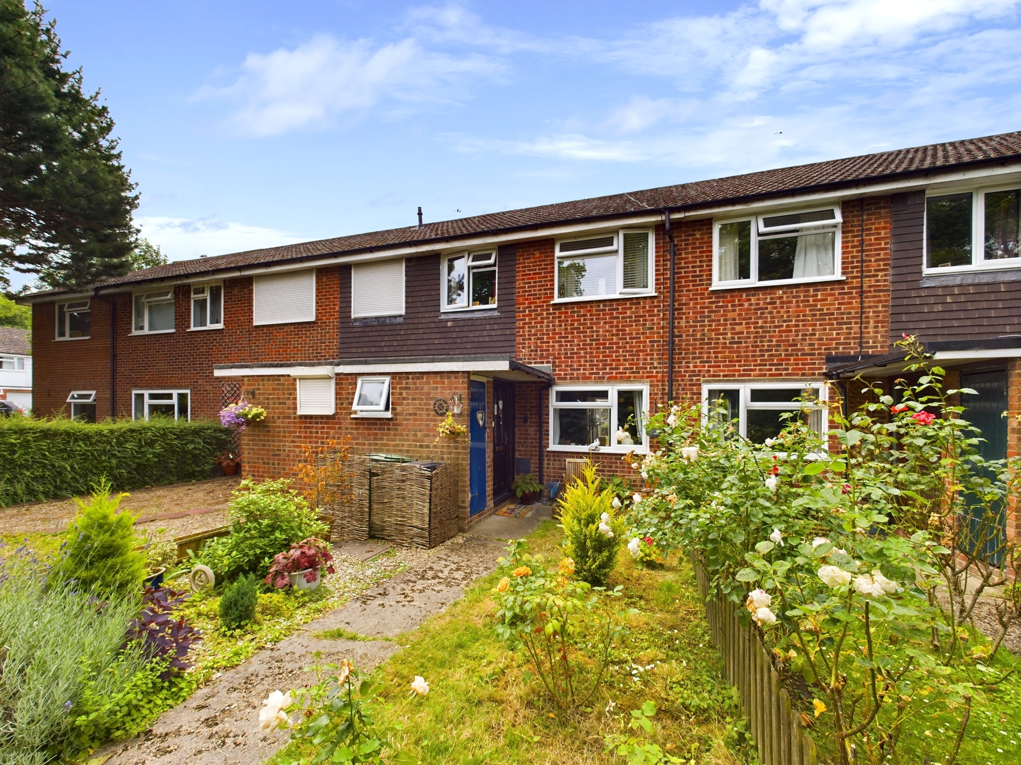



Estover Way

Chinnor

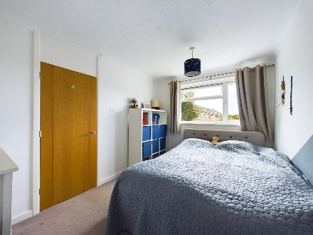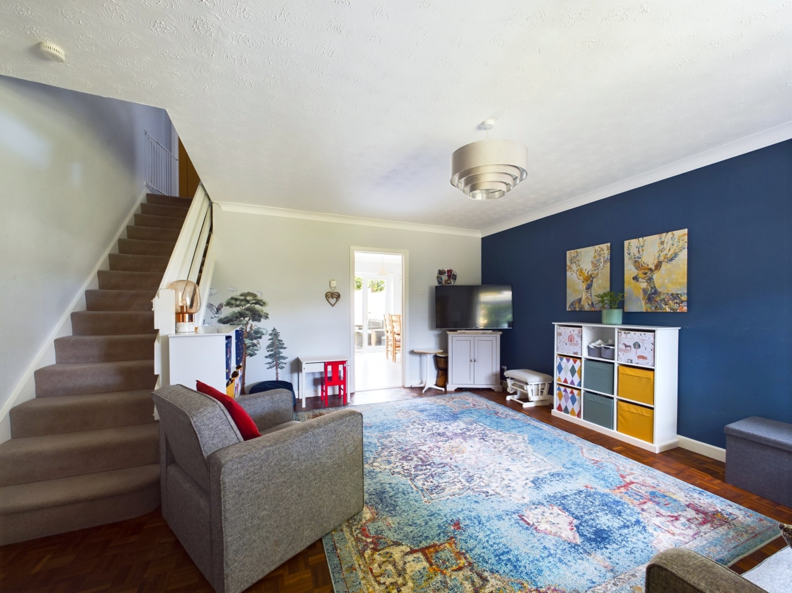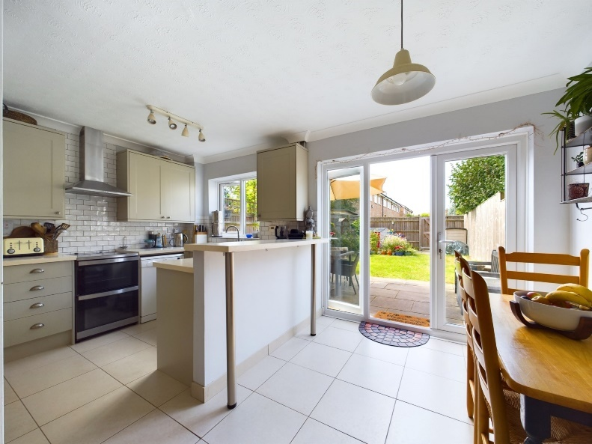

Estover Way

Chinnor

OX39 4TF

Guide Price: £375,000

A beautifully presented, spacious and airy, 3 bedroom home. Offering easy flow living with a well appointed open plan kitchen/diner, south facing garden and garage. Situated on a quiet road within level walking distance of local shops, amenities and schools,

This property is warm and inviting with a good flow throughout. The entrance porch has space for shoes and coats and a separate WC. The main reception room follows on and has well preserved original parquet flooring, generous space for soft furnishings and storage and doorway through to the kitchen/diner. The kitchen area is conveniently laid out with eye level storage, bonus pantry cupboard under the stairs, and space for white goods and free standing fridge freezer. There is a breakfast bar and plenty of space for a family dining table and also benefits from French doors out to the colourful well kept south facing garden.

Upstairs are two good sized double bedrooms with built in storage, a further third single bedroom, modern bathroom with overhead shower and heated towel rail, airing cupboard, landing storage cupboard, and access to the boarded loft with ladder and lights.

**Outside:**

The pretty rear, south facing garden has a generous patio area for outdoor dining and socialising, raised flower beds and a space for children's play area. The remaining garden is laid to lawn. One of the benefits of the garden is that it is not directly overlooked and feels very private. There is also rear access to a footpath that runs along the back of the neighbouring properties to the single garage and parking.

At the front of the property is another pretty garden space with flowers and seating area to enjoy the morning sun and watch the world go by.

The house is accessed from a footpath that adjoins neighbouring streets, Robins Platt or Ashridge.

**Other notable features**; gas central heating, double glazing throughout.

**Location**

Situated at the foot of the Chiltern Hills, Chinnor is a popular village conveniently situated on the Oxfordshire/Buckinghamshire borders. Within the village there are good local facilities including a variety of shops, churches, pubs and restaurants, post office, doctor`s surgery, a nursery and two combined schools. Chinnor lies within catchment for the highly regarded Lord Williams`s secondary school in Thame.

M40(Junction 6) is within 3 miles giving access to Oxford(20 miles), High Wycombe(13 miles) and London(48 miles). Princes Risborough mainline station is within 5 miles (Marylebone 35 minutes).

**Council Tax Band C**

**EPC Rating C**

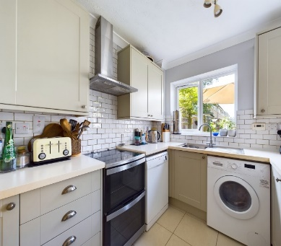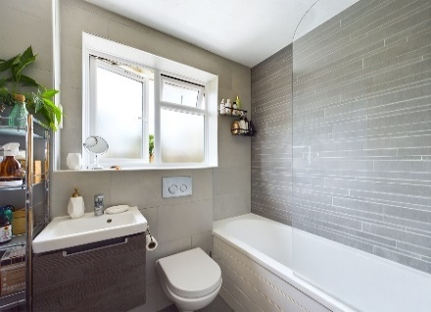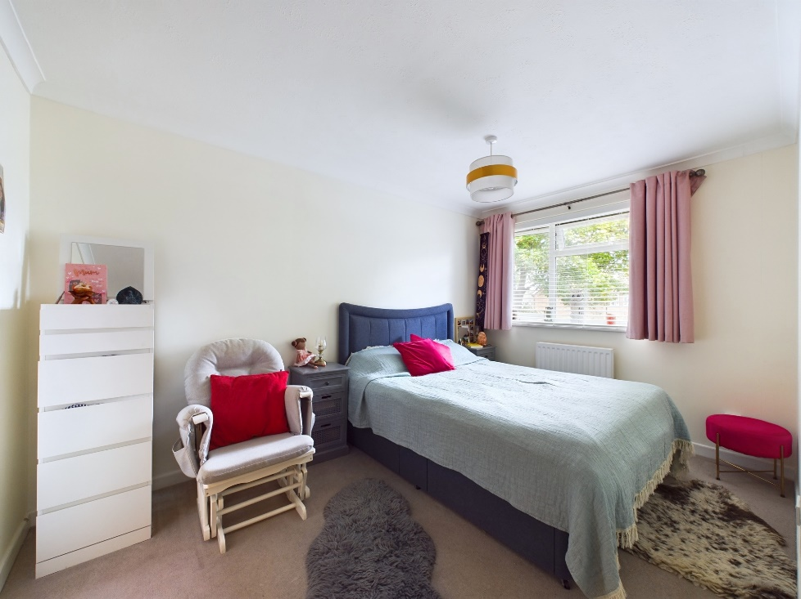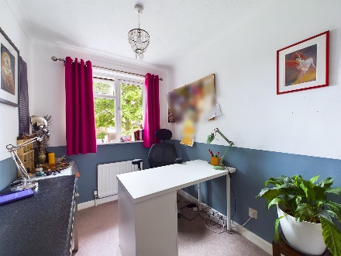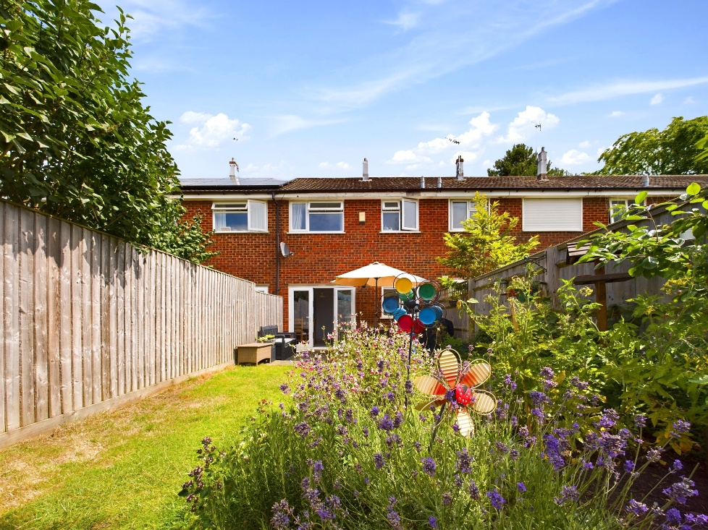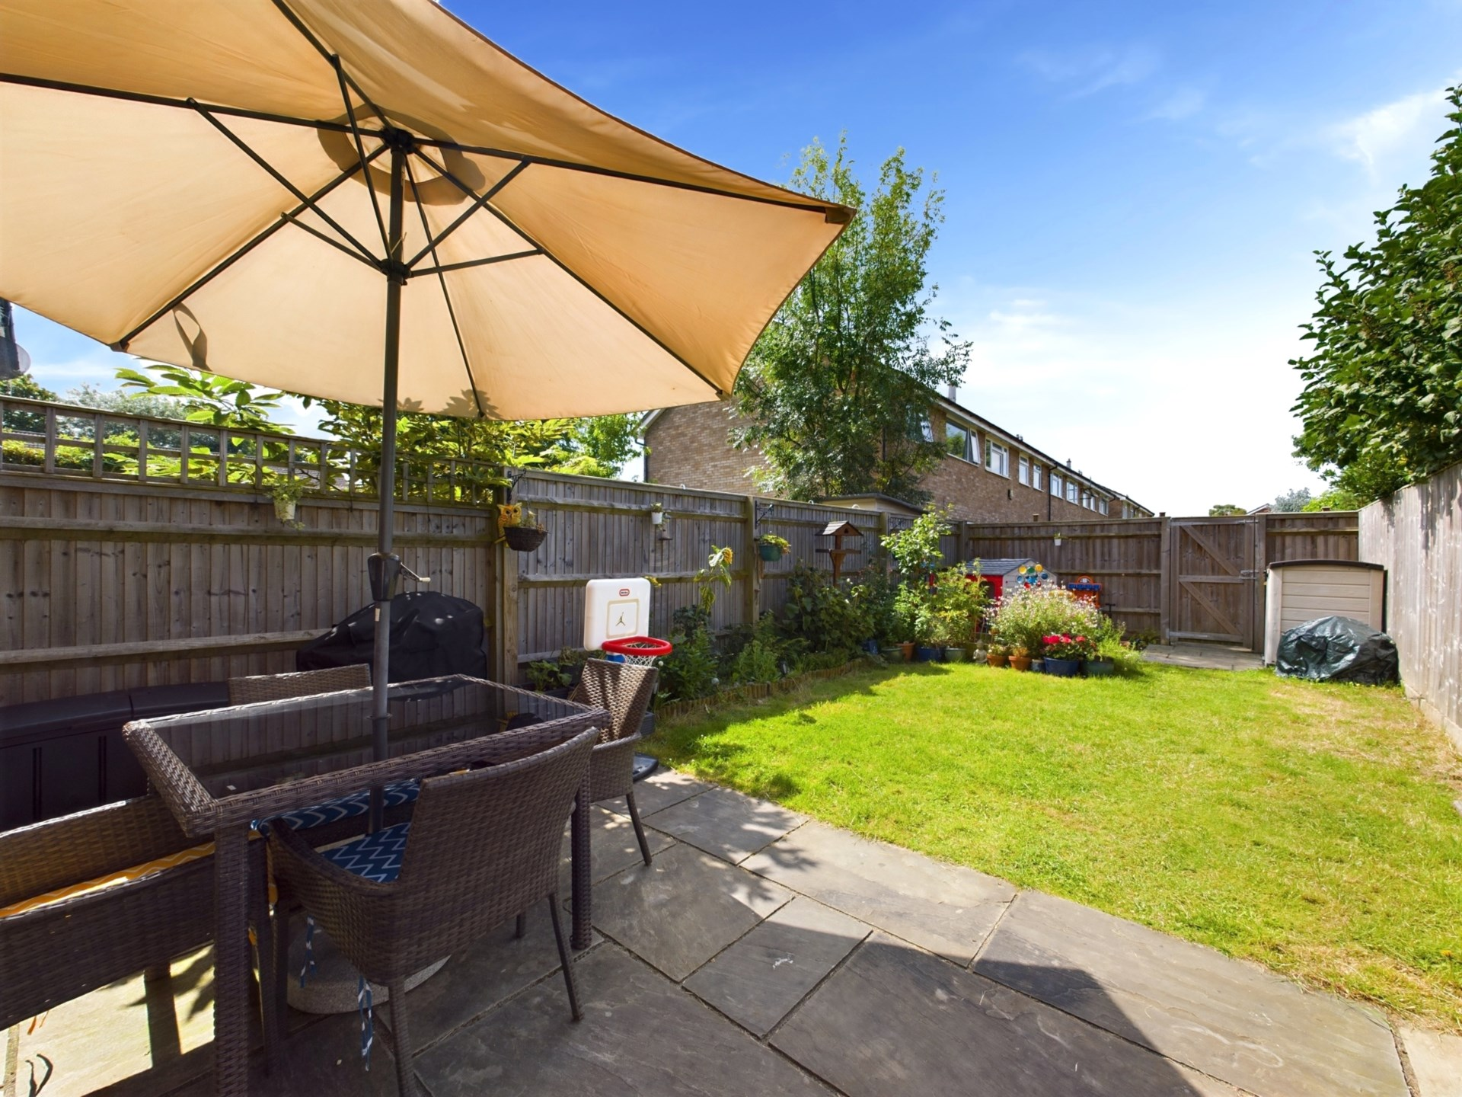

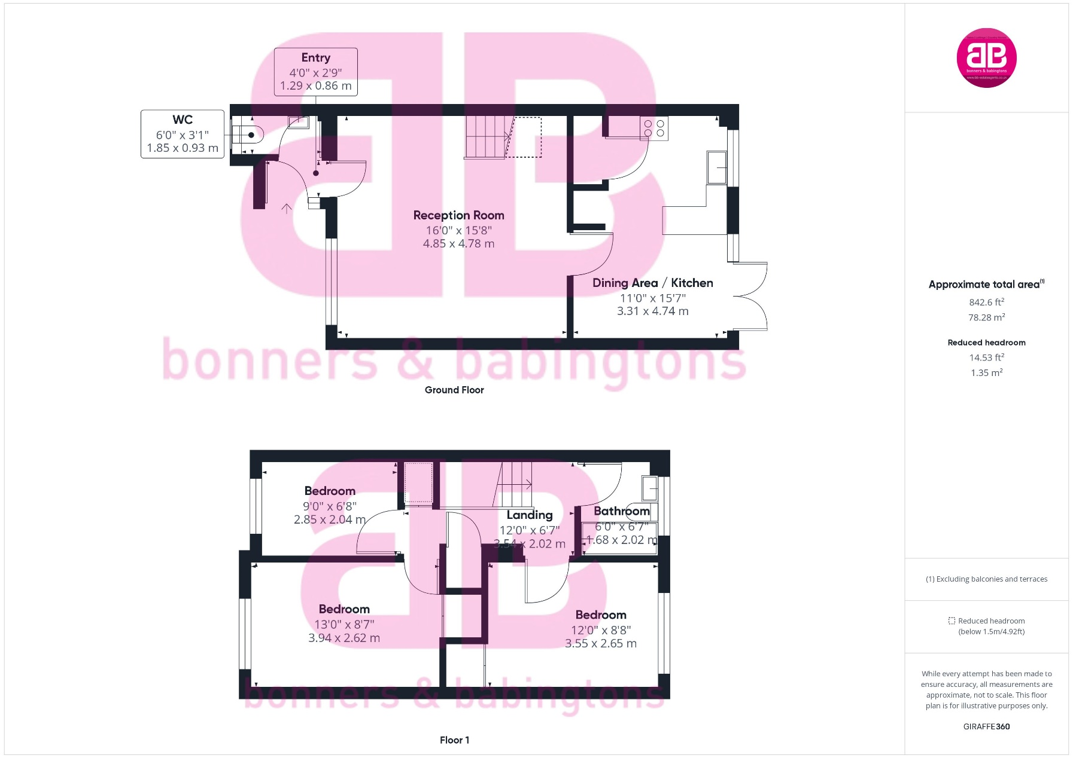

Zoopla LogoNAEA Propertymark Protected CMYKRM_Logo_NoStrap_Colourfacebook logo

**Disclaimer**

We endeavour to make our particulars accurate and reliable. They are for guidance only and are intended to give a fair overall summary of the property. They do not form part of any contract or offer, and should not be relied upon as a statement or representation of fact. Measurements, areas and distances are approximate and photographs provided for guidance only. No undertaking is given as to the structural condition of the property, or any necessary consents, or the operating ability or efficiency of any service, system or appliance. Prospective purchasers must satisfy themselves with regard to each of these points. If there is any particular aspect of the property about which you would like further information, please contact us, especially, before you travel to the property. B2170

Robert House, 19 Station Road, Chinnor, Oxfordshire, OX39 4PU

01844 354554

www.bb-estateagents.co.uk