bb-logo-final

Duke Street

Princes Risborough

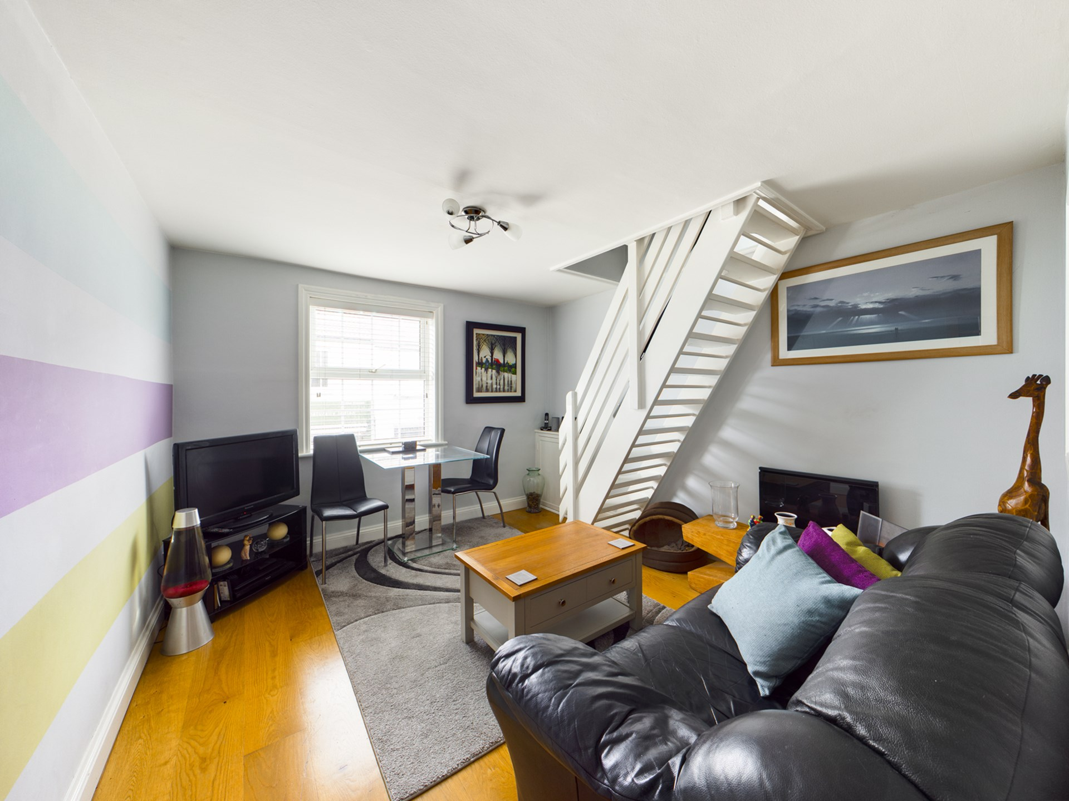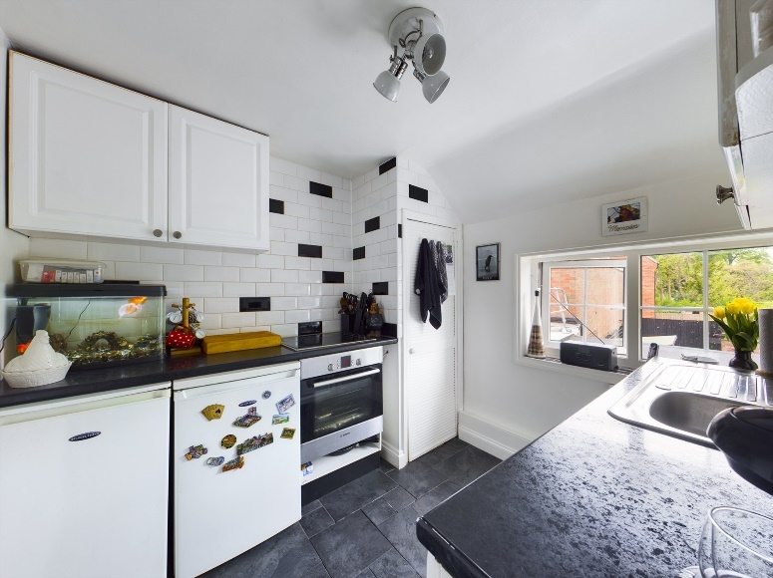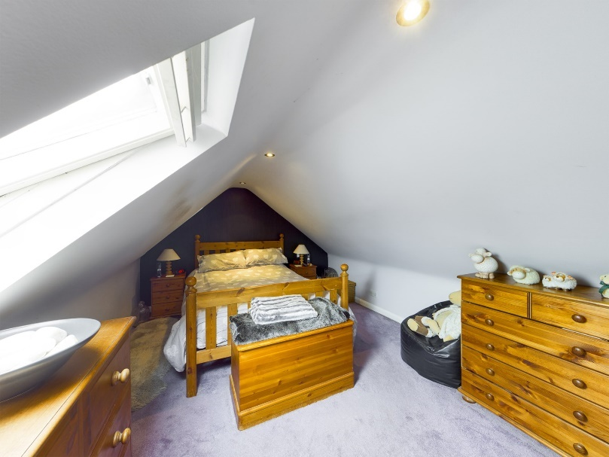

Duke Street

Princes Risborough

Buckinghamshire

HP27 0AT

Guide Price - £225,000

An extremely well presented apartment with accommodation arranged over two floors. Situated with in the heart of Princes Risborough. Two Bedrooms,Living Room, Kitchen and Shower Room. The property also has the benefit of a rear garden (conditions apply). The property is sold without an onward chain.

Constructed above a parade of shops this first floor apartment offers peasant and economical accommodation. Access to the property is via a stairway to its own Front Door. Small Entrance Hall, Living room, Kitchen, Shower room. Bedroom. From the living room there is a staircase that then leads to the Main Bedroom. At the rear there is a well presented garden with two storage shed one with light and power. Agents Note the rear garden is leased to the property and a small charge is payable per month. The property itself enjoys a recently extended lease of 125 years.

NO ONWARD CHAIN!

LENGTH LEASE – 125 YEARS

GROUND RENT – £150.00

Princes Risborough

The attractive market town of Princes Risborough offers a post office, a leisure centre and a good range of local shops including a Tesco, Marks & Spencer Simply Food and Costa Coffee. Further, more comprehensive leisure and shopping facilities can be found in High Wycombe, Aylesbury and Oxford all within easy reach. Excellent schooling is provided locally with a good choice of private and state schools close by including grammar schools in High Wycombe and Aylesbury.

There is access to the M40 motorway for London and the Midlands just 6 miles away (J6) and Princes Risborough station offers an excellent main line rail service to London (Marylebone - 35 minutes) and the Midlands.

EPC RATING - F

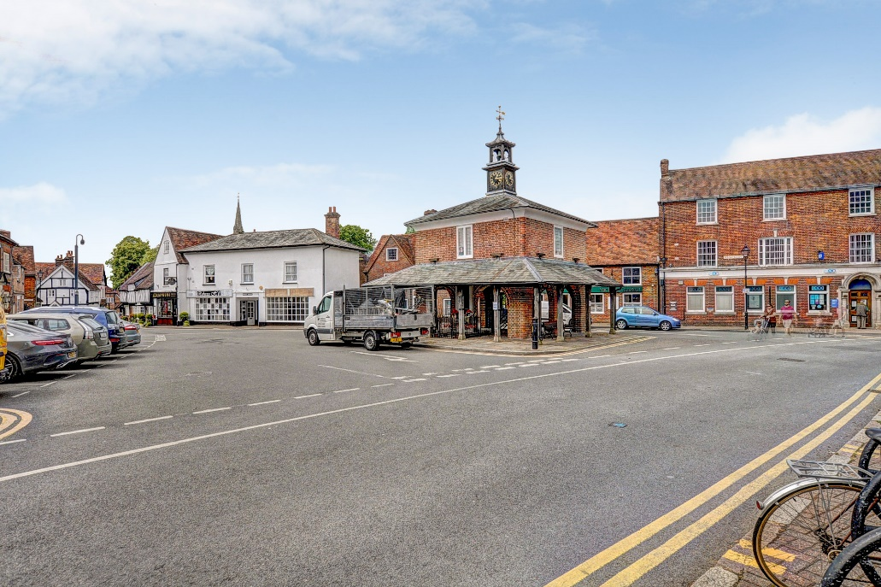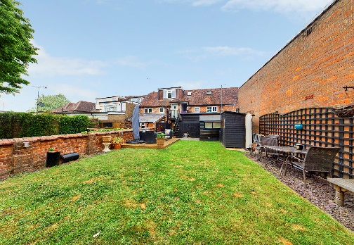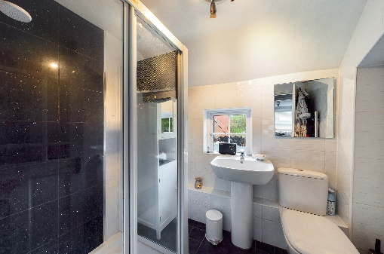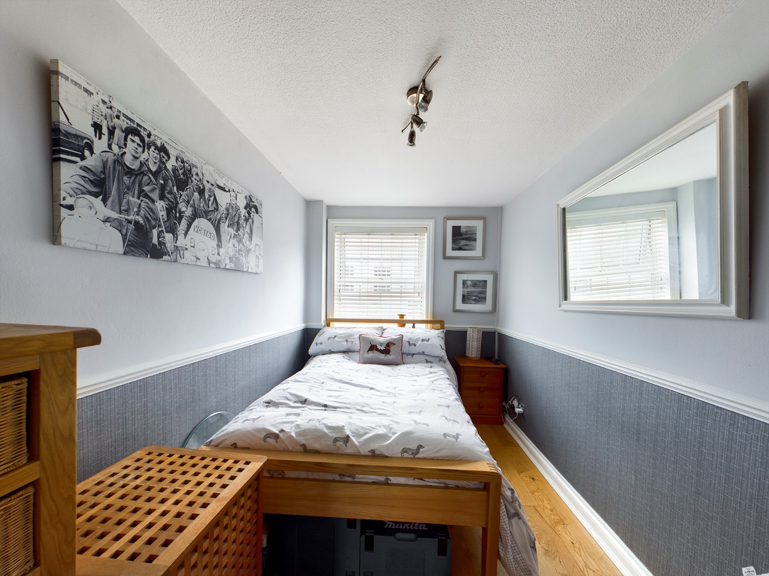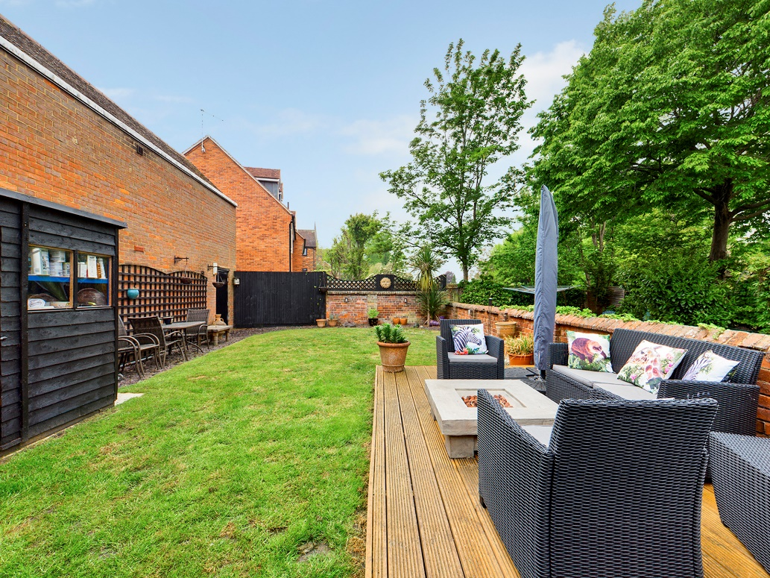

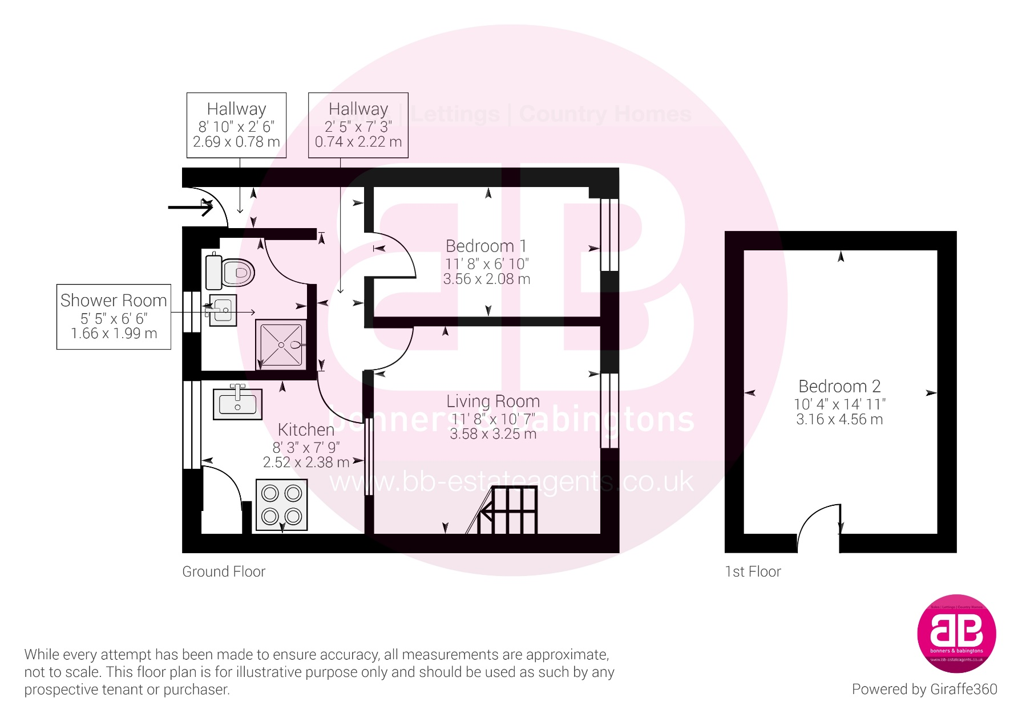

Zoopla LogoNAEA Propertymark Protected CMYKRM_Logo_NoStrap_Colourfacebook logoPrimelocation lscape

**Disclaimer**

We endeavour to make our particulars accurate and reliable. They are for guidance only and are intended to give a fair overall summary of the property. They do not form part of any contract or offer, and should not be relied upon as a statement or representation of fact. Measurements, areas and distances are approximate and photographs provided for guidance only. No undertaking is given as to the structural condition of the property, or any necessary consents, or the operating ability or efficiency of any service, system or appliance. Prospective purchasers must satisfy themselves with regard to each of these points. If there is any particular aspect of the property about which you would like further information, please contact us, especially, before you travel to the property. B2170

78 High Street, Princes Risborough, Buckinghamshire, HP27 0AX

01844 343661

www.bb-estateagents.co.uk