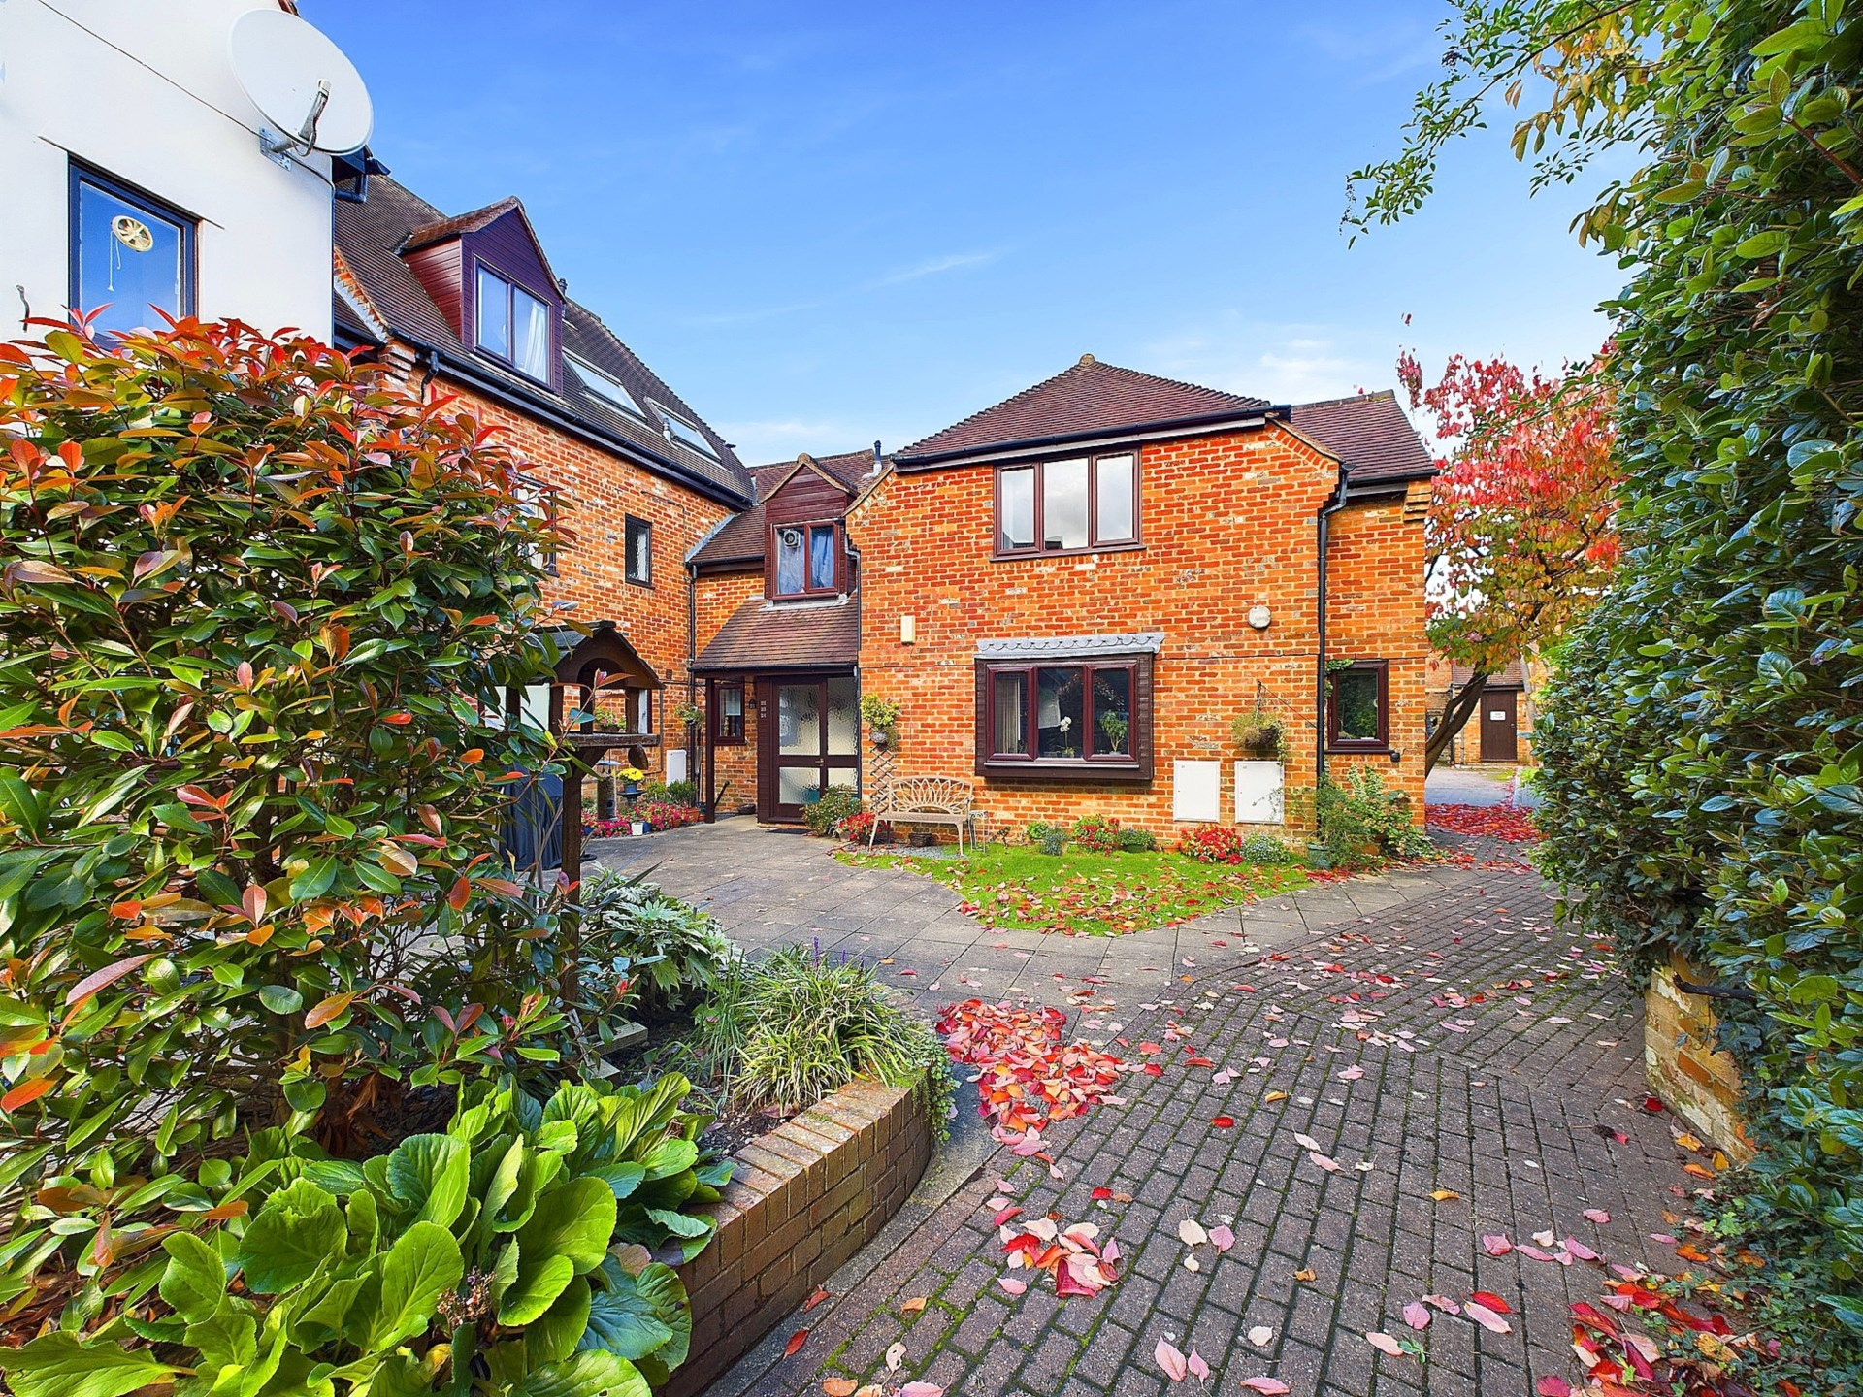bb-logo-final

Malthouse Square

Princes Risborough

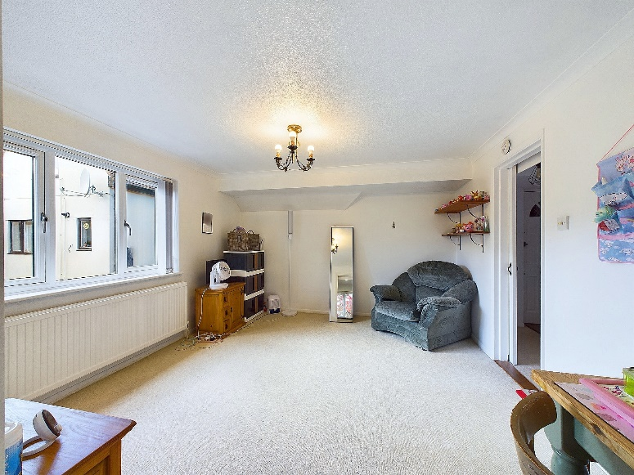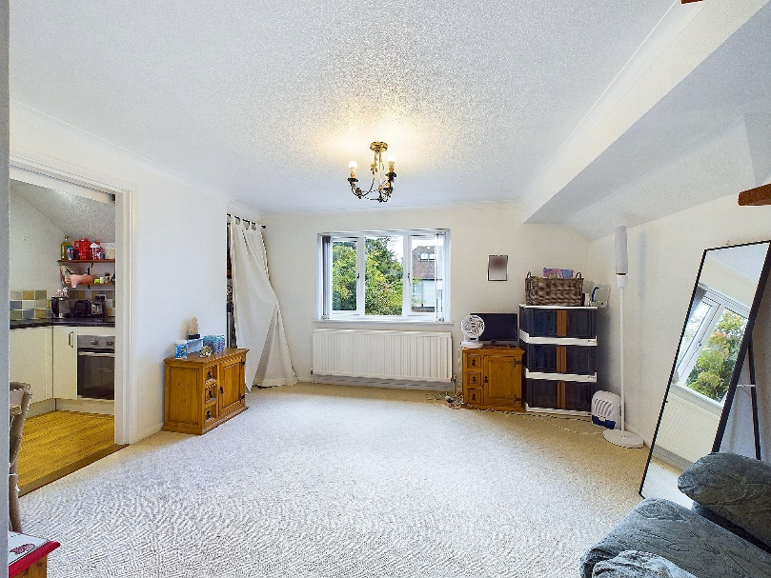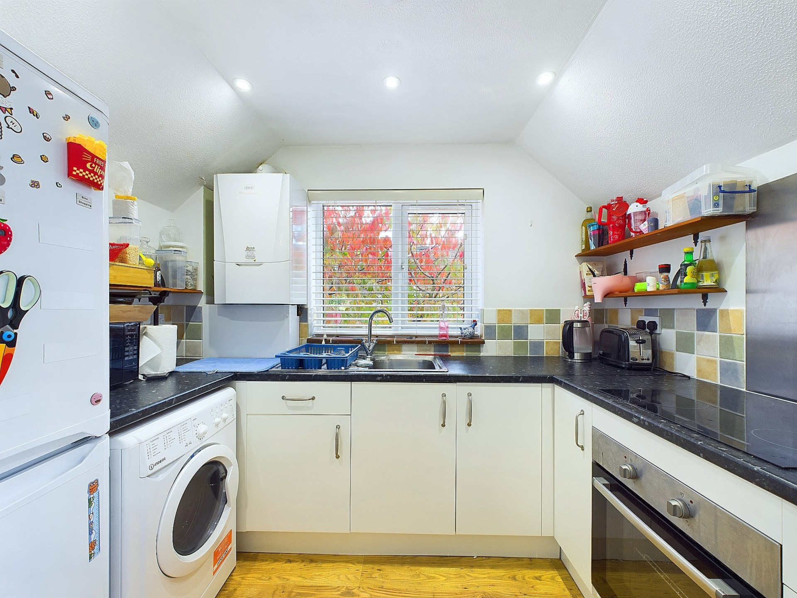

Malthouse Square

Princes Risborough

Buckinghamshire

HP27 9AZ

Guide Price - £220,000

A well presented one bedroom first floor apartment positioned centrally within the town of Princes Risborough offering excellent amenities and transport links all within walking distance of the property.

The property accommodation comprises of the following, an entrance hallway linking to a good sized, light and airy living room, a modern separate kitchen with built in electric oven and electric hob, a double bedroom with built in wardrobes and a modern bathroom with bath and over head shower.

Outside there is private secluded courtyard and one allocated parking space for the apartment.

Other notable features include, mains gas central heating system and double glazed windows.

This a fantastic opportunity for any first time buyers looking to get themselves on to the property ladder or for any investors as the property has been successfully rented for a number of years.

Council Tax Band – C

Service Charge - £1054.20 Annually

Lease – 991 Years

Share of freehold

Princes Risborough

The attractive market town of Princes Risborough offers a post office, a leisure centre and a good range of local shops including a Tesco, Marks & Spencer Simply Food and Costa Coffee. Further, more comprehensive leisure and shopping facilities can be found in High Wycombe, Aylesbury and Oxford all within easy reach. Excellent schooling is provided locally with a good choice of private and state schools close by including grammar schools in High Wycombe and Aylesbury.

There is access to the M40 motorway for London and the Midlands just 6 miles away (J6) and Princes Risborough station offers an excellent main line rail service to London (Marylebone - 35 minutes) and the Midlands.

EPC Rating - C

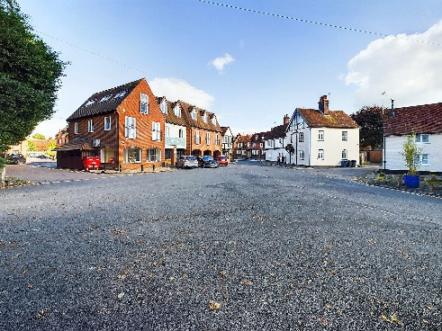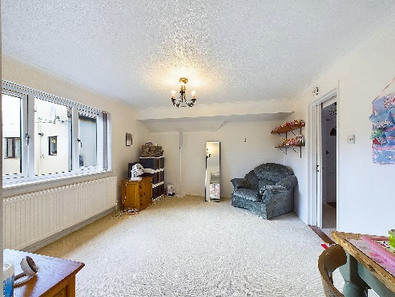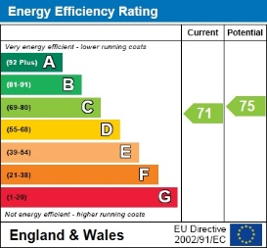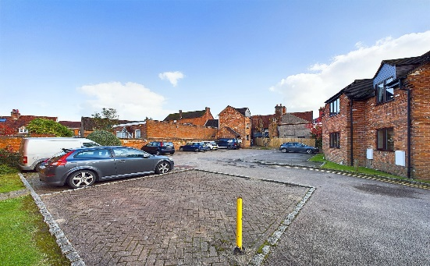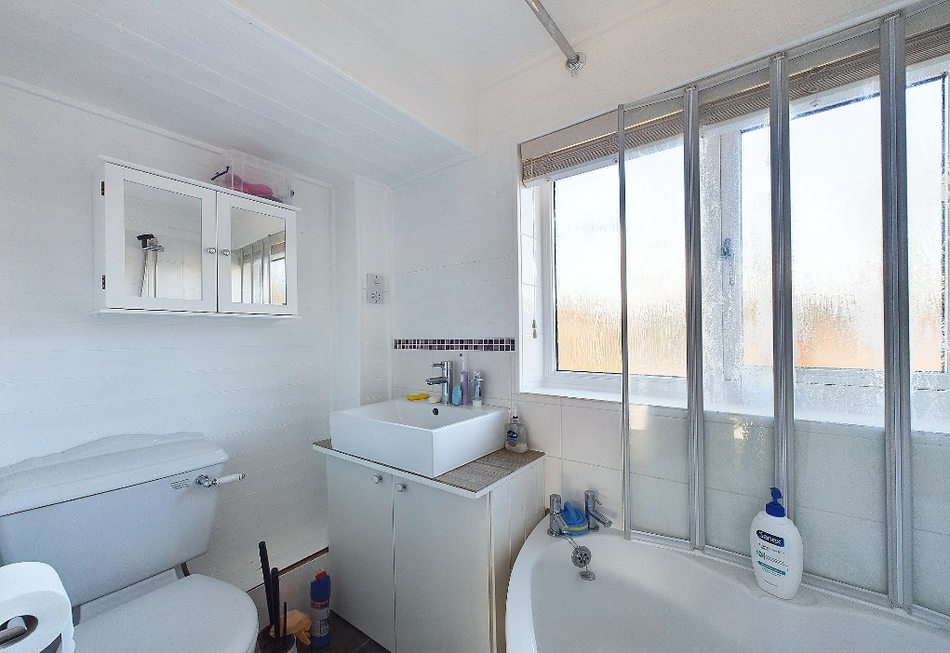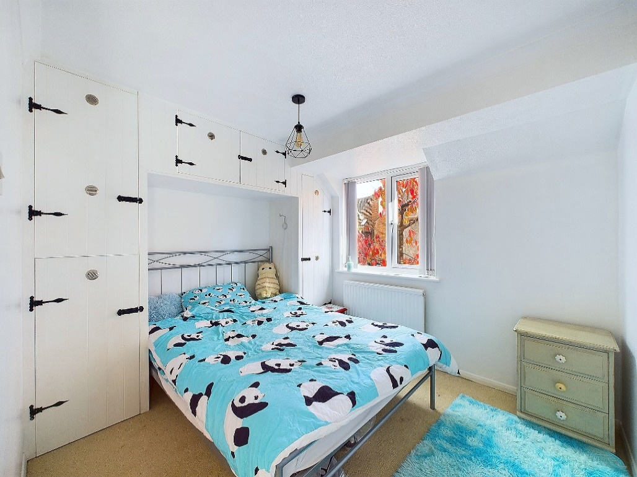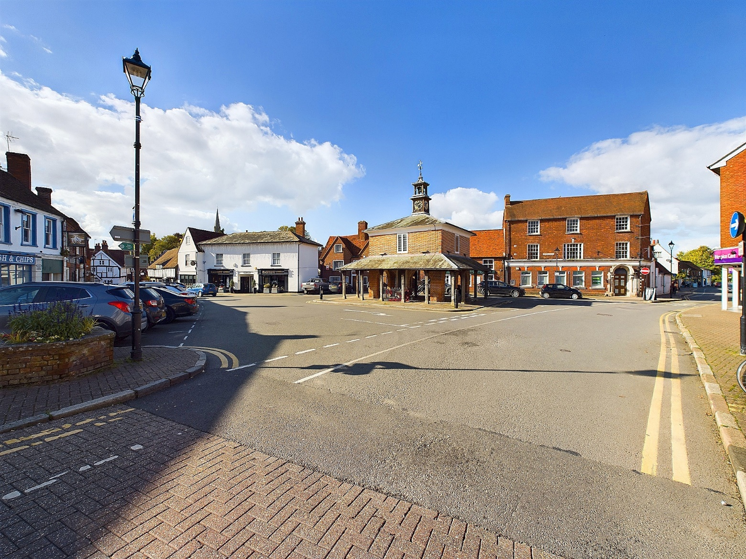

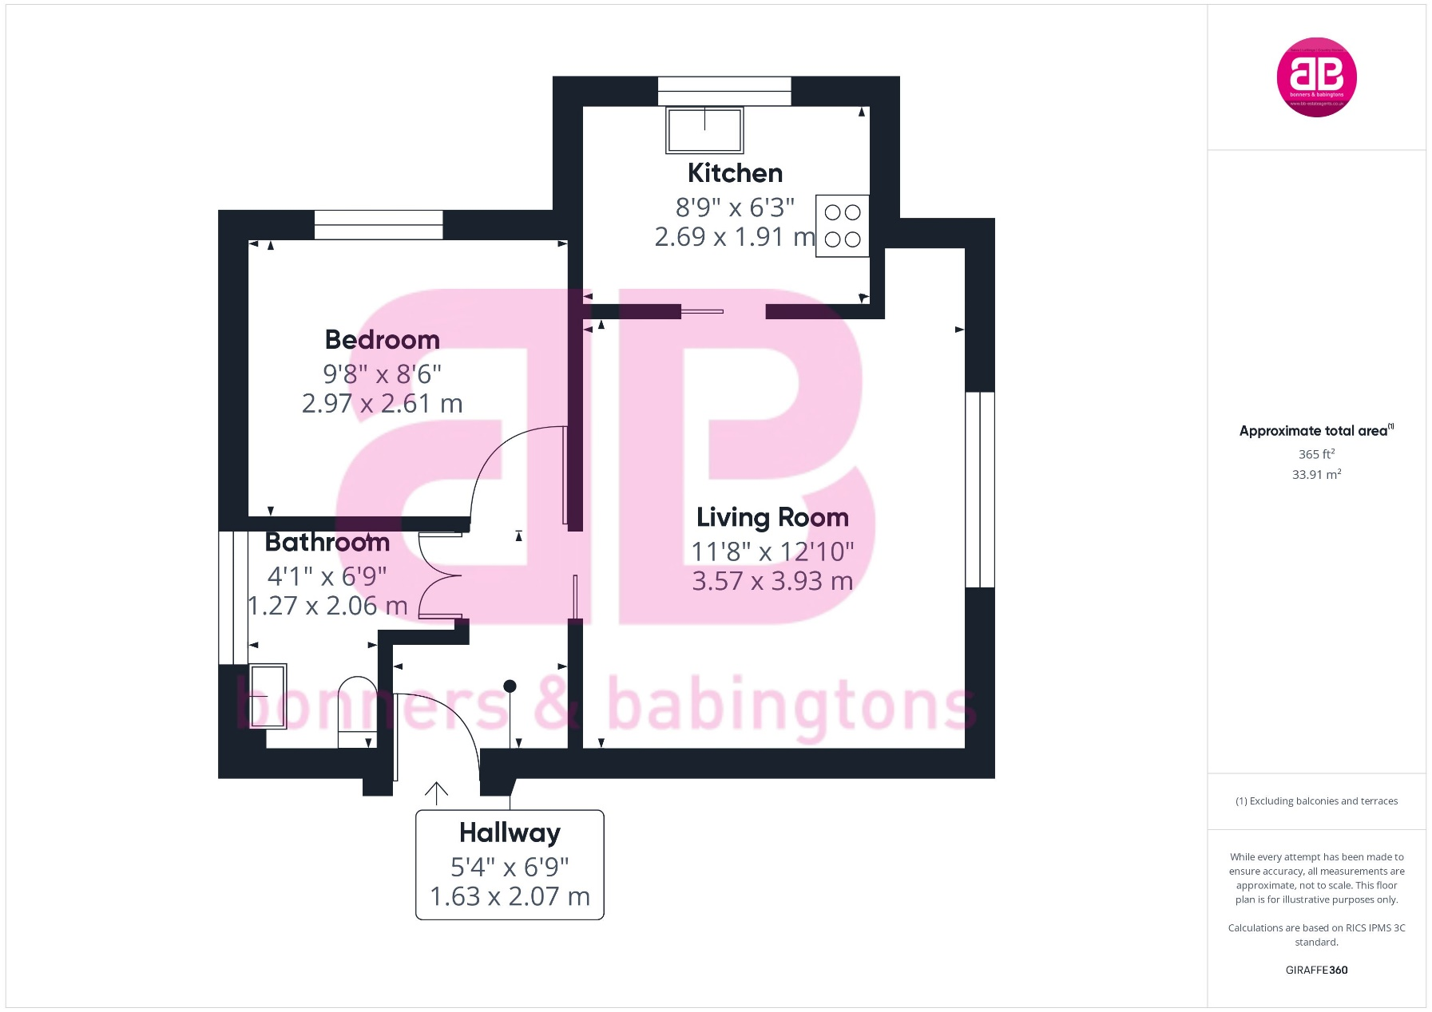

Zoopla LogoNAEA Propertymark Protected CMYKRM_Logo_NoStrap_Colourfacebook logoPrimelocation lscape

**Disclaimer**

We endeavour to make our particulars accurate and reliable. They are for guidance only and are intended to give a fair overall summary of the property. They do not form part of any contract or offer, and should not be relied upon as a statement or representation of fact. Measurements, areas and distances are approximate and photographs provided for guidance only. No undertaking is given as to the structural condition of the property, or any necessary consents, or the operating ability or efficiency of any service, system or appliance. Prospective purchasers must satisfy themselves with regard to each of these points. If there is any particular aspect of the property about which you would like further information, please contact us, especially, before you travel to the property. B2170

78 High Street, Princes Risborough, Buckinghamshire, HP27 0AX

01844 343661

www.bb-estateagents.co.uk