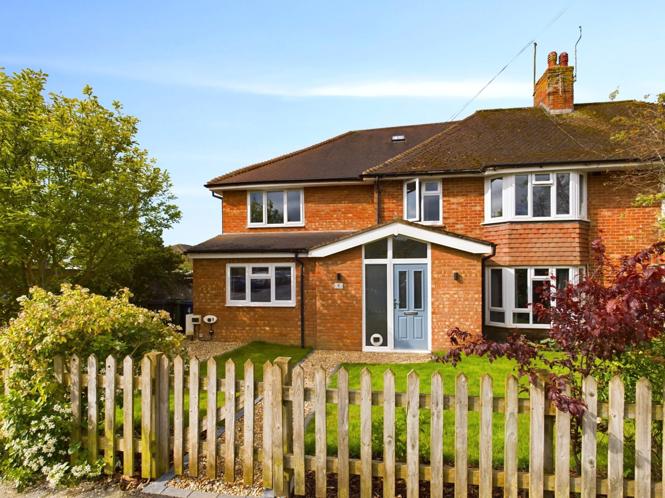bb-logo-final

**Loddon Road**

Bourne End

www.bb-estateagents.co.uk

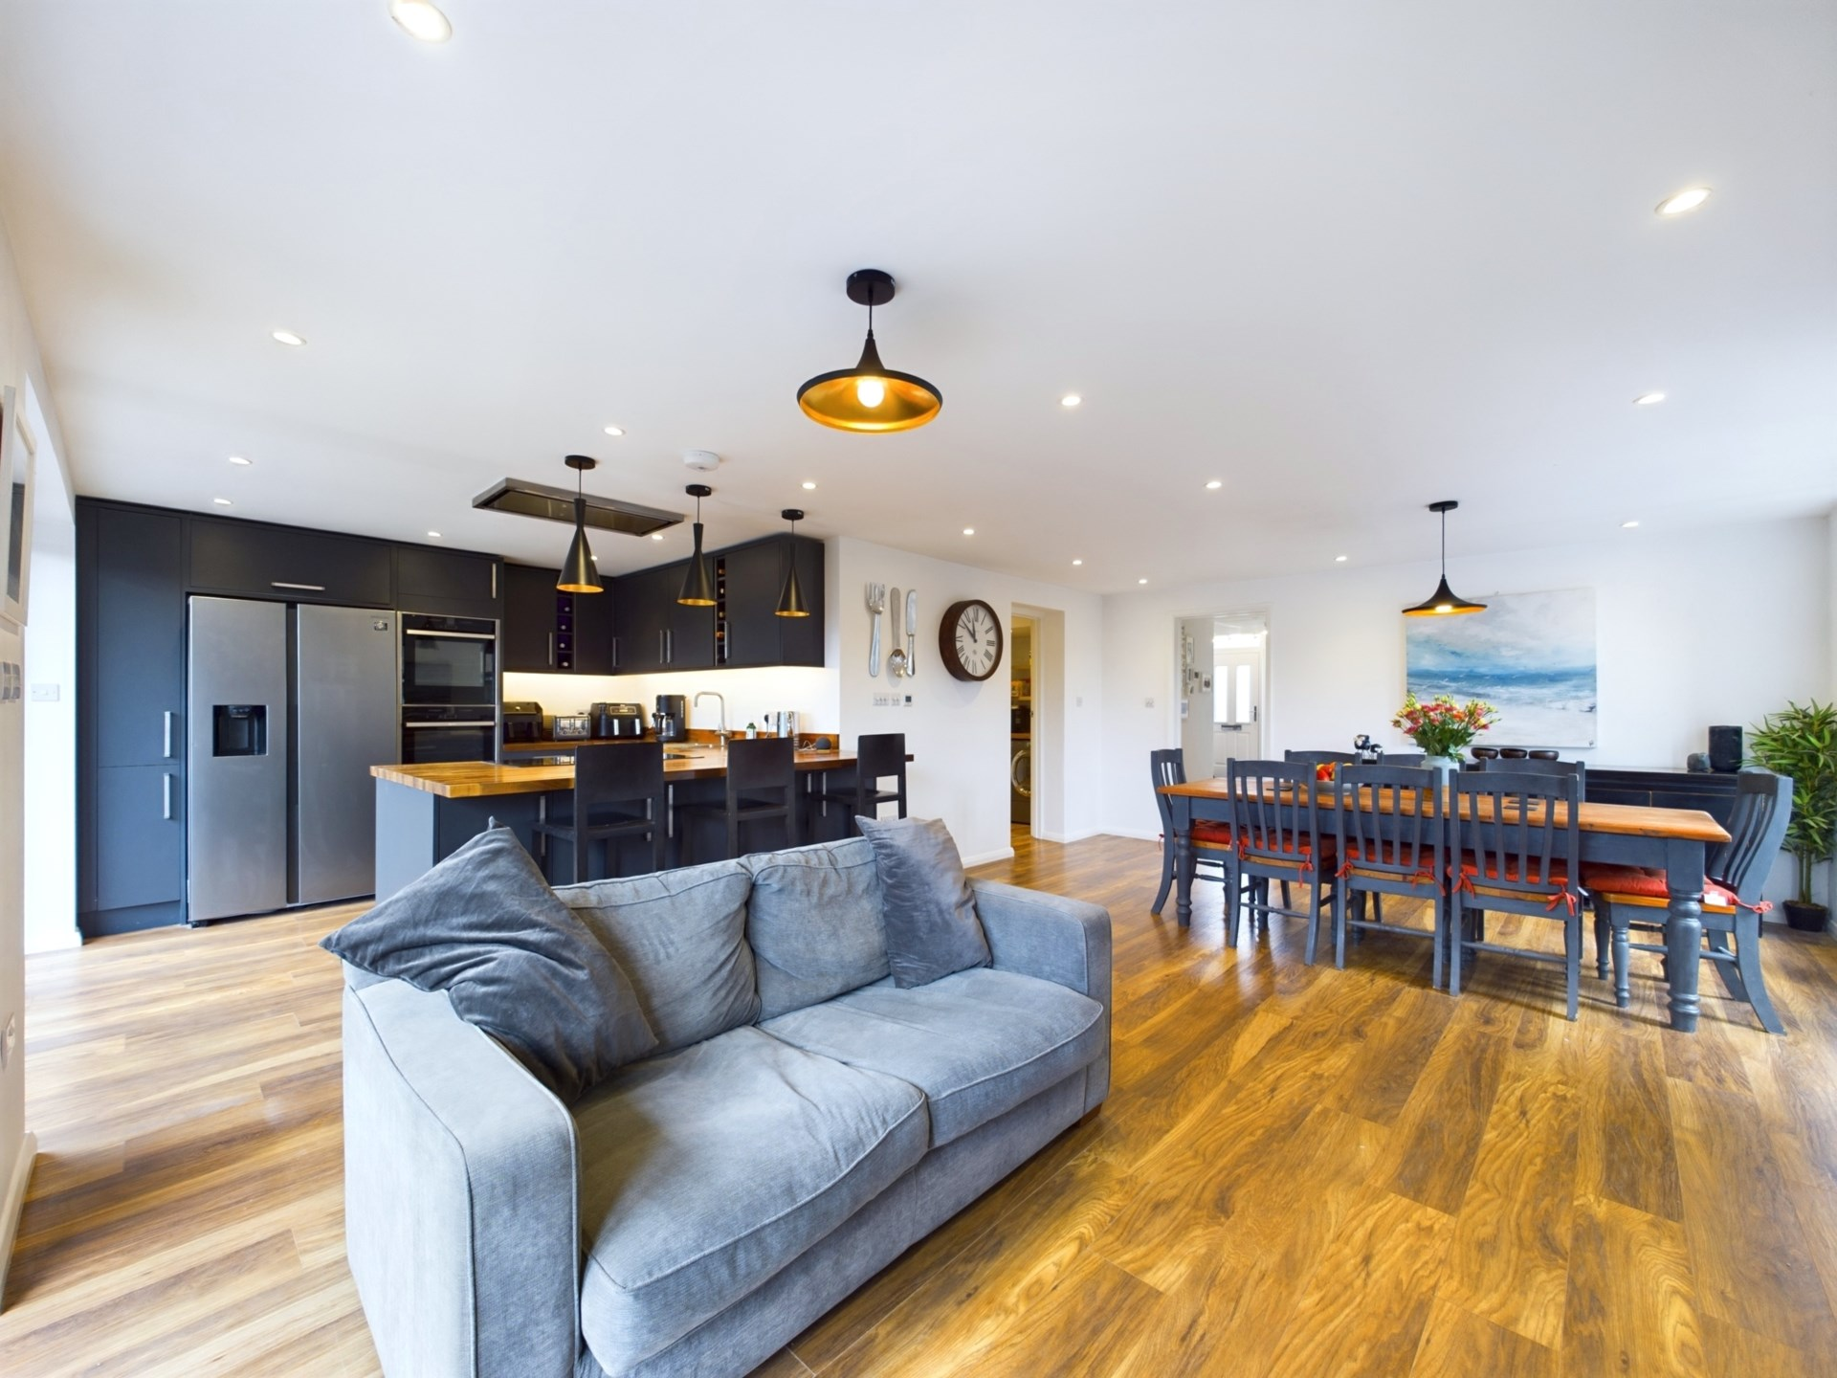

3 Anglers Court, Spittal Street, Marlow, Bucks, SL7 3HJ

01628 333800

www.bb-estateagents.co.uk

A fabulous 5 bedroom bay fronted home with stunning contemporary interior offering over 2,000 sq ft of flexible living accommodation with superb `open plan` kitchen/dining room situated in the sought after riverside village of Bourne End enjoying excellent transport links.

Marlow 3.4 miles, Maidenhead 5.6 miles High Wycombe 6.2 miles, Heathrow 19 miles, London 30 miles

Loddon Road, Bourne End, Buckinghamshire, SL8 5LT

* Flexible Living Space
* Over 2,000 sq ft of Accommodation
* 5 Bedrooms
* 3 Reception Rooms
* Fantastic ‘Open Plan’ Kitchen/Dining Room with Bi-Fold Doors
* Master Bedroom with Stylish En Suite
* 3 Bathrooms
* Driveway wit EV Charging Point
* Stunning Contemporary Interior
* Kitchen With Integrated Appliances
* Good Size Utility Room
* Wrap Around Gardens
* Excellent Transport Links

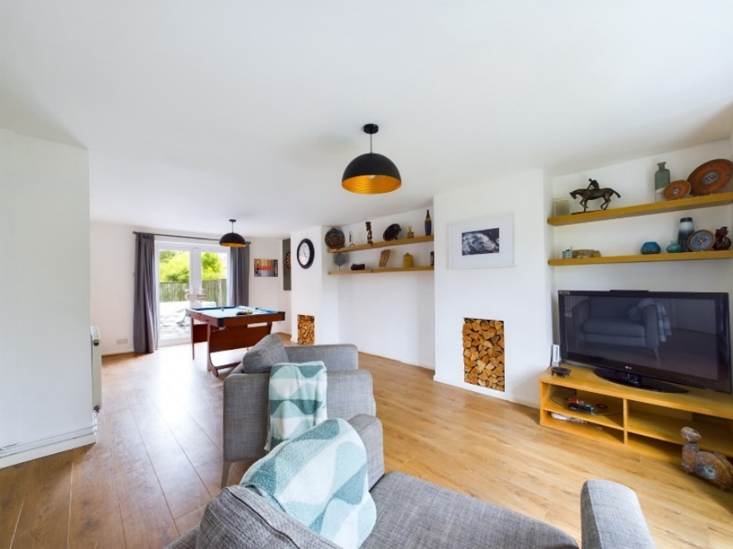

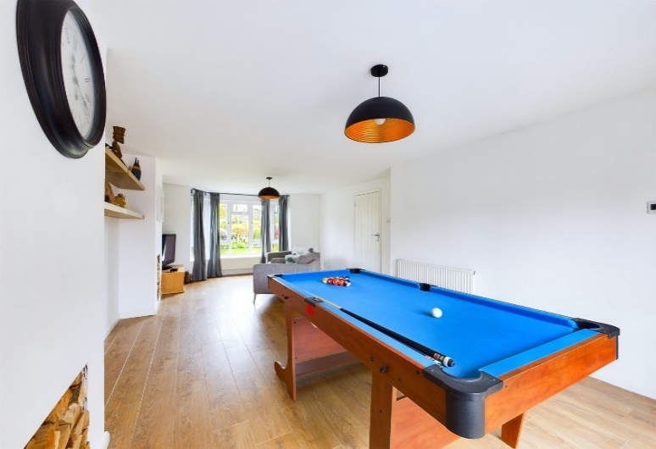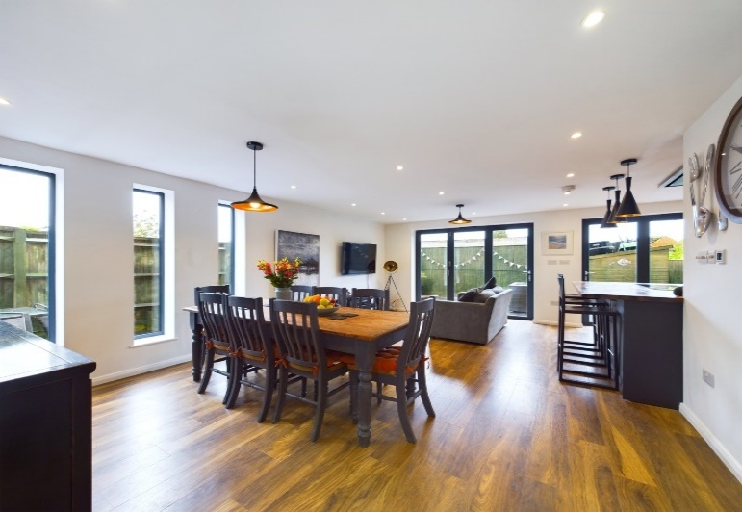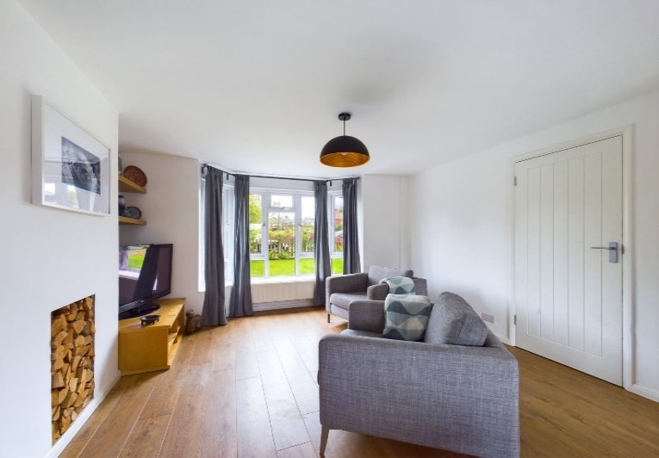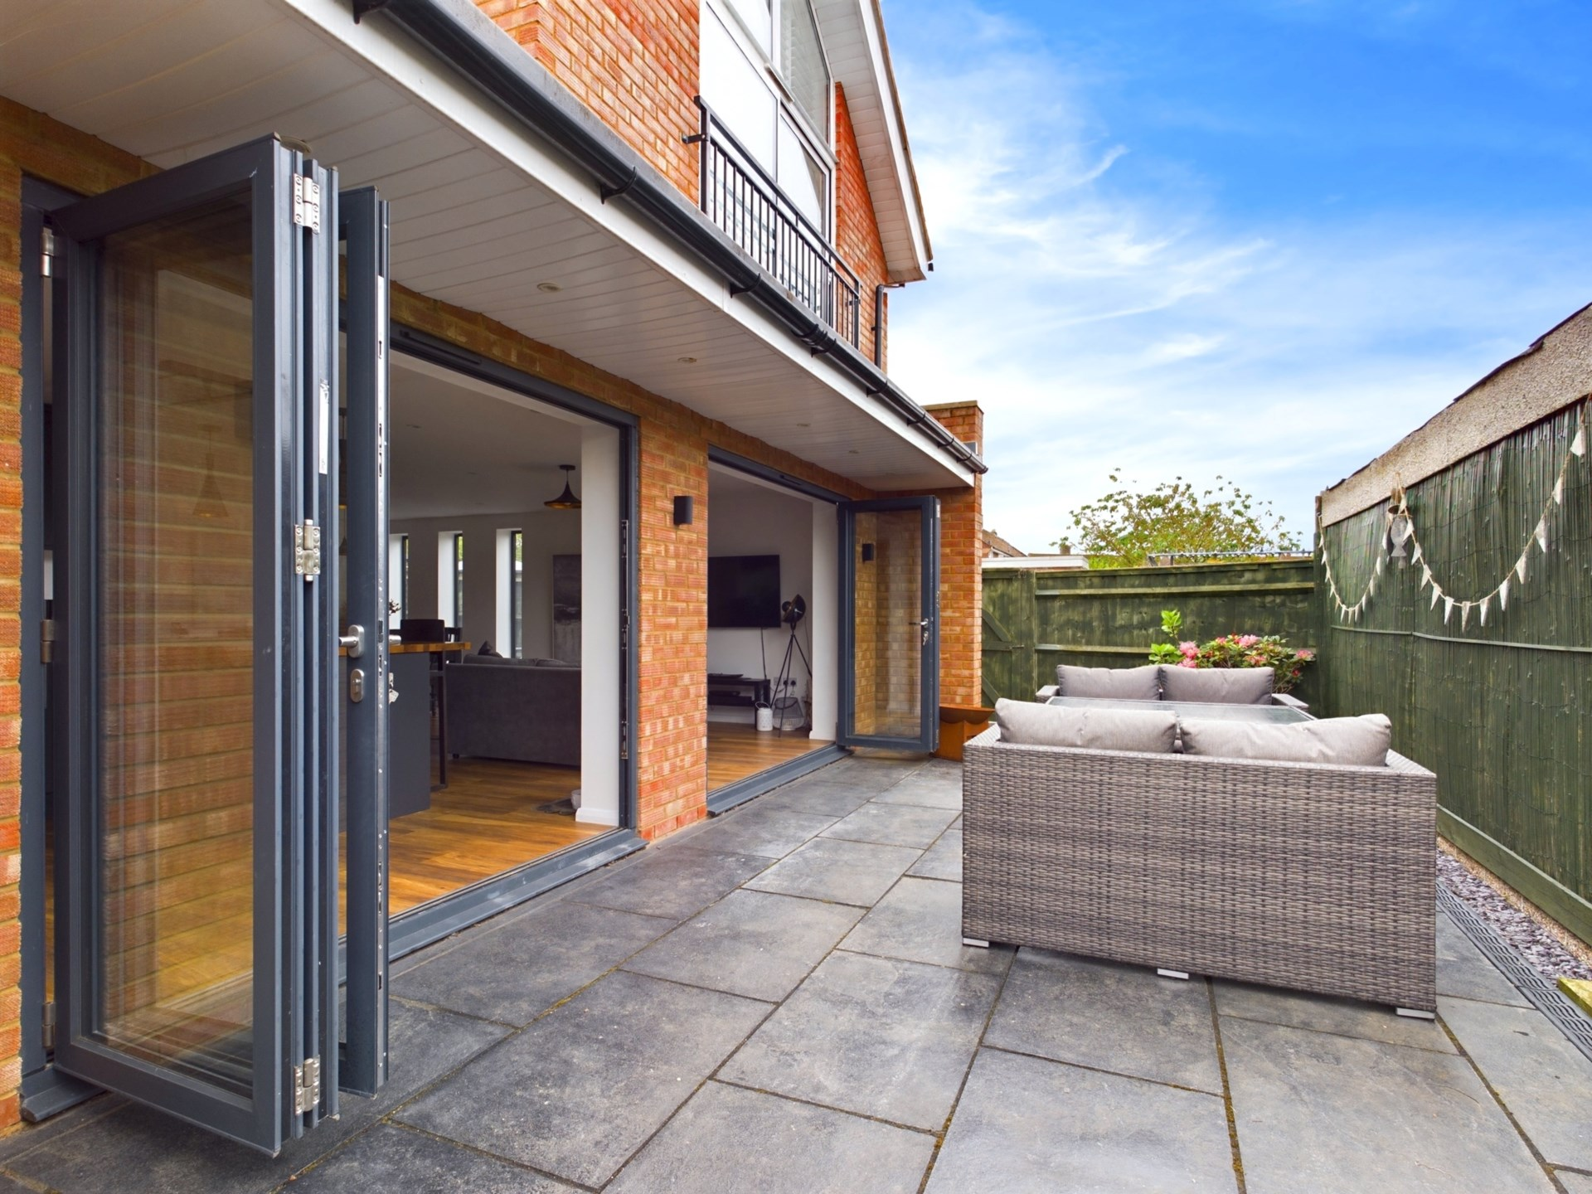

Bourne End

Located in the popular and picturesque village of Bourne End, the property benefits from an enviable location, with an array of local amenities close by.

The village boasts a selection of quaint shops, cafes and restaurants, including the popular Spade Oak and The Bounty pubs. The nearby River Thames offers beautiful scenic walks and boating opportunities, while the historic market town of Marlow is just a short drive away, with its boutique shops and array of dining options.

For schooling Bourne End is served by its own primary school and the Bourne End Academy.

As well as the natural beauty of the surrounding area, residents of Bourne End also benefit from excellent transport links, with convenient access to the M40 and M25 motorways, and a direct rail service to London Paddington within easy reach. With its stunning location and impressive array of features, this property offers the perfect opportunity to enjoy an idyllic lifestyle in one of Buckinghamshire`s most sought-after locations.

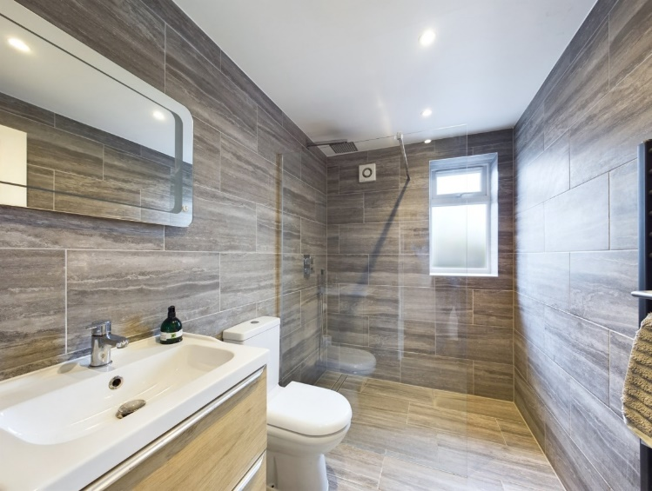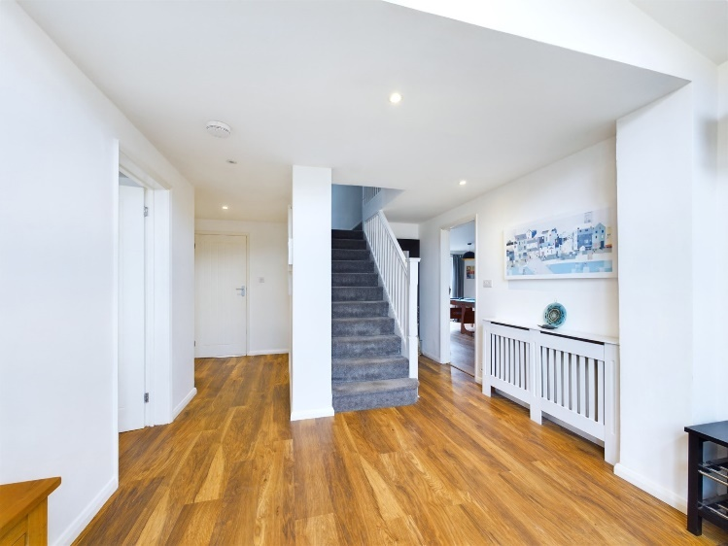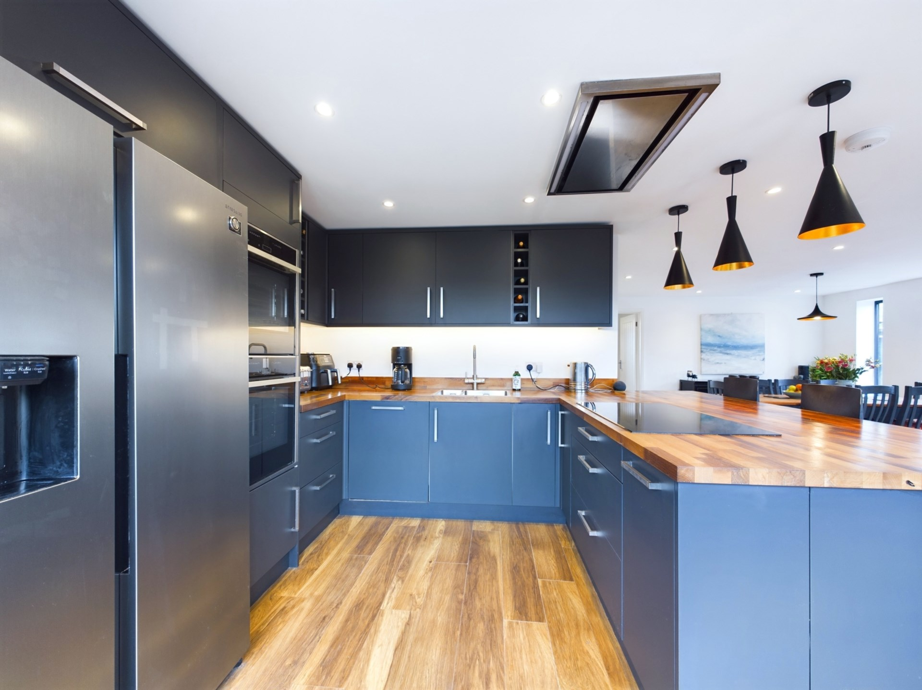

Description

Nestled in the heart of the charming village of Bourne End in Buckinghamshire, this stunning semi-detached property boasts five spacious bedrooms, three modern bathrooms and three inviting reception rooms. The property has been thoughtfully designed to combine traditional features with contemporary conveniences, offering the perfect blend of classic elegance and modern functionality.

Upon entering the property, you will be immediately drawn to the welcoming atmosphere created by the light, airy reception hall. The ground floor comprises of a fabulous `open plan` kitchen/dining room, perfect for hosting dinner parties with twin Bi-Fold doors onto the rear entertaining terrace and fully fitted kitchen with integrated appliances, a formal double aspect sitting/dining room with bay window and family room/study. There is also a well equipped utility room and superb shower/wet room.

The first floor houses four generously-sized bedrooms and a single bedroom, the master bedroom boasts a vaulted ceiling with full height picture window, extensive wardrobe space and luxury private ensuite bathroom. There a large family bathroom with corner bath and separate shower

Outside

Outside, the property offers a landscaped garden, ideal for enjoying the warmer months with friends and family. A large wrap round terrace area provides the perfect spot for al fresco dining and entertaining.

To the front there is off road parking with an EV Charging point and lawn area part enclosed with picket fencing. The property also benefits from gas central heating, zoned underfloor heating and replacement double glazing.

General Remarks and Stipulations

Tenure

Freehold

Services

Gas, Electric, Mains Drainage, Water

EPC Rating

C 79/86

Local Authority

Buckinghamshire Council

Counil Tax Band D

Post Code

SL8 5LT

Viewing

Strictly by appointment with Bonners & Babingtons

Fixtures and Fittings

To be confirmed

Important Notice

Bonners & Babingtons, their clients and any joint agents give notice that:

1. They are not authorised to make or give any representations or warranties in relation to the property either here or elsewhere, either on their own behalf or on behalf of their client or otherwise. They assume no responsibility for any statement that may be made in these particulars. These particulars do not form part of any offer or contract and must not be relied upon as statements or representations of fact.

2. Any areas, measurements or distances are approximate. The text, photographs and plans are for guidance only and are not necessarily comprehensive. It should not be assumed that the property has all necessary planning, building regulation or other consents and Bonners & Bonners & Babingtons have not tested any services, Babingtons have not tested any services, equipment or facilities. Purchasers must satisfy themselves by inspection or otherwise.



