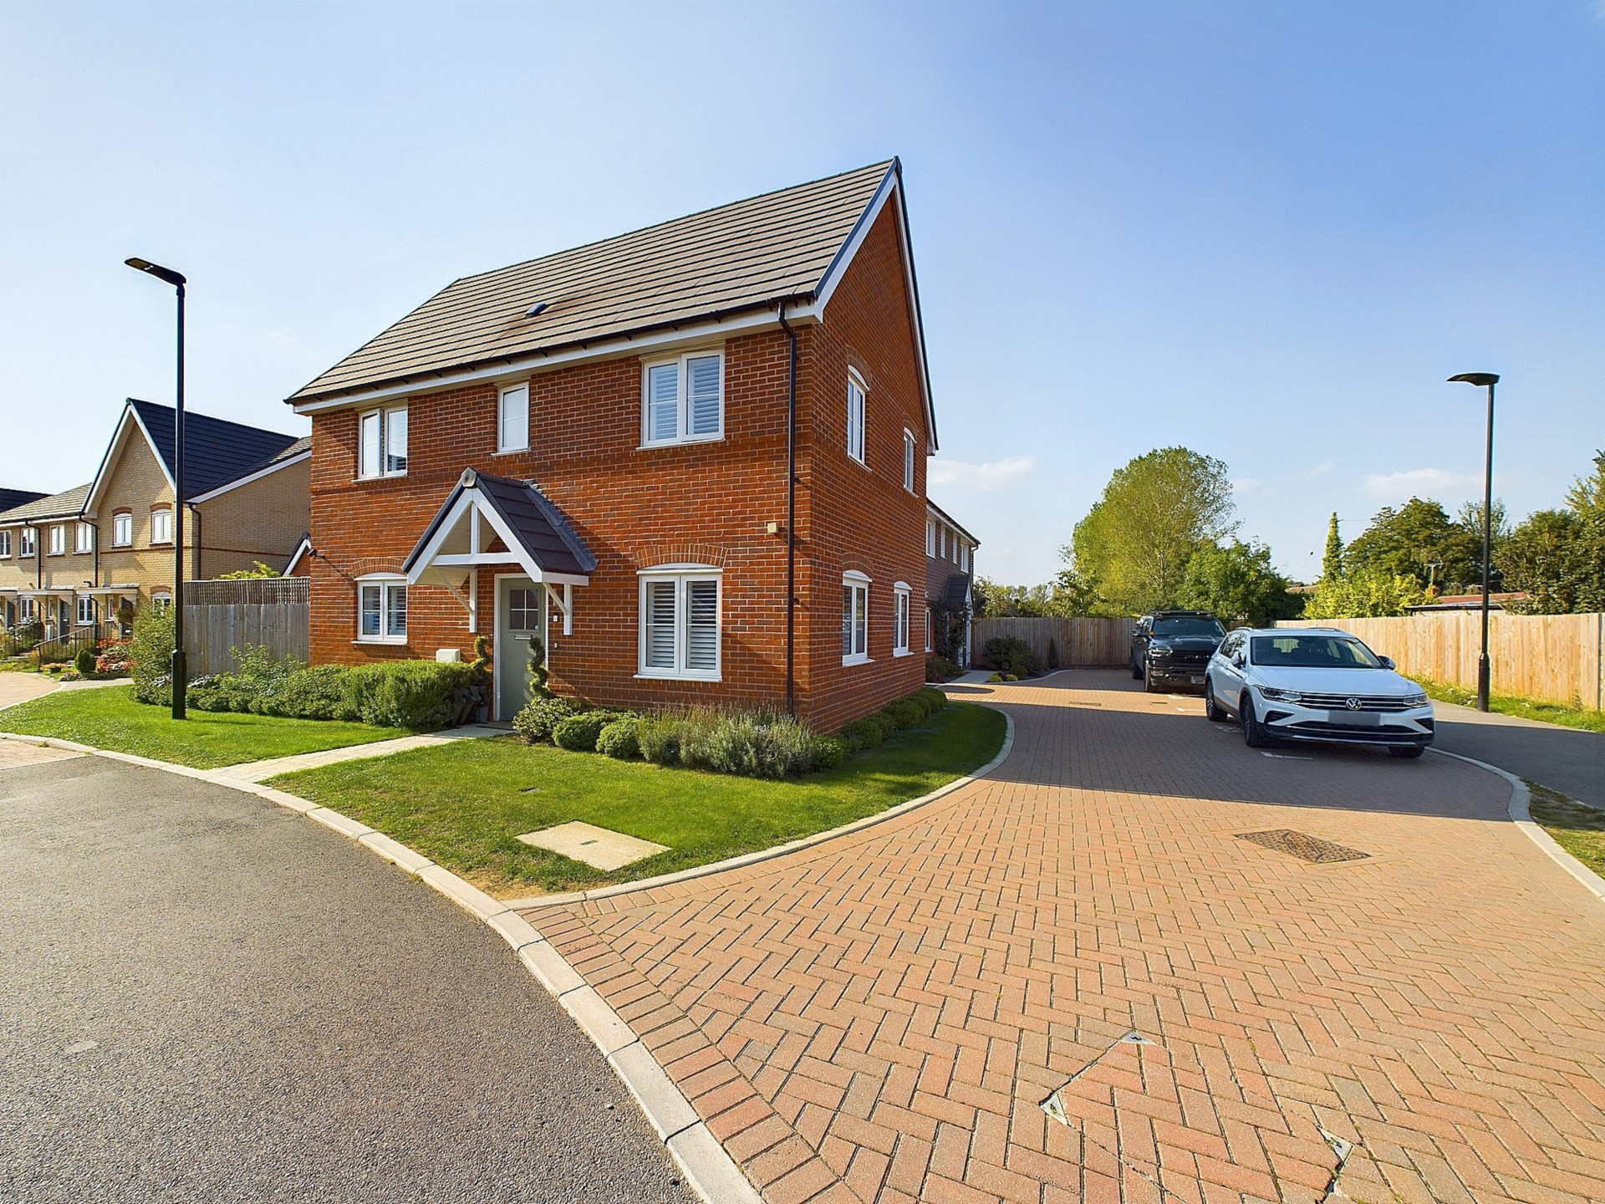bb-logo-final

Harrow Road

Longwick

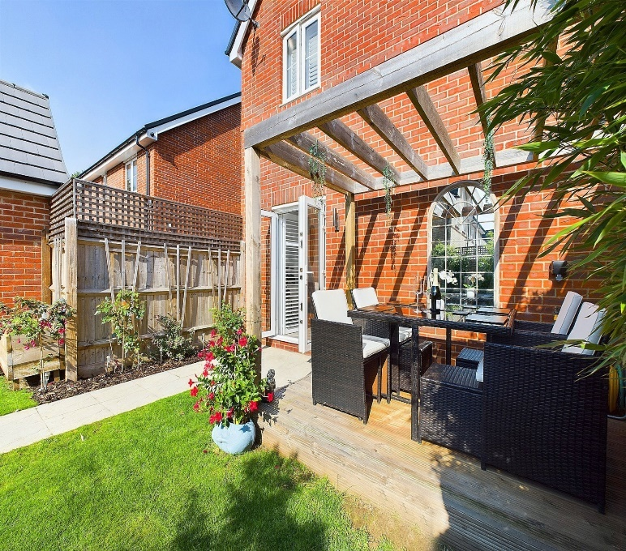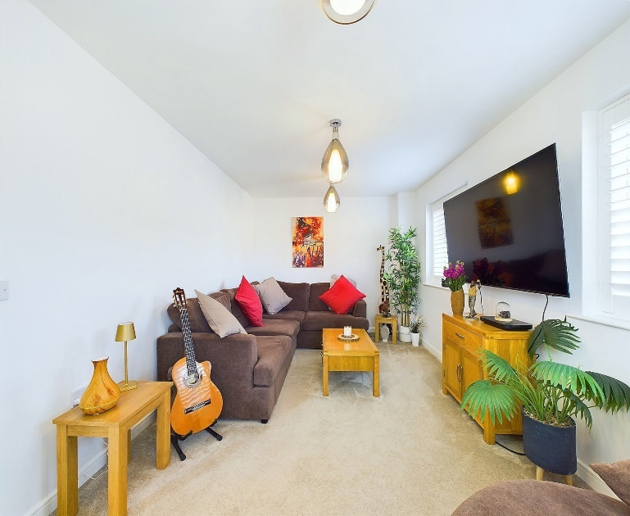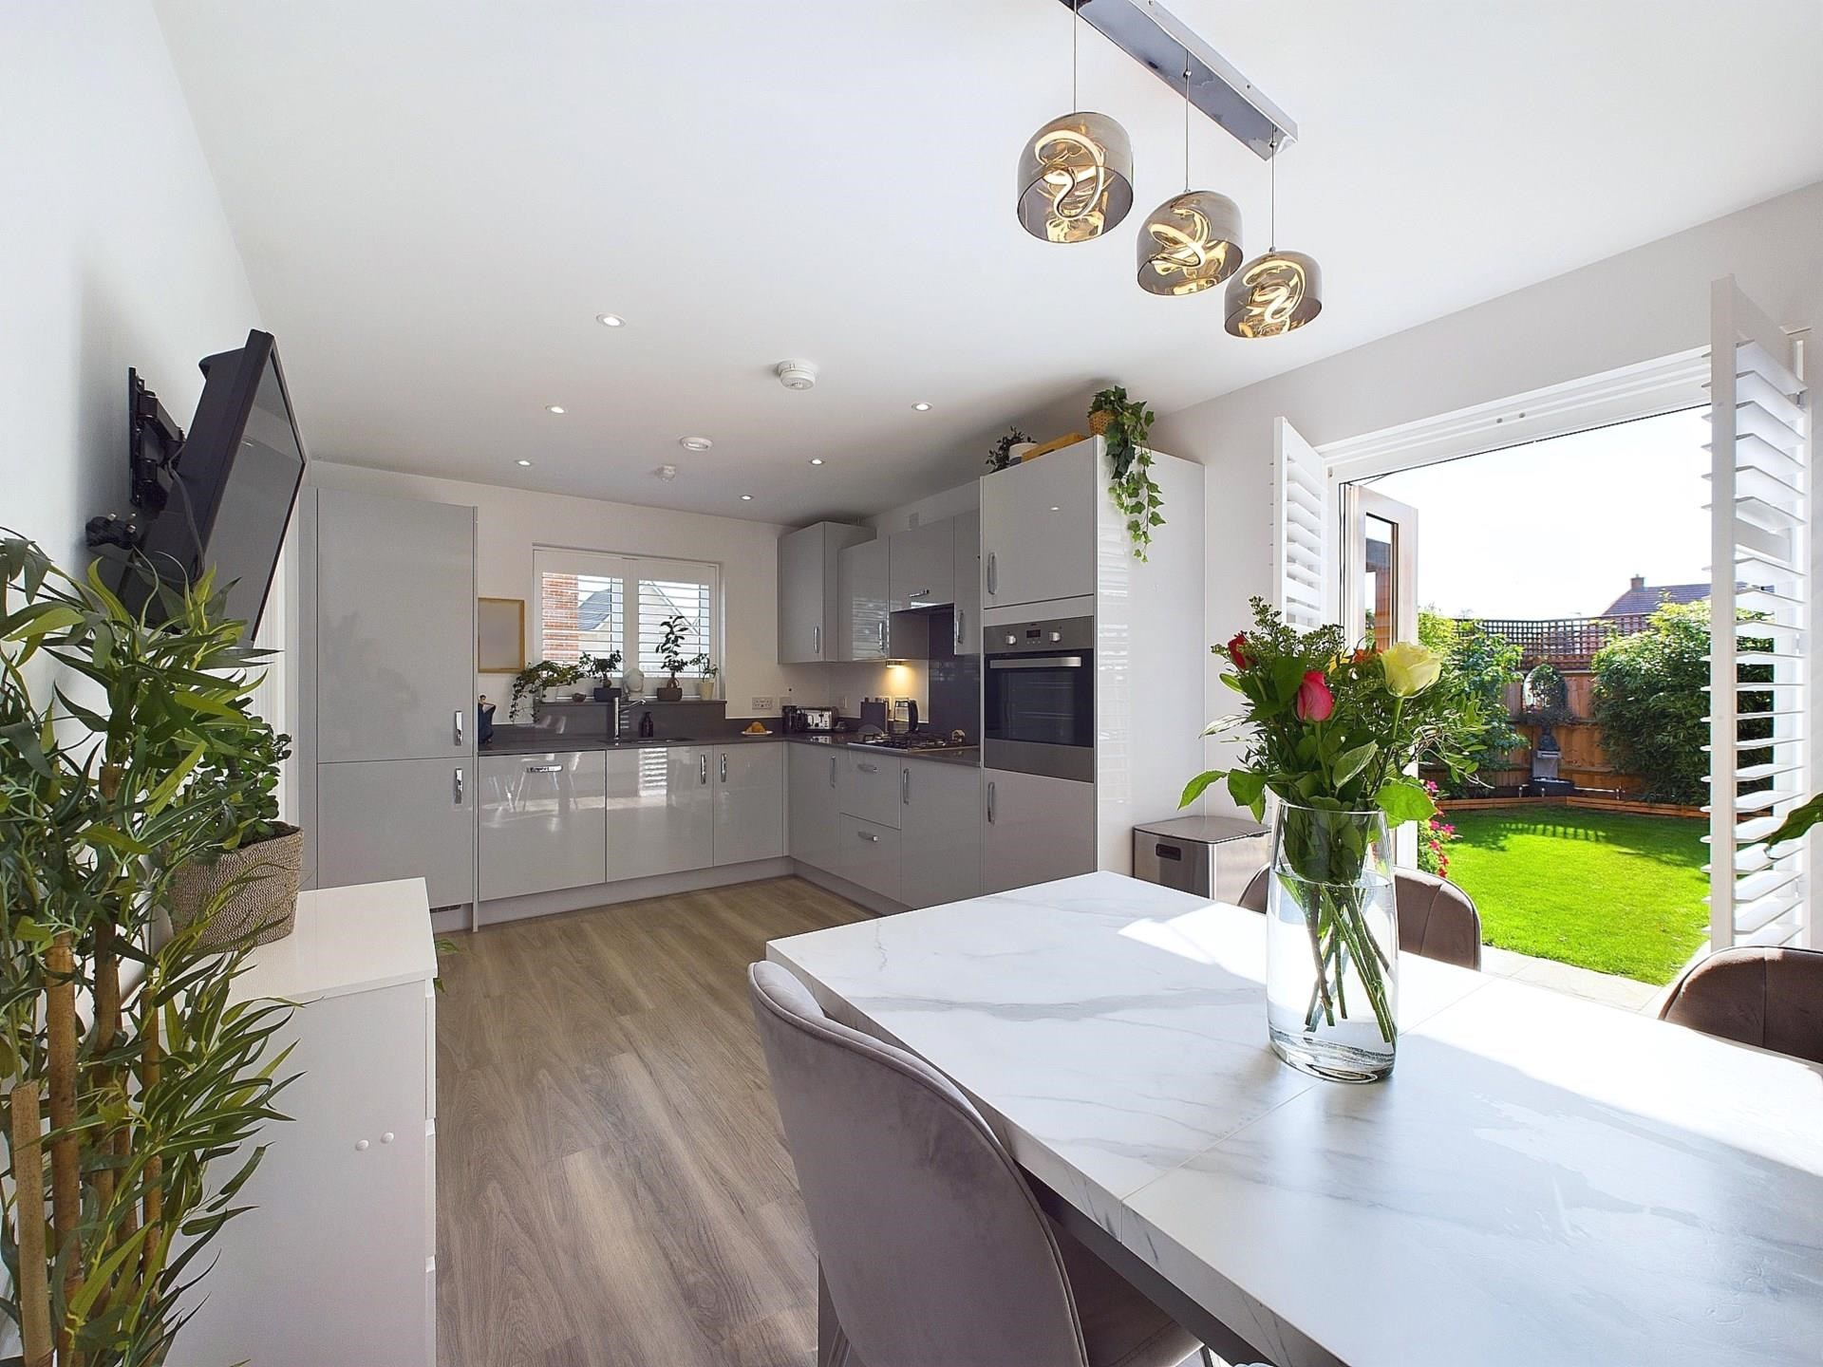

Harrow Road,

Longwick,

Buckinghamshire,

HP27 9EY

Guide Price - £500,000

Nestled in the charming village of Longwick, Buckinghamshire, this beautiful detached property presents an exceptional opportunity for those seeking a tranquil yet well-connected lifestyle. The home offers a fine blend of modern comforts with a classic village setting, making it a perfect match for families, professionals, or anyone looking for a peaceful retreat within easy reach of nearby towns and transport links.

Upon entering the property, you are greeted by a spacious and inviting hallway, which sets the tone for the rest of the home, with its natural light and immaculate condition.

The lounge is a perfect space for family gatherings or entertaining guests and boasts ample space for various seating arrangements, with large windows allowing natural light to flood in, creating a bright and airy atmosphere.

The kitchen is a functional and stylish space equipped with modern appliances, ample storage, and a generous dining area. Ideal for preparing meals or hosting dinner parties, it seamlessly blends form and function. Double French doors from the kitchen leads out to the rear garden, a well-tended outdoor area perfect for summer barbecues, al fresco dining, or simply relaxing in the peace of your own private sanctuary. The garden is both manageable and beautifully designed, offering a mix of lawn and patio spaces.

Upstairs, the property features three well-proportioned bedrooms. The master bedroom is a spacious and tranquil retreat and includes an en-suite bathroom, featuring a modern walk-in shower, vanity unit, and sleek fittings, adding a touch of luxury to everyday living. The second bedroom is a comfortable double with a built-in wardrobe and the third bedroom is ideal for young children, as a spare room or office.

The family bathroom is well-appointed and stylish, featuring a bath with an overhead shower, a modern vanity unit, and contemporary tiling. Both bathrooms in the property, alongside the downstairs W.C have been finished to a high standard, ensuring that the home is `TURN-KEY`

The home also benefits from gas central heating, double-glazed windows, bespoke high-quality fitted blinds and off-street parking with a garage and also benefits from plenty of visitor bays.

Longwick

Longwick, Buckinghamshire, is a picturesque village located at the foot of the Chiltern Hills, an Area of Outstanding Natural Beauty. The village offers a perfect blend of countryside charm with modern conveniences, making it a highly desirable location for families and individuals alike. Despite its peaceful setting, Longwick is conveniently located near the bustling market towns of Princes Risborough and Thame, where you will find a variety of shops, restaurants, and amenities.

The village is also home to a well-regarded local pub, The Red Lion, which is the perfect spot to enjoy a relaxed meal or a drink with friends. For those who prefer cooking at home, there is a local farm shop where you can purchase fresh, locally sourced produce.

For families, Longwick offers excellent schooling options. The local primary school has a good reputation, and there are a number of well-regarded secondary schools in the surrounding areas, including in nearby Thame and Aylesbury. Additionally, there are several independent schools within driving distance, offering further educational choices.

EPC RATING – B

COUNCIL TAX BAND - E

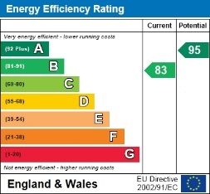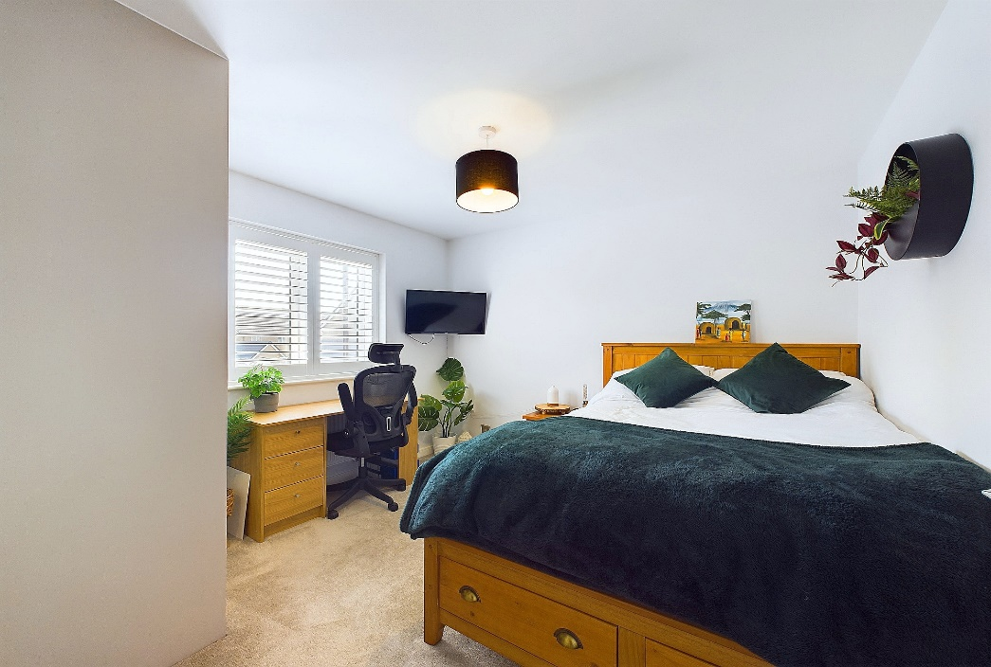

Zoopla LogoNAEA Propertymark Protected CMYKRM_Logo_NoStrap_Colourfacebook logoPrimelocation lscape

**Disclaimer**

We endeavour to make our particulars accurate and reliable. They are for guidance only and are intended to give a fair overall summary of the property. They do not form part of any contract or offer, and should not be relied upon as a statement or representation of fact. Measurements, areas and distances are approximate and photographs provided for guidance only. No undertaking is given as to the structural condition of the property, or any necessary consents, or the operating ability or efficiency of any service, system or appliance. Prospective purchasers must satisfy themselves with regard to each of these points. If there is any particular aspect of the property about which you would like further information, please contact us, especially, before you travel to the property. B2170

78 High Street, Princes Risborough, Buckinghamshire, HP27 0AX

01844 343661

www.bb-estateagents.co.uk