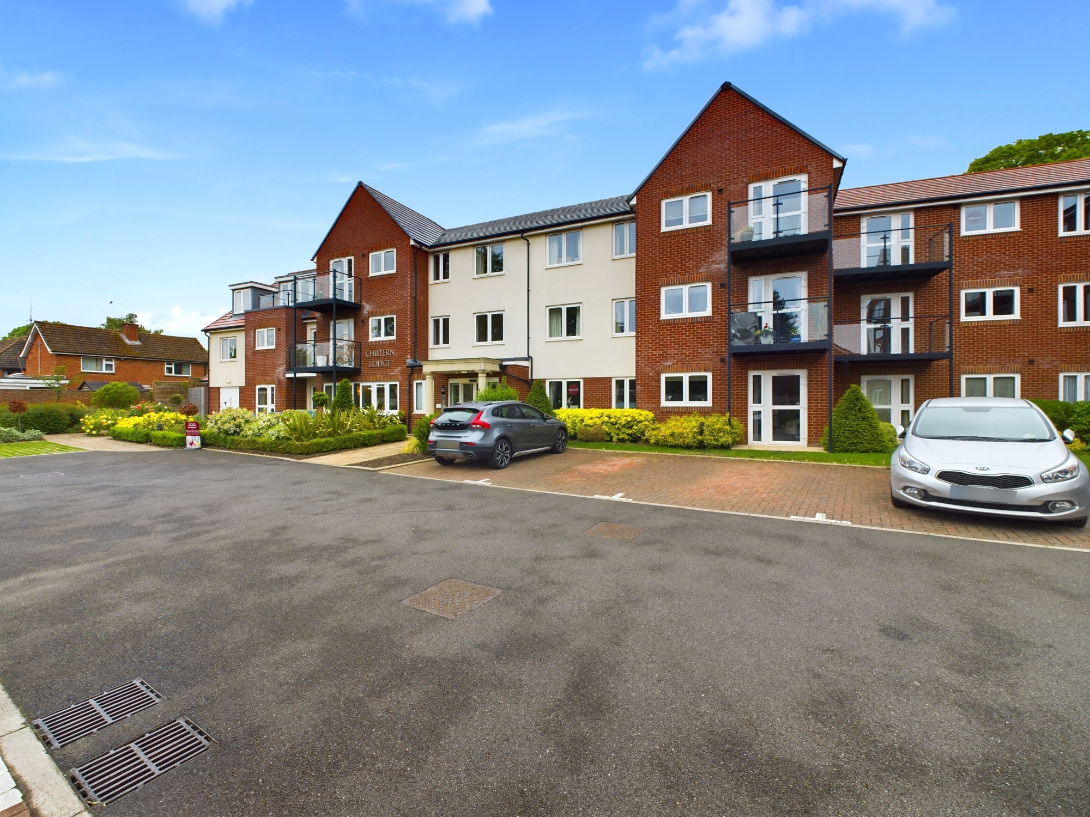bb-logo-final

Chiltern Lodge

Princes Risborough

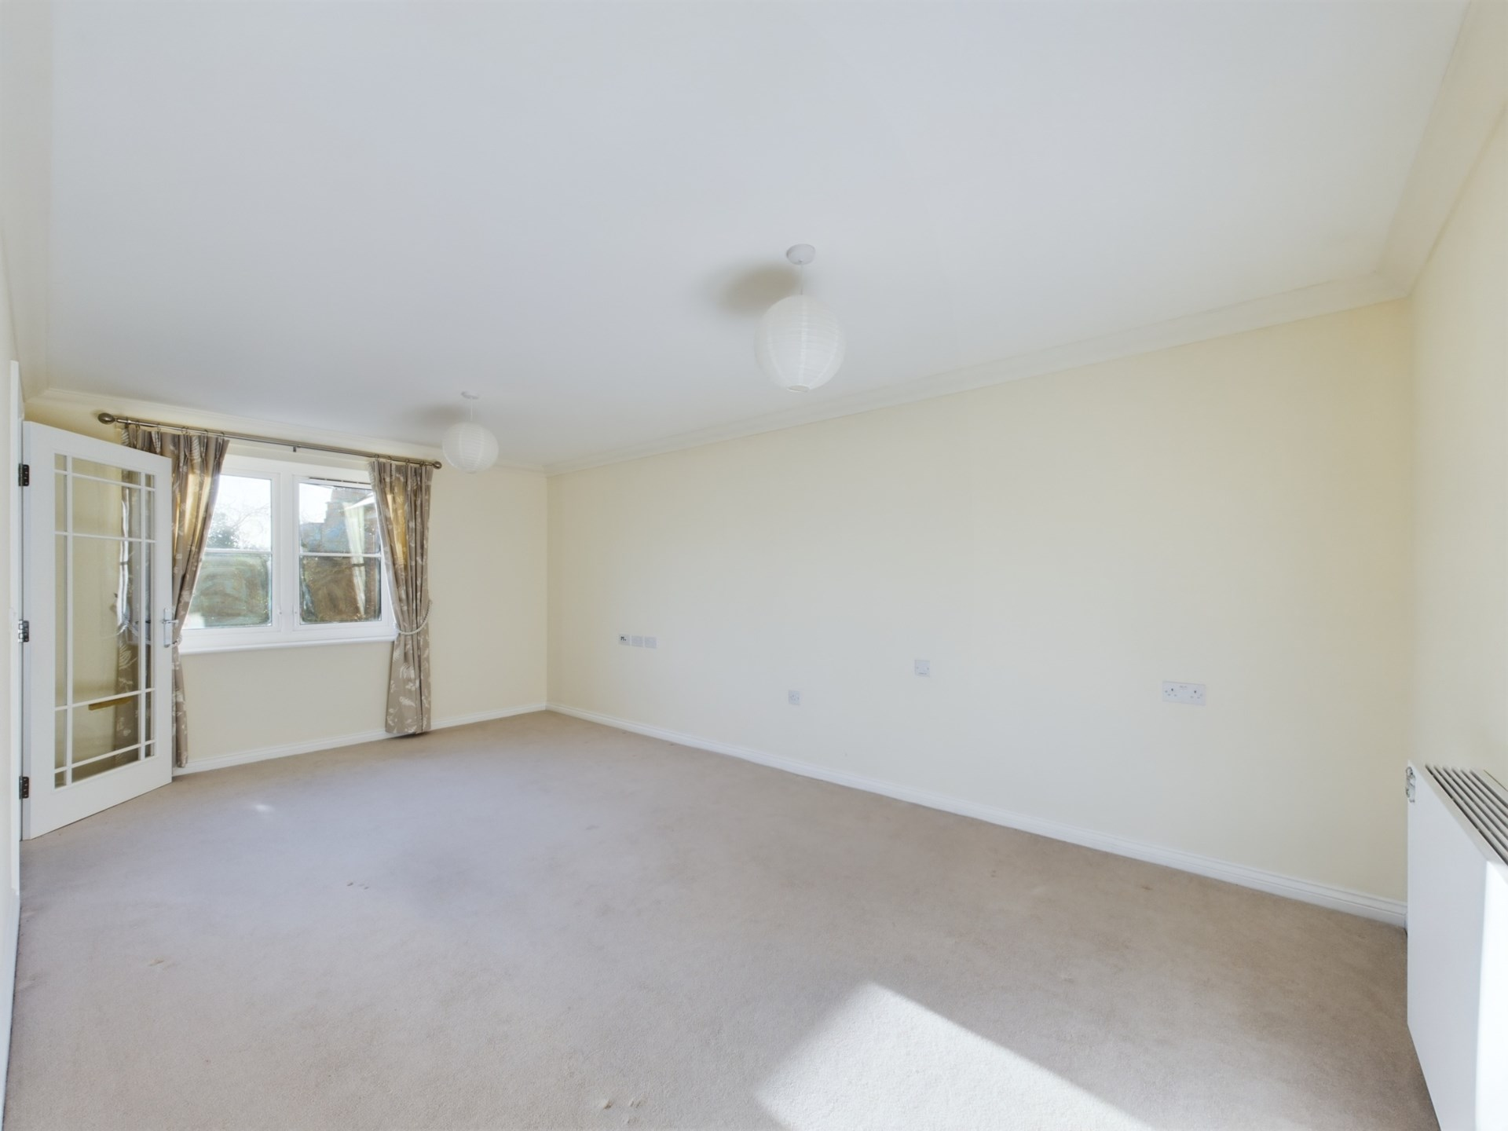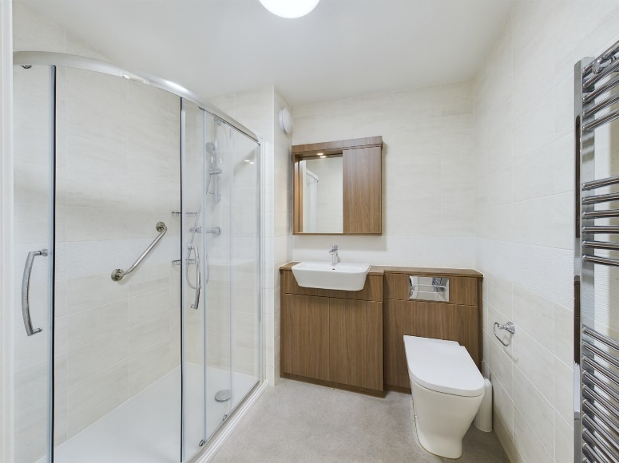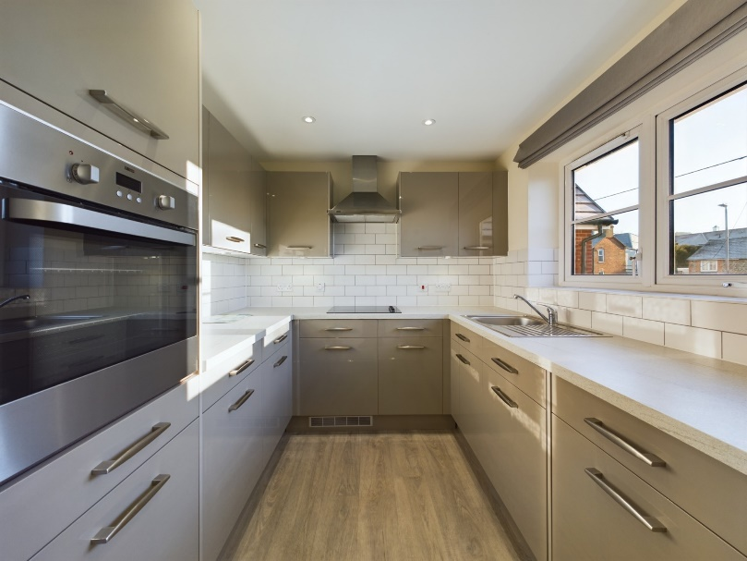

Chiltern Lodge

Princes Risborough

Buckinghamshire

HP27 9ES

Guide Price - £225,000

An immaculately presented one bedroom, first floor retirement apartment which is located within close proximity to the town centre. The property is located within a short walk of the town centre of Princes Risborough with excellent amenities, supermarkets and transport links.

The property accommodation comprises of the following, entrance hallway with large storage cupboard, good sized living room, modern separate kitchen with fitted appliances including a fridge / freezer, dishwasher and washing machine. There is also a good sized double bedroom with fitted wardrobes and a modern shower room with walk in shower.

Outside there are communal gardens as well as a car park for residents only.

Other notable features include, mains gas central heating system and double glazed windows.

The lodge offers independent living for all the residents and there is a large reception room with bar for the residents to enjoy at all times if they wish. The lodge manager is on hand throughout the day to support the owners and keep the development in perfect shape as well as arranging many regular events for the owners as well as coffee mornings and games afternoons. There is also a guest suite for any friends or family that wish to stay and only costs £25.00 per night which beats any local hotel.

Princes Risborough

The attractive market town of Princes Risborough offers a post office, a leisure centre and a good range of local shops including a Tesco, Marks & Spencer Simply Food and Costa Coffee. Further, more comprehensive leisure and shopping facilities can be found in High Wycombe, Aylesbury and Oxford all within easy reach. Excellent schooling is provided locally with a good choice of private and state schools close by including grammar schools in High Wycombe and Aylesbury.

There is access to the M40 motorway for London and the Midlands just 6 miles away (J6) and Princes Risborough station offers an excellent main line rail service to London (Marylebone - 35 minutes) and the Midlands.

EPC RATING - B

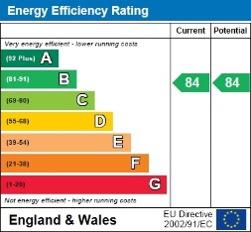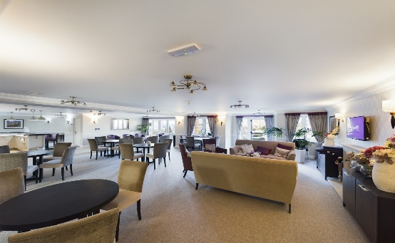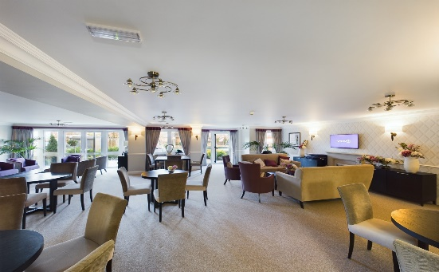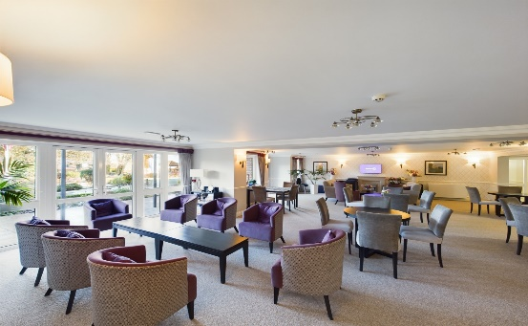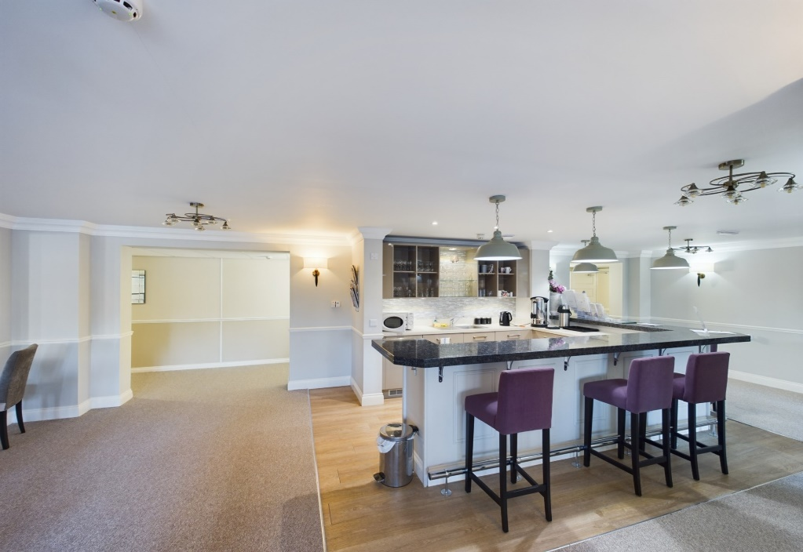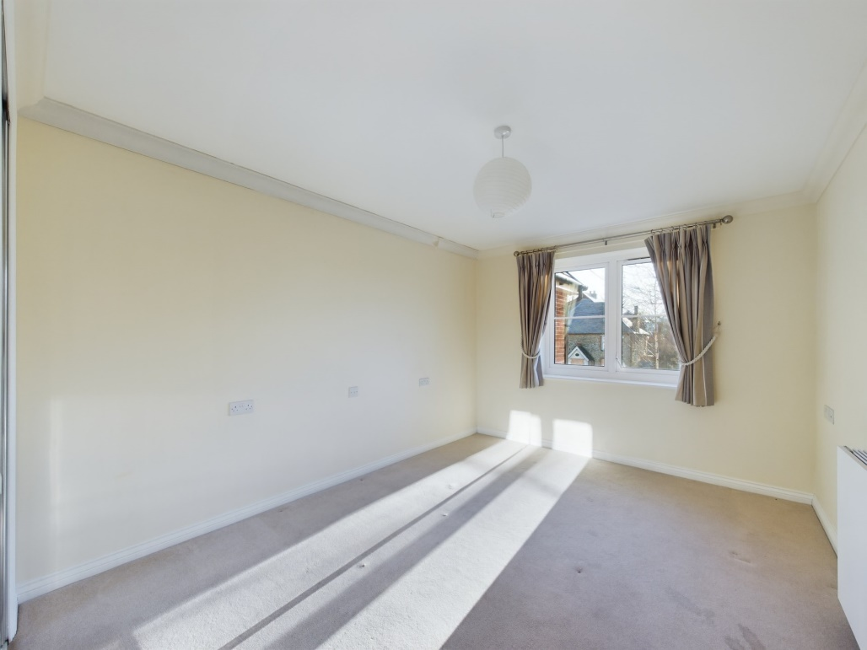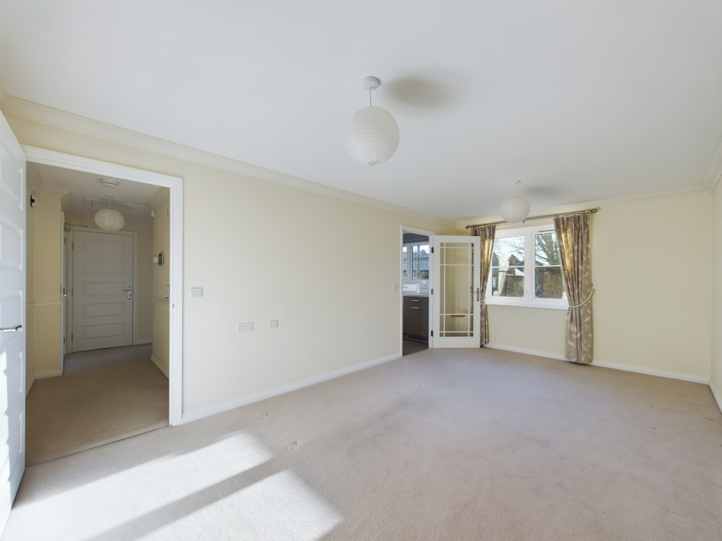

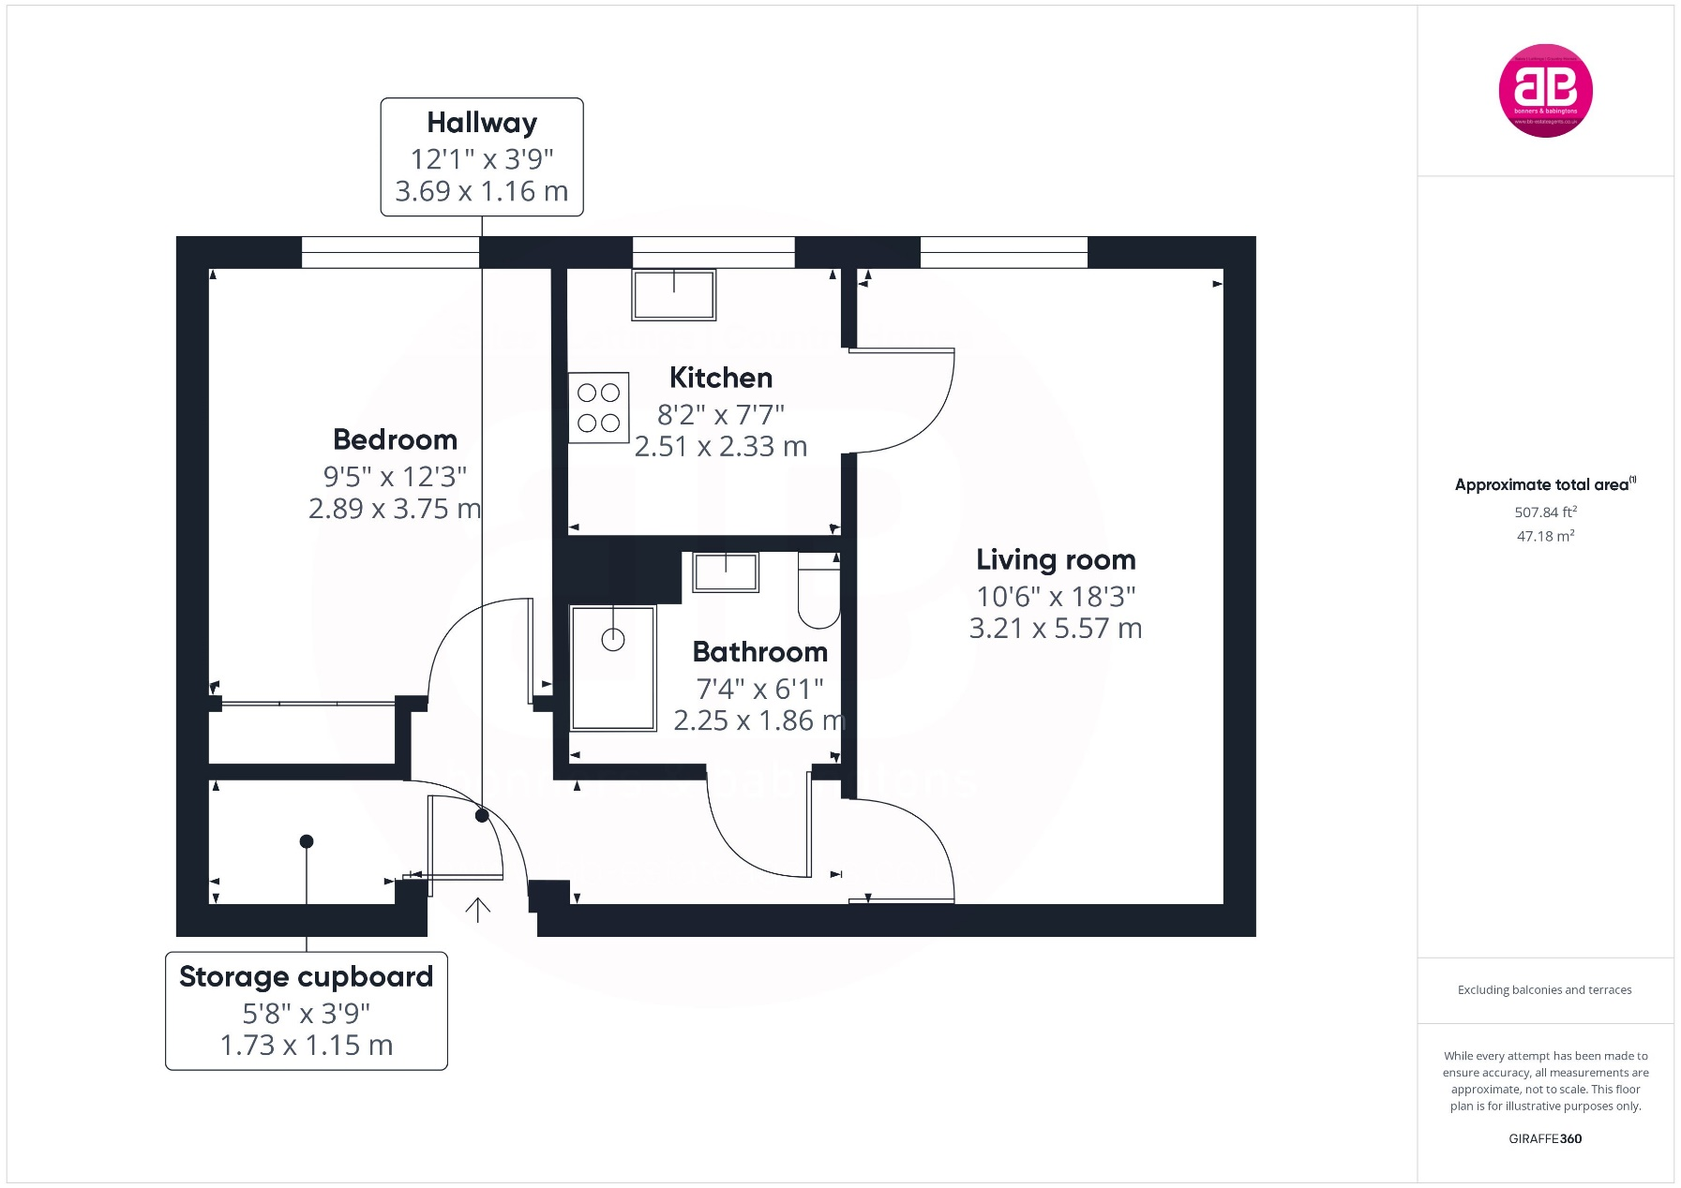

Zoopla LogoNAEA Propertymark Protected CMYKRM_Logo_NoStrap_Colourfacebook logoPrimelocation lscape

**Disclaimer**

We endeavour to make our particulars accurate and reliable. They are for guidance only and are intended to give a fair overall summary of the property. They do not form part of any contract or offer, and should not be relied upon as a statement or representation of fact. Measurements, areas and distances are approximate and photographs provided for guidance only. No undertaking is given as to the structural condition of the property, or any necessary consents, or the operating ability or efficiency of any service, system or appliance. Prospective purchasers must satisfy themselves with regard to each of these points. If there is any particular aspect of the property about which you would like further information, please contact us, especially, before you travel to the property. B2170

78 High Street, Princes Risborough, Buckinghamshire, HP27 0AX

01844 343661

www.bb-estateagents.co.uk