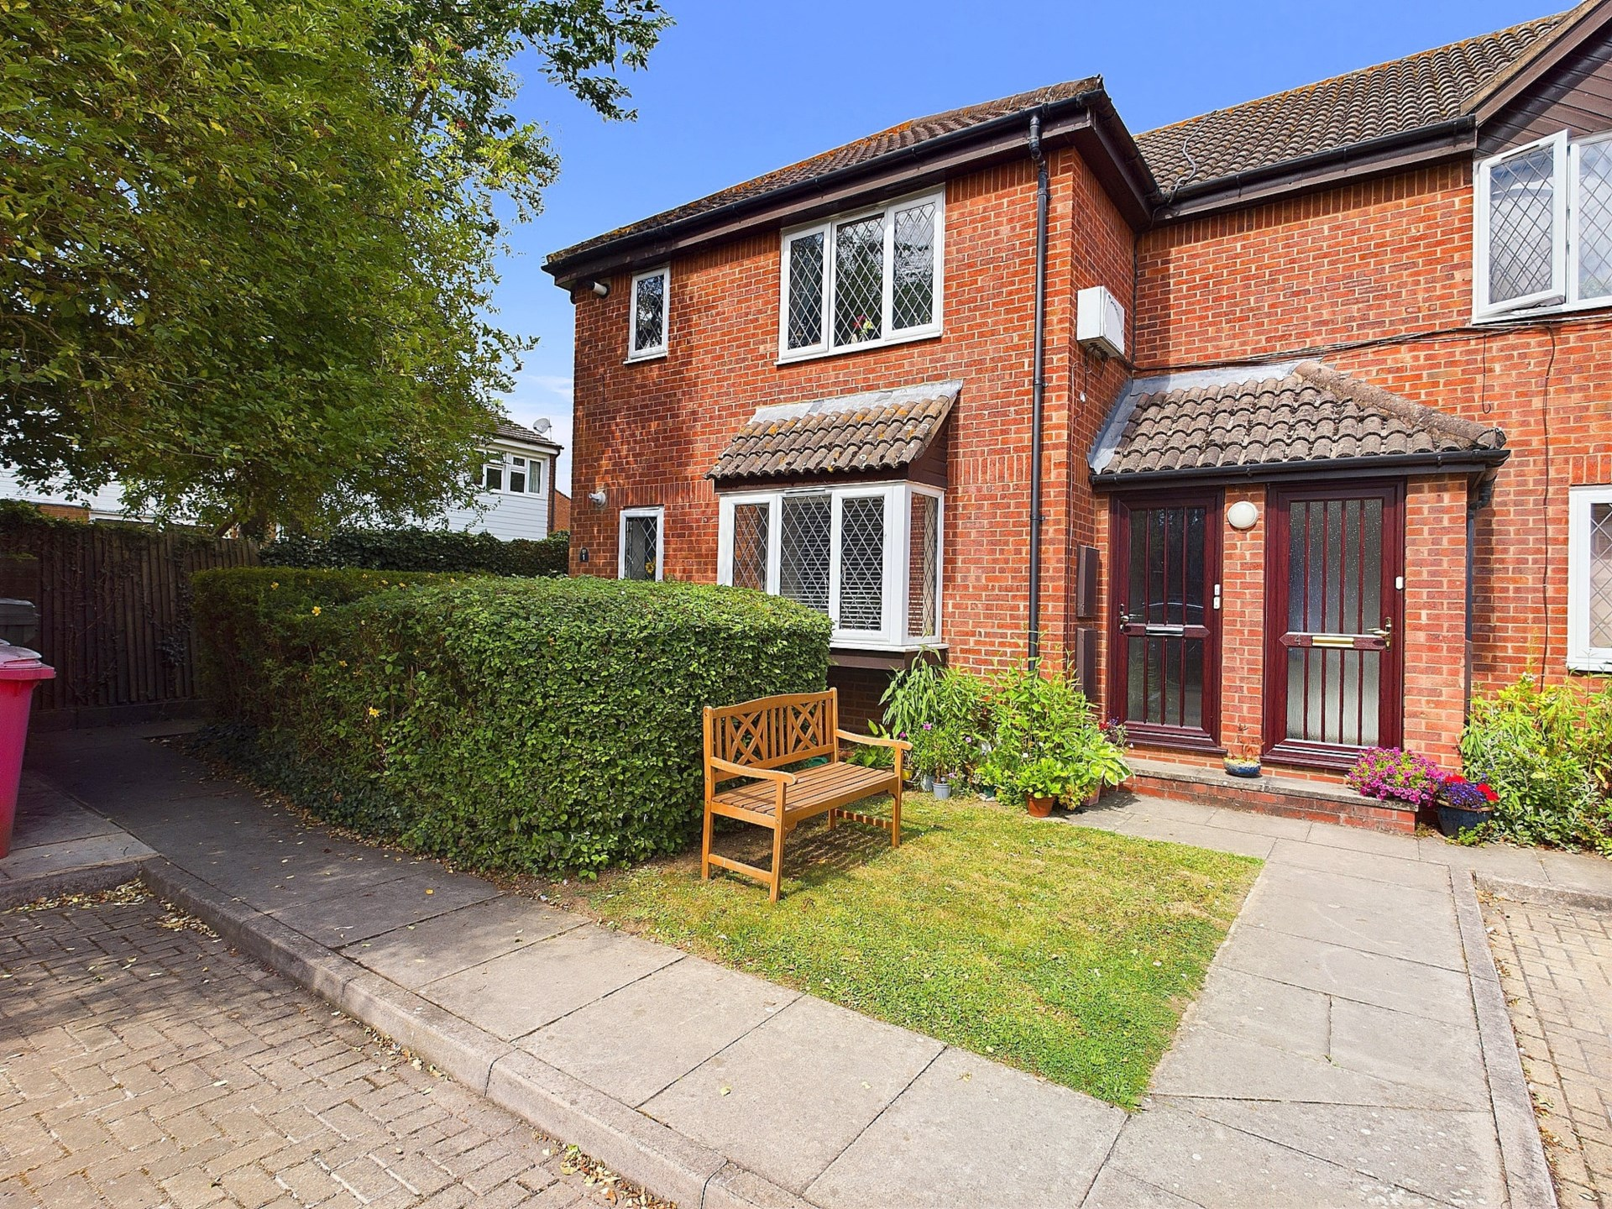bb-logo-final

Gunthorpe Road

Marlow

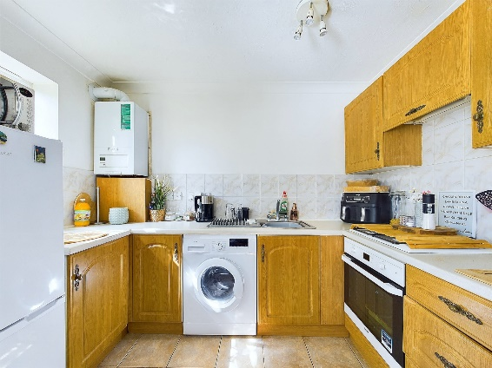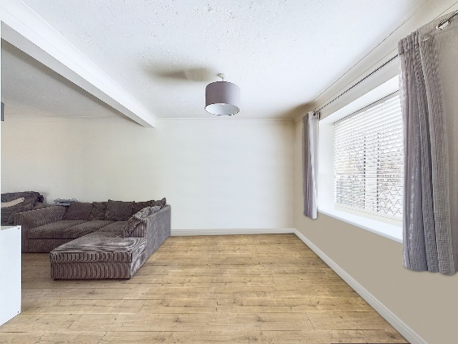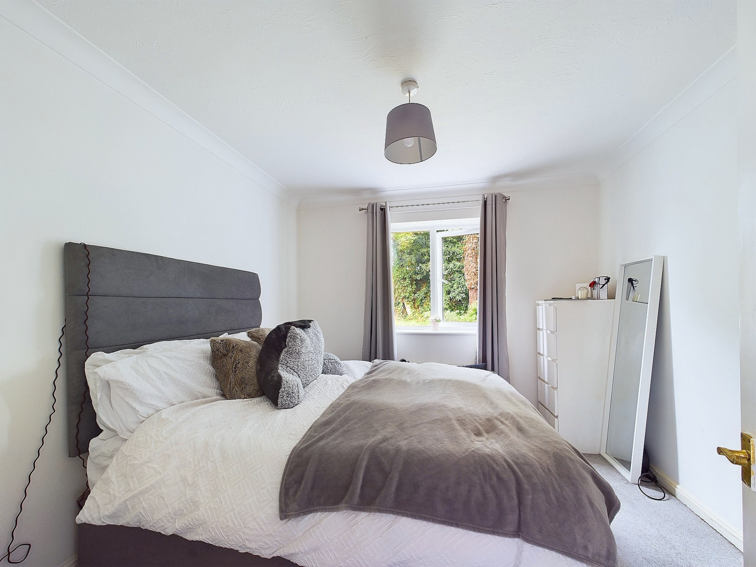

Ravenscourt

Marlow

Buckinghamshire

SL7 1XY

- Tenure:- Leasehold

- O.I.E.O £230,000

-Lease 89 Years remaining

£917 P/A Service Charge

£224 P/A Ground Rent

Band C – Council Tax

EPC RATING - C

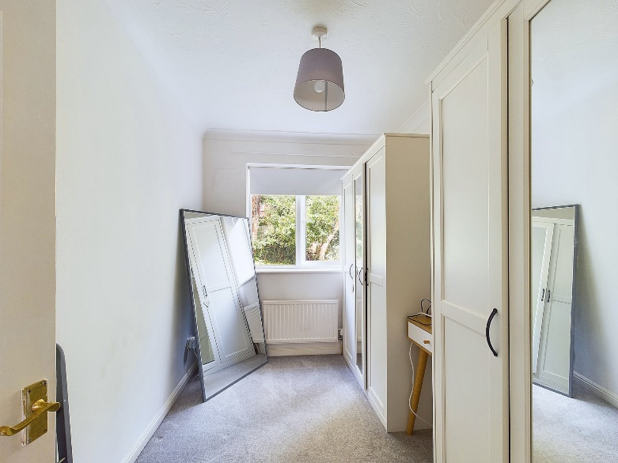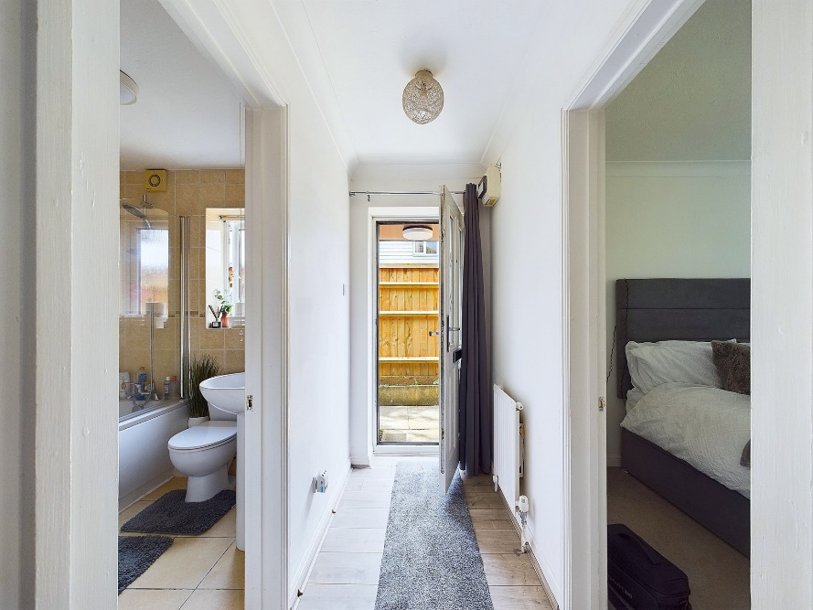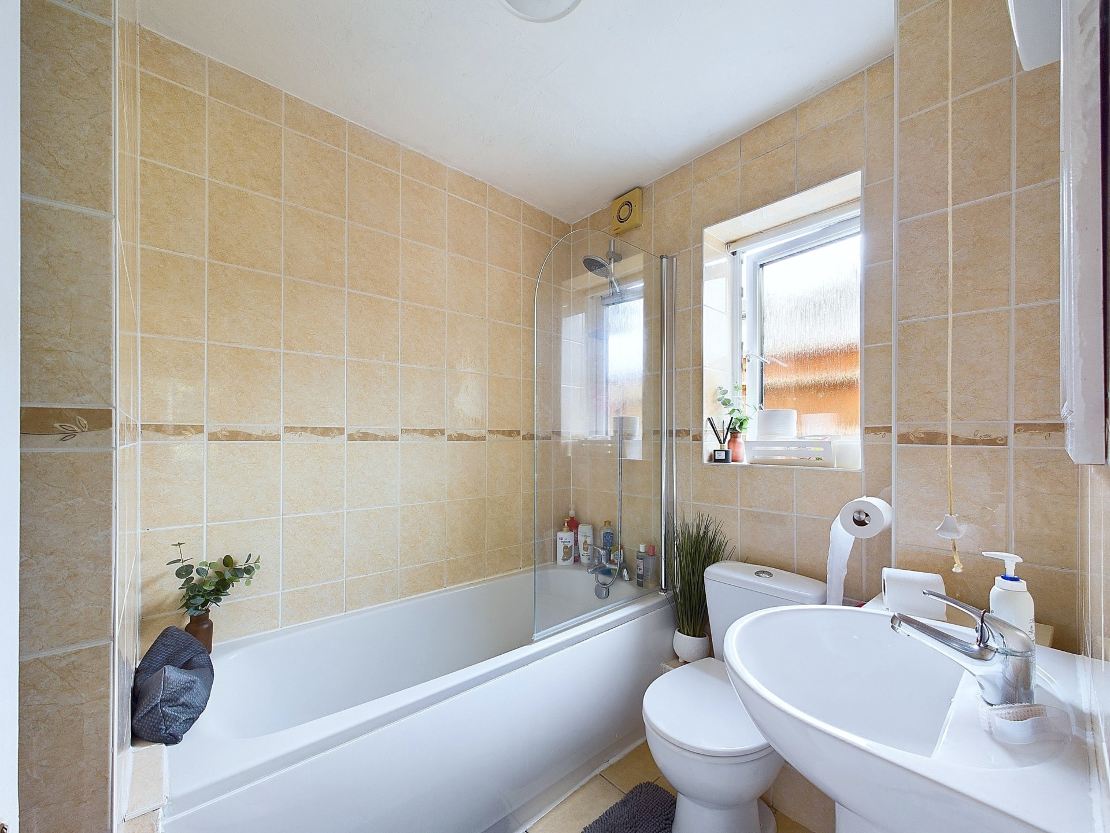

BONNERS & BABINGTONS offer - Tucked away on this EXCLUSIVE BESPOKE DEVELOPMENT this delightful TWO BEDROOM GROUND FLOOR apartment is an ideal first time or investment opportunity. With communal gardens, parking and NO ONWARD CHAIN we highly recommend an internal inspection.

This smashing apartment is situated on a bespoke development to the east of Marlow town centre and would be perfect for first time buyers, investment buyers or downsizers. Positioned on the ground floor this property has all its accommodation across one level. On entering the property there is a bedroom on your left with the family bathroom opposite on the right. Moving along the hallway you enter a lovely large living space with a door to a further bedroom and open plan access to the kitchen. Plenty of space for a single occupier or couple to start their journey on the property ladder or a old couple looking to downsize in the area. To the outside there is a large communal garden at the rear plus residents parking to the front. Only a short walk from this apartment will get you over the bridge and into countryside & woodland walks plus lakeside strolls with Little Marlow Village only a fifteen minute walk away. Marlow Train Station is only 10 minutes walk and Marlow High Street is just over a mile away. With the added bonus of easy access to the A404 you could be on the M40 in five minutes or the M4 in ten.

Marlow town centre is a thriving and stylish riverside community with a comprehensive range of shops and excellent pubs and restaurants. Nearby Marlow Station has a regular train service to London Paddington via Maidenhead (from 44 mins) with links to the City of London, via the Elizabeth Line. Access to the M4 and M40 is via the A404(M) and London Heathrow is approximately 22 miles away.

There is a wide range of educational and recreational facilities in the area. Excellent local schools are numerous and include Sir William Borlase in Marlow.

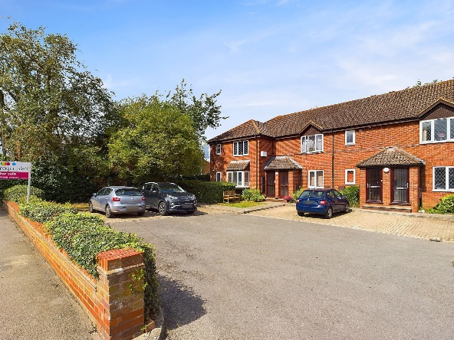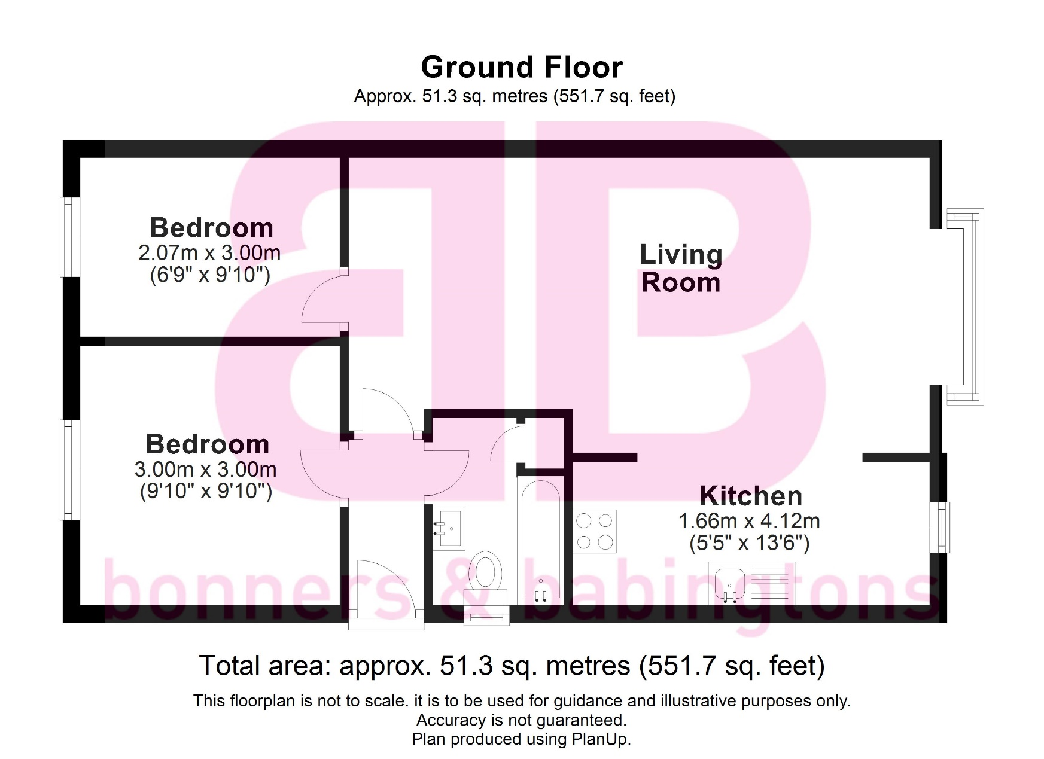

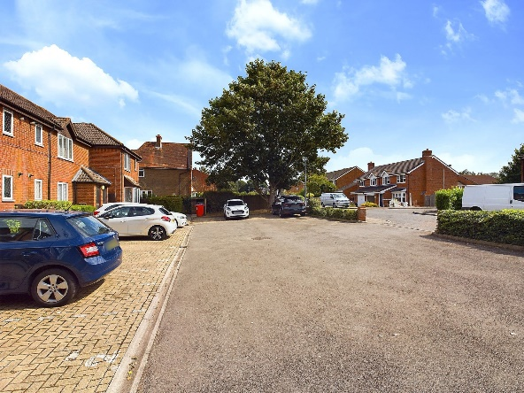

3 Anglers Court, Spittal Street, Marlow, Bucks, SL7 3HJ

01628 333800

www.bb-estateagents.co.uk

