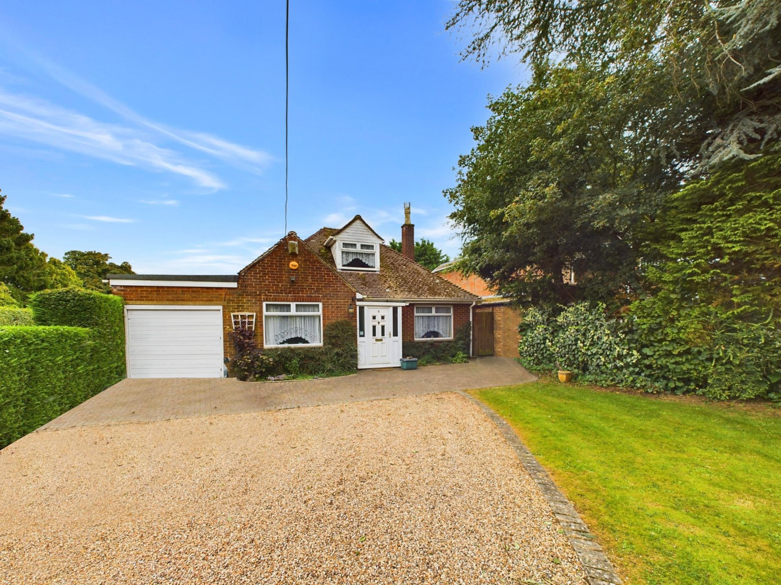



Lowes Close

Stokenchurch

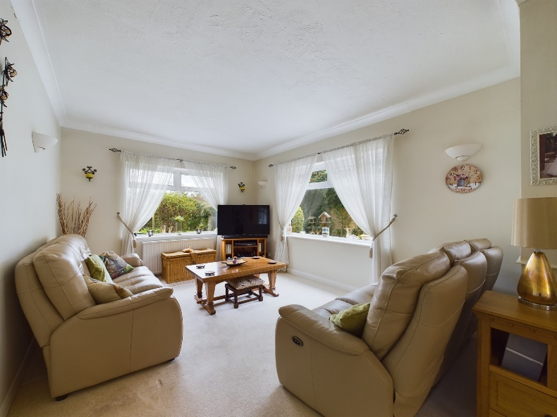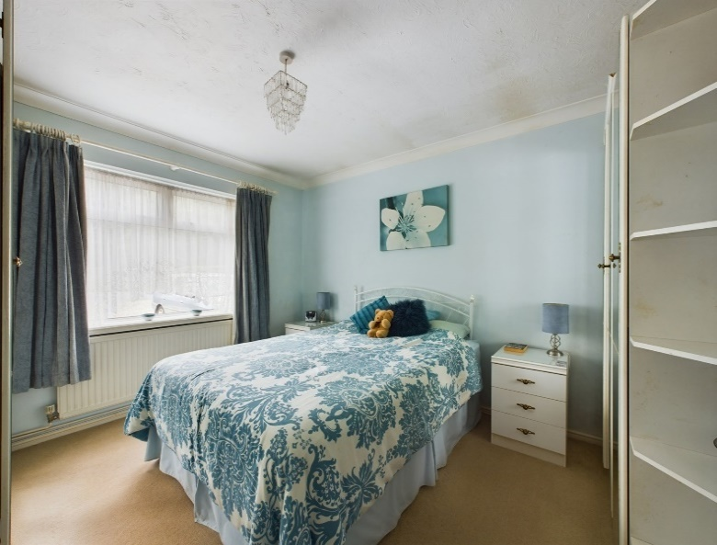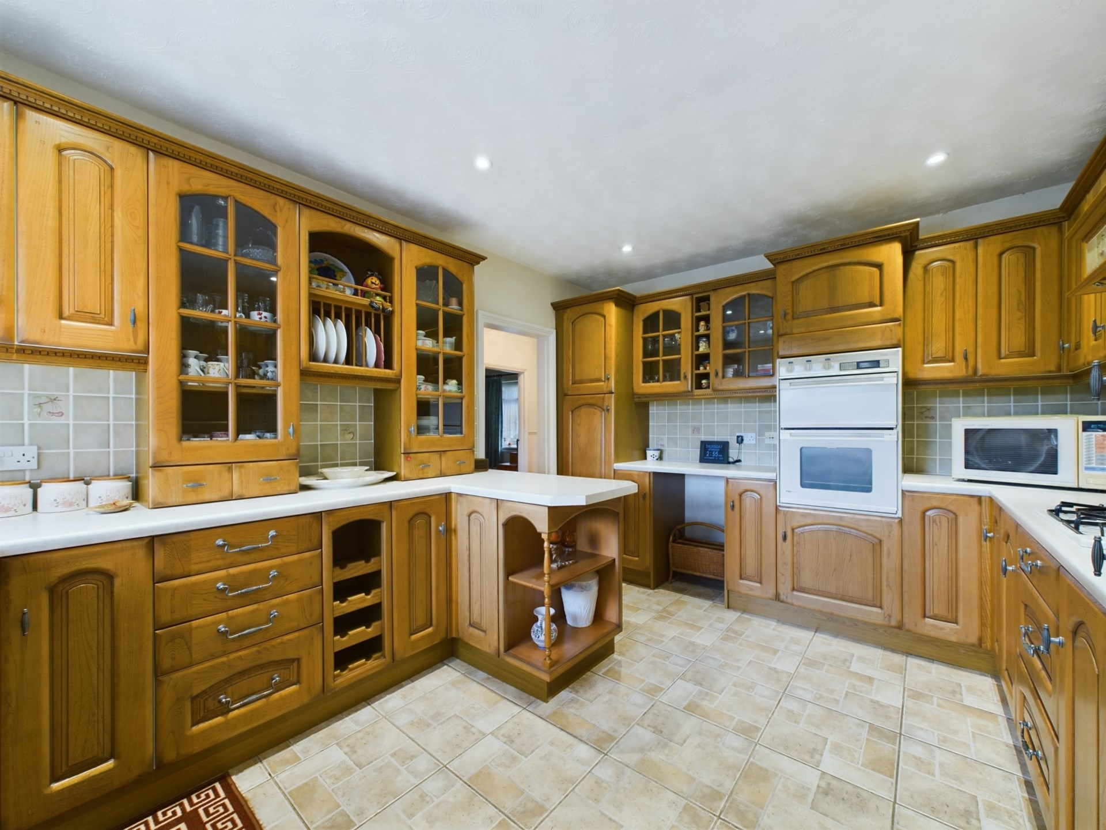

Lowes Close

Stokenchurch

Buckinghamshire

HP14 3TN

OIEO £485,000

A rarely available 3 double bedroom detached bungalow, situated in a no through road, on the outskirts of Stokenchurch village. The property boasts a large south east facing garden, a spacious driveway for multiple vehicles and potential for improvement. Offered `For Sale` with NO UPPER CHAIN!

The property consists of; an entrance porch opening into the hallway where all rooms lead from. The kitchen provides ample eye and waist level storage units, with space for white goods. The open plan living/dining room is dual aspect creating a light and airy space. There are 3 double bedrooms, one currently being used as an extra reception room. In addition, there is also a conservatory which is a great addition to the house as it creates extra living space, providing patio doors to the sunny rear garden.

**Outside**

To the front of the property there is a gated driveway, with space for multiple vehicles and a small lawn area. To the rear of the property there is a low maintenance garden, which is south east facing. It`s mainly laid to lawn with shrub borders and boasts a patio area, ideal for alfresco dining. There is a single garage with an up and over door.

**Location**

Stokenchurch is a popular Buckinghamshire village situated in the Chiltern Hills. The village facilities include shops for day to day use, a doctor`s surgery, post office, library, Primary School, numerous pubs and restaurants. There is excellent walking and riding in the area. A more extensive range of facilities can be found in High Wycombe, approximately nine miles distant.

For the commuter there is easy access to the M40 motorway at Junction 5, providing links to Oxford, Birmingham, London, the M25 and M4 motorway networks. The nearest railway station is in High Wycombe with links to London Marylebone and Birmingham.

EPC -Rating D

Council Tax Band E

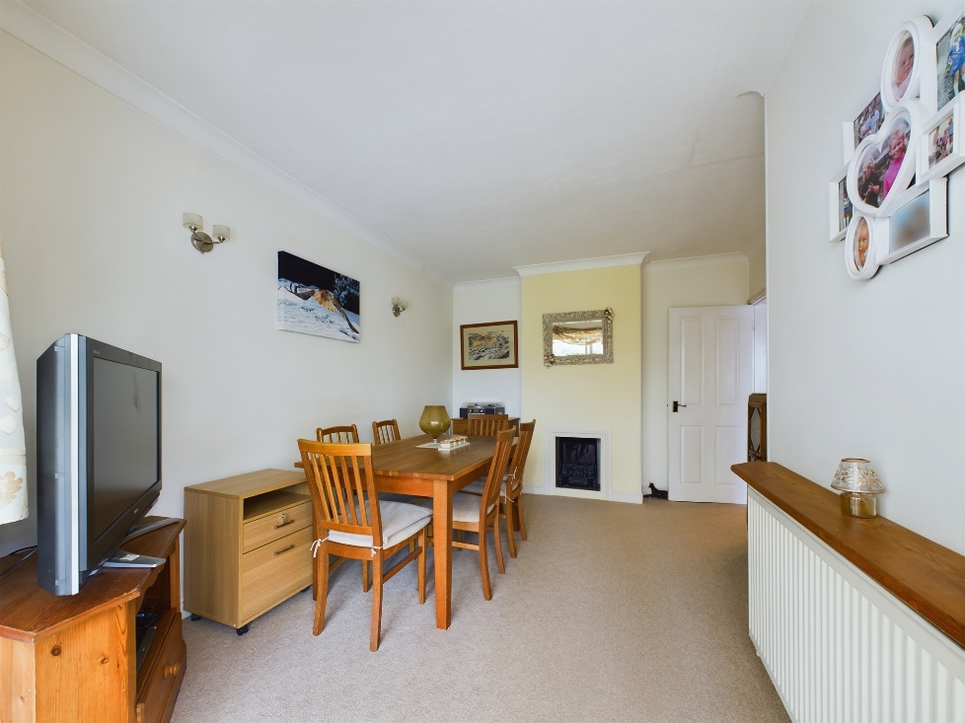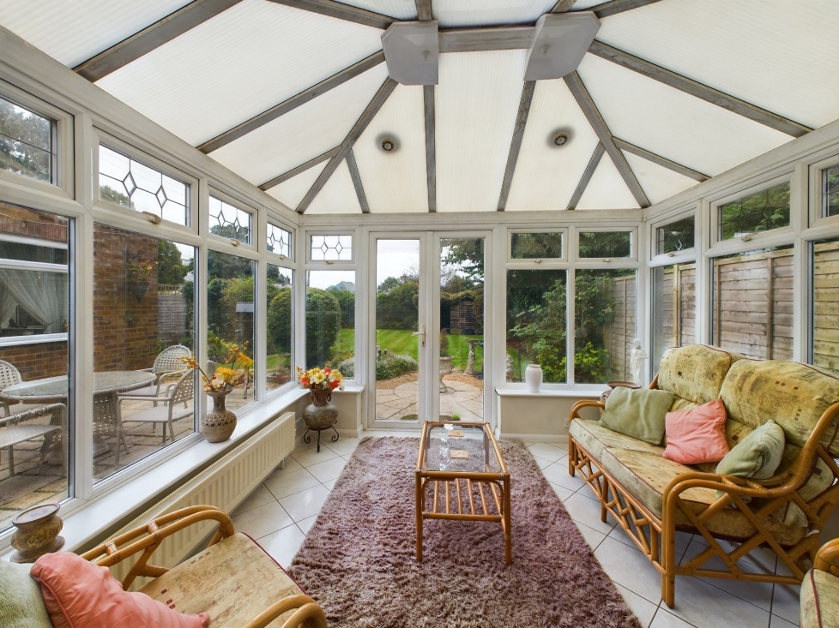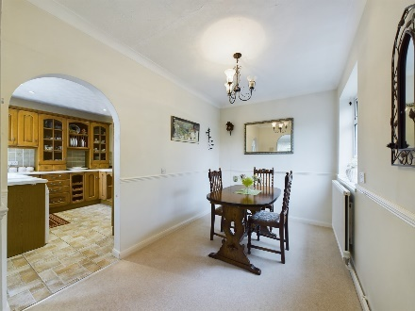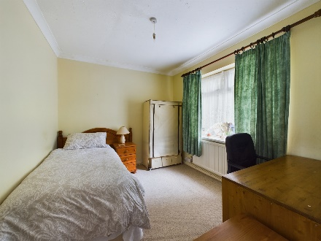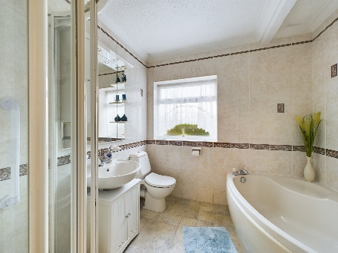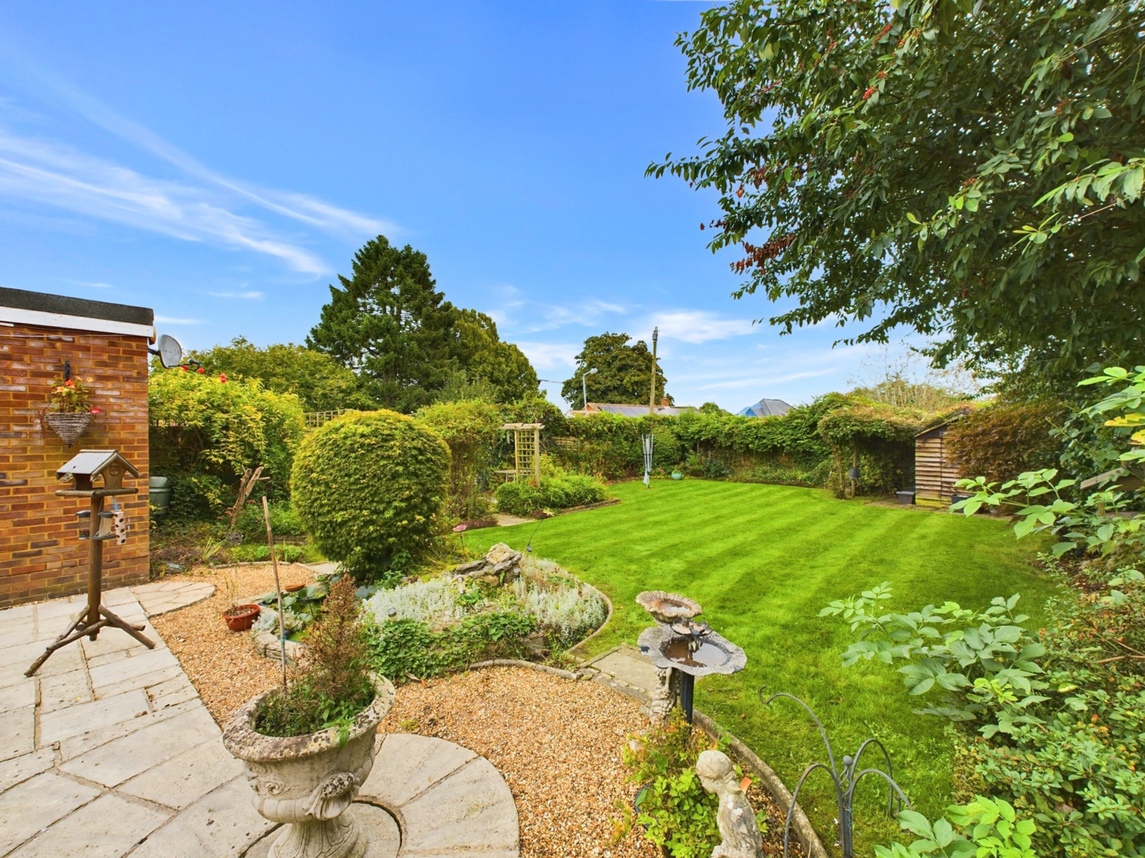

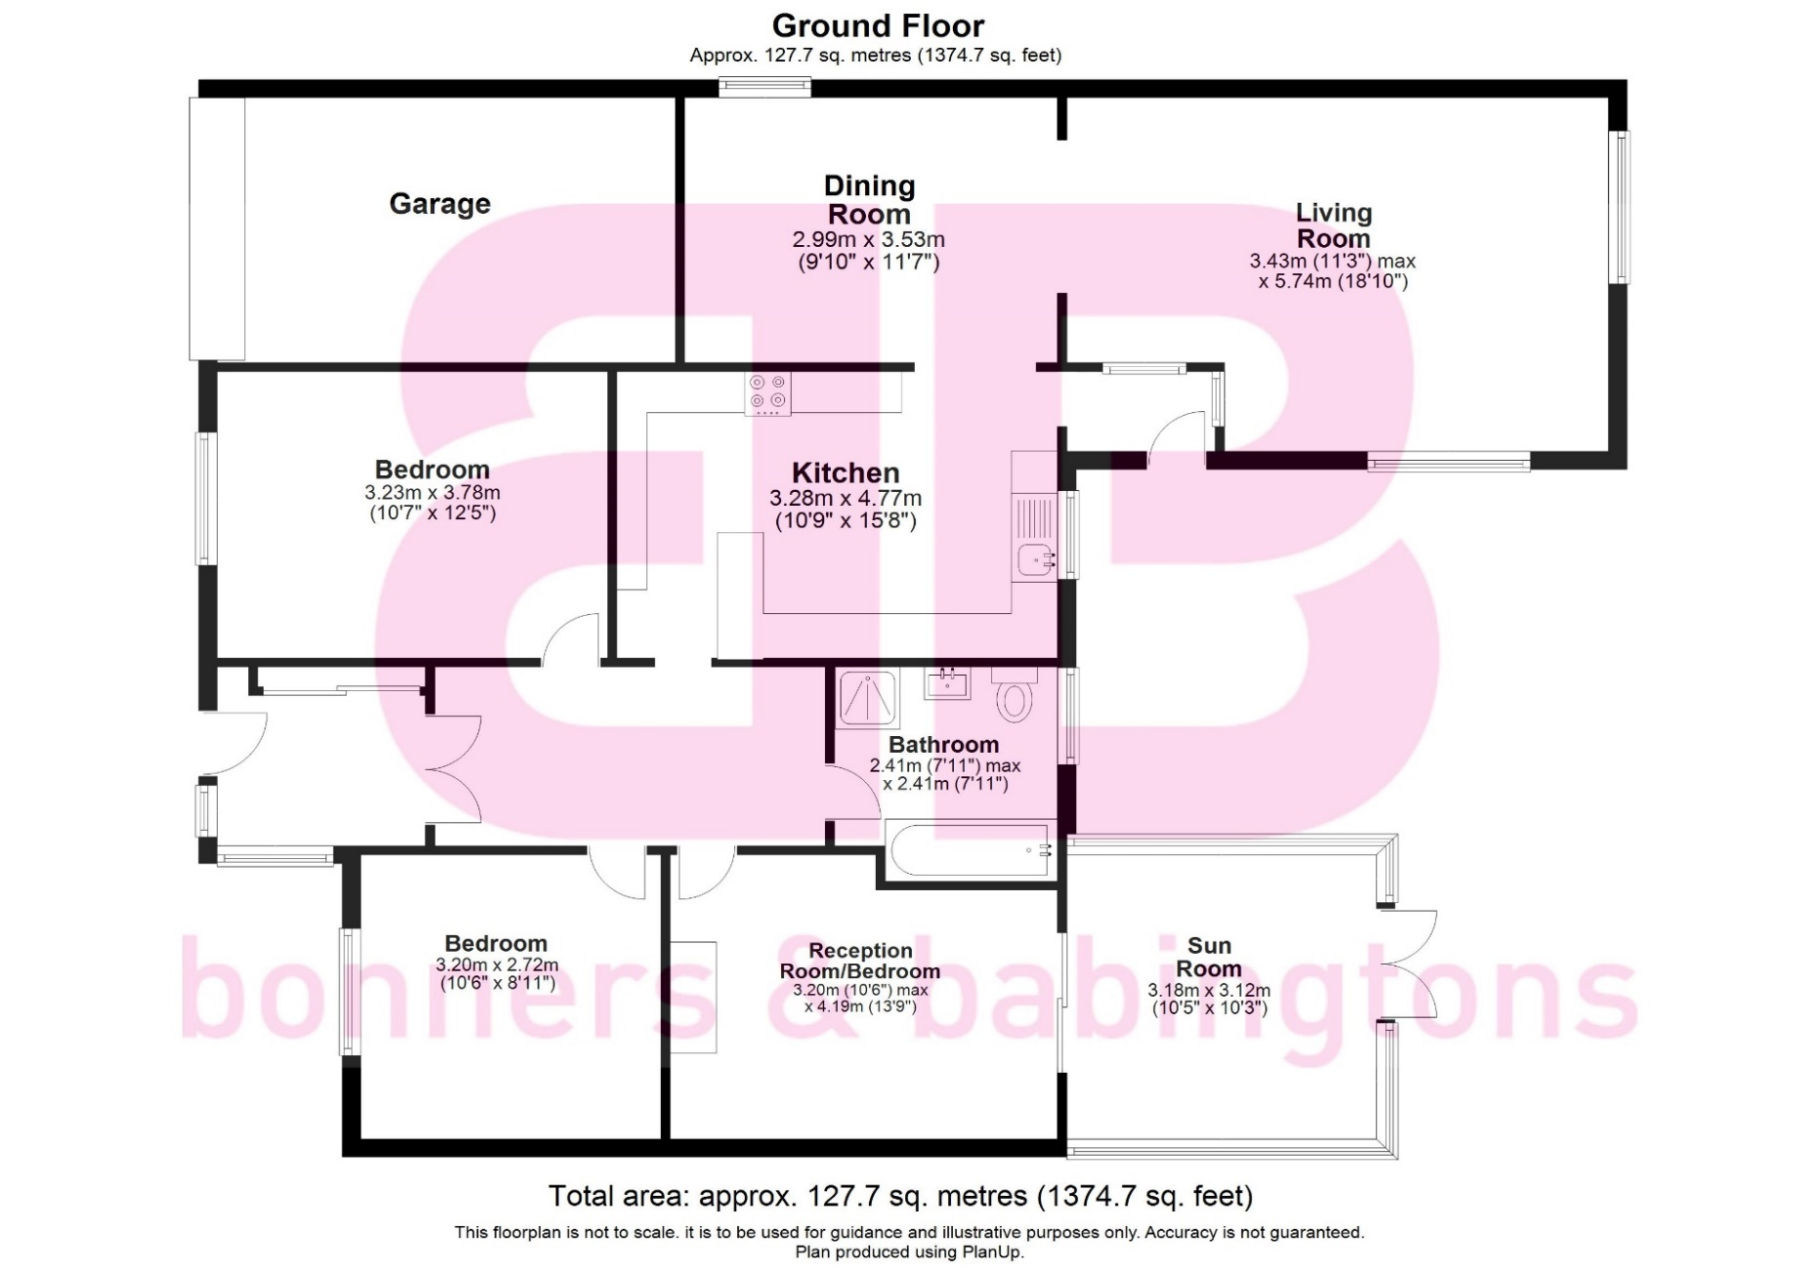

Zoopla LogoNAEA Propertymark Protected CMYKRM_Logo_NoStrap_Colourfacebook logoPrimelocation lscape

**Disclaimer**

We endeavour to make our particulars accurate and reliable. They are for guidance only and are intended to give a fair overall summary of the property. They do not form part of any contract or offer, and should not be relied upon as a statement or representation of fact. Measurements, areas and distances are approximate and photographs provided for guidance only. No undertaking is given as to the structural condition of the property, or any necessary consents, or the operating ability or efficiency of any service, system or appliance. Prospective purchasers must satisfy themselves with regard to each of these points. If there is any particular aspect of the property about which you would like further information, please contact us, especially, before you travel to the property. B2170

1 Karenza, Wycombe Road, Stokenchurch, Buckinghamshire,

HP14 3DA

01494 485560

www.bb-estateagents.co.uk