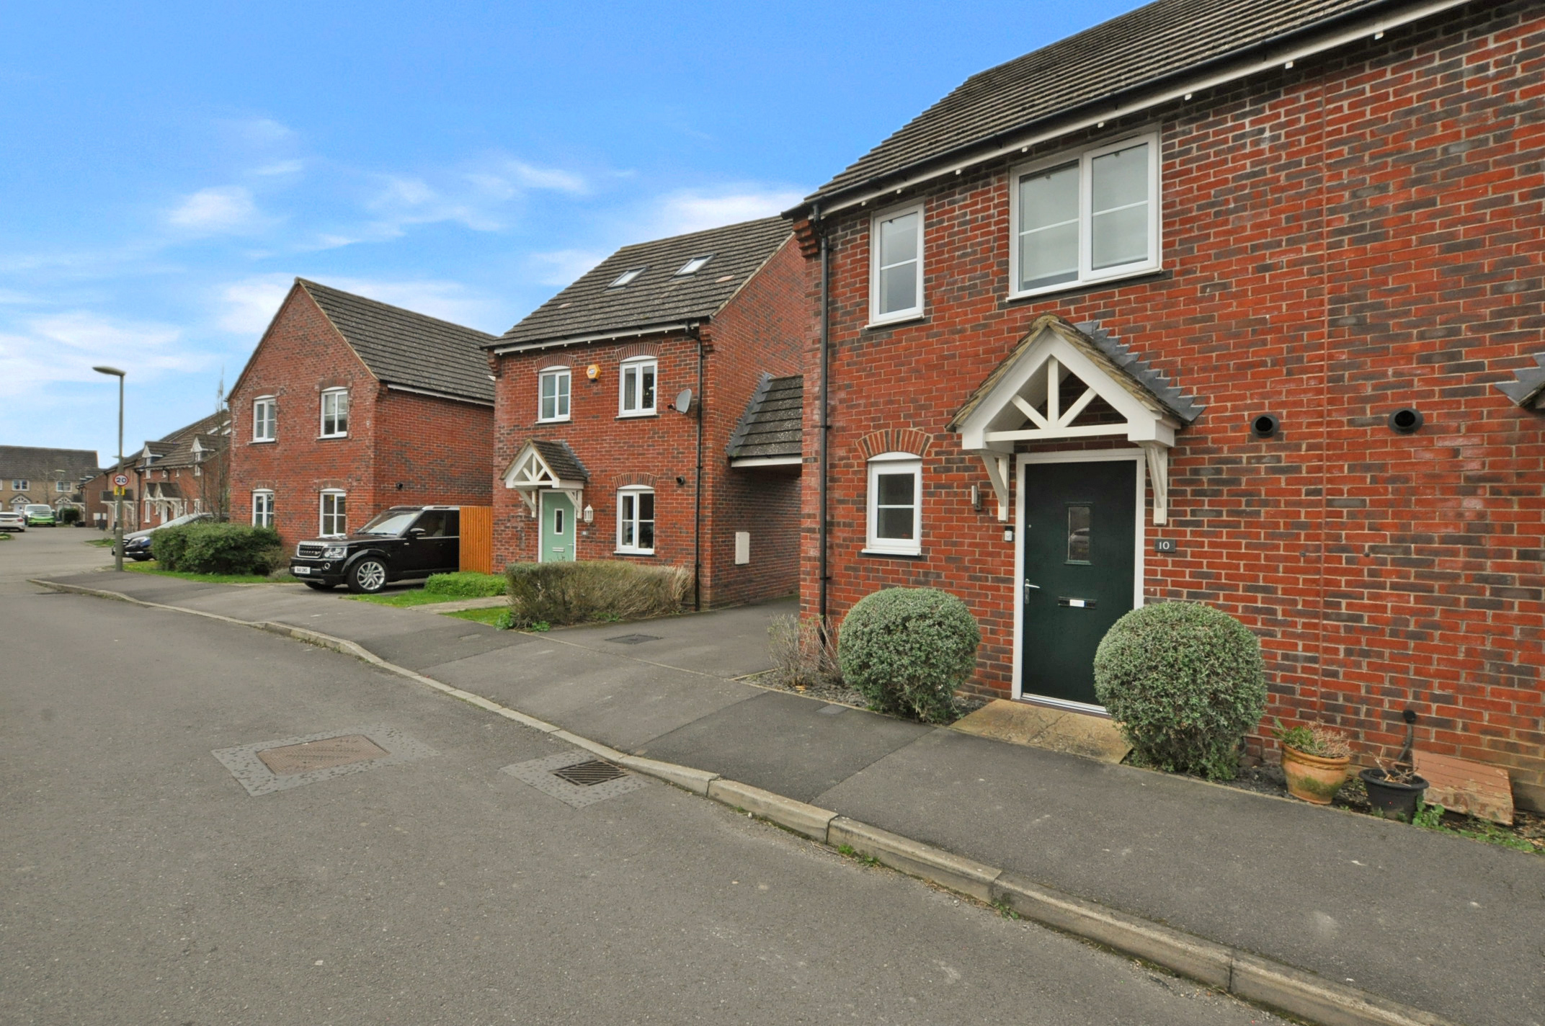bb-logo-final

Chalkpit Lane

Chinnor

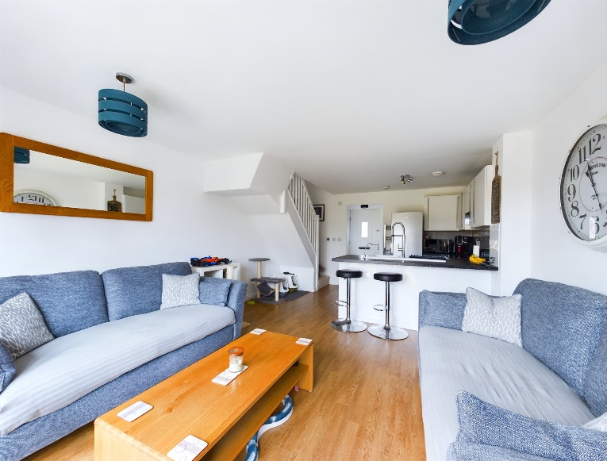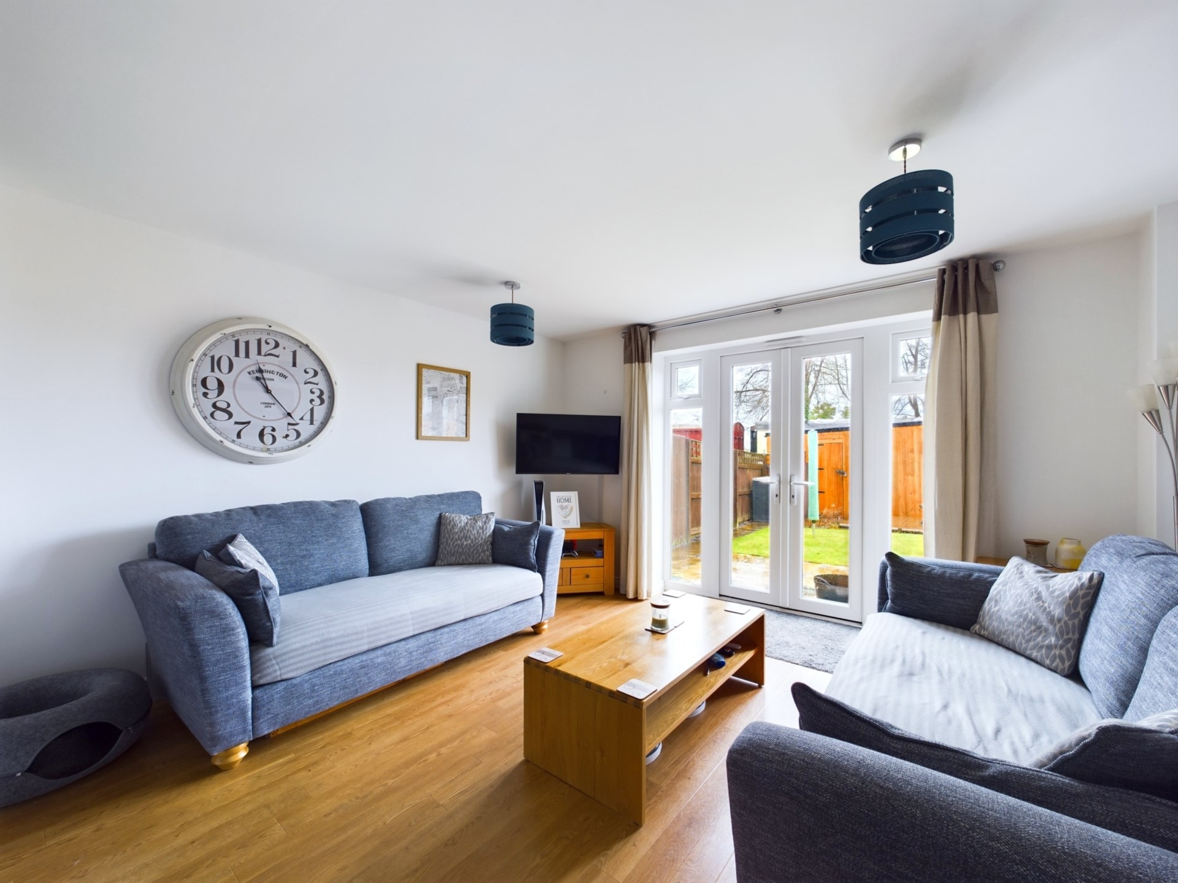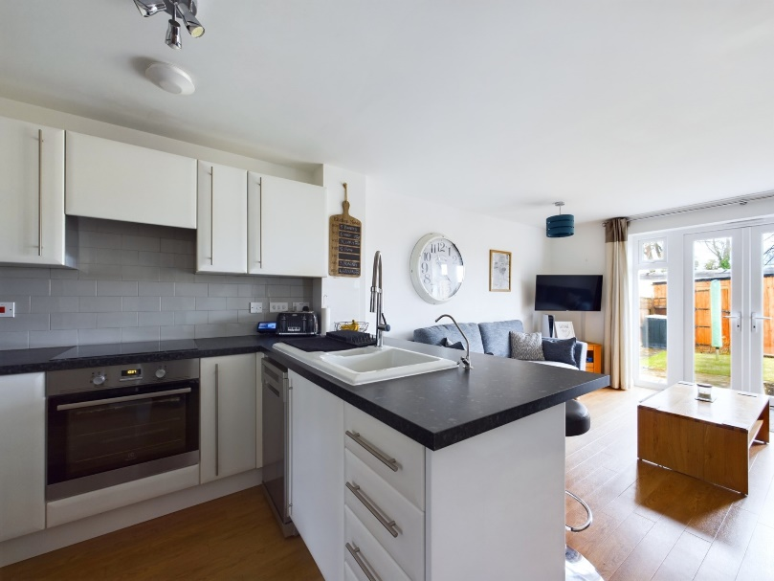

Chalkpit Lane

Chinnor

OX39 4DF

Offers in Excess of: £350,000

A really lovely two bedroom, two bathroom semi detached property situated on a popular road, with stunning views of the Chiltern Hills and nearby access to the beautiful Old Kiln Lakes nature reserve. Close to local shops and amenities and Chinnor`s infant and primary schools. Excellent transport links.

The property consists of an entrance hallway with access to the downstairs WC and large, practical utility/storage cupboard. Continuing on from the entrance is the well appointed open plan kitchen, housing an integrated double oven, electric hob, space for a slim-line dishwasher and fridge/freezer and includes a sociable breakfast bar area.The living room has French doors to the enclosed pretty garden backing on to the historic Chinnor Steam Heritage railway.

Upstairs comprises; Two double bedrooms, with the master bedroom benefitting from an ensuite with rainfall shower, vanity sink and heated towel rail. There is also a modern family bathroom with bath and overhead rainfall shower, vanity sink and heated towel rail.

Outside; The garden is mainly laid to lawn with an area of composite decking for summer entertaining. In addition, there is a large wooden storage shed. The property has two allocated parking spaces at the rear of the house, however one has been utilised by the shed and can be accessed via the garden or double doors from the driveway. There is ample visitor parking on the shared driveway to the side of the property.

Other notable features include gas central heating, UPVC double glazing, part boarded loft with ladder and wifi controlled light switches and heating.

**Location**

Situated at the foot of the Chiltern Hills, Chinnor is a popular village conveniently situated on the Oxfordshire/Buckinghamshire borders. Within the village there are good local facilities including a variety of shops, churches, pubs and restaurants, post office, doctor`s surgery, a nursery and two combined schools. Chinnor lies within catchment for the highly regarded Lord Williams`s secondary school in Thame.

M40(Junction 6) is within 3 miles giving access to Oxford(20 miles), High Wycombe(13 miles) and London(48 miles). Princes Risborough mainline station is within 5 miles (Marylebone 35 minutes).

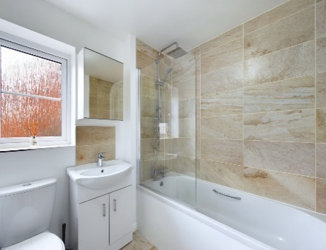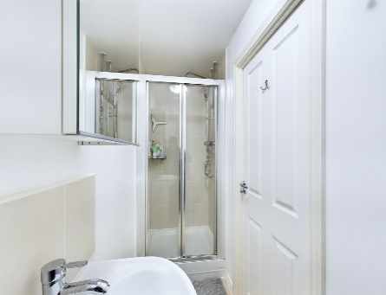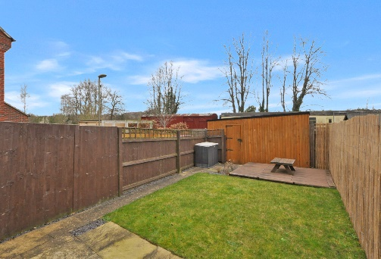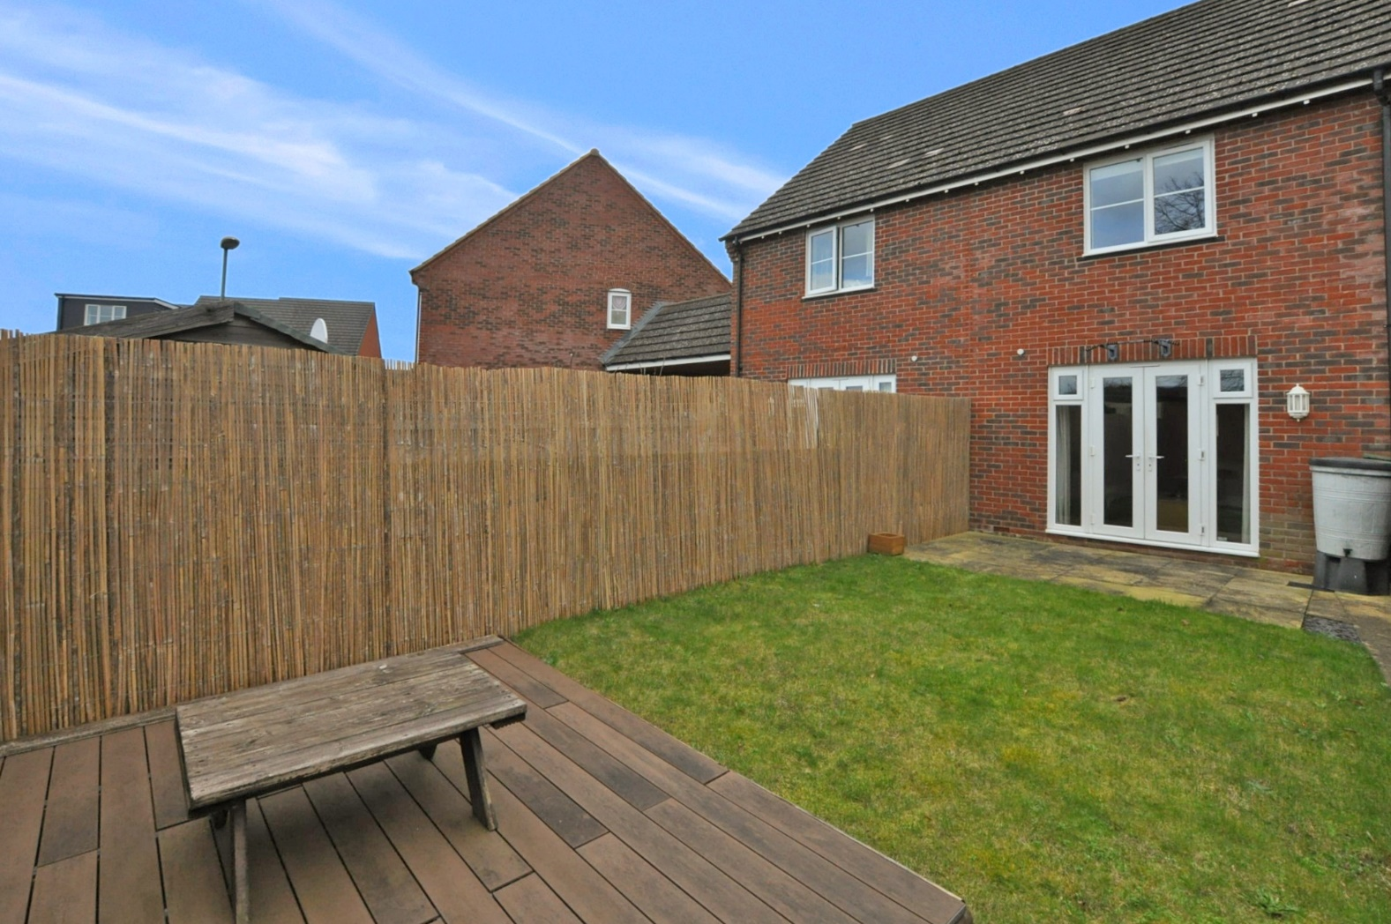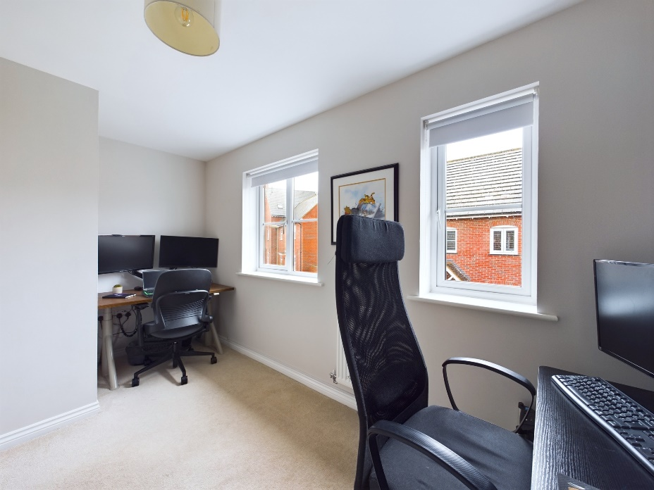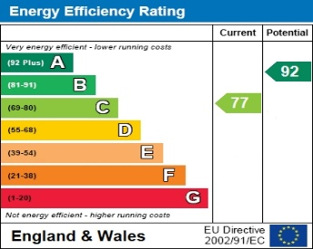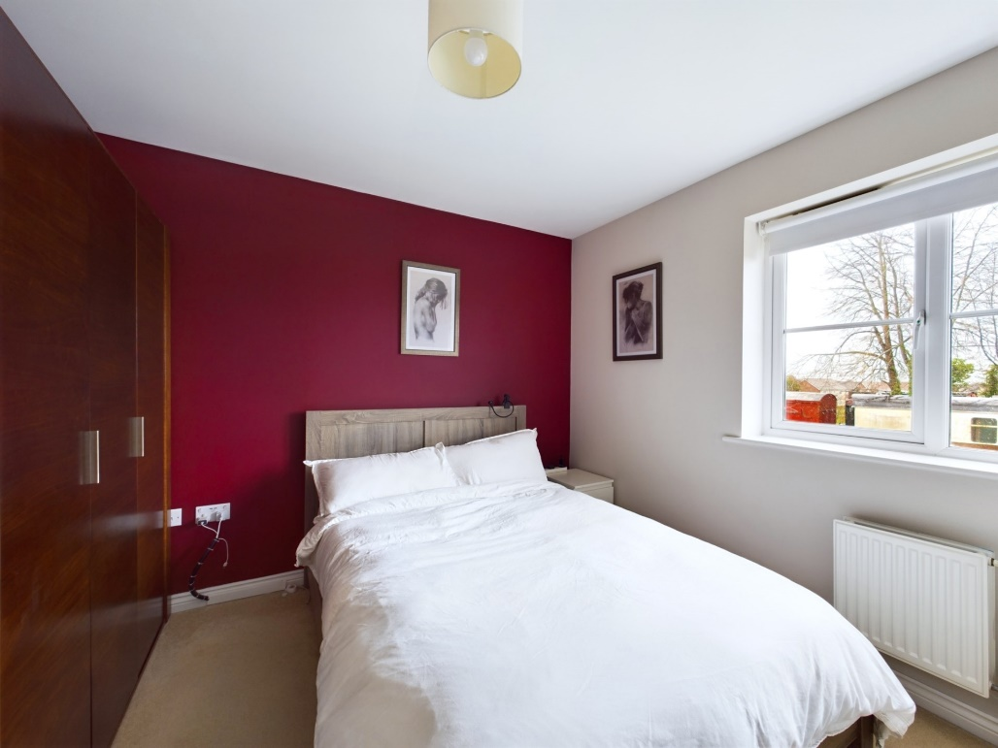

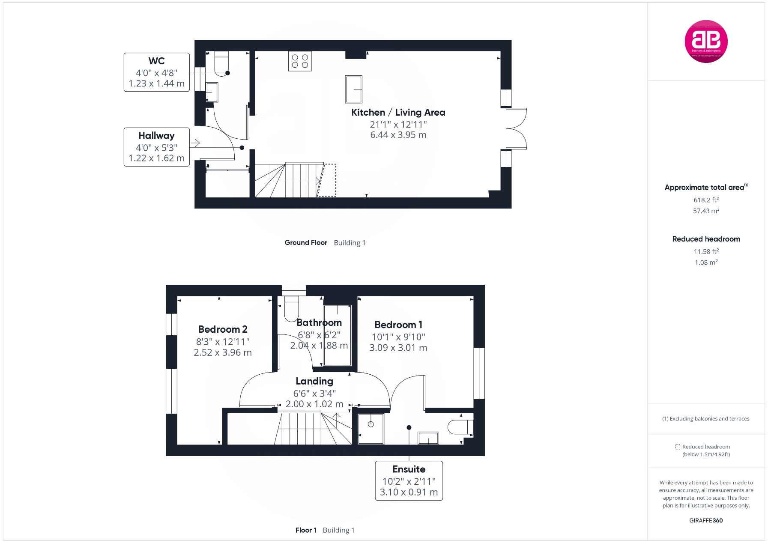Zoopla LogoNAEA Propertymark Protected CMYKRM_Logo_NoStrap_Colourfacebook logoPrimelocation lscape

**Disclaimer**

We endeavour to make our particulars accurate and reliable. They are for guidance only and are intended to give a fair overall summary of the property. They do not form part of any contract or offer, and should not be relied upon as a statement or representation of fact. Measurements, areas and distances are approximate and photographs provided for guidance only. No undertaking is given as to the structural condition of the property, or any necessary consents, or the operating ability or efficiency of any service, system or appliance. Prospective purchasers must satisfy themselves with regard to each of these points. If there is any particular aspect of the property about which you would like further information, please contact us, especially, before you travel to the property. B2170

Robert House, 19 Station Road,

Chinnor, Oxfordshire OX39 4PU

01844 354554

www.bb-estateagents.co.uk