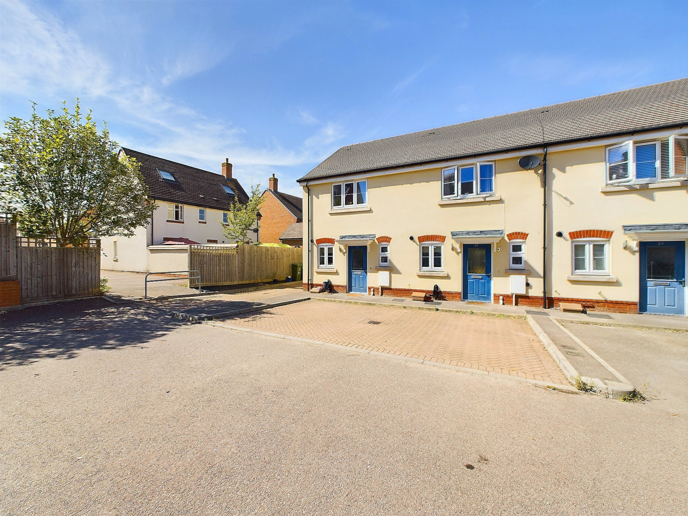bb-logo-final

Millway Furlong

Haddenham

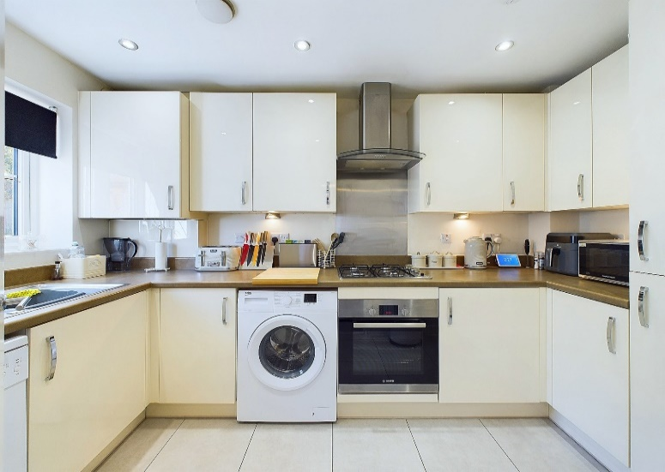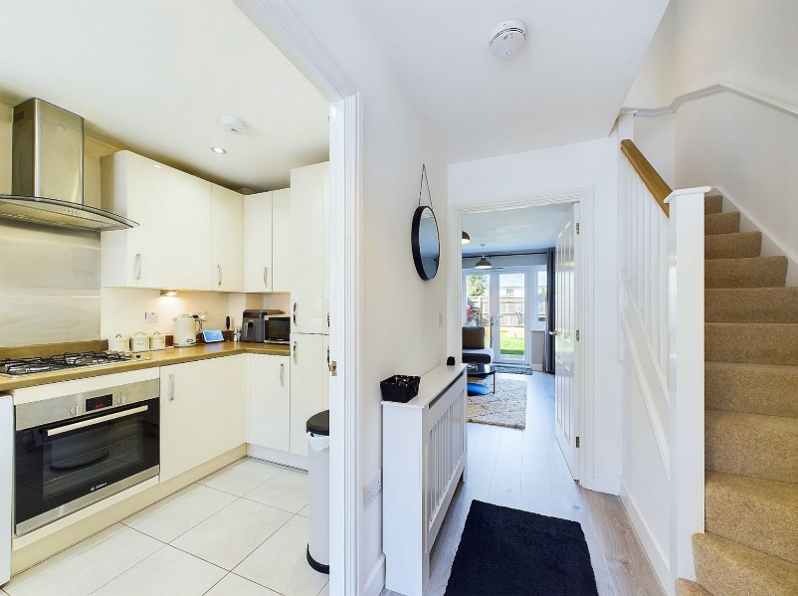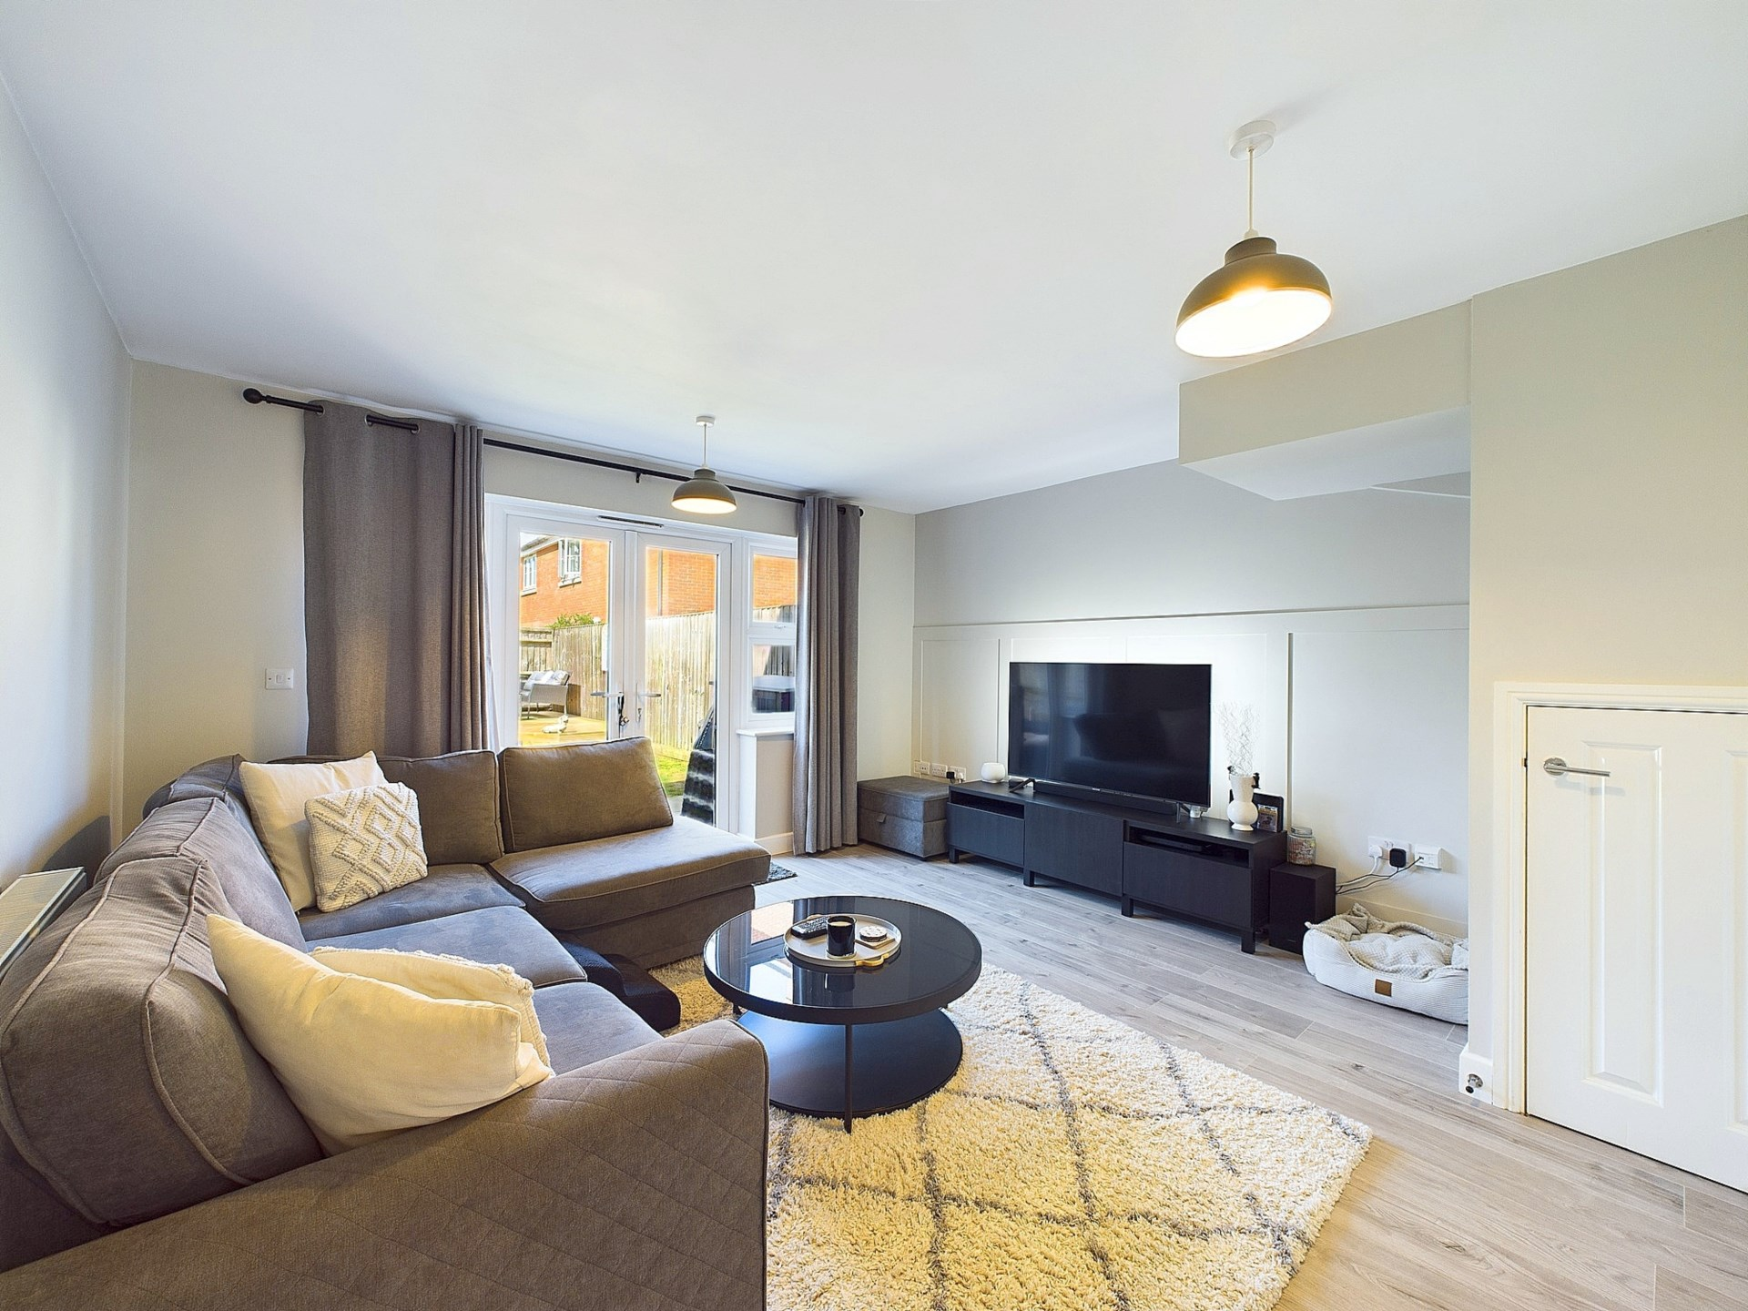

Millway Furlong,

Haddenham,

Buckinghashire,

HP17 8SD

Guide Price - £350,000

This charming two-bedroom terrace is situated in the village of Haddenham, Buckinghamshire. The property benefits from 2 allocated parking spaces, a well-proportioned garden to the rear and modern living throughout. The interior has been maintained by the current owners making this property ideal for those searching for a home without work.

The home features allocated parking for your convenience to the front of the property and a maintained rear garden, complete with a stylish decking area perfect for outdoor relaxation or entertaining.

Inside, the property is finished to a contemporary standard throughout. The kitchen is equipped with modern appliances, making it a functional and inviting space for cooking and meal preparation. The well-proportioned living room is spacious, providing ample room for both lounging and dining, ideal for everyday living. Downstairs you will also find a WC.

Upstairs you will find two double bedrooms which are flooded with natural light and a family bathroom. Both rooms have ample space and the main bedroom has a built in storage cupboard. This property combines modern comforts with the tranquillity of village life, making it a perfect home for those seeking a peaceful yet connected lifestyle. Haddenham and Thame Parkway is 600m walk away from the property and offers direct access into London.

Haddenham

Haddenham is a delightful village with a strong sense of community. The village offers a range of amenities, including a post office, convenience store, and several pubs and restaurants. The village also has a primary school, making it an ideal location for families.

For those who enjoy the outdoors, Haddenham is surrounded by beautiful countryside, with plenty of walking and cycling routes to explore. The village is also home to a nature reserve, providing a haven for wildlife and a peaceful retreat for visitors.

For those who enjoy history and culture, Haddenham has plenty to offer. The village is home to several historic buildings, including the Grade II listed St Mary`s Church. The village also hosts a range of events throughout the year, including a popular annual beer festival.

For those who enjoy shopping and entertainment, Haddenham is conveniently located just a short drive from the bustling town of Aylesbury. Aylesbury offers a range of shops, restaurants, and entertainment options, including a cinema and theatre.

EPC RATING – B

COUNCIL TAX BAND - D

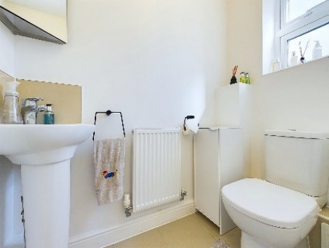

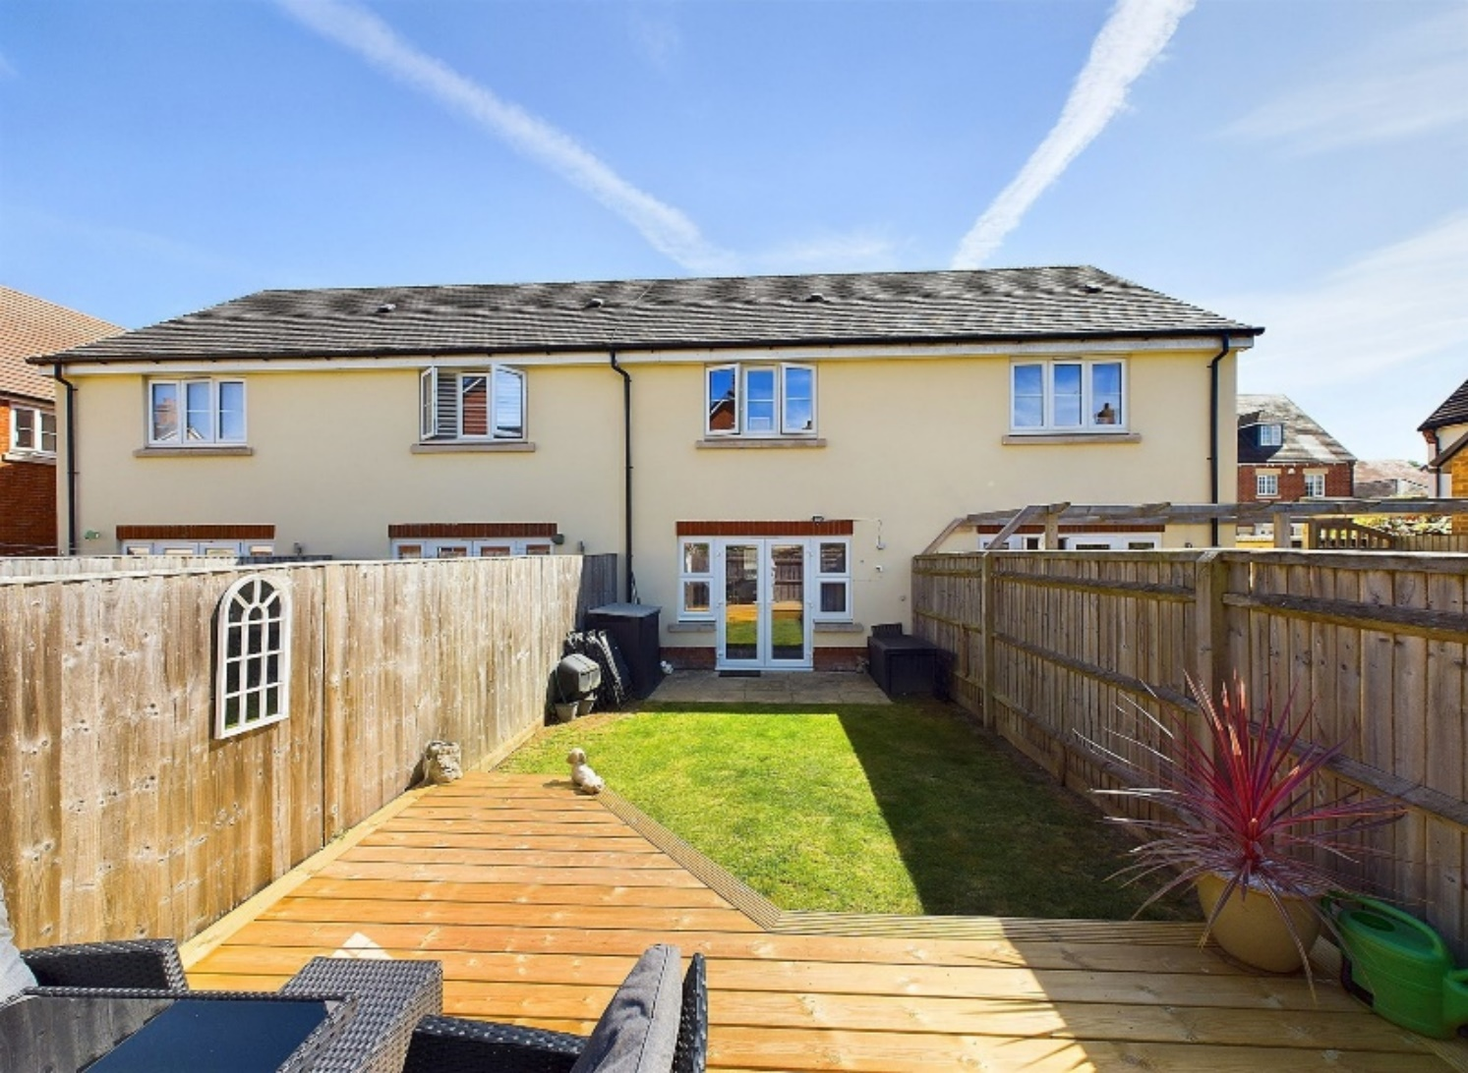

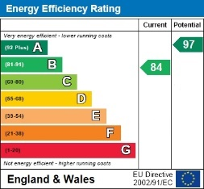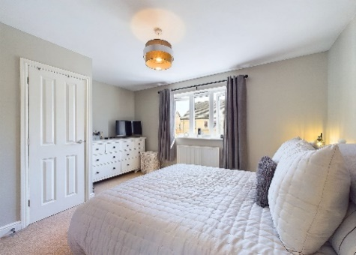

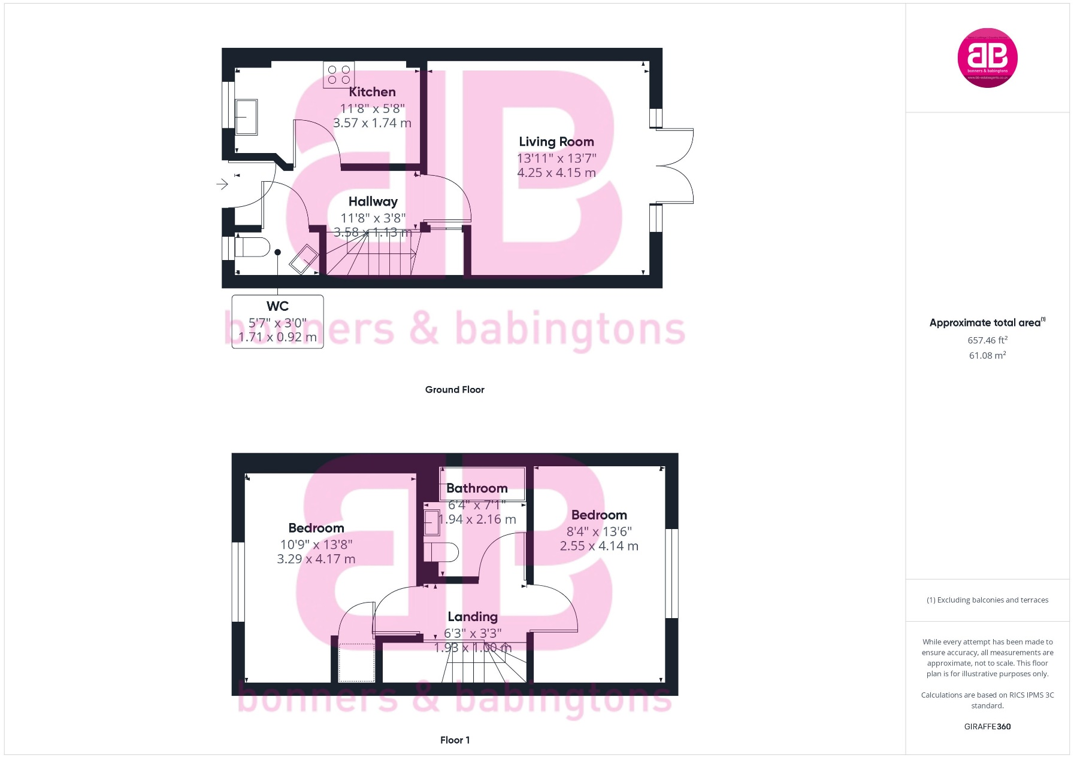

Zoopla LogoNAEA Propertymark Protected CMYKRM_Logo_NoStrap_Colourfacebook logoPrimelocation lscape

**Disclaimer**

We endeavour to make our particulars accurate and reliable. They are for guidance only and are intended to give a fair overall summary of the property. They do not form part of any contract or offer, and should not be relied upon as a statement or representation of fact. Measurements, areas and distances are approximate and photographs provided for guidance only. No undertaking is given as to the structural condition of the property, or any necessary consents, or the operating ability or efficiency of any service, system or appliance. Prospective purchasers must satisfy themselves with regard to each of these points. If there is any particular aspect of the property about which you would like further information, please contact us, especially, before you travel to the property. B2170

78 High Street, Princes Risborough, Buckinghamshire, HP27 0AX

01844 343661

www.bb-estateagents.co.uk