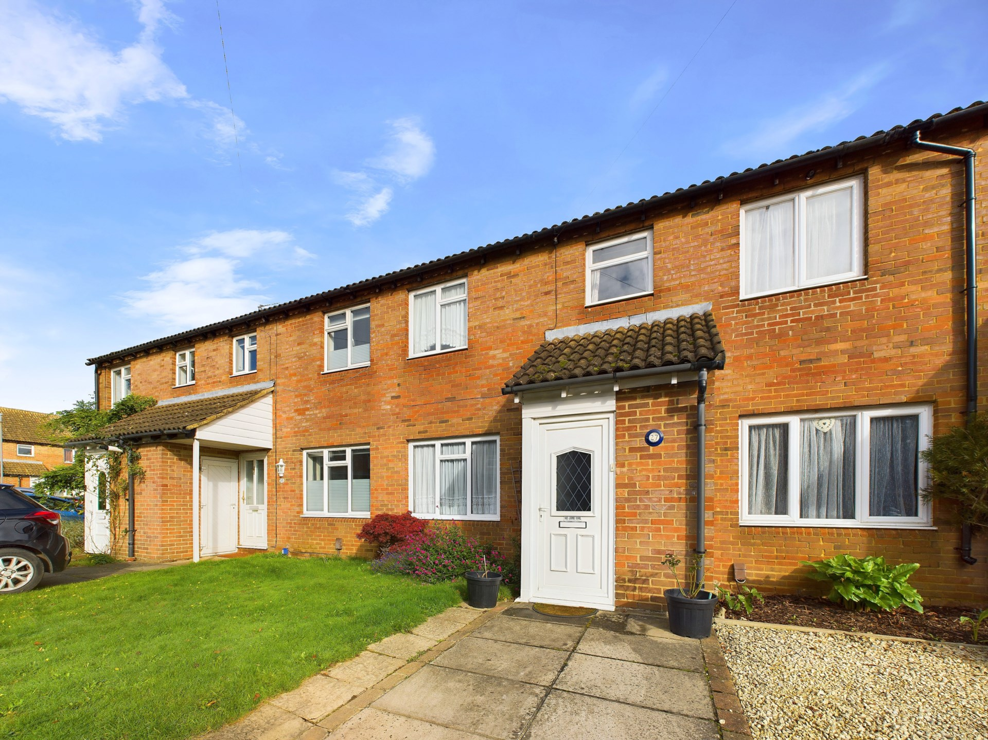bb-logo-final

Jerome Close

Marlow

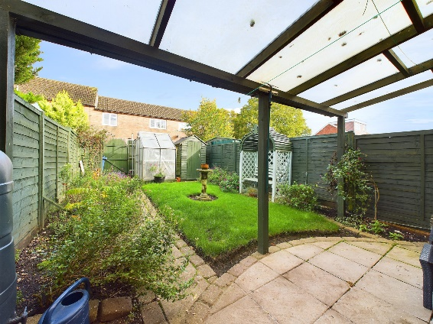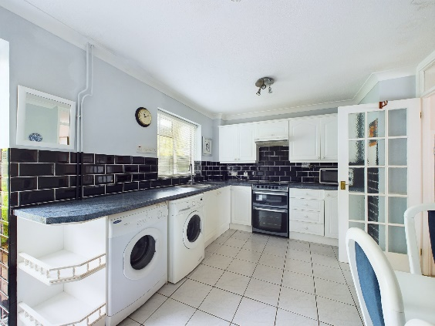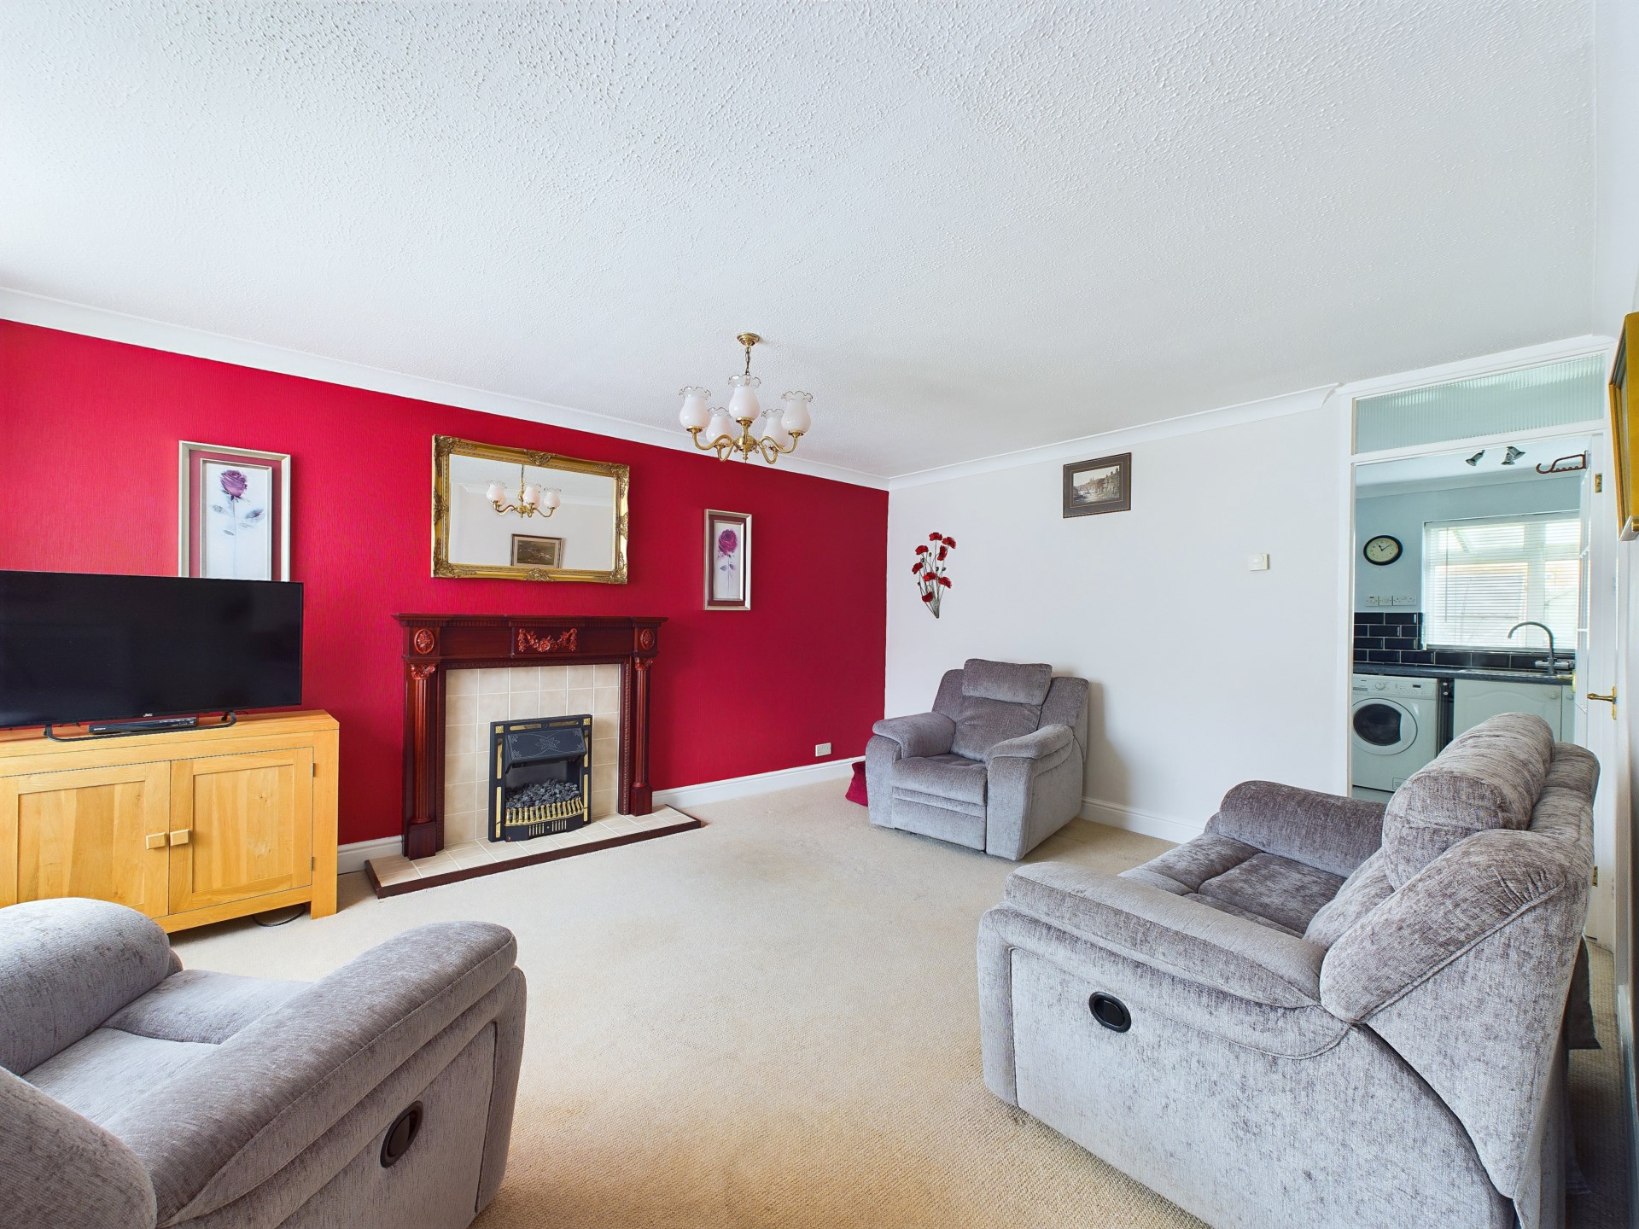

- Tenure:- Freehold

- £430,000

- -124

£0

£0

Band C

Jerome Close

Marlow

Buckinghamshire

SL7 1TX

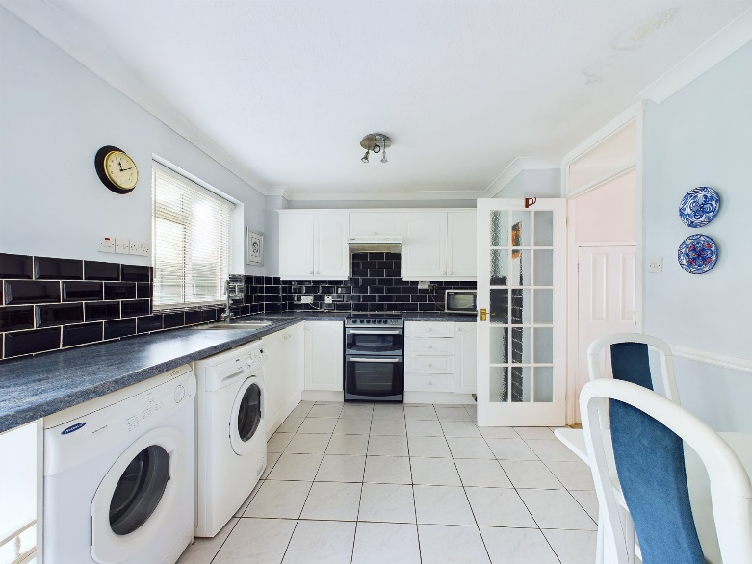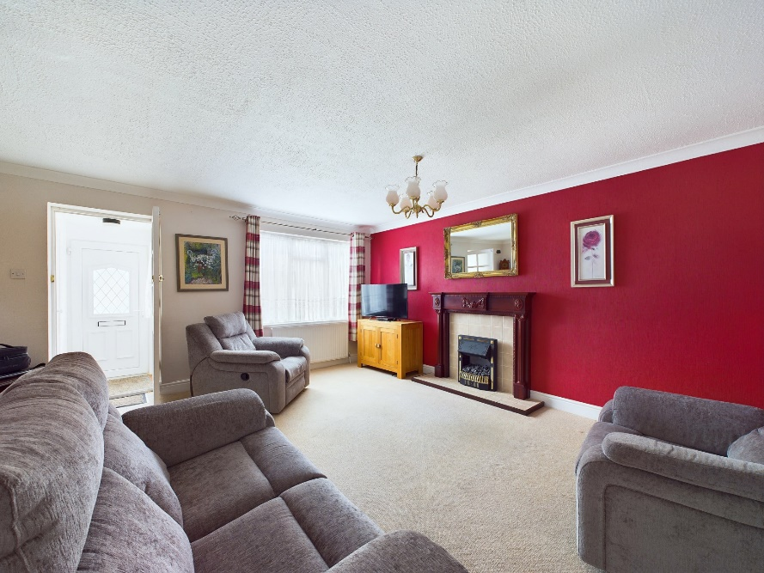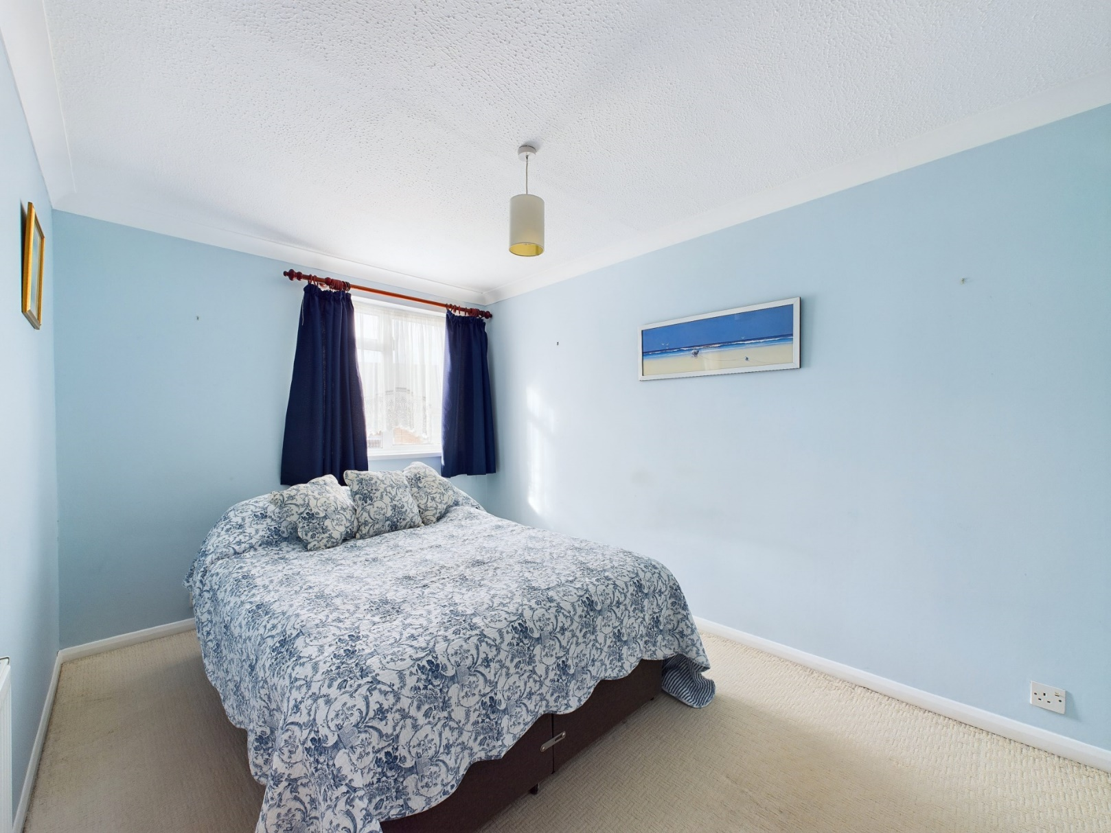

Looking to get onto the property ladder and purchase your first home then look no further than this three bedroom terraced family home. Offered to the market with no onward chain this property is an ideal first time or second stepper purchase. Situated in a traffic free location this property briefly comprises living room, dining kitchen on the ground floor, three bedrooms and a family bathroom on the first floor this property also has a private rear garden and a paved front garden which is currently used as a driveway. The property is also in the catchment areas for many sought-after schools including GMS and Sir William Borlase.

Marlow town centre is a thriving and stylish riverside community with a comprehensive range of shops and excellent pubs and restaurants. Nearby Marlow Station has a regular train service to London Paddington via Maidenhead (from 44 mins) with links to the City of London, via the Elizabeth Line. Access to the M4 and M40 is via the A404(M) and London Heathrow is approximately 22 miles away.

There is a wide range of educational and recreational facilities in the area. Excellent local schools are numerous and include Sir William Borlase in Marlow.

BONNERS & BABINGTONS offer - Situated in a traffic free location approximately one mile east of Marlow Town Centre this delightful three bedroom terraced home is offered to the market with no onward chain. Benefitting from parking and private gardens this is an ideal first time purchase.

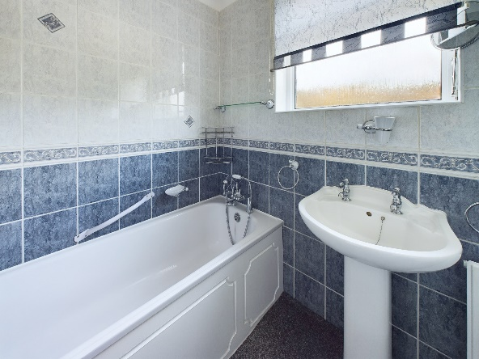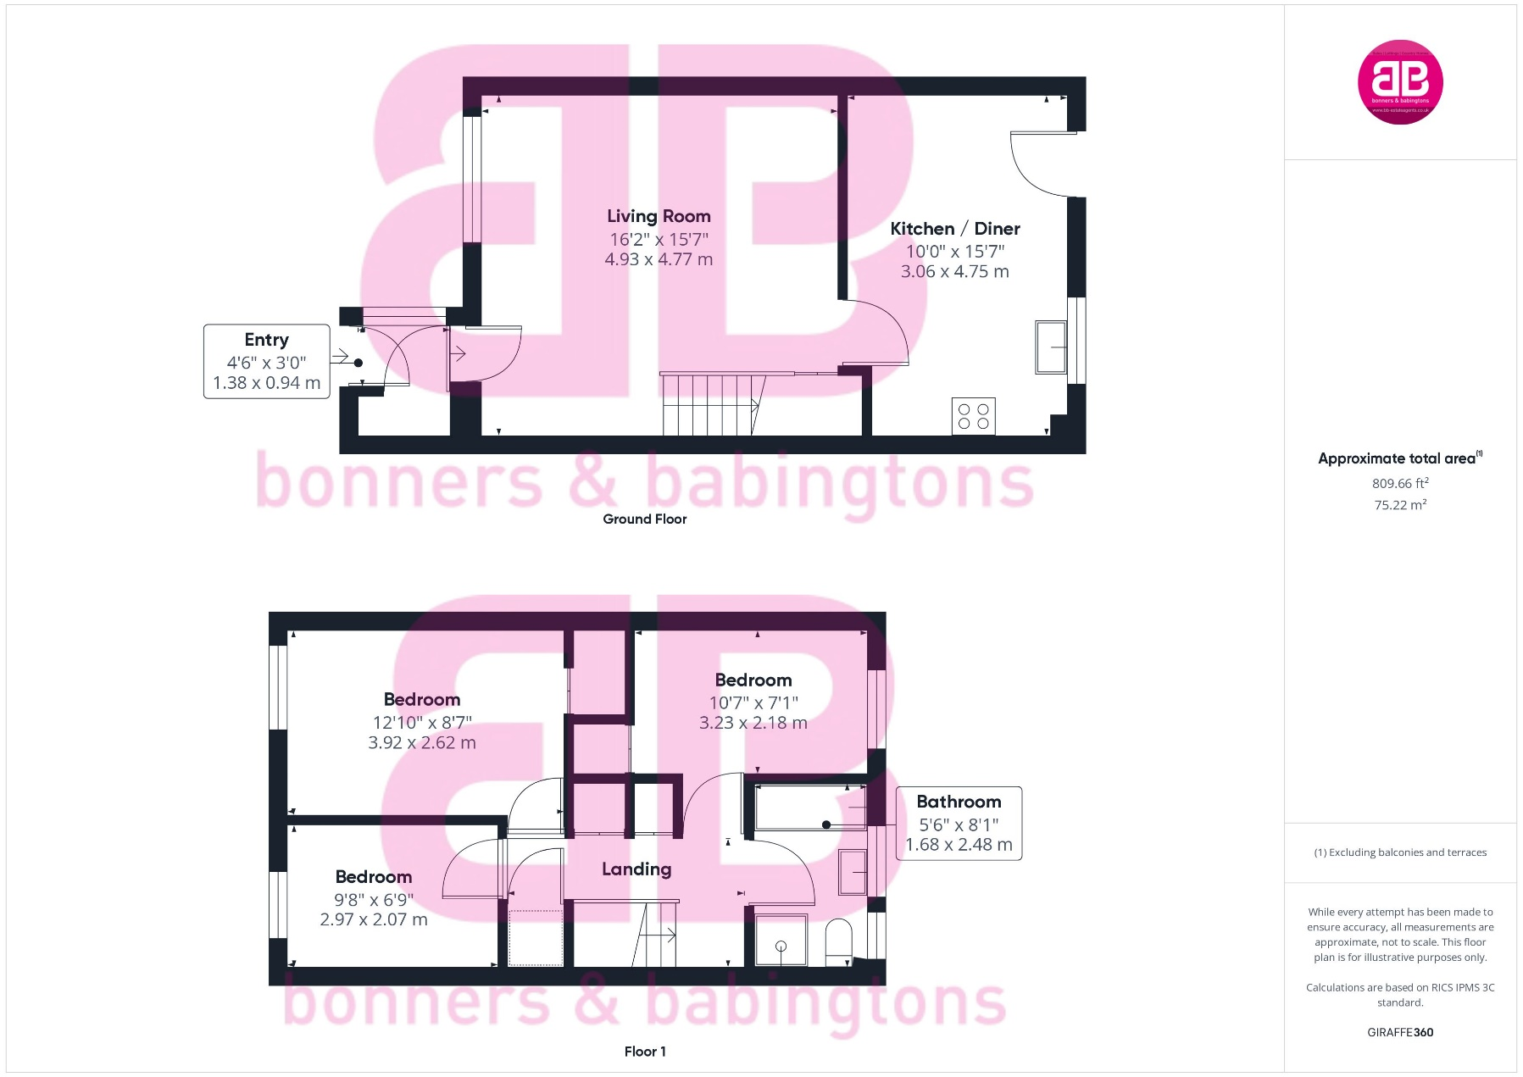

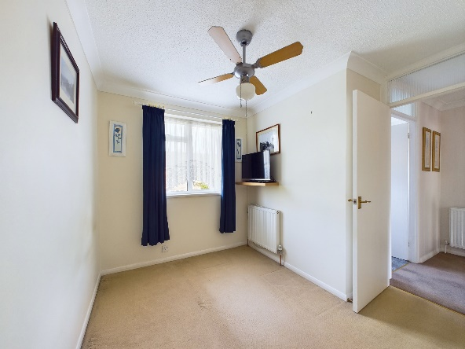

3 Anglers Court, Spittal Street, Marlow, Bucks, SL7 3HJ

01628 333800

www.bb-estateagents.co.uk

