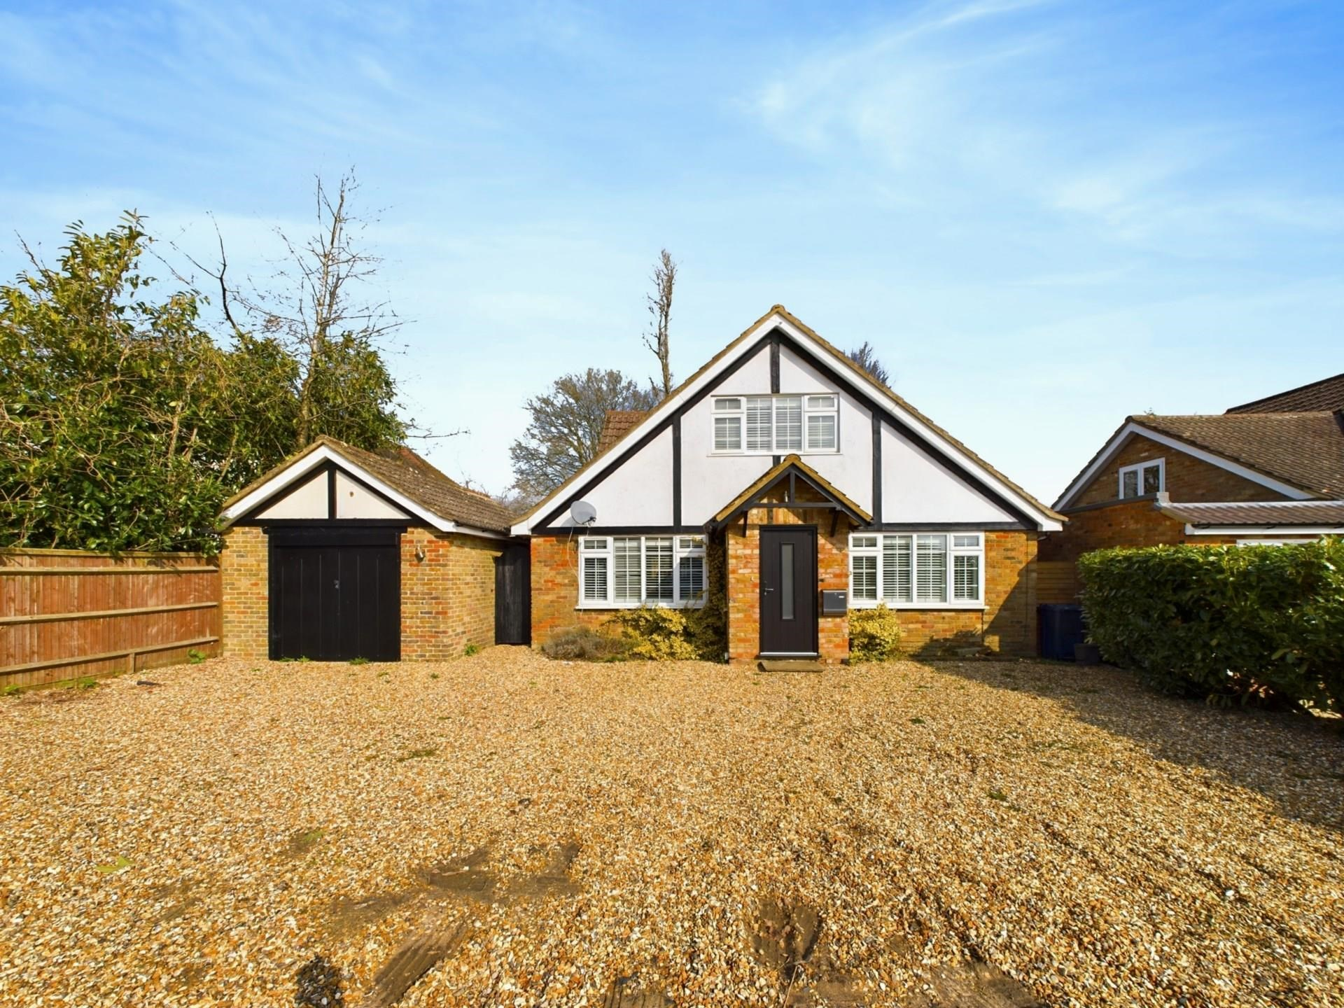



Green Lane

Stokenchurch

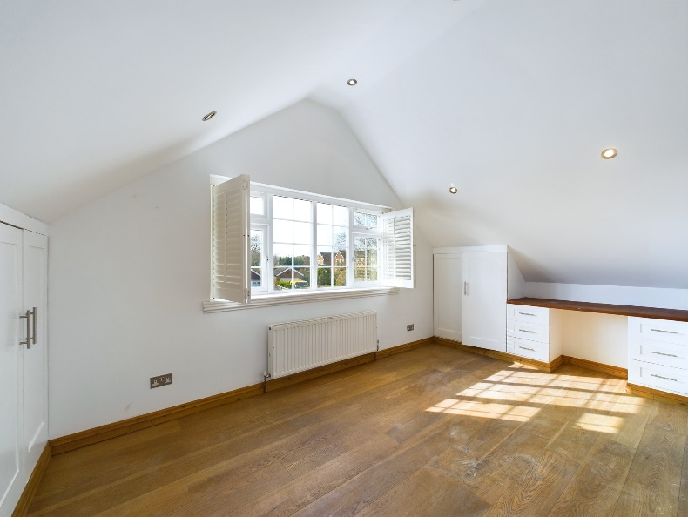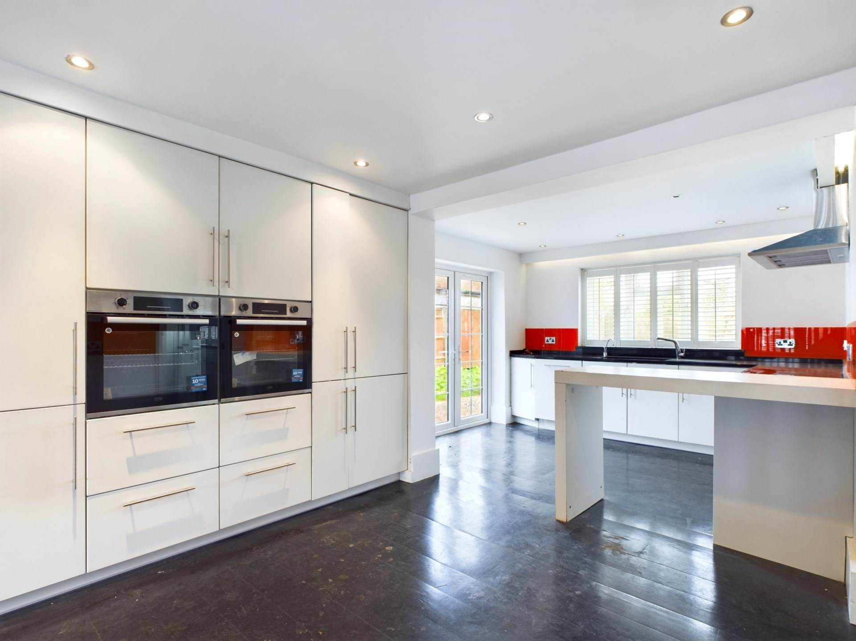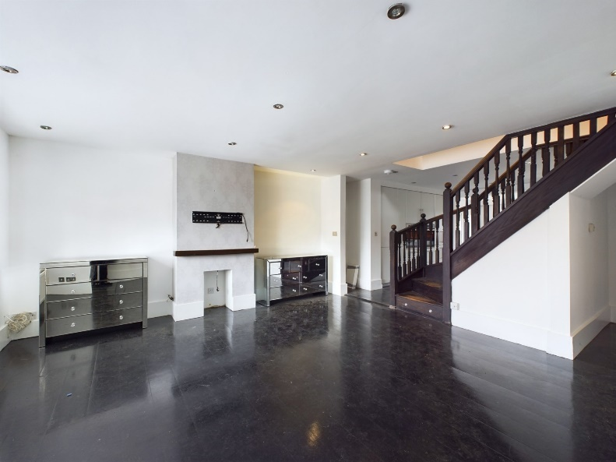

Green Lane,

Stokenchurch,

Buckinghamshire,

HP14 3TU

Price £550,000

Bonners and Babingtons are proud to present this 4 bedroom detached chalet bungalow offering spacious and flexible accommodation, close to local shops and amenities. Offered to the market with NO ONWARD CHAIN!

On the ground floor there is a large open plan living room with a feature fireplace. The modern kitchen/breakfast room is beautifully appointed with ample eye and waist level storage and intergrated appliances such as double oven, induction hob, fridge freezer and dishwasher. The kitchen follows through to the generous utility room with space for white goods. There is an additional reception room which overlooks the front of the property, perfect for a study for those working from home or alternatively a fifth bedroom. In addition, there is a single bedroom and family bathroom with a shower over the bath and a heated towel rail, and a sink.

Upstairs

To the first floor is a large, double bedroom with fitted storage and an en-suite shower room, a further double bedroom with built-in storage and a further single bedroom. The sunny rear garden is laid mainly to lawn and offers a large patio area, ideal for alfresco dining in the summer months.

Outside

To the front of the property there is ample off-street parking for a number of cars leading to garage providing access to the rear garden with an up and over door.

Location

Stokenchurch is a popular Buckinghamshire village situated in the Chiltern Hills. The village facilities include shops for day to day use, a doctor`s surgery, post office, library, Primary School, numerous pubs and restaurants. There is excellent walking and riding in the area. A more extensive range of facilities can be found in High Wycombe, approximately nine miles distant.

For the commuter there is easy access to the M40 motorway at Junction 5, providing links to Oxford, Birmingham, London, the M25 and M4 motorway networks. The nearest railway stations are High Wycombe and Princes Risborough with links to London Marylebone and Birmingham.

EPC – D

Council Tax Band -

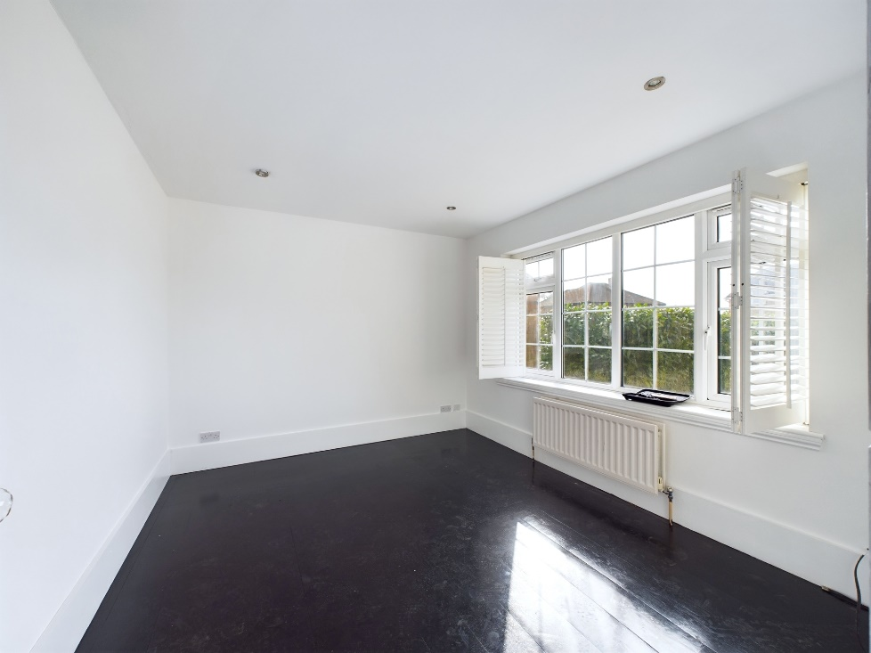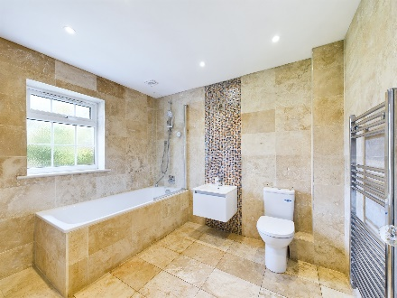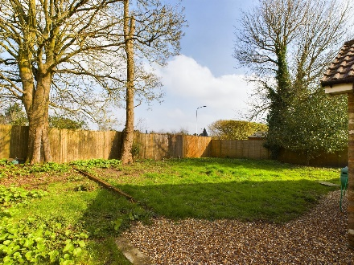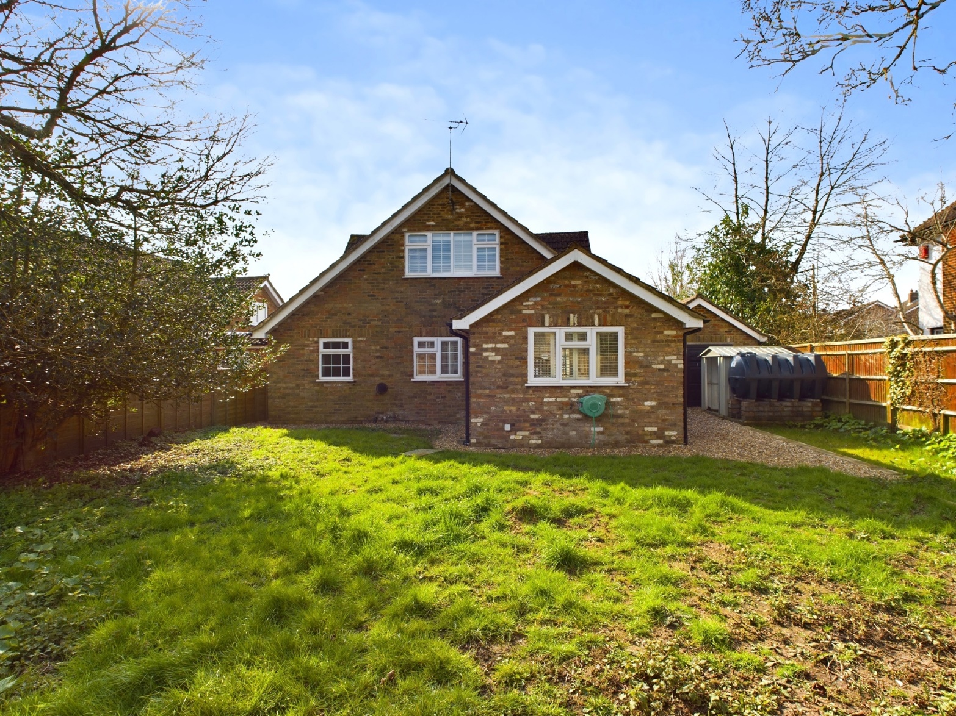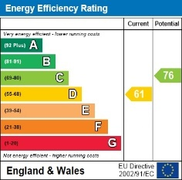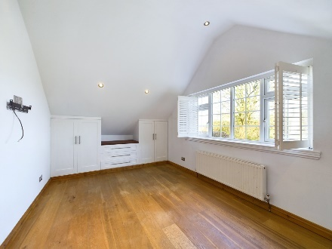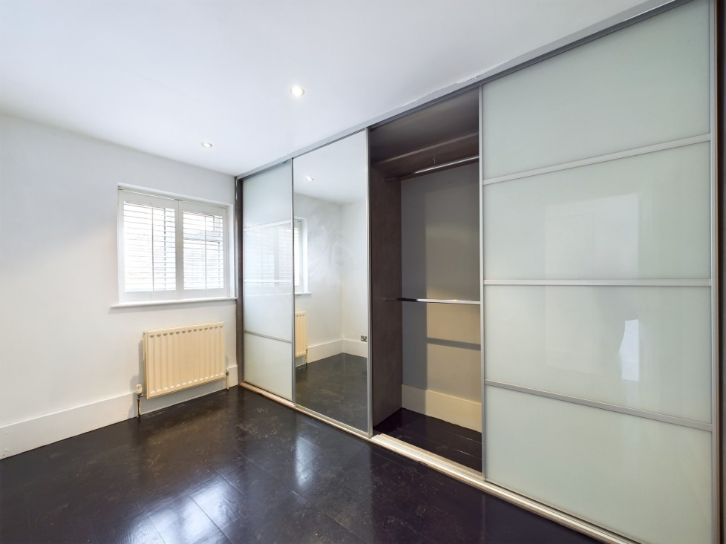

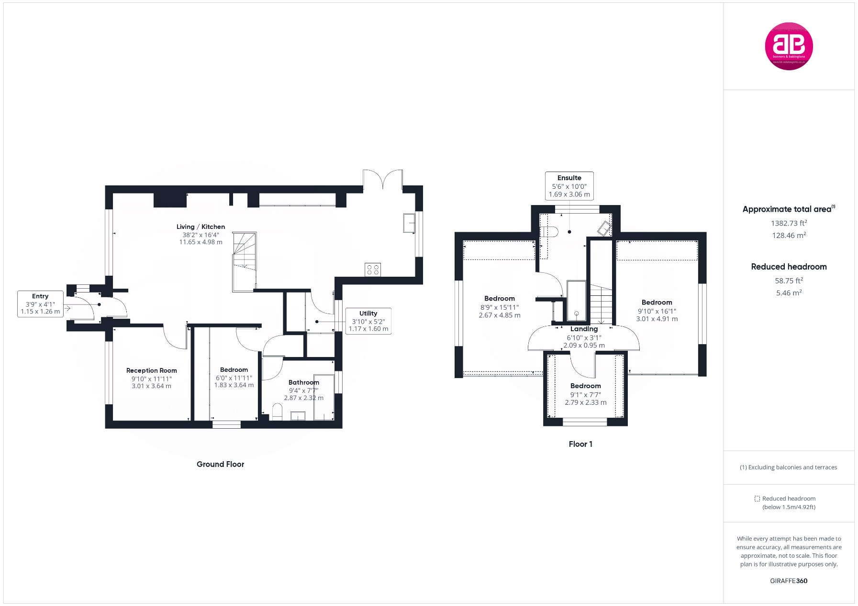

Zoopla LogoNAEA Propertymark Protected CMYKRM_Logo_NoStrap_Colourfacebook logo

**Disclaimer**

We endeavour to make our particulars accurate and reliable. They are for guidance only and are intended to give a fair overall summary of the property. They do not form part of any contract or offer, and should not be relied upon as a statement or representation of fact. Measurements, areas and distances are approximate and photographs provided for guidance only. No undertaking is given as to the structural condition of the property, or any necessary consents, or the operating ability or efficiency of any service, system or appliance. Prospective purchasers must satisfy themselves with regard to each of these points. If there is any particular aspect of the property about which you would like further information, please contact us, especially, before you travel to the property. B2170

1 Karenza, Wycombe Road, Stokenchurch, Buckinghamshire, HP14 3DA

01494 485560

www.bb-estateagents.co.uk