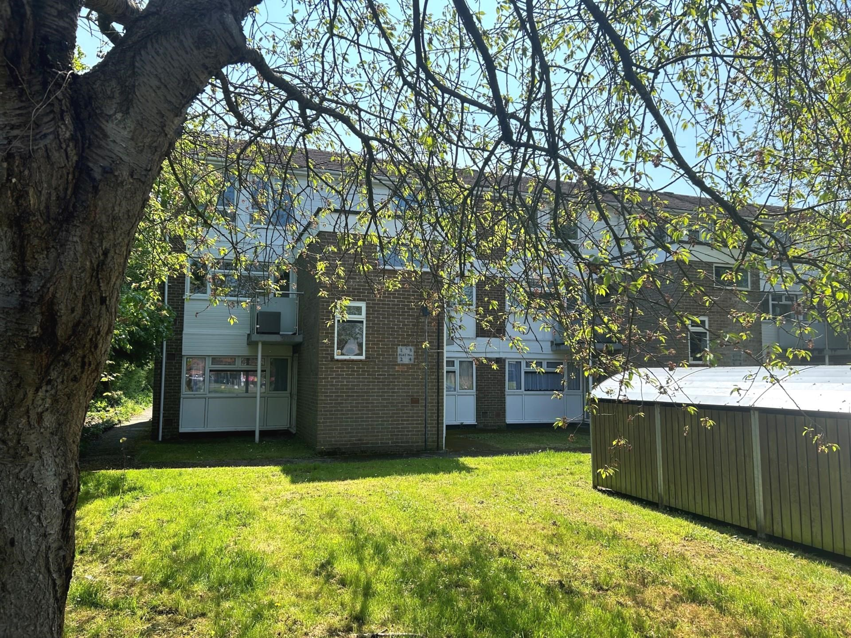bb-logo-final

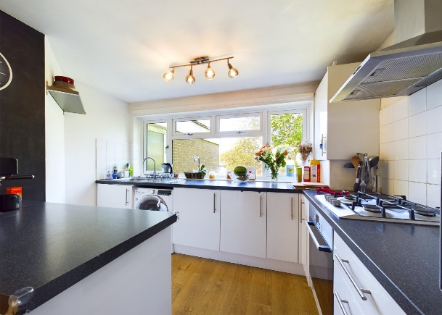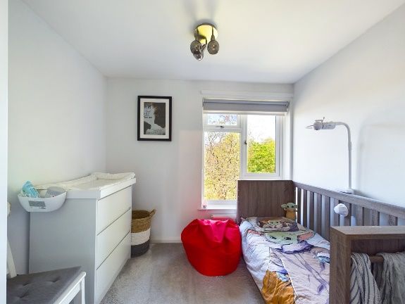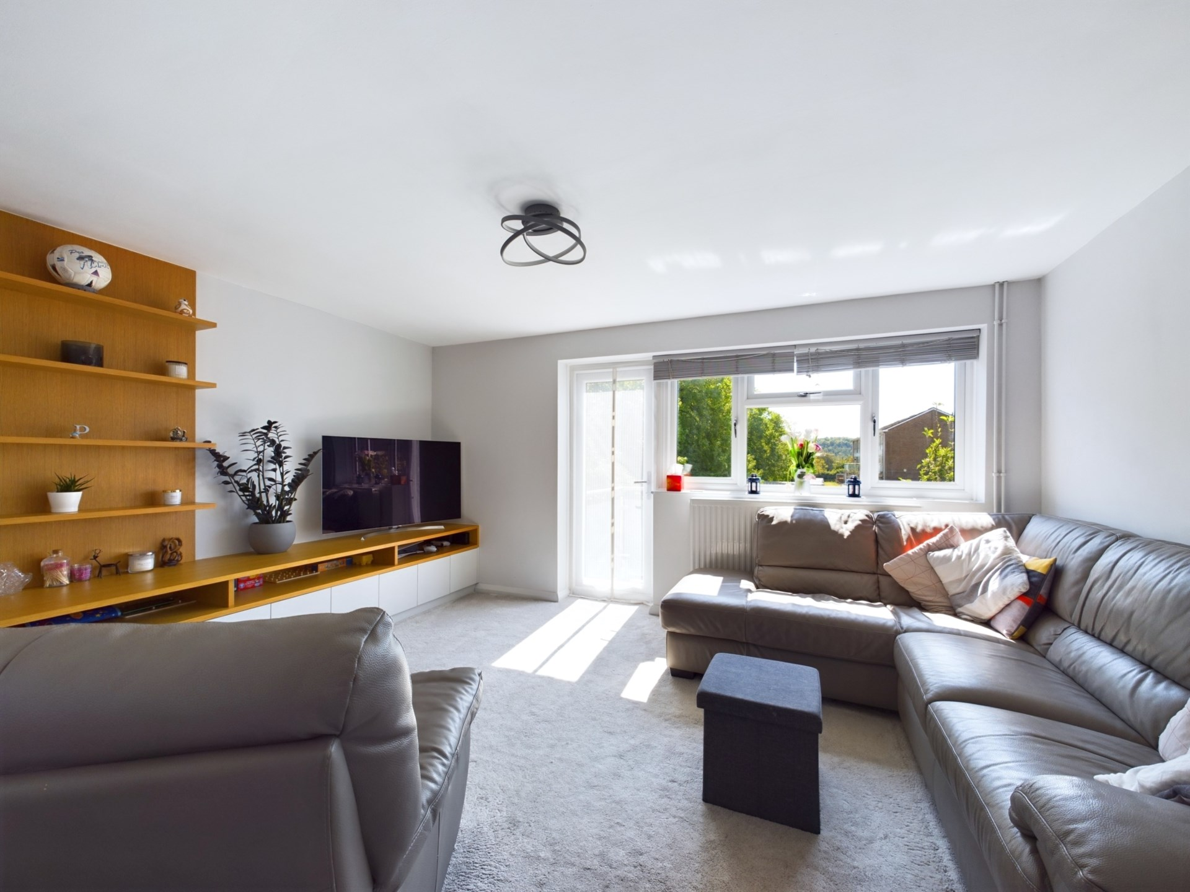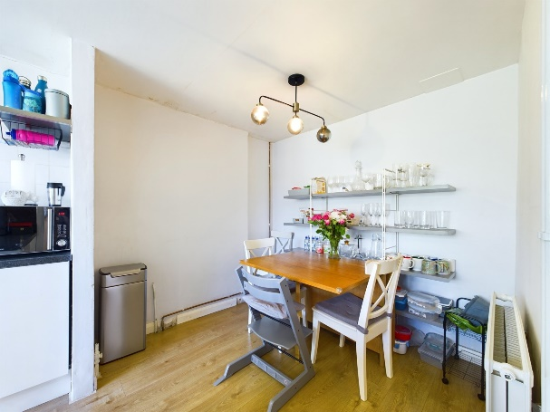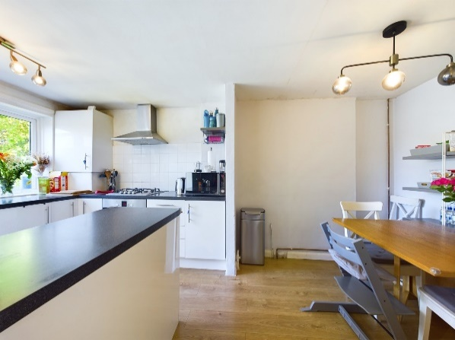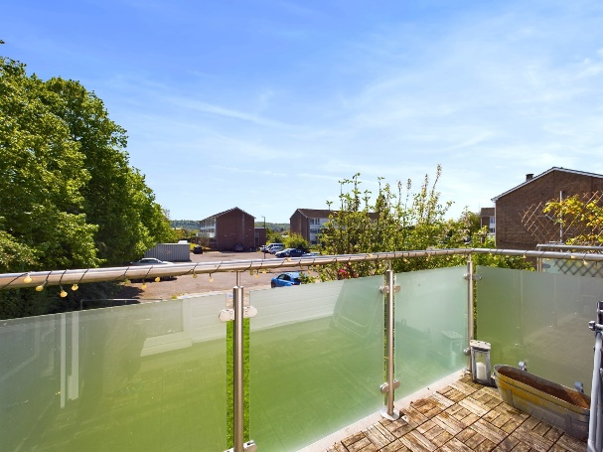

- Guide Price: £325,000

- Tenure: Leasehold

- Property Lease: 85 years unexpired

- Service Charge: £86 pm

- Ground Rent: £10 pa

- Buckinghamshire Council

- EPC Rating B

- Council Tax Band Band C

**Foxes Piece**

**Marlow**

**Buckinghamshire**

**SL7 1HE**

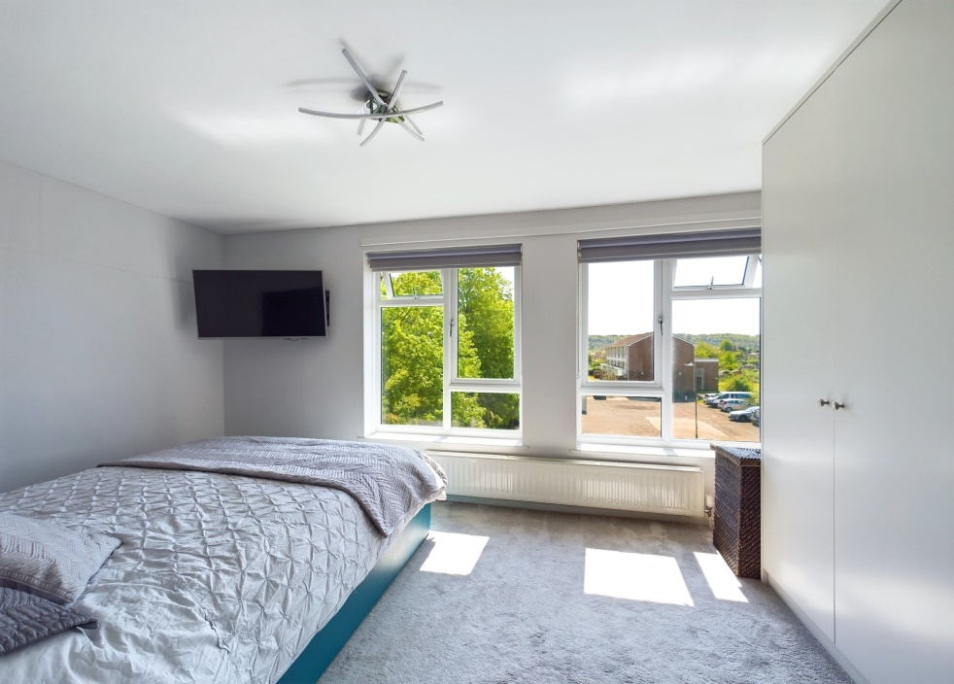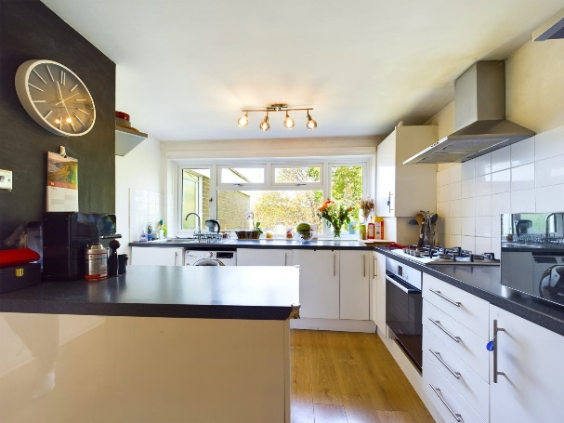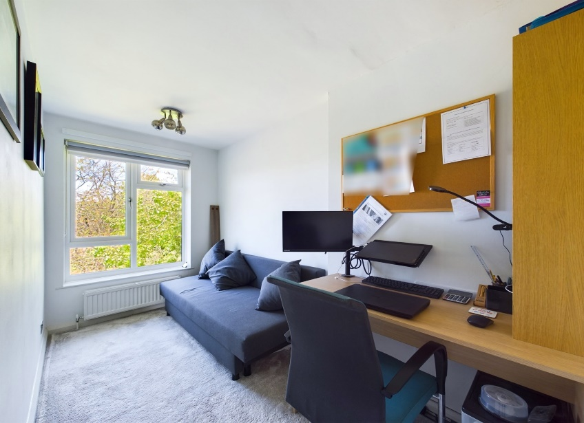

A light and spacious three bedroom split level duplex apartment situated on the first and second floors situated within a short level walk of the High Street.

There is a security entry phone system, communal gardens and ample parking. The accommodation briefly comprises entrance hall with storage, open plan kitchen/dining room, good size living room with access to the balcony.

On the first floor there is a landing with access to the loft space, large principle bedroom, 2 further bedrooms and refitted bathroom and WC. There is a second balcony to the front accessed off the communal hallway.

Marlow town centre is a thriving and stylish riverside community with a comprehensive range of shops and excellent pubs and restaurants. Nearby Marlow Station has a regular train service to London Paddington via Maidenhead (from 1hr 5 mins) with links to the City of London, further enhanced with the Crossrail Link from Maidenhead. Access to the M4 and M40 is via the A404(M) and London Heathrow is about 22 miles away.

There is a wide range of educational and recreational facilities in the area. Excellent local schools are numerous and include Sir William Borlase in Marlow.

