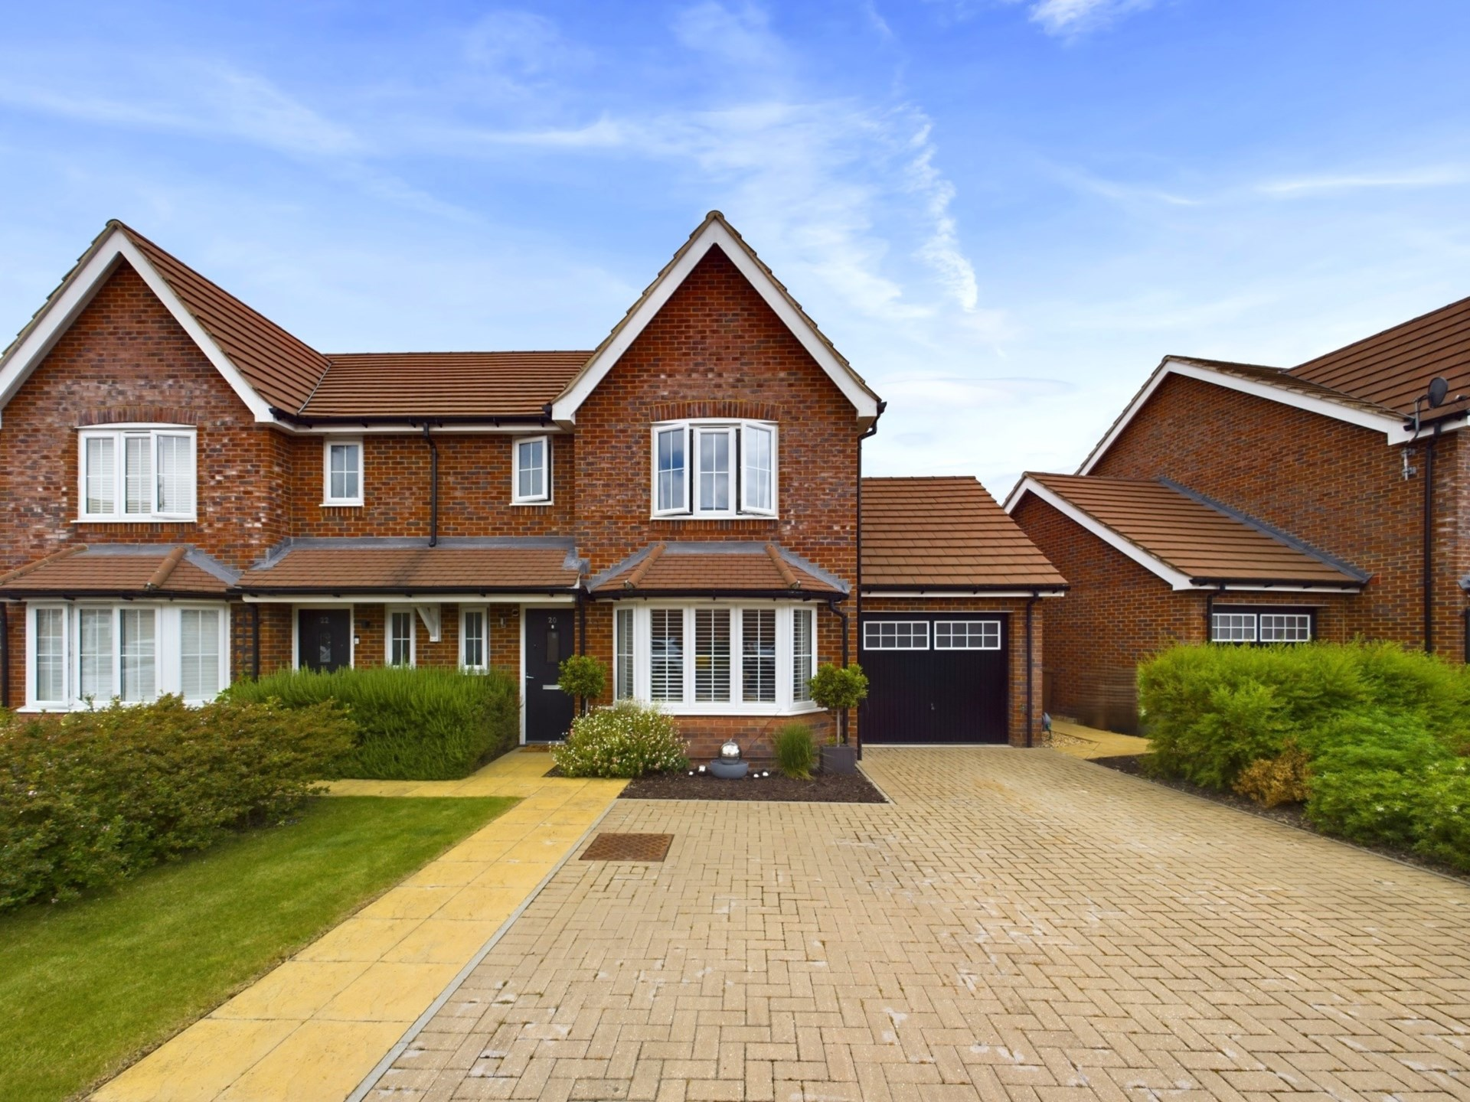



Braken Road

Chinnor

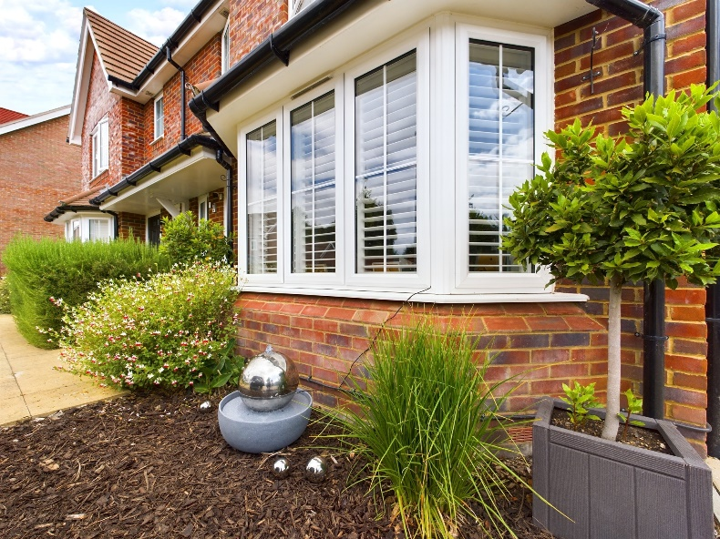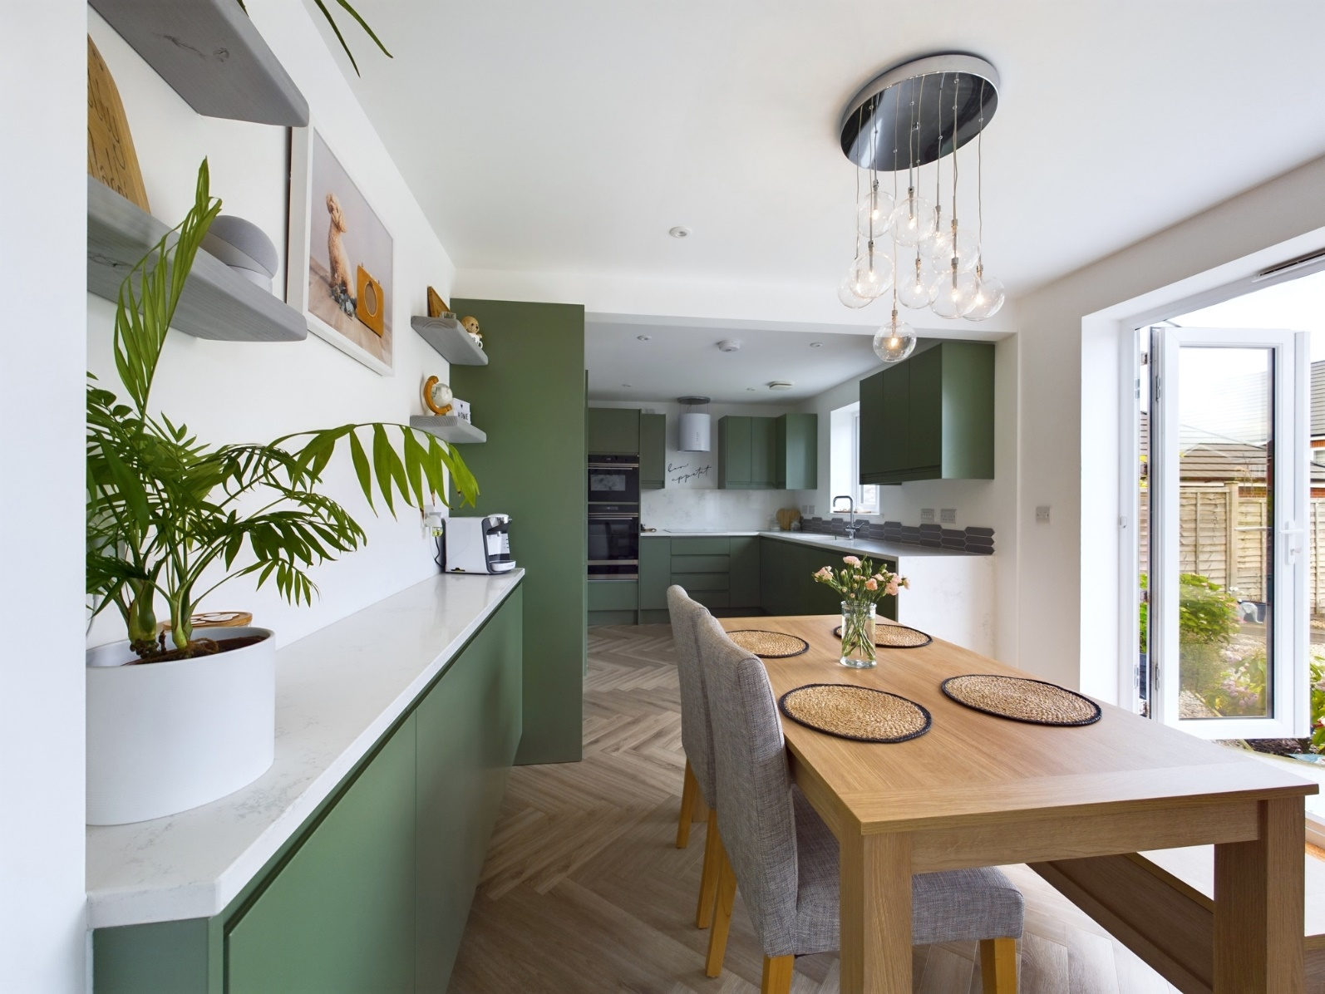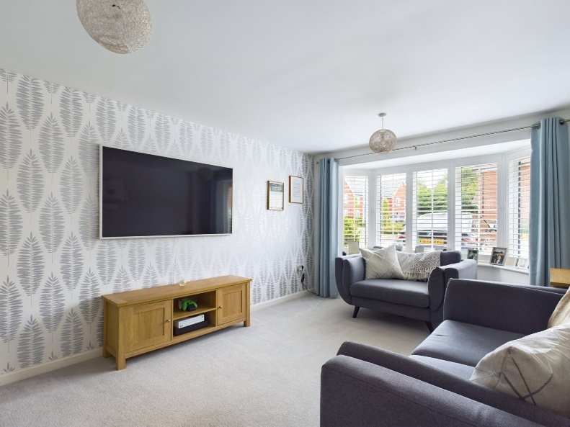

Braken Road

Chinnor

OX39 4FU

Offers in Excess of: £500,000

Not your average 3 bed semi! This 4 year old, already wonderful family home, has extended and redesigned living space, enhancing it`s desirability on a quiet development within walking distance to local shops, schools and amenities There is also a nearby children`s play area and access to many wonderful countryside walks

On entering the property, the bright and airy hallway leads to all further rooms. The main reception room benefits from a bay window with plenty of space for comfortable furniture and is a cosy retreat after a long day.

The extended kitchen/family room boasts a contemporary and stylish kitchen with underfloor heating, has ample eye and waist level storage, integrated full length fridge and freezer, double oven, quartz work tops, ceramic sink with hot tap, space for a dining table and additional room for a sofa or workspace, and a door to the separate laundry room that utilises some of the garage space and is a bonus addition to the home. There is plumbing for a washing machine and tumble dryer, and has further storage cupboards.

From the kitchen are French doors to the enclosed rear, landscaped garden, making this a really wonderful indoor/outdoor space, a great place to socialise with family or friends. There is also a downstairs wc.

Upstairs are three good size bedrooms with the master benefiting from fitted wardrobes, a luxury ensuite with double shower, heated towel rail and vanity unit. There is also a large linen cupboard and family bathroom with bath and overhead shower, heated towel rail and vanity unit.

Outside: The rear enclosed garden has been landscaped with thoughtful design to include a large patio, a barbecue area, raised decking with additional seating at the end of the garden and a home office. The rest of the garden is laid to lawn with a beautiful selection of colourful plants and shrubs and a modern water feature. There is side access to the front of the property and garage with remaining storage and off road parking for multiple cars.

Other notable features; remaining NHBC warranties, gas central heating with combi boiler, double glazing throughout, part boarded loft.

**Location**

Situated at the foot of the Chiltern Hills, Chinnor is a popular village conveniently situated on the Oxfordshire/Buckinghamshire borders. Within the village there are good local facilities including a variety of shops, churches, pubs and restaurants, post office, doctor`s surgery, a nursery and two combined schools. Chinnor lies within catchment for the highly regarded Lord Williams`s secondary school in Thame.

M40(Junction 6) is within 3 miles giving access to Oxford(20 miles), High Wycombe(13 miles) and London(48 miles). Princes Risborough mainline station is within 5 miles (Marylebone 35 minutes).

Council Tax Band D

EPC to Follow

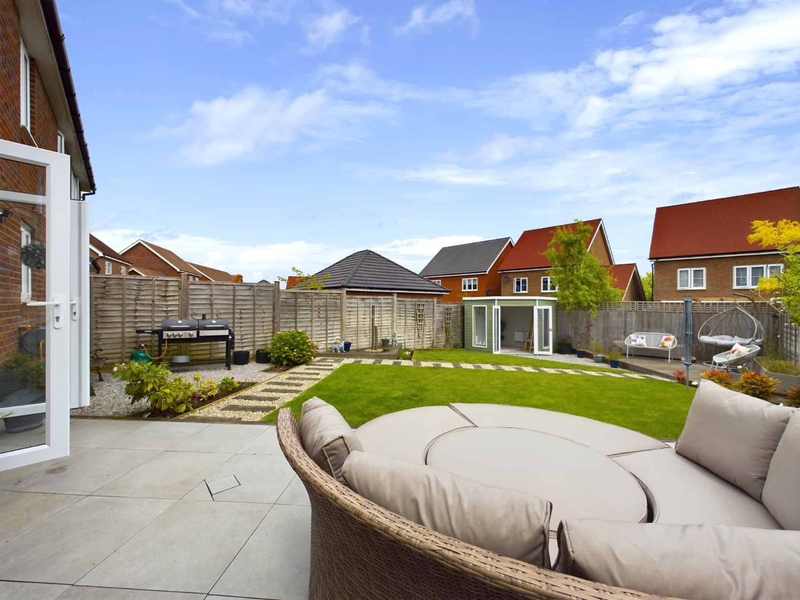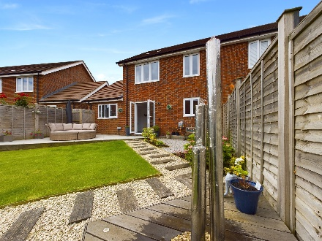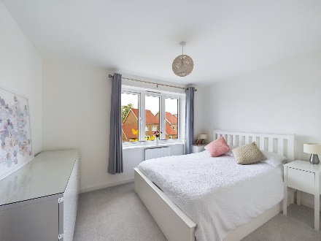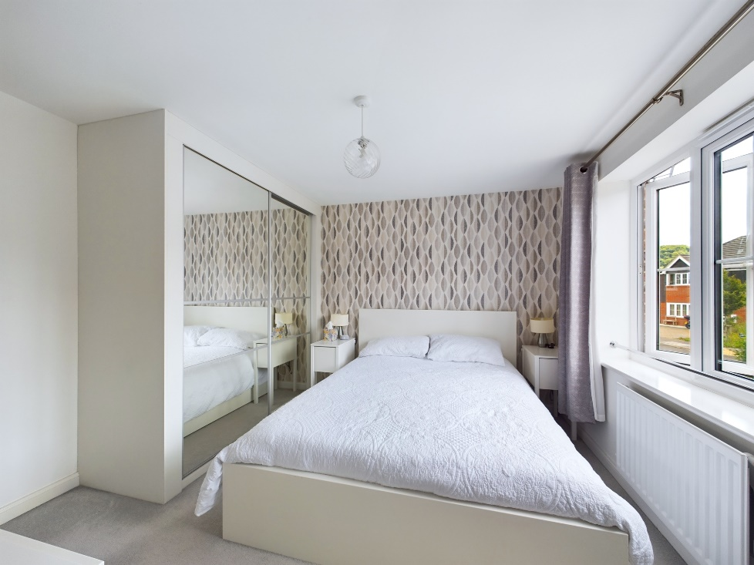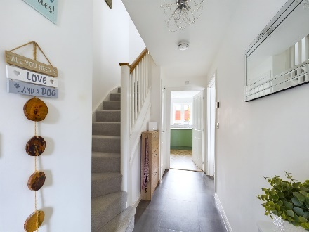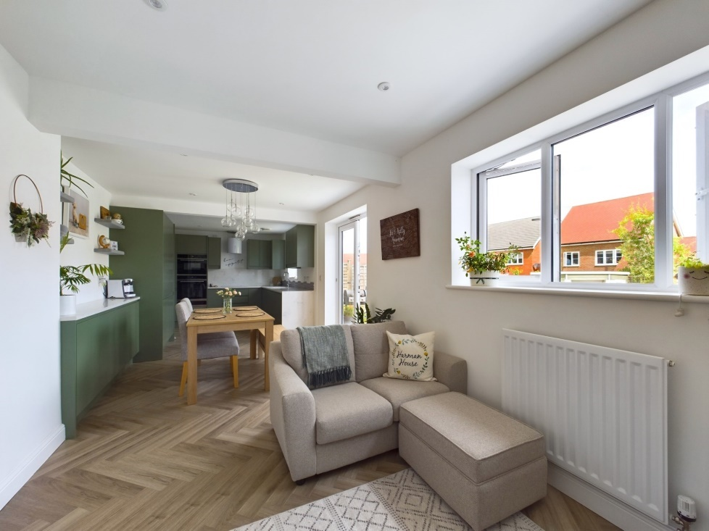

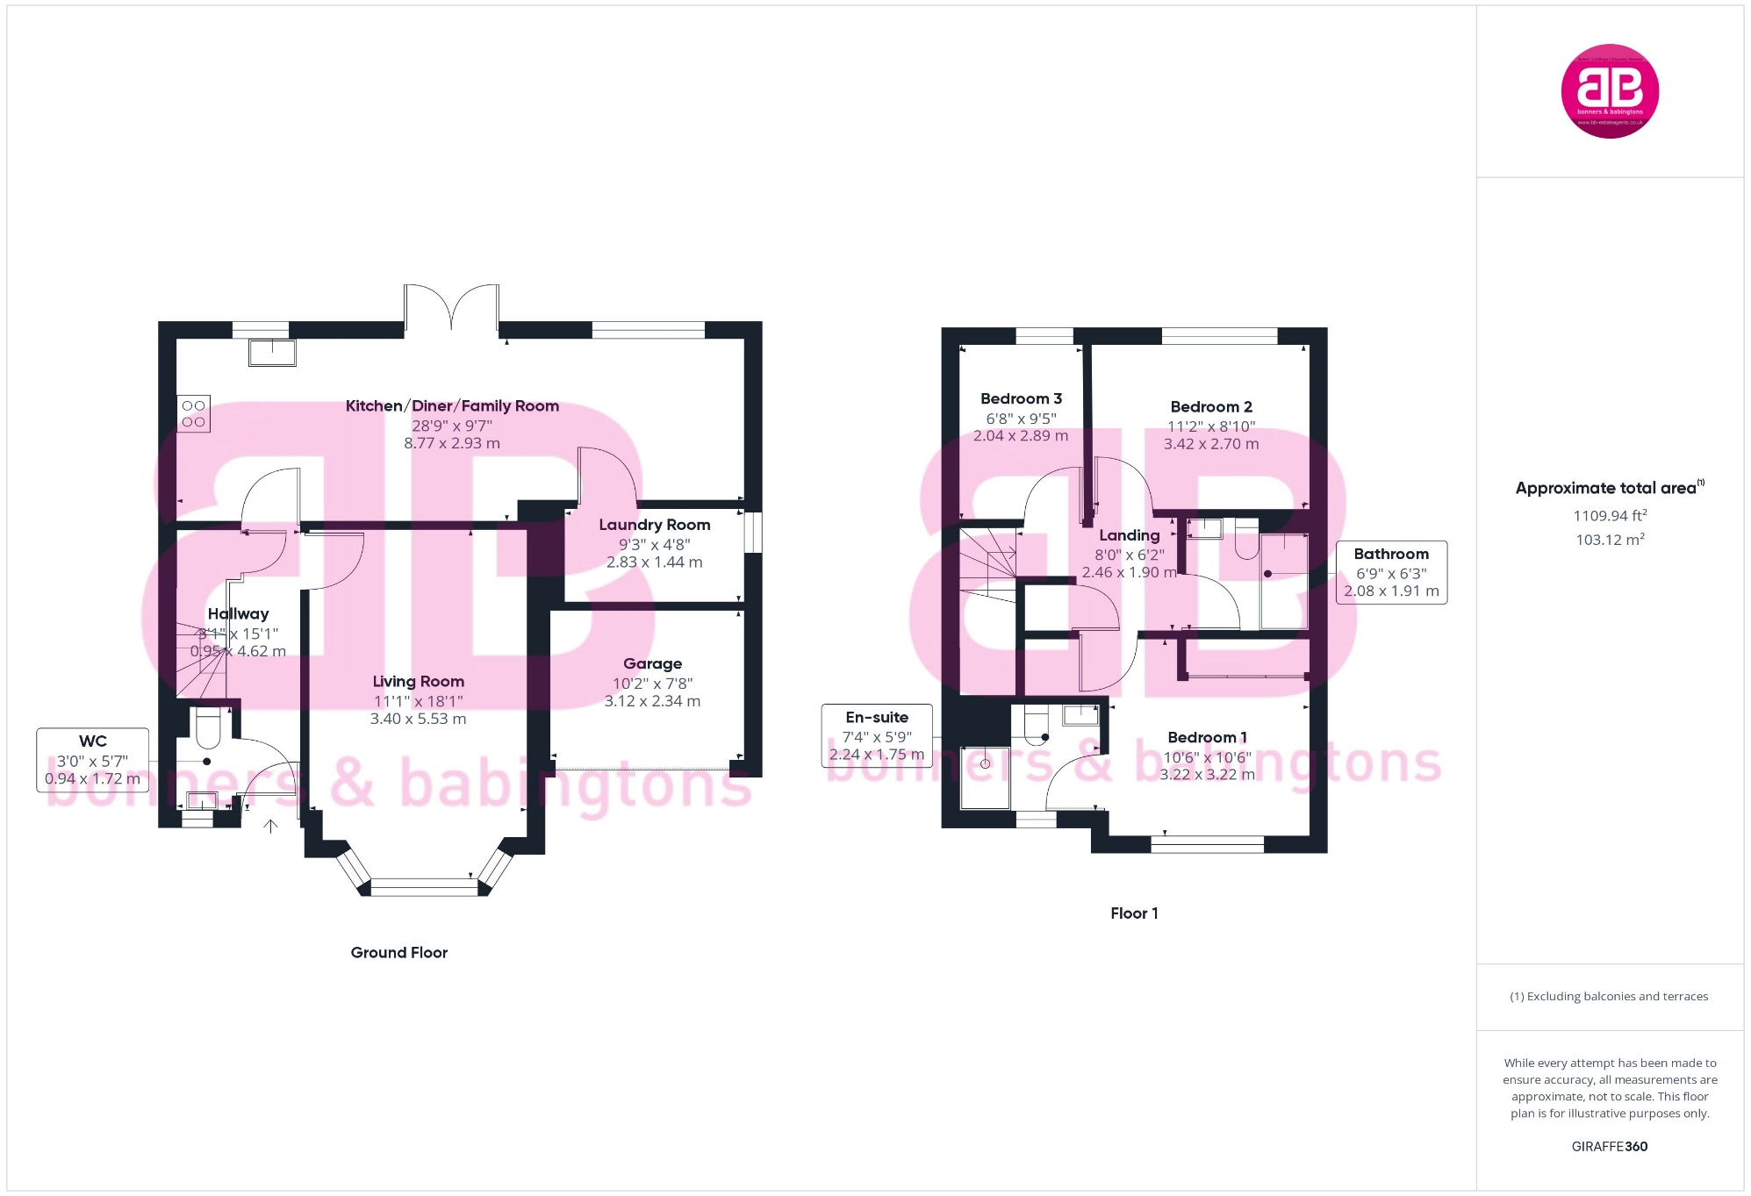

Zoopla LogoNAEA Propertymark Protected CMYKRM_Logo_NoStrap_Colourfacebook logo

**Disclaimer**

We endeavour to make our particulars accurate and reliable. They are for guidance only and are intended to give a fair overall summary of the property. They do not form part of any contract or offer, and should not be relied upon as a statement or representation of fact. Measurements, areas and distances are approximate and photographs provided for guidance only. No undertaking is given as to the structural condition of the property, or any necessary consents, or the operating ability or efficiency of any service, system or appliance. Prospective purchasers must satisfy themselves with regard to each of these points. If there is any particular aspect of the property about which you would like further information, please contact us, especially, before you travel to the property. B2170

Robert House, 19 Station Road, Chinnor, Oxfordshire, OX39 4PU

01844 354554

www.bb-estateagents.co.uk