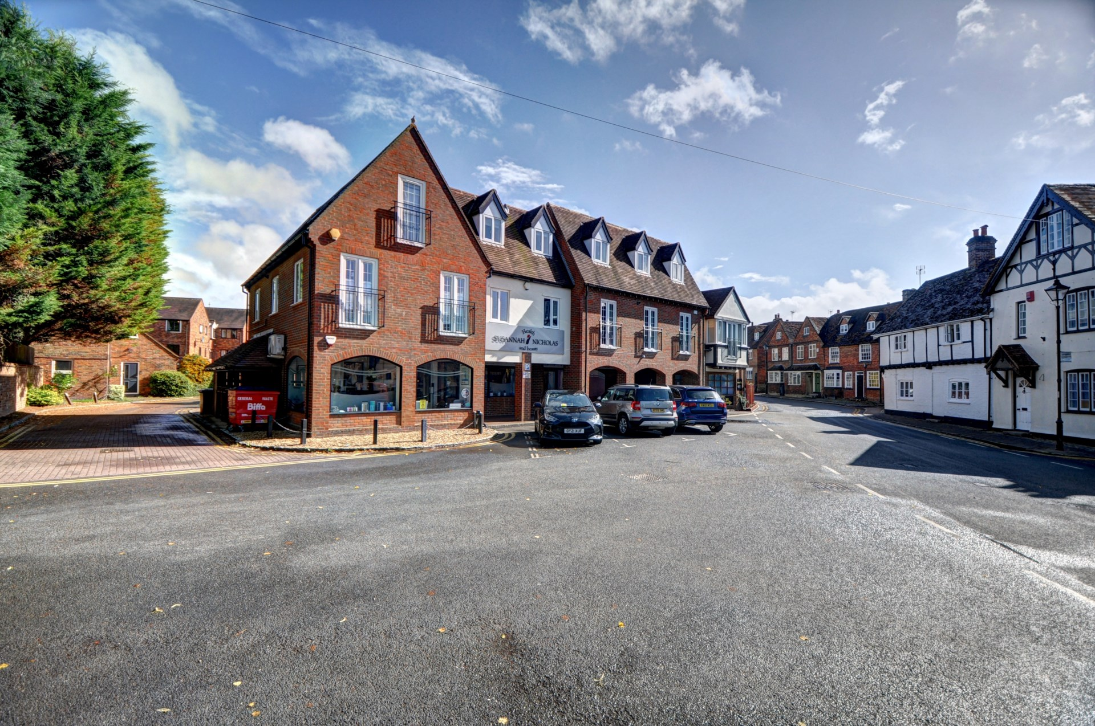bb-logo-final

Malthouse Square

Princes Risborough

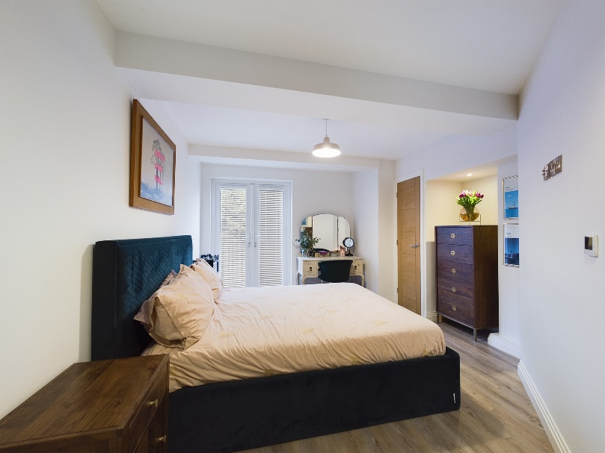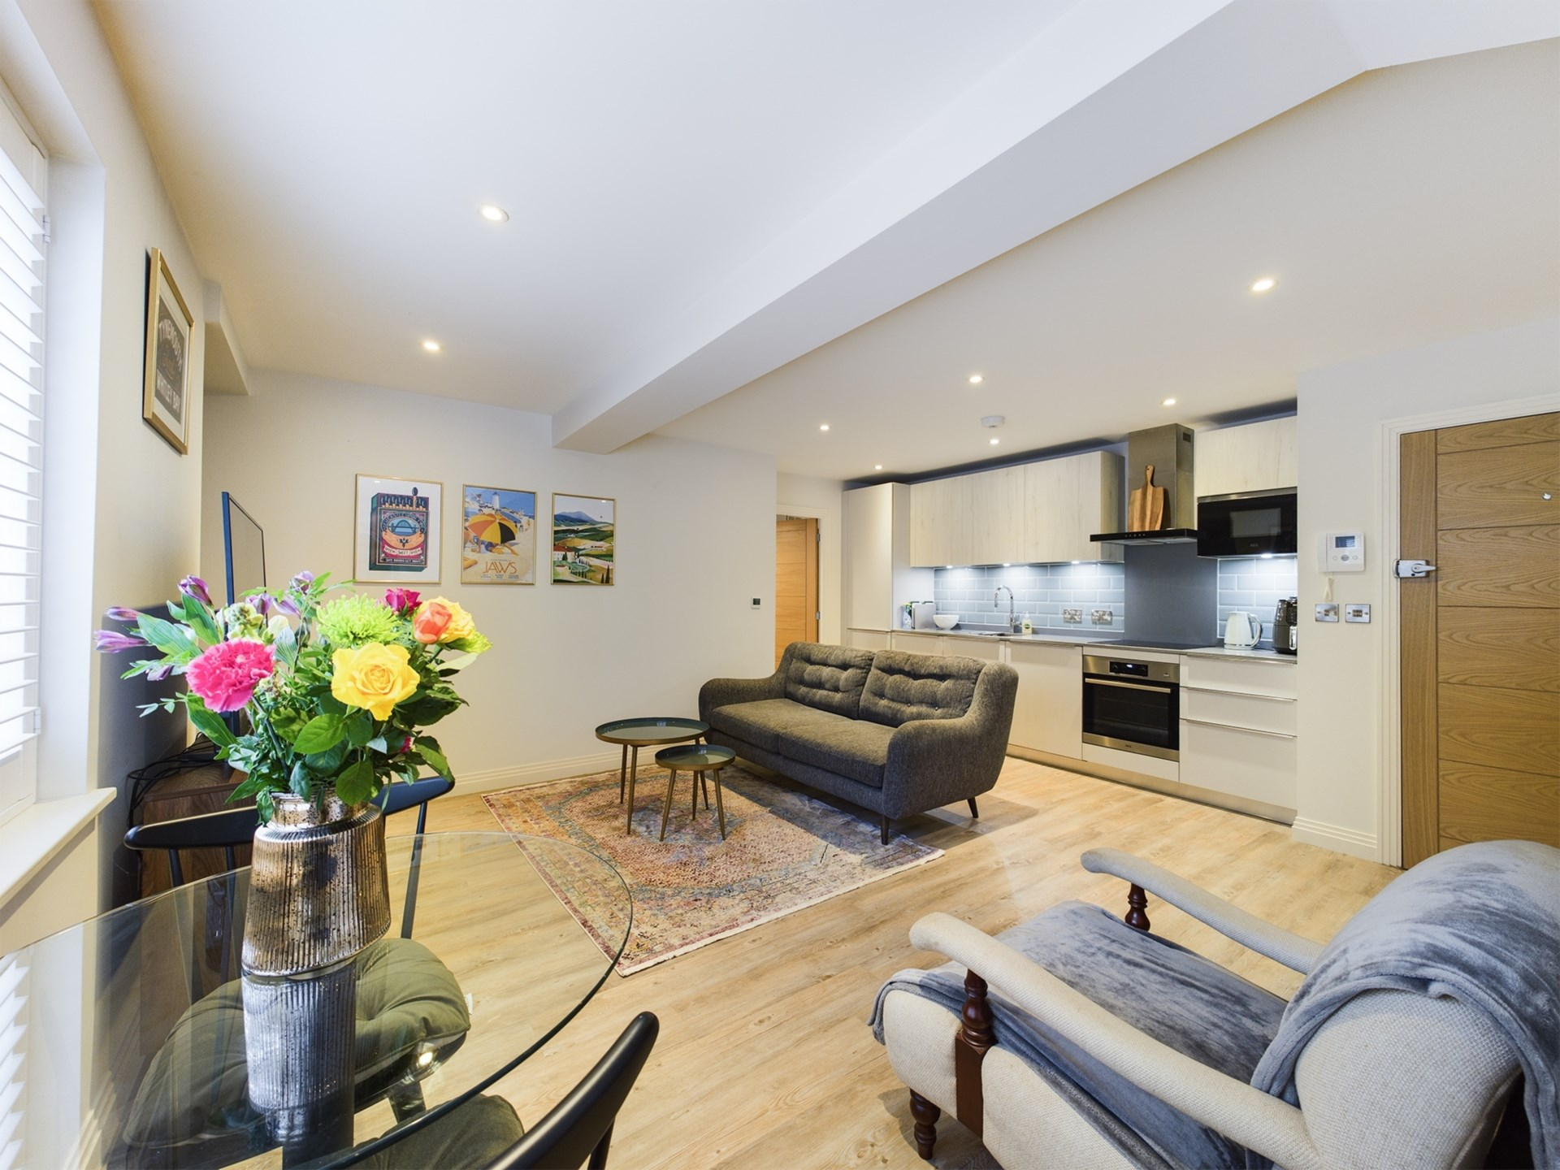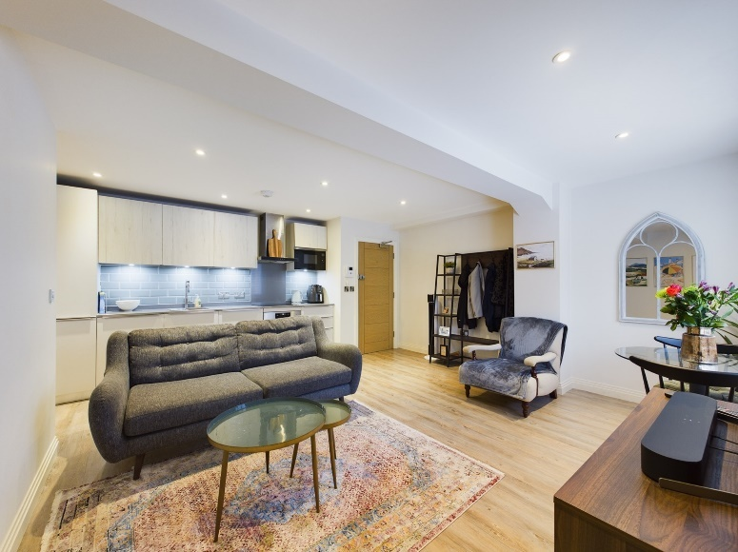

The Malthouse

Malthouse Square

Princes Risborough

Buckinghamshire

HP27 9AZ

Offers Over - £240,000

Lease – 123 years

Service Charge - £1080 per year

Ground rent - £200 per year

Council tax band - B

A luxury and stylish one bedroom first floor apartment, converted back in 2021. The property is located within the heart of Princes Risborough town center with local amenities, leisure center / gym as well as the mainline train station all within walking distance of the property.

The property accommodation comprises of the following, a good sized open plan living room / kitchen area. The kitchen has been fitted to a high standard and benefits from AEG fitted appliances including a Zanussi fridge / freezer, Siemens dishwasher and a washing machine. There is also a double bedroom with fitted wardrobes, newly updated ensuite shower room with heated bluetooth mirror and speaker and a balcony, a perfect area to sit and have a drink in the summer months.

Other notable features include, main gas central heating system (under floor heating) controlled with digital thermostats, double glazed windows and a 8 year NHBC WARRANTY.

Princes Risborough

The attractive market town of Princes Risborough offers a post office, a leisure centre and a good range of local shops including a Tesco, Marks & Spencer Simply Food and Costa Coffee. Further, more comprehensive leisure and shopping facilities can be found in High Wycombe, Aylesbury and Oxford all within easy reach. Excellent schooling is provided locally with a good choice of private and state schools close by including grammar schools in High Wycombe and Aylesbury.

There is access to the M40 motorway for London and the Midlands just 6 miles away (J6) and Princes Risborough station offers an excellent main line rail service to London (Marylebone - 35 minutes) and the Midlands.

EPC RATING - B

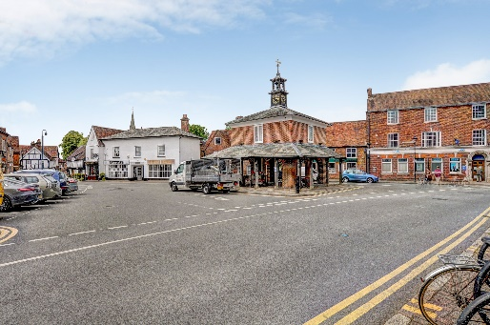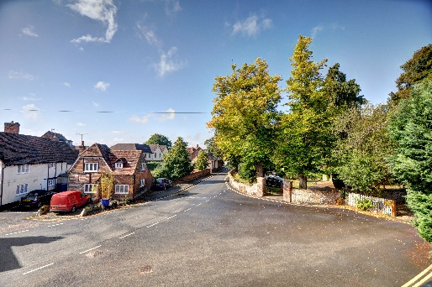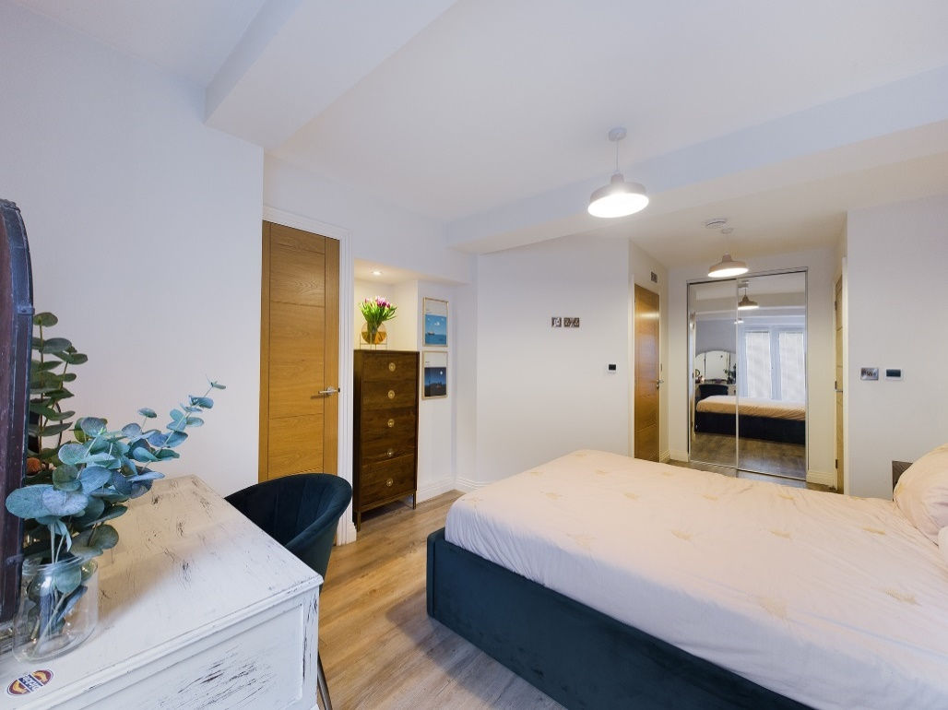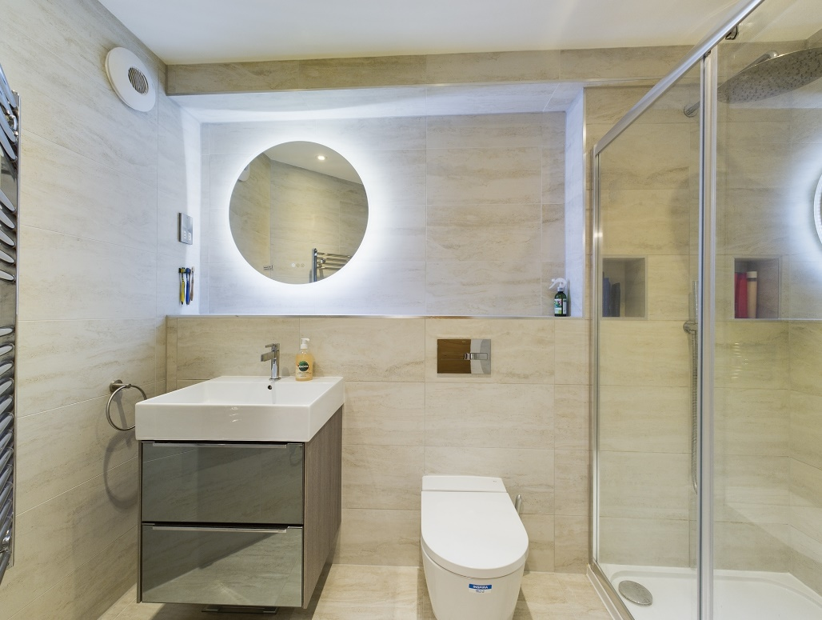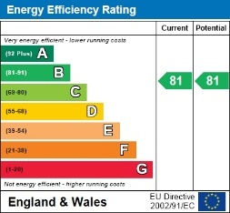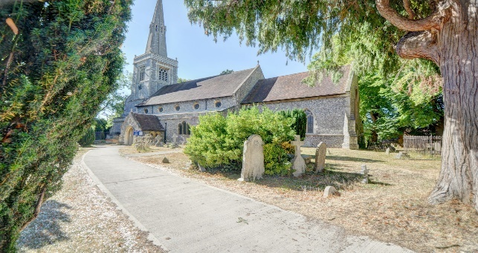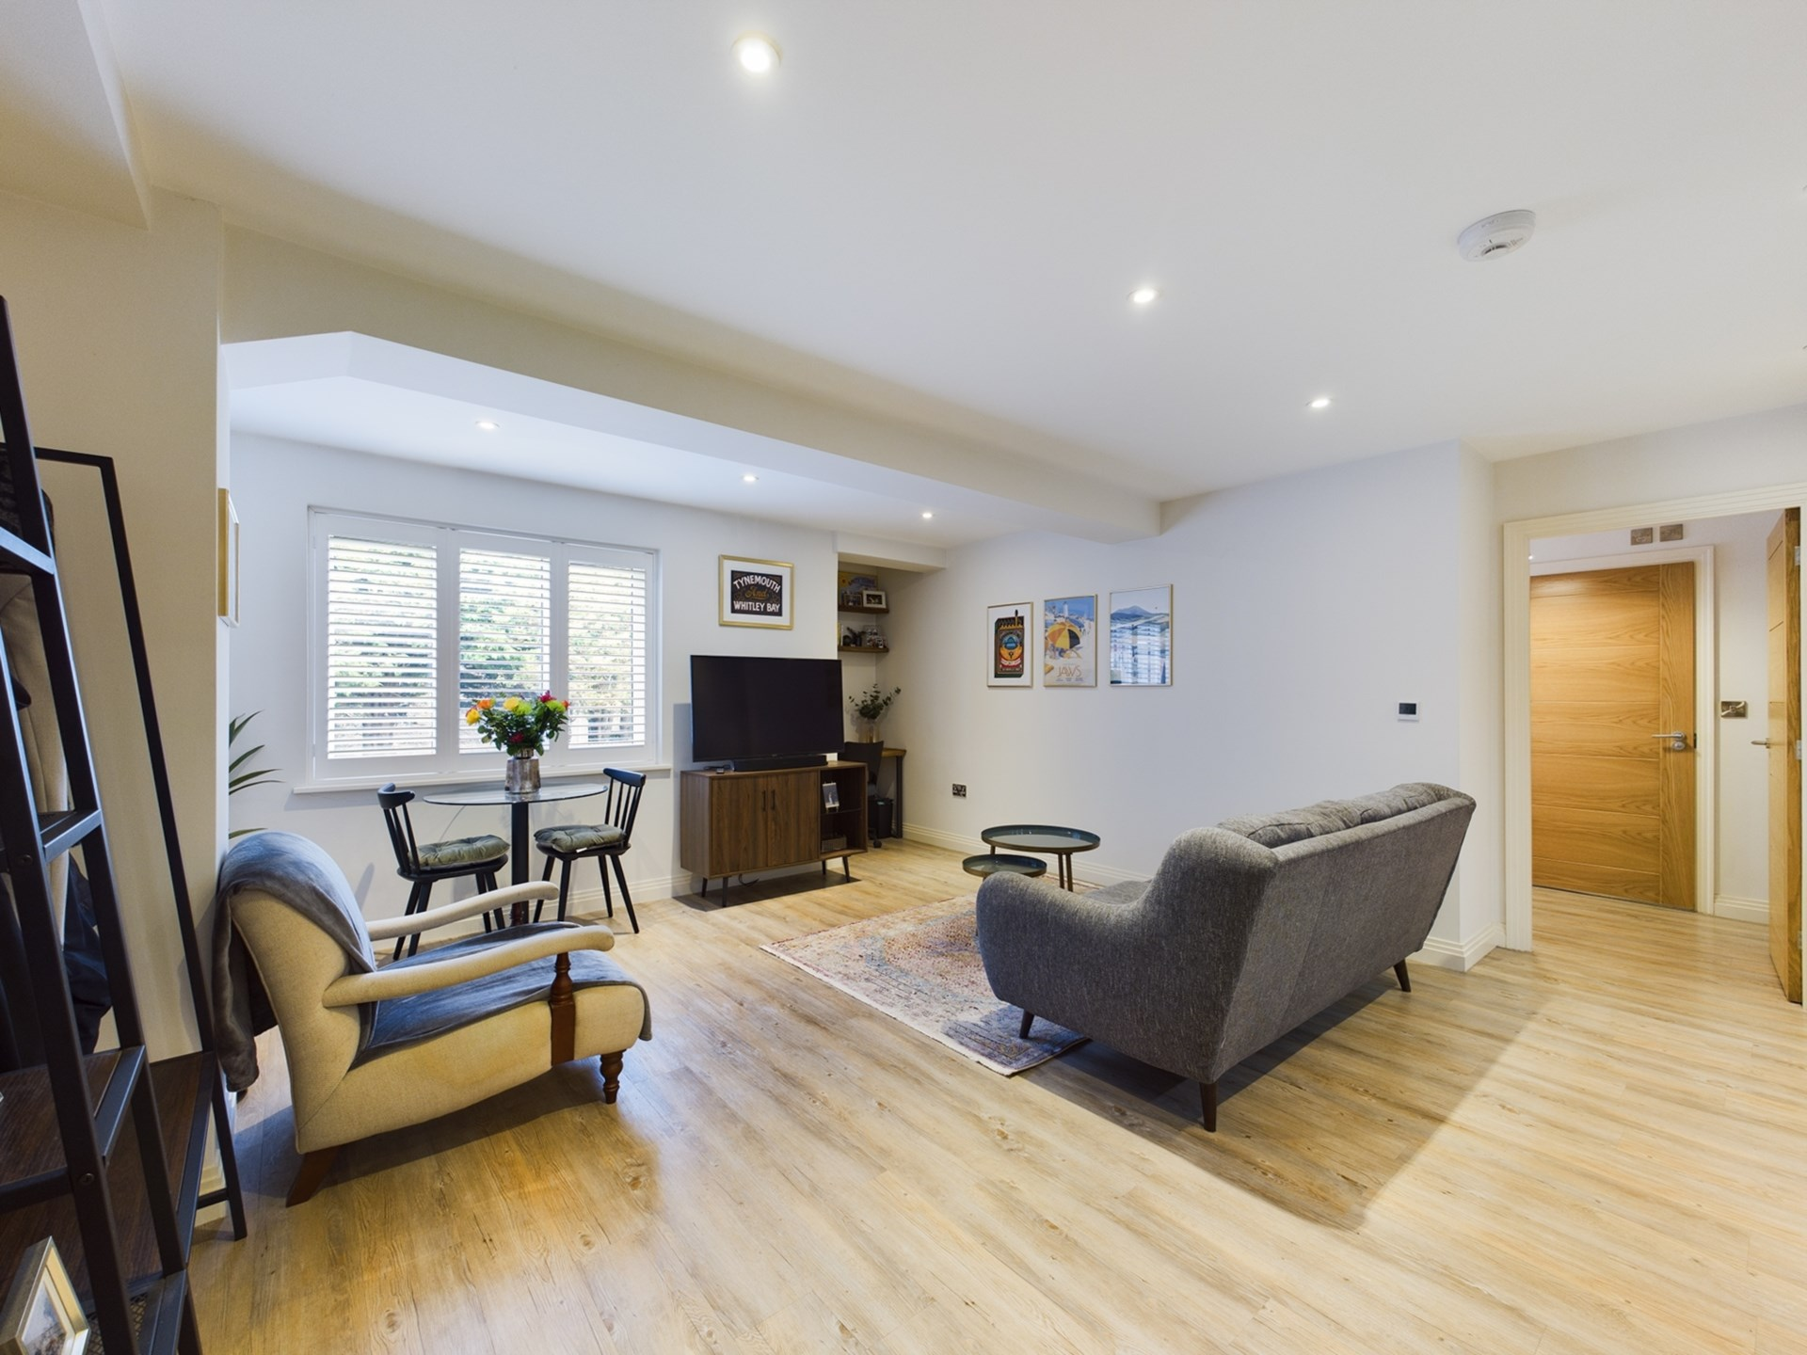

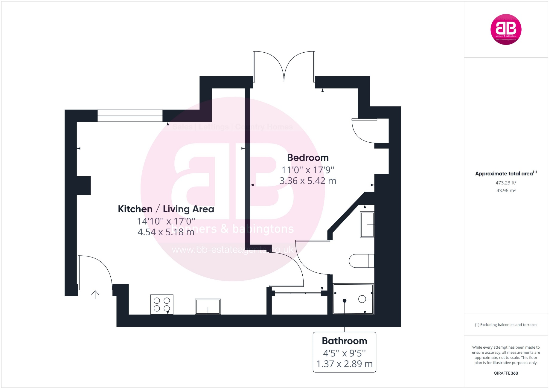

Zoopla LogoNAEA Propertymark Protected CMYKRM_Logo_NoStrap_Colourfacebook logoPrimelocation lscape

**Disclaimer**

We endeavour to make our particulars accurate and reliable. They are for guidance only and are intended to give a fair overall summary of the property. They do not form part of any contract or offer, and should not be relied upon as a statement or representation of fact. Measurements, areas and distances are approximate and photographs provided for guidance only. No undertaking is given as to the structural condition of the property, or any necessary consents, or the operating ability or efficiency of any service, system or appliance. Prospective purchasers must satisfy themselves with regard to each of these points. If there is any particular aspect of the property about which you would like further information, please contact us, especially, before you travel to the property. B2170

78 High Street, Princes Risborough, Buckinghamshire, HP27 0AX

01844 343661

www.bb-estateagents.co.uk