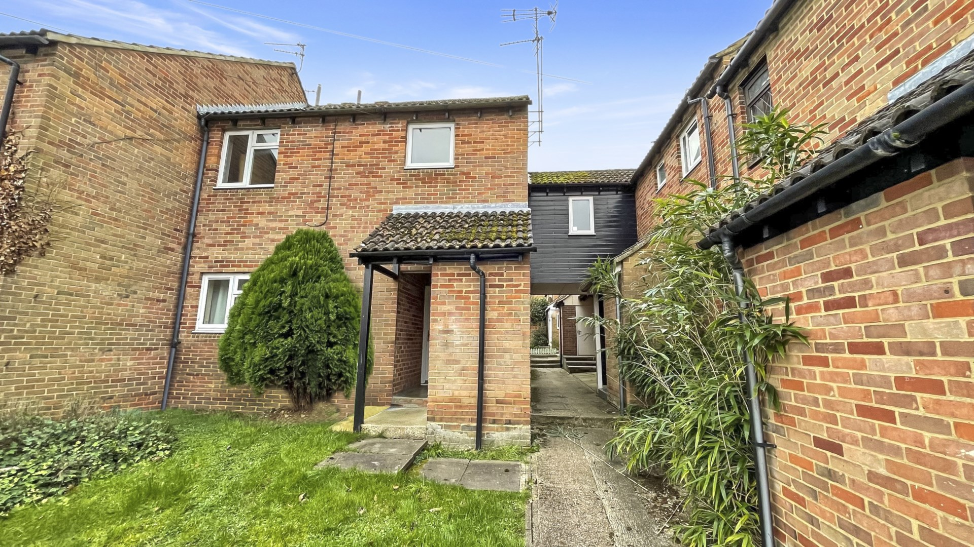bb-logo-final

James Close

Marlow

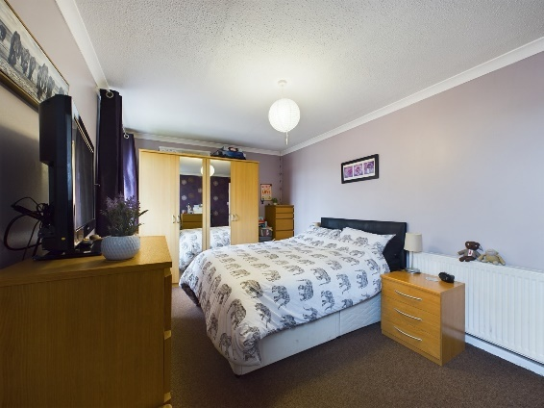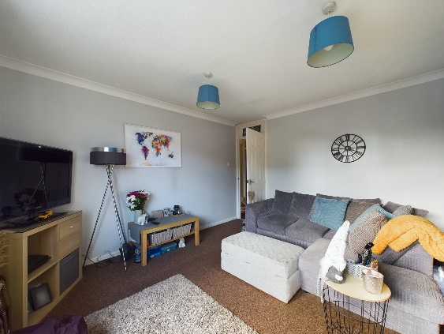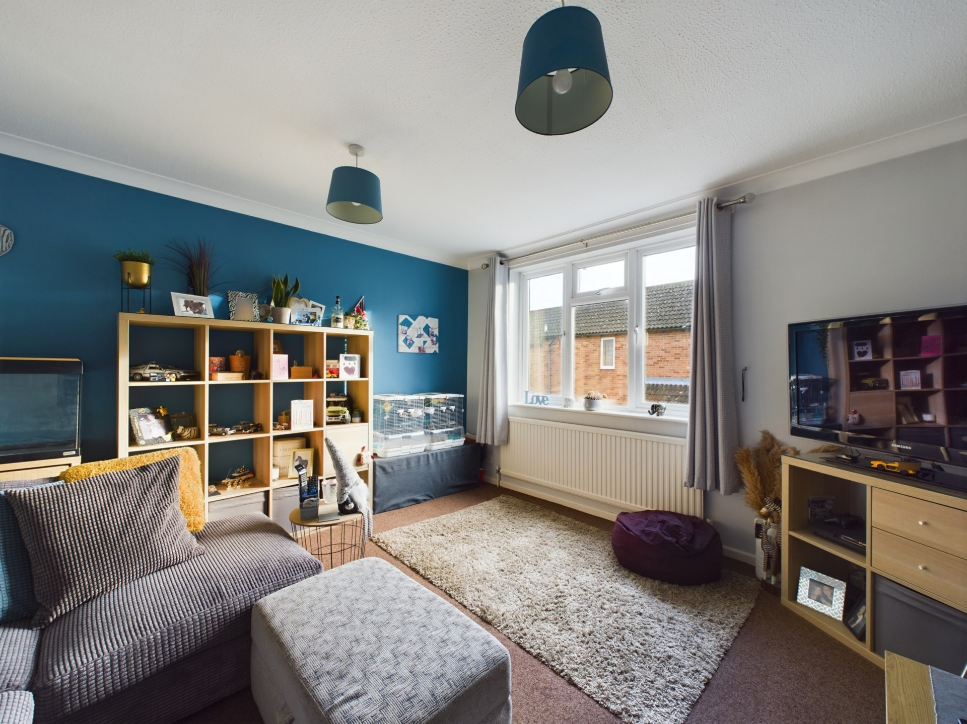

**- Tenure:- Leasehold**

**- Guide Price: £280,000**

**- Lease Length: 87 years**

**- Service Charge: £326 p/a**

**- Ground Rent: £10 p/a**

**- Council Tax Band: C**

**- EPC Rating: C**

James Close

Marlow

Buckinghamshire

SL7 1TS

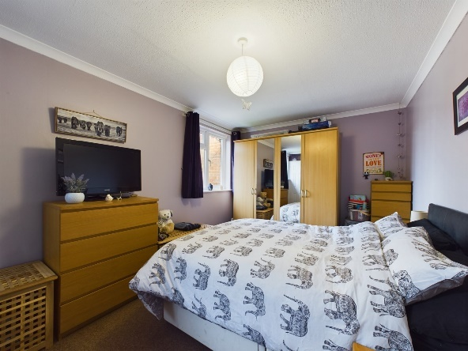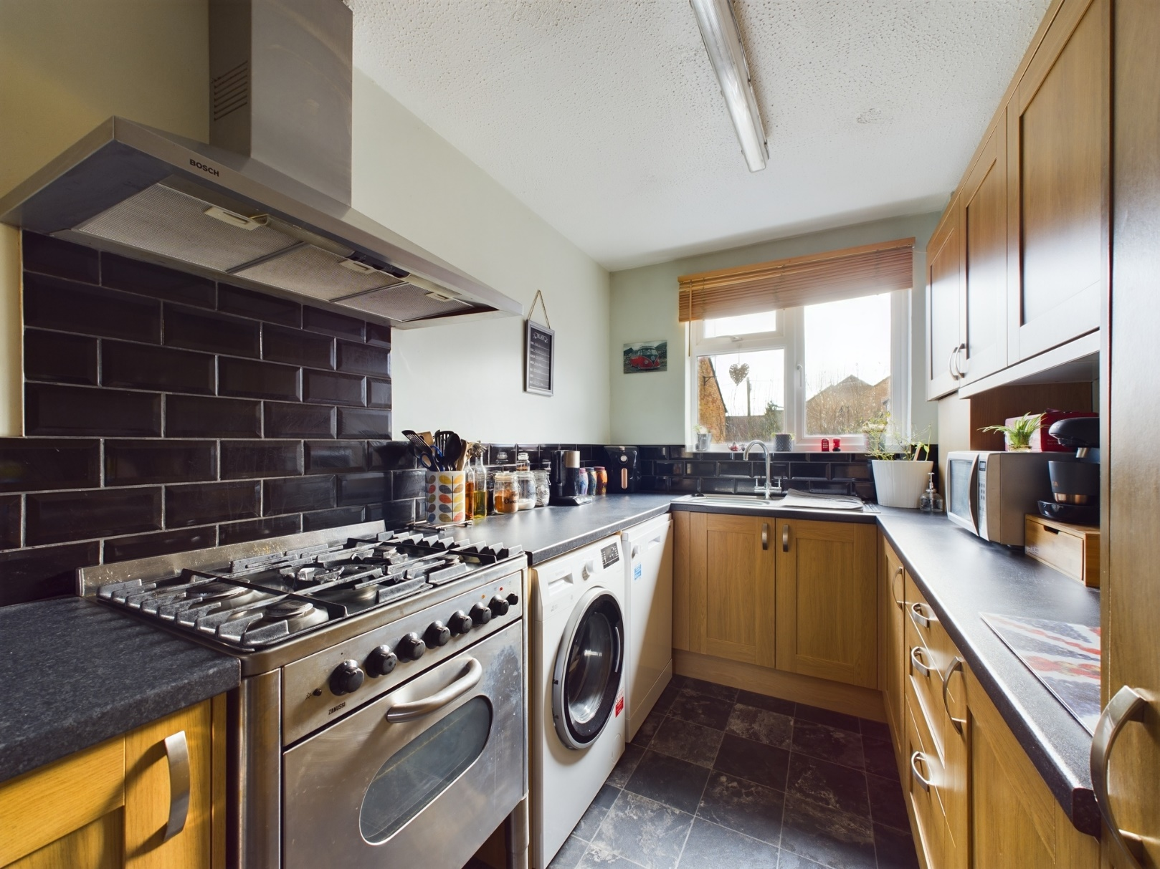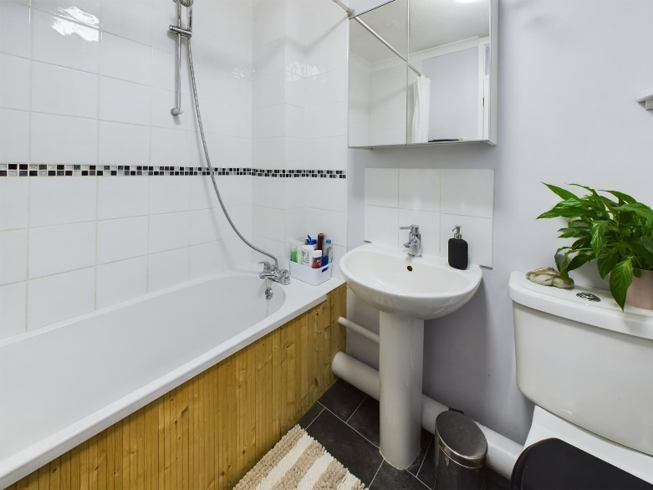

A SPACIOUS and extremely well presented TWO Bedroom first floor MAISONETTE which has been REFURBISHED in recent years & benefits from its own southerly aspect GARDEN. The property is situated in a CUL-DE-SAC with residents` PARKING & is about one mile from Marlow Town Centre.

A light and airy two bedroom first floor maisonette situated in a cul-de-sac within about one mile from Marlow High Street. The property has been refurbished in recent years and accommodation includes lounge/diner, refitted kitchen, two bedrooms and family bathroom. Externally there are residents` parking bays and an enclosed rear garden with a southerly aspect. The property also benefits from gas central heating and double glazed windows.

Marlow town centre is a thriving and stylish riverside community with a comprehensive range of shops and excellent pubs and restaurants. Nearby Marlow Station has a regular train service to London Paddington via Maidenhead (from 1hr 5 mins) with links to the City of London, further enhanced when Crossrail opens in Maidenhead. Access to the M4 and M40 is via the A404(M) and London Heathrow is about 22 miles away.

There is a wide range of educational and recreational facilities in the area. Excellent local schools are numerous and include Sir William Borlase in Marlow.

