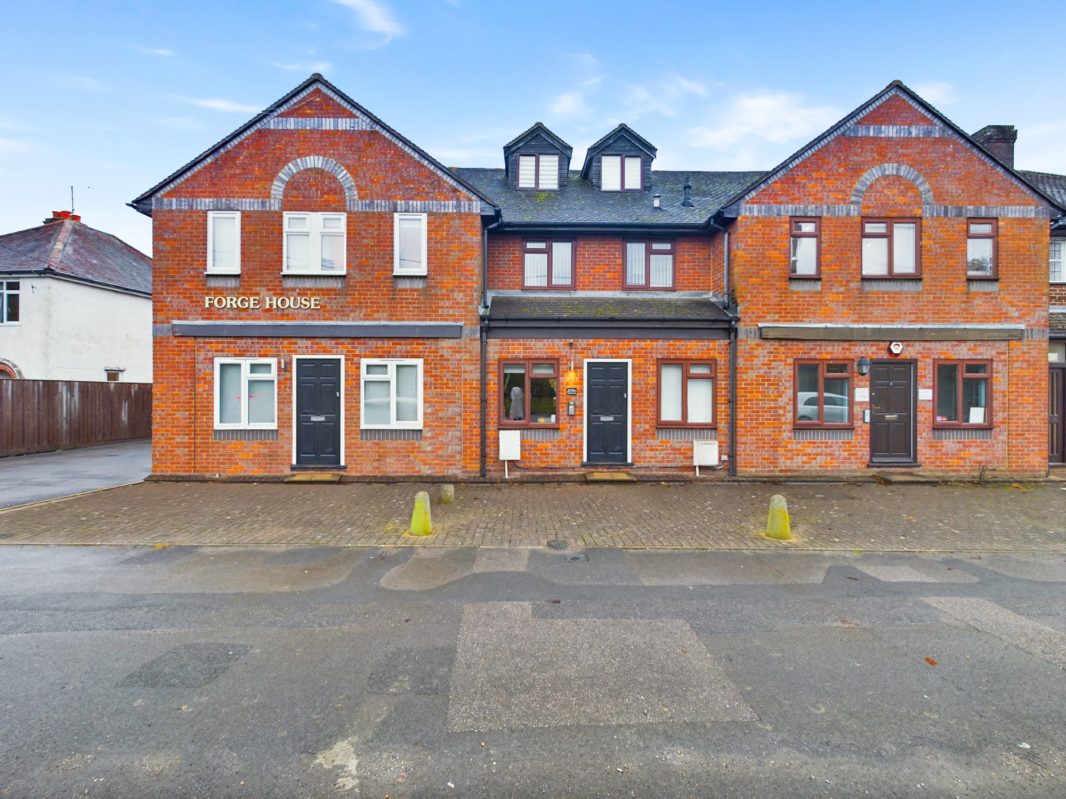bb-logo-final

Summerleys Road

Princes Risborough

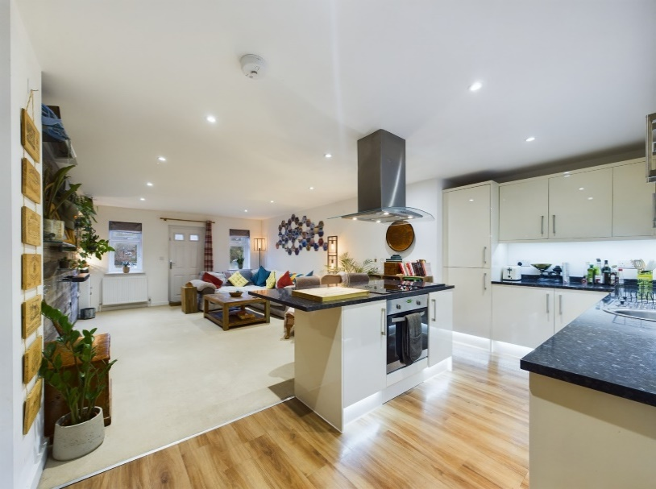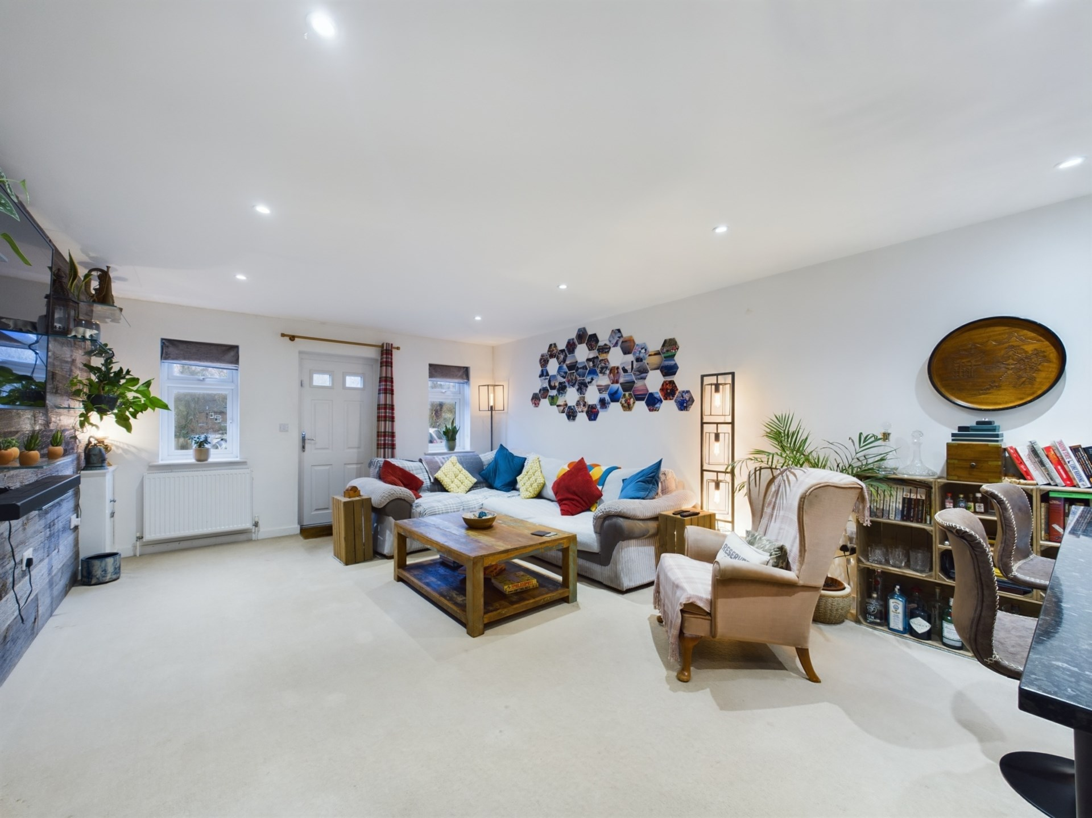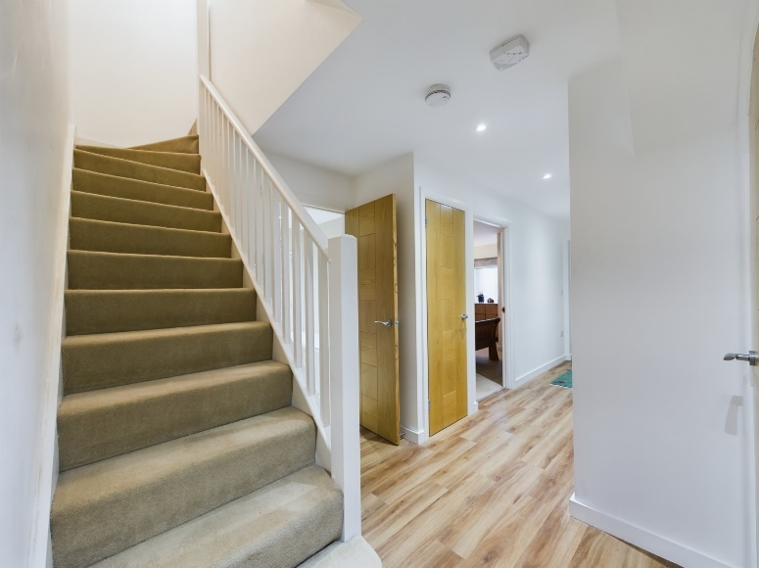

1 Forge House,

Summerleys Road, Princes Risborough,

Buckinghamshire,

HP27 9DT

Offers Over £300,000.

This recently converted and spacious duplex apartment is conveniently situated for the mainline station and town centre.

This fabulous home offers a stunning contemporary interior and `high end` specification throughout, blending modern contemporary living in an idealistic location.

The property is sold with a share of the freehold and an extensive 122 year lease.

The accommodation briefly comprises entrance hall with storage, 26ft open plan living room and superb kitchen with integrated appliances, two double bedrooms, stylish bathroom and two allocated parking spaces.

Forge House, is has easy walkable access to the Chiltern Hills and The Ridgeway. A lovely local pub 5 minutes walk and town centre 10 minutes walk.

Princes Risborough

The attractive market town of Princes Risborough offers a post office, bank, a leisure centre and a good range of local shops including a Tesco, Marks & Spencer Simply Food and Costa Coffee. Further, more comprehensive leisure and shopping facilities can be found in High Wycombe, Aylesbury and Oxford all within easy reach. Excellent schooling is provided locally with a good choice of private and state schools close by including grammar schools in High Wycombe and Aylesbury.

There is access to the M40 motorway for London and the Midlands just 6 miles away (J6) and Princes Risborough station offers an excellent main line rail service to London (Marylebone - 34 minutes) and the Midlands.

EPC RATING – C

COUNCIL TAX BAND - C

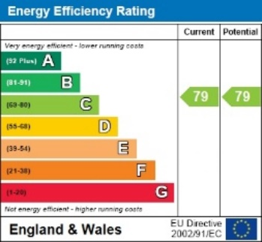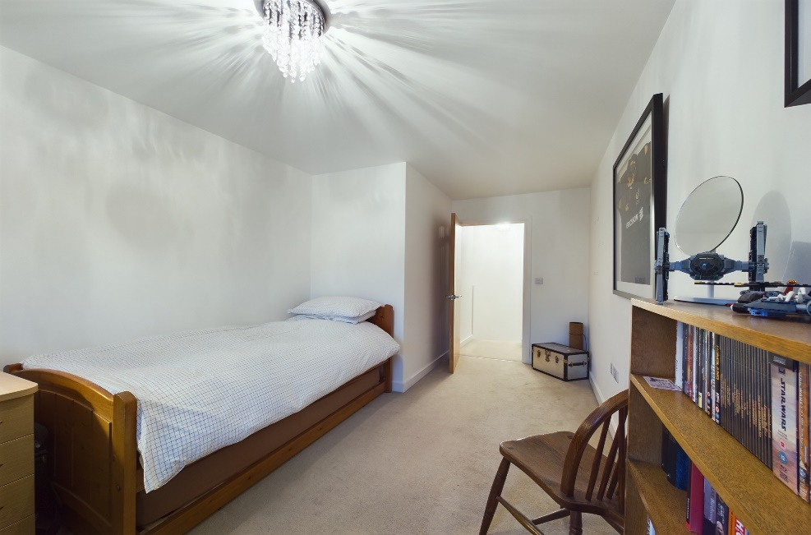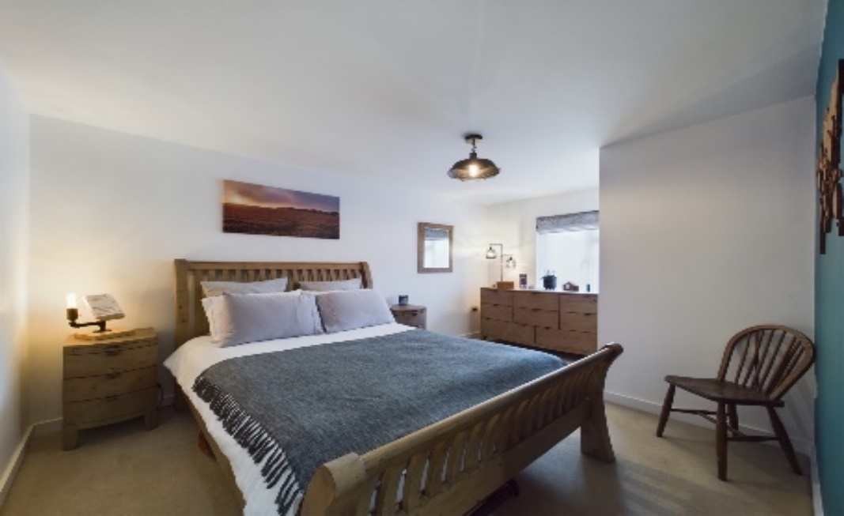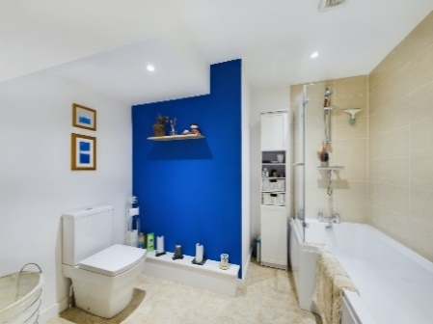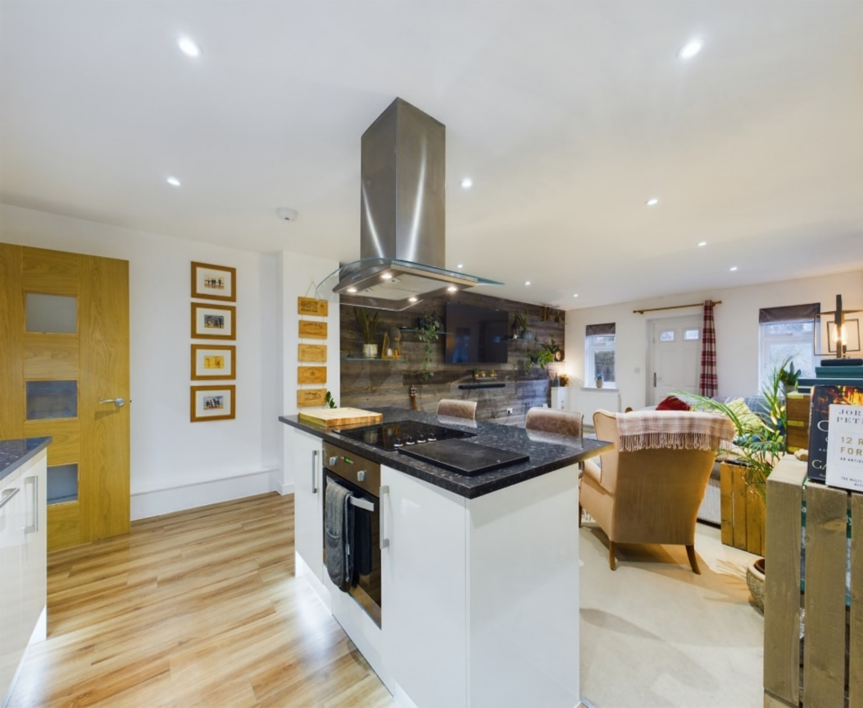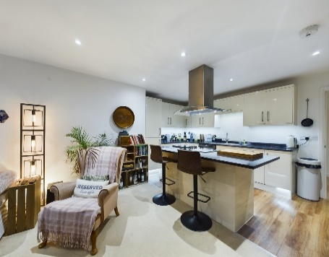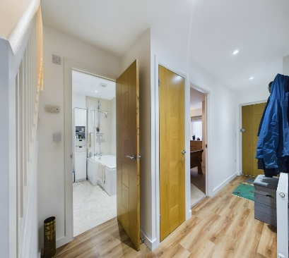

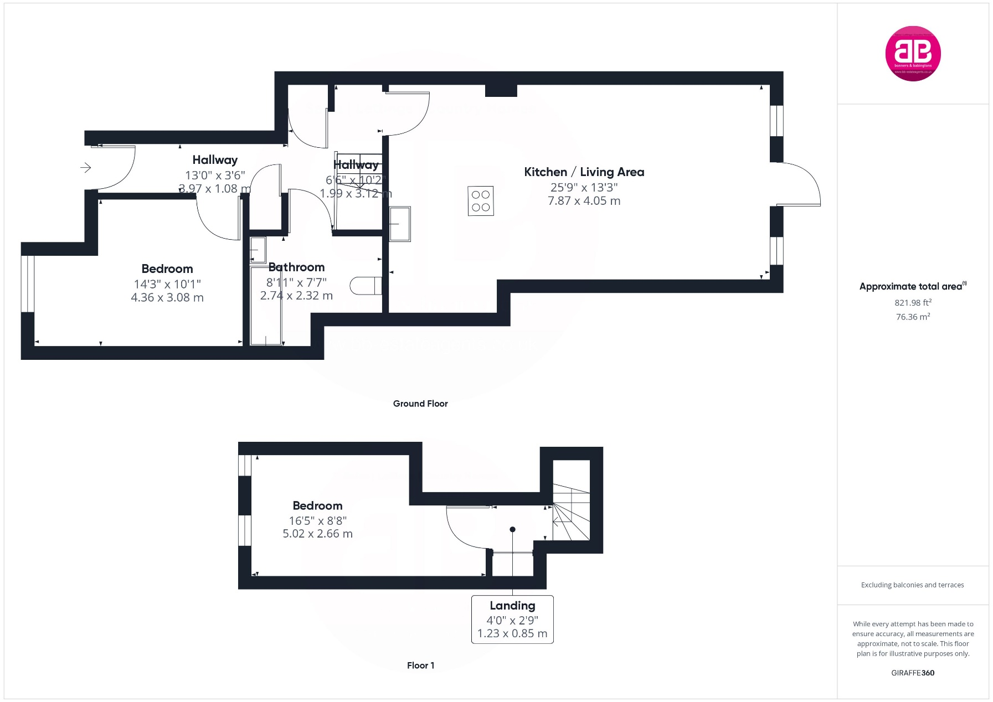

Zoopla LogoNAEA Propertymark Protected CMYKRM_Logo_NoStrap_Colourfacebook logoPrimelocation lscape

**Disclaimer**

We endeavour to make our particulars accurate and reliable. They are for guidance only and are intended to give a fair overall summary of the property. They do not form part of any contract or offer, and should not be relied upon as a statement or representation of fact. Measurements, areas and distances are approximate and photographs provided for guidance only. No undertaking is given as to the structural condition of the property, or any necessary consents, or the operating ability or efficiency of any service, system or appliance. Prospective purchasers must satisfy themselves with regard to each of these points. If there is any particular aspect of the property about which you would like further information, please contact us, especially, before you travel to the property. B2170

78 High Street, Princes Risborough, Buckinghamshire, HP27 0AX

01844 343661

www.bb-estateagents.co.uk