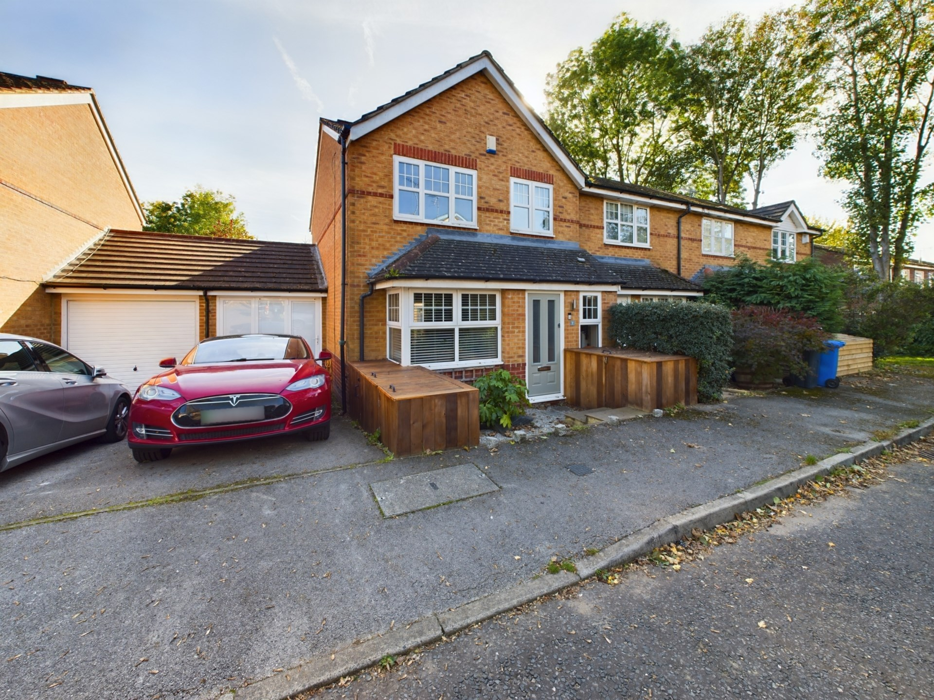bb-logo-final

Kiln Croft Close

Marlow

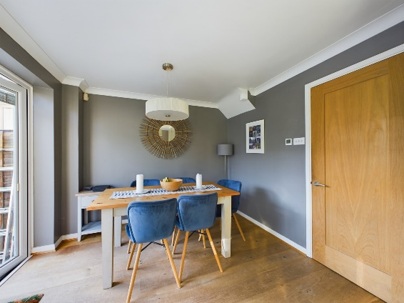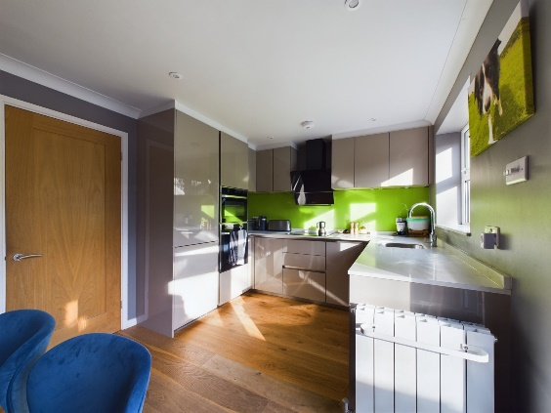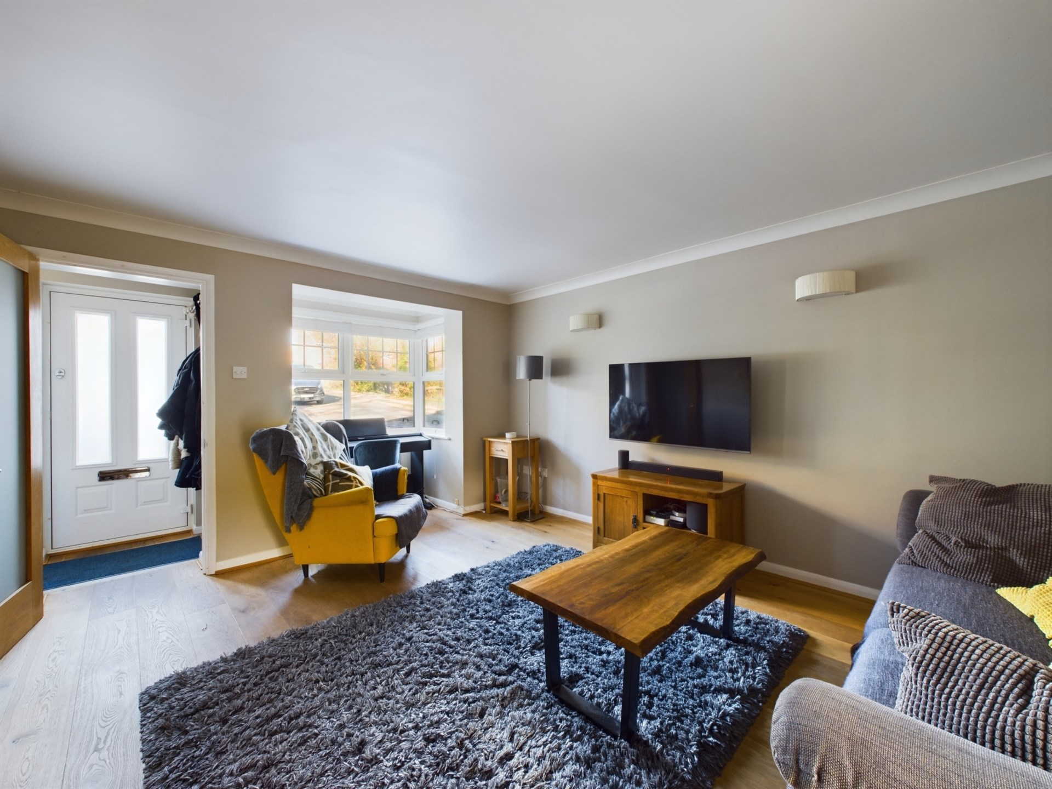

**- Tenure: Freehold**

**- Guide Price: £575,000**

**- Council Tax Band: E**

**- EPC Rating: D**

**- Local Authority: BCC**

Kiln Croft Close

Marlow

Buckinghamshire

SL7 1US

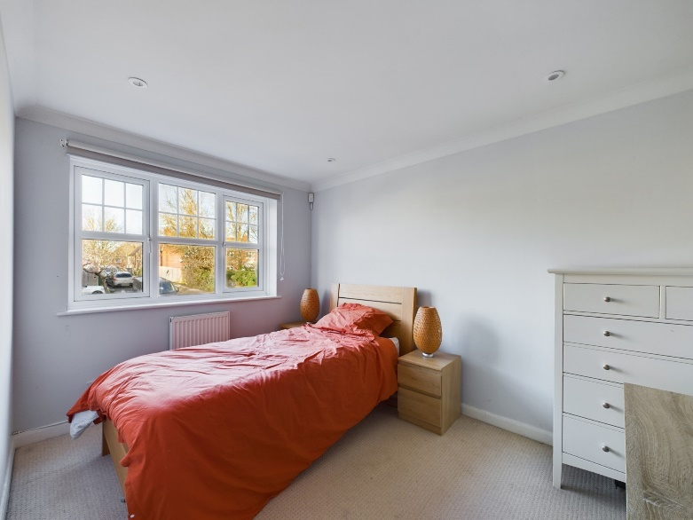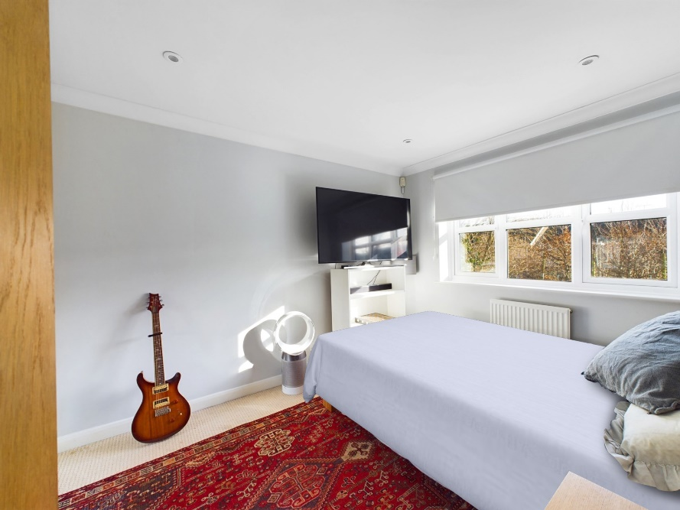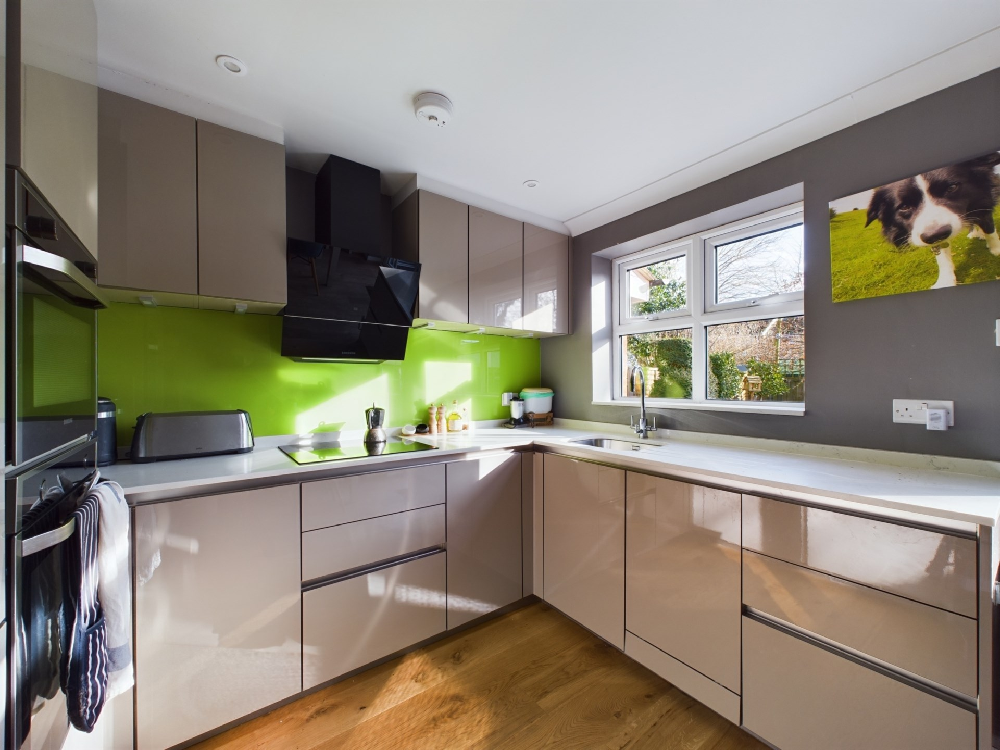

Bonners & Babingtons are delighted to offer to the market this delightfully presented three bedroom family home situated in a secluded cul-de-sac approximately one mile east of Marlow Town Centre.

With open countryside, lakes and woodland walks on its doorstep this vacant property has everything a family could need. On entering the property you are greeted by a cosy entrance hall with door to ground floor WC and door through to the living room. The living room is nice size with bay window to the front aspect, stairs to first floor and door through to the kitchen diner. The kitchen diner has an array of wall and base units with plenty of work space, services for appliances, window to rear aspect and bi-fold doors to the garden. On the first floor there are three good sized bedrooms and a refitted family bathroom.Outside there is a generous south facing garden with flower bed boarders, patio area, ideal for alfresco dining and door to the annexe. The annexe is a multi-functional room which is currently used as an office / gym but could be a studio or even additional living space. With doors to front and rear plus a large velux window there is plenty of light coming through. To the front of the property there is a driveway as well as a small storage unit. As well as having open countryside nearby the property is ideally situated for the A404 and access to the M4 or M40 Motorway as well as being only a short walk to Marlow Train Station.

Marlow town centre is a thriving and stylish riverside community with a comprehensive range of shops and excellent pubs and restaurants. Nearby Marlow Station has a regular train service to London Paddington via Maidenhead (from 1hr 5 mins) with links to the City of London, further enhanced with the recently opened Crossrail Link from Maidenhead. Access to the M4 and M40 is via the A404(M) and London Heathrow is about 22 miles away. There is a wide range of educational and recreational facilities in the area. Excellent local schools are numerous and include Sir William Borlase in Marlow.

**Situated in this secluded cul-de-sac to the east of Marlow Town Centre this well proportioned three bedroom family home benefits from no onward chain, parking, annexe office and private rear garden. Viewings are highly recommended.**



