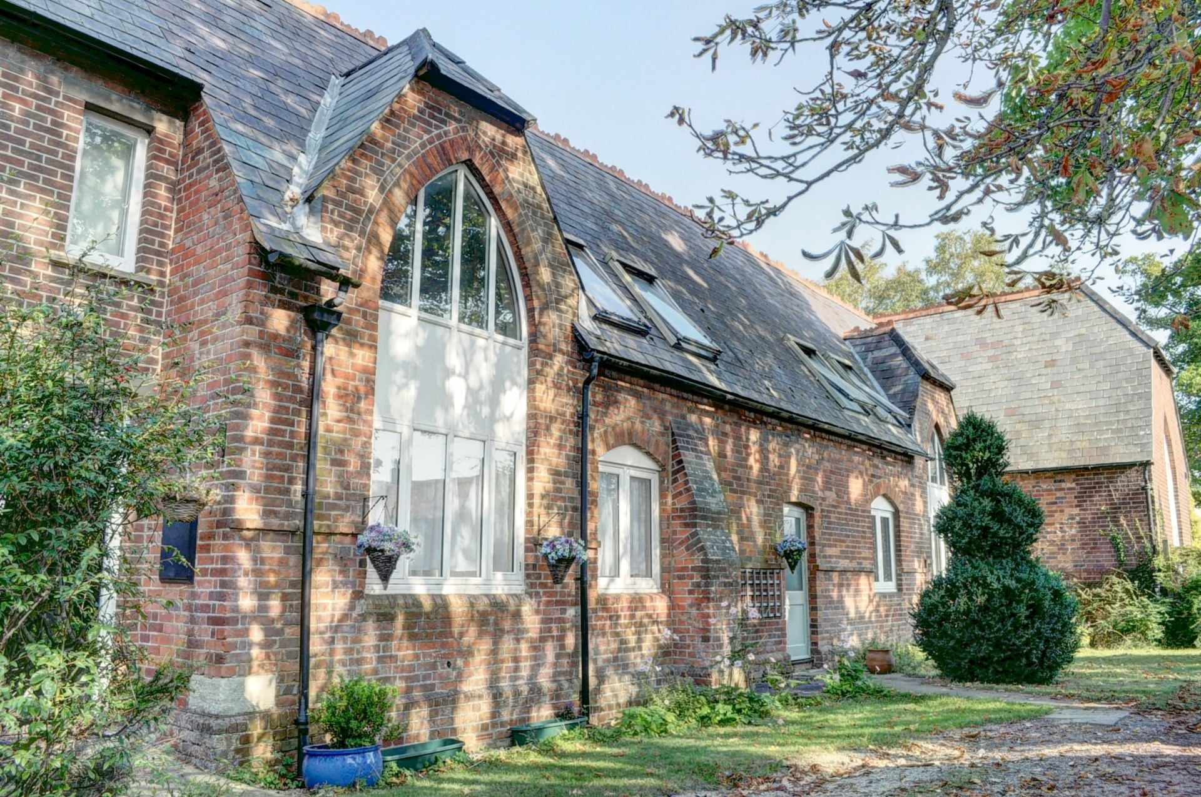



Oakley Road

Chinnor

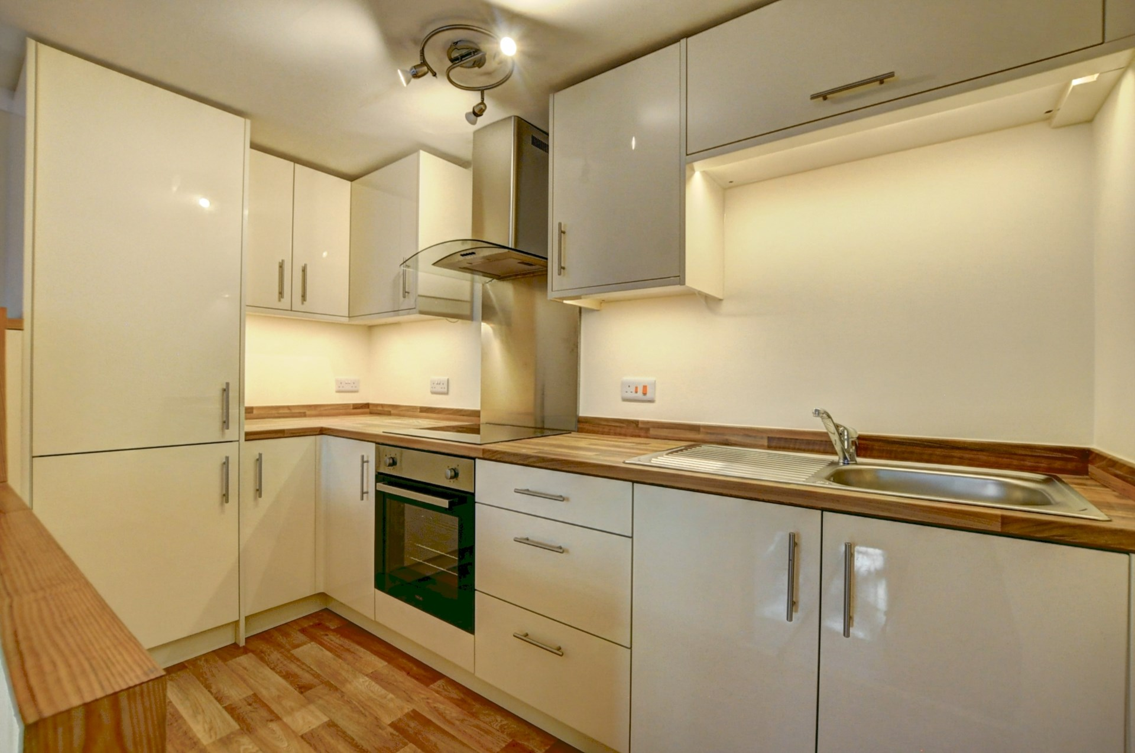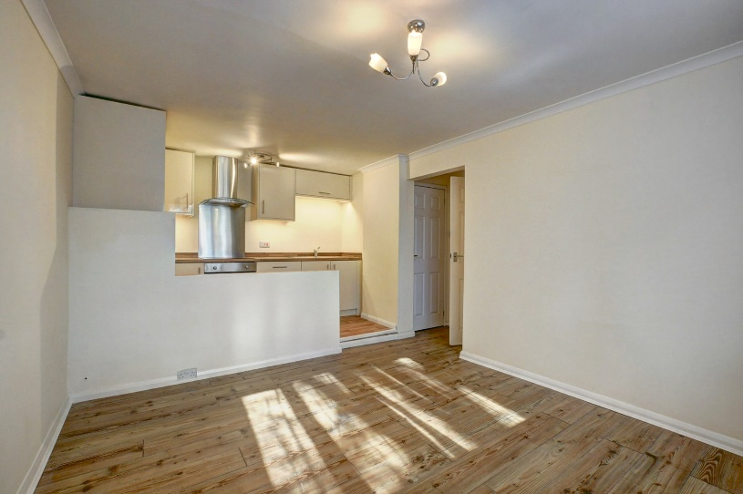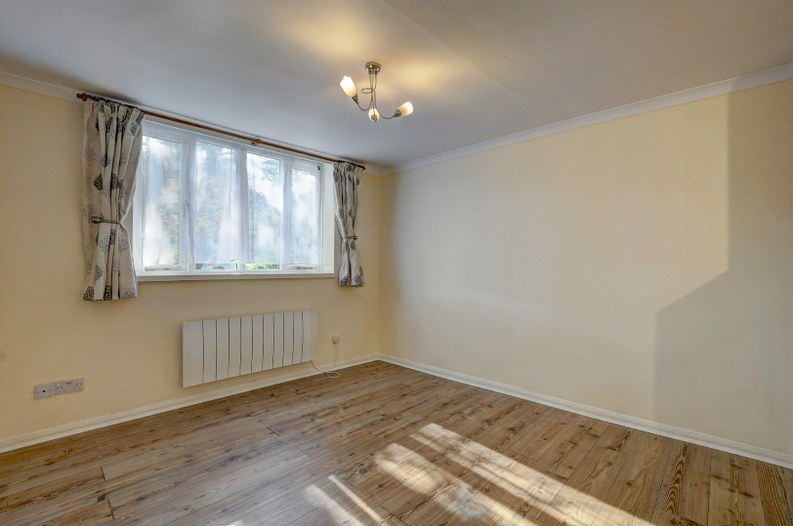

Oakley Road

Chinnor

OX39 4ET

Guide Price: £190,000

This well presented one bedroom ground floor apartment formally St Andrews primary school.Boasting many original features, is an ideal first time buyer or investment property.

Share of freehold and offered chain free. Close to local shops and amenities.

The apartment consists of; entrance hallway with a useful storage cupboard, one double bedroom, modern bathroom with P shaped bath and overhead shower , an open plan lounge with storage cupboard, modern kitchen area, that has ample eye and waist level storage units, fitted oven with hob and integrated fridge/freezer.

Other notable features include: Double glazing throughout, ample off road parking and a communal seating area.

Location

Situated at the foot of the Chiltern Hills, Chinnor is a popular village conveniently situated on the Oxfordshire/Buckinghamshire borders. Within the village there are good local facilities including a variety of shops, churches, pubs and restaurants, post office, doctor`s surgery, a nursery and two combined schools. Chinnor lies within catchment for the highly regarded Lord Williams`s secondary school in Thame.

M40(Junction 6) is within 3 miles giving access to Oxford(20 miles), High Wycombe(13 miles) and London(48 miles). Princes Risborough mainline station is within 5 miles (Marylebone 35 minutes).

Council Tax Band A

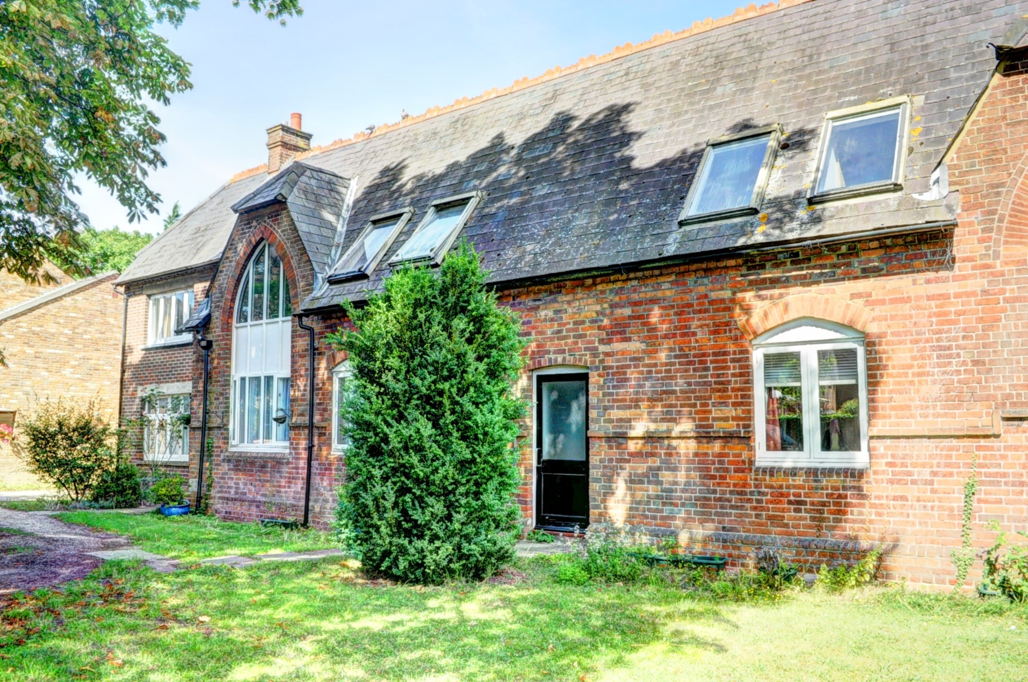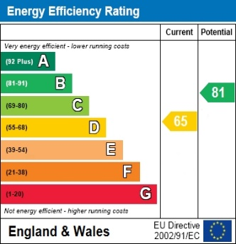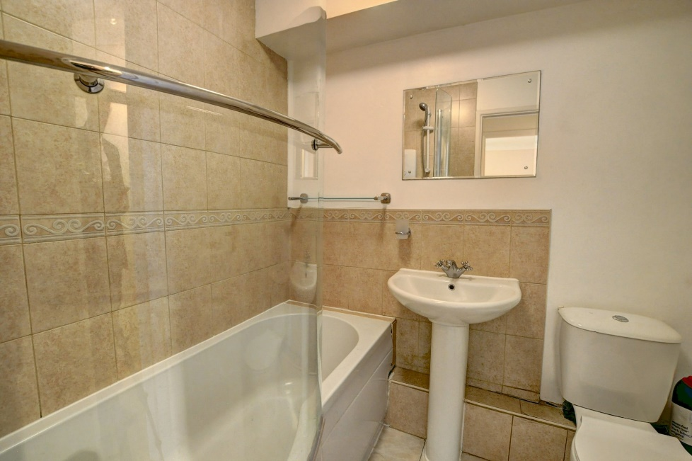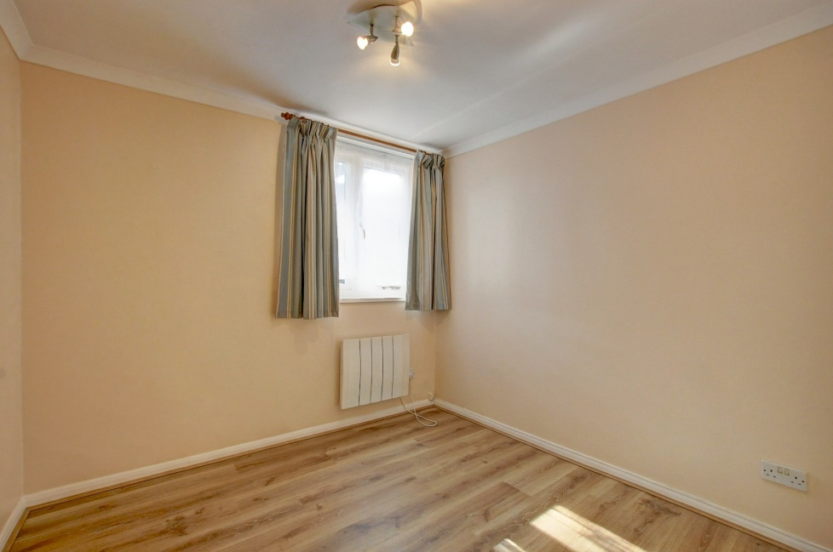

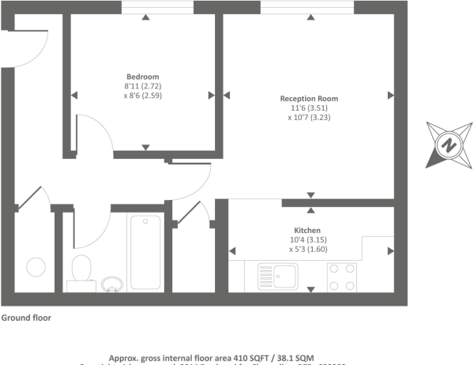Zoopla LogoNAEA Propertymark Protected CMYKRM_Logo_NoStrap_Colourfacebook logo

**Disclaimer**

We endeavour to make our particulars accurate and reliable. They are for guidance only and are intended to give a fair overall summary of the property. They do not form part of any contract or offer, and should not be relied upon as a statement or representation of fact. Measurements, areas and distances are approximate and photographs provided for guidance only. No undertaking is given as to the structural condition of the property, or any necessary consents, or the operating ability or efficiency of any service, system or appliance. Prospective purchasers must satisfy themselves with regard to each of these points. If there is any particular aspect of the property about which you would like further information, please contact us, especially, before you travel to the property. B2170

Robert House, 19 Station Road, Chinnor, Oxfordshire, OX39 4PU

01844 354554

www.bb-estateagents.co.uk