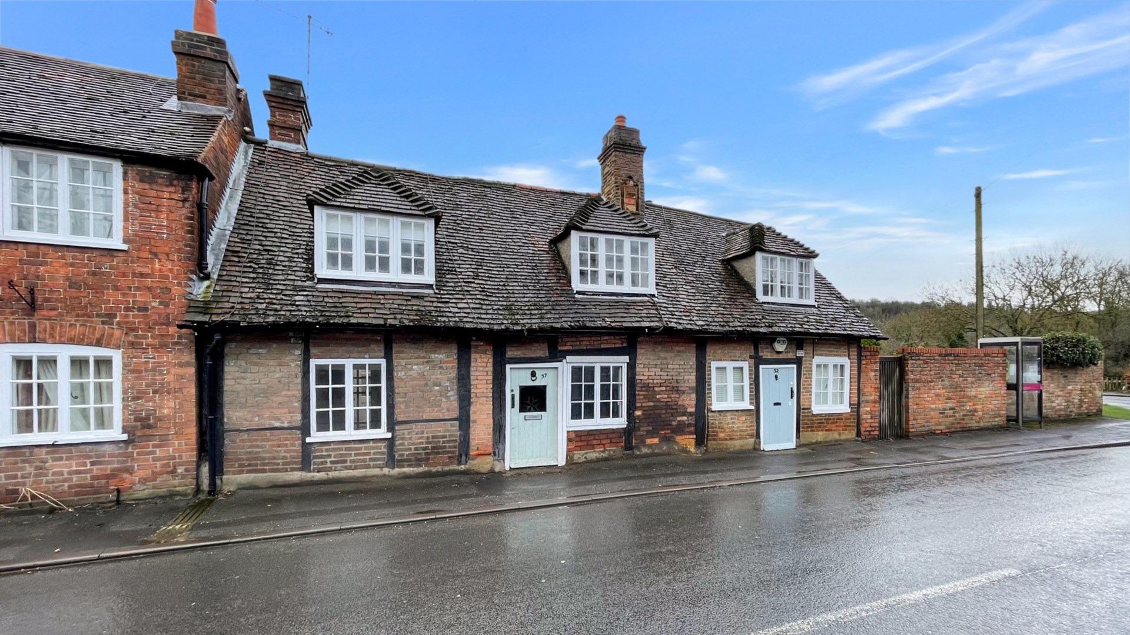bb-logo-final

Marlow Road

Bisham

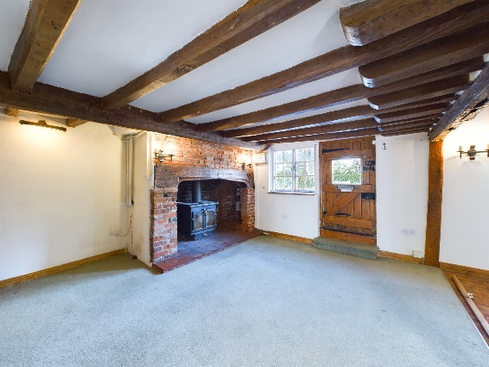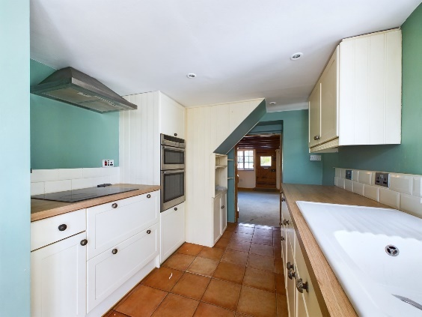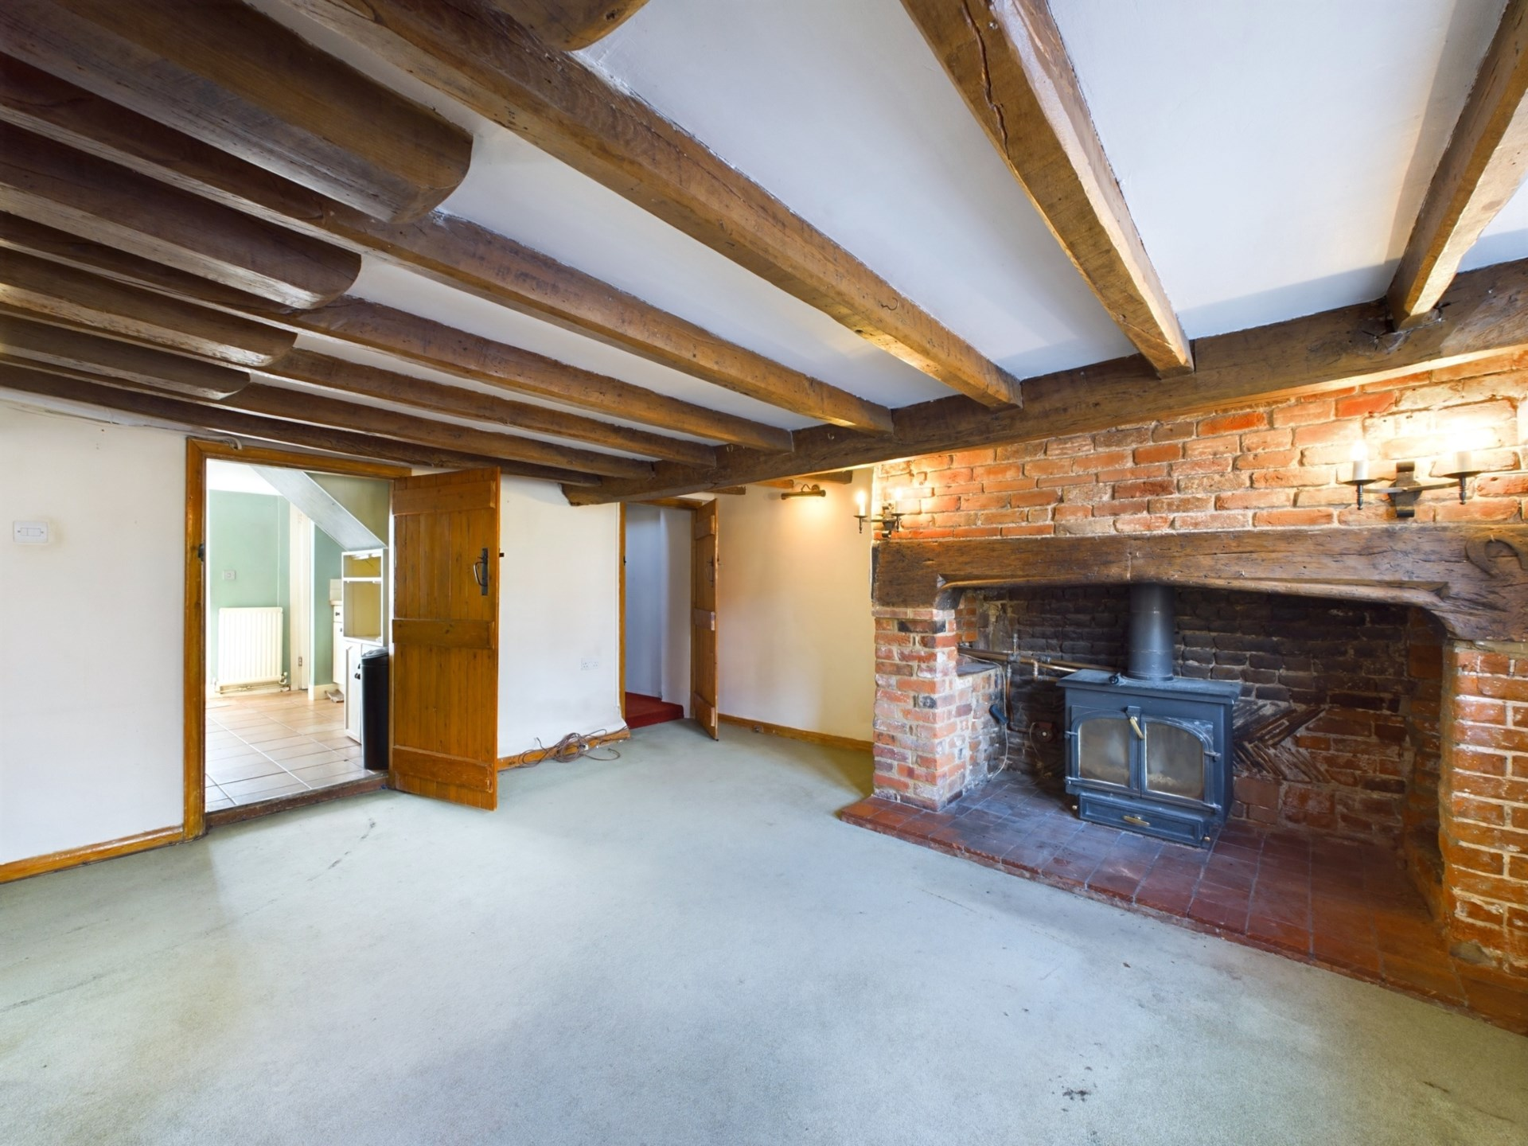

**- Tenure: Freehold**

**- Guide Price: £525,000**

**- Local Authority: WMDC**

**- Council Tax Band: E\***

**- EPC Rating: D**

*(deleted under review)

Marlow Road

Bisham

Berkshire

SL7 1RR

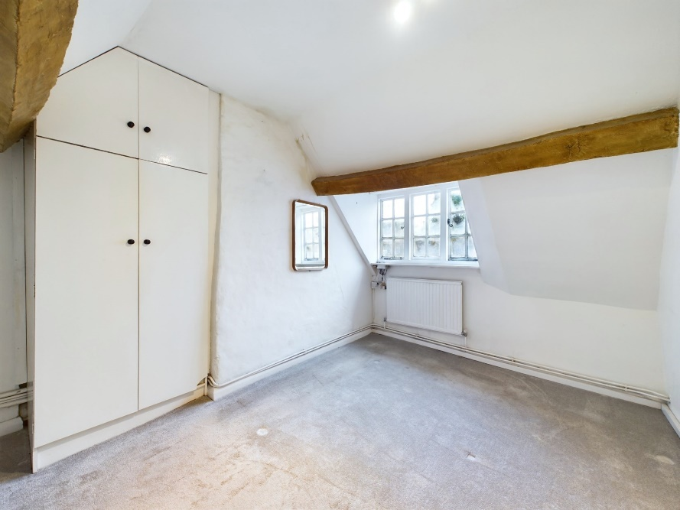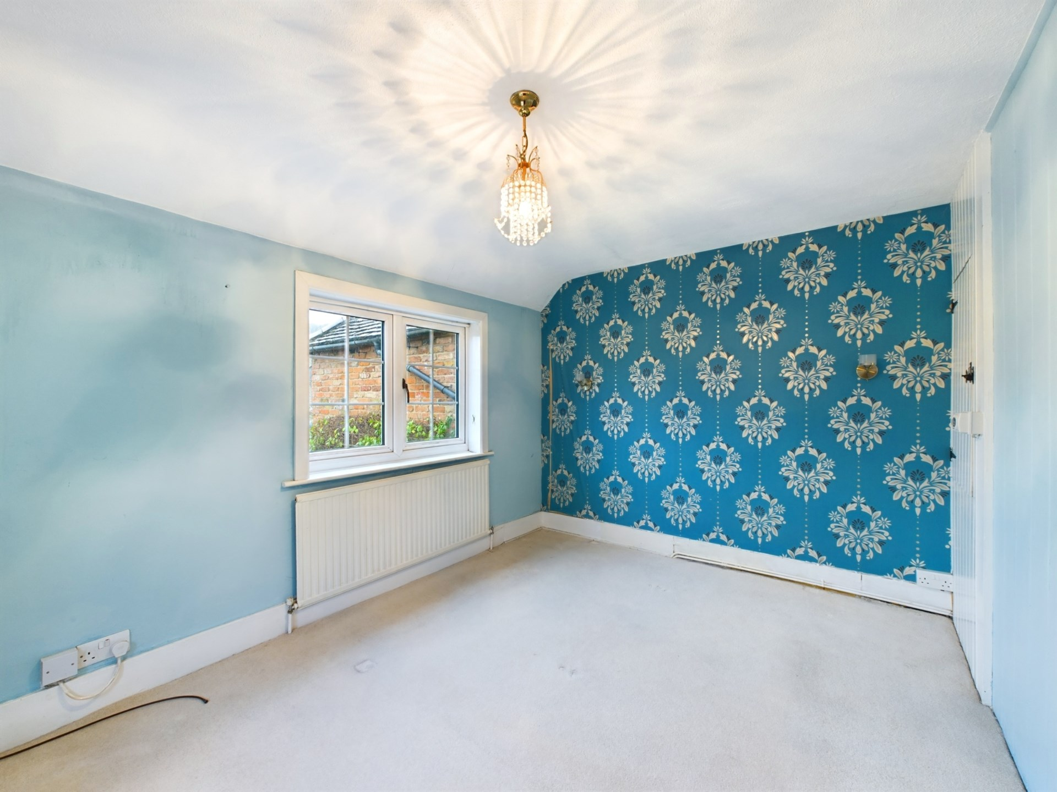

Situated in the ever popular village of Bisham this Grade II listed terraced cottage is available with no onward chain. With three bedrooms, garden and room for parking this property is highly recommended for viewing.

If you are looking for plenty of character and quirkiness then look no further than this Grade II listed cottage situated in the quaint and popular village of Bisham. This property simply oozes character with its beams, latched doors and lime plastered walls, it is a real joy of a property and could be an amazing opportunity for that buyer looking for something slightly different! On entering the property (from the rear) there is a refitted kitchen with a range of wall and base units, work surfaces and sink. leading off the kitchen is the shower room and further along there is the living room. The living room has the classic cottage style with exposed beams, feature fireplace and windows to the front as well as the front door (which is hardly used). On the first floor prepare yourself for all quirky features you would come to expect from a property like this, slightly uneven floors, odd shaped doors, exposed beams all throughout the three good sized bedrooms.

Outside there is a useful lean too / utility room with power and lighting leading on to a pleasant cottage garden which is mainly laid to lawn with mature trees and shrubs. At the end of the garden is a gated area that is easily converted into a driveway with parking and a further storage shed.

The property requires a degree of refurbishment but could be a fantastic home for someone looking for village living in a fantastic cottage.

The property is located within walking distance of both Bisham primary school and the village church and is within one mile of Marlow High Street which offers an array of bustling individual shops, cafes and restaurants including Tom Kerridge`s 2 Michelin Star ‘Hand & Flowers` and recently opened ‘The Ivy Marlow Garden`. Local recreation facilities include golf at Temple and Harleyford, walking, cycling and riding in the Hambleden Valley and at nearby National Trust lands, and clubs in Marlow for rowing, tennis, cricket, bowls, hockey, rugby and football, as well as the National Sports centre at Bisham Abbey. Marlow Station is within one and half miles providing access to London Paddington via Maidenhead and the A404 Marlow Bypass is accessed from Bisham roundabout providing fast routes to the M4 J8/9 and the M40 J4 Handy Cross.

