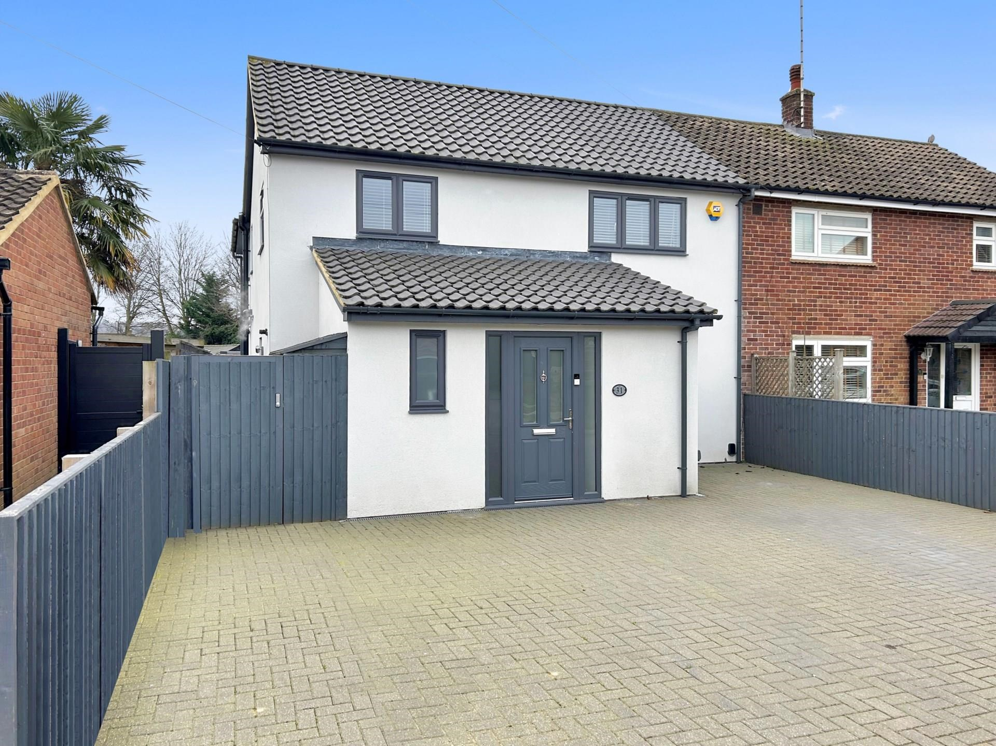



Allanson Road

Marlow

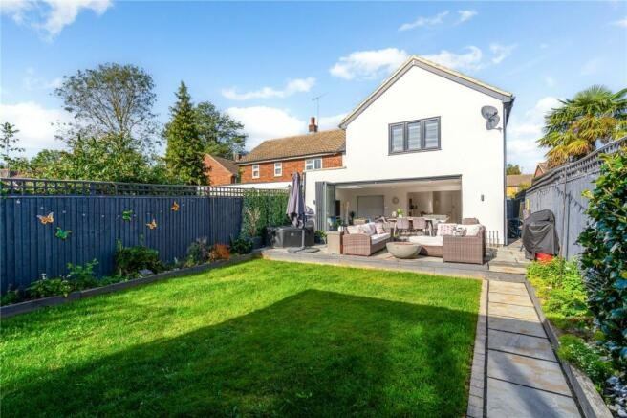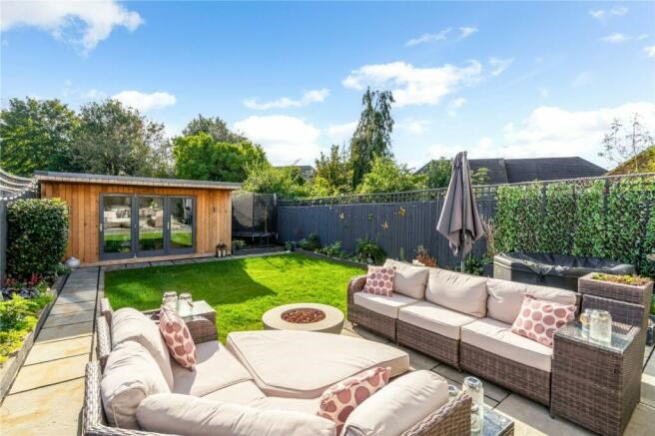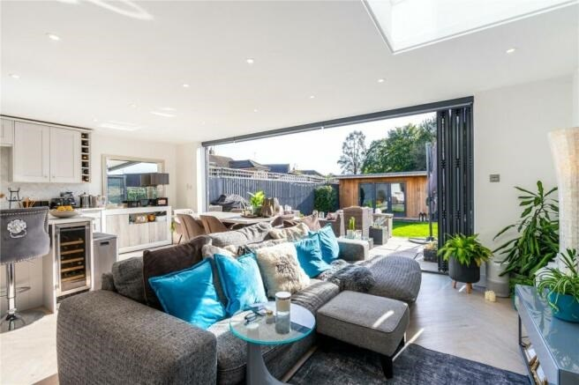

Allanson Road

Marlow

Bucks

SL7 1LE

Guide Price £800,000

A stunning 4 bedroom extended home situated in a quiet close within walking distance of the town centre and train station. The property offers a stylish contemporary interior with good size rooms including a superb `open plan` kitchen/living/dining space with Bi-fold doors.

The accommodation briefly comprises on the ground floor, reception hall, cloakroom, living room, study area, a fantastic `open plan` kitchen/dining space with integrated appliances and Bi-Fold doors opening out onto the rear entertaining terrace and separate utility room. On the first floor the landing gives access to the fully boarded loft space with ladder and light, a lovely size master bedroom with en suite bathroom and vaulted ceilings, 3 further generous bedrooms and principle bathroom.

Outside the landscaped rear garden enjoys a sunny aspect with paved entertaining terrace ideal for alfresco dining, lawn beyond and a large purpose built summer house and ample off road parking.

The property also benefits from replacement double glazing and gas central heating.

Marlow town centre is a thriving and stylish riverside community with a comprehensive range of shops and excellent pubs and restaurants.

Nearby Marlow Station has a regular train service to London Paddington via Maidenhead (from 1hr 5 mins) with links to the City of London, further enhanced when Crossrail opens in Maidenhead. Access to the M4 and M40 is via the A404(M) and London Heathrow is about 22 miles away.

There is a wide range of educational and recreational facilities in the area. Excellent local schools are numerous and include Sir William Borlase in Marlow.

Council Tax Band F

Tenure - Freehold

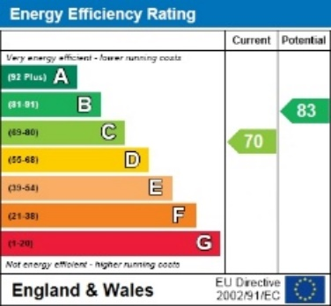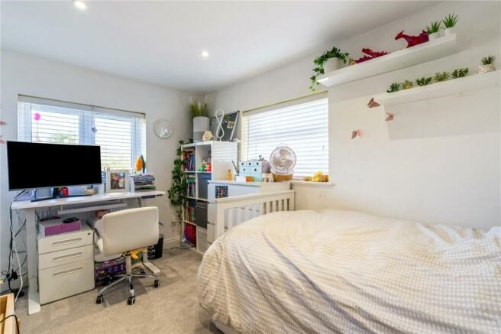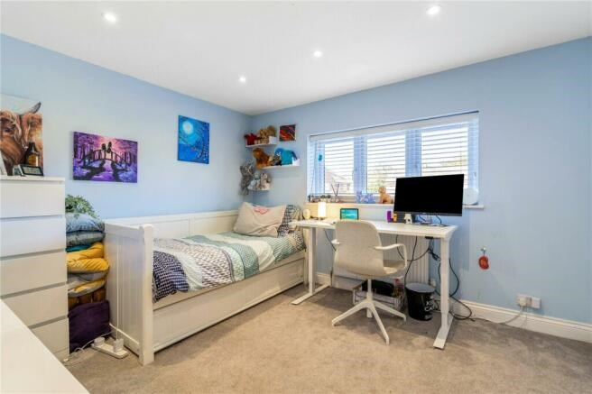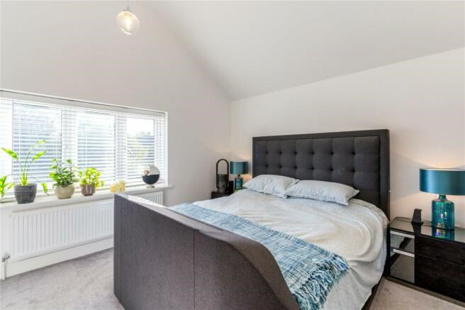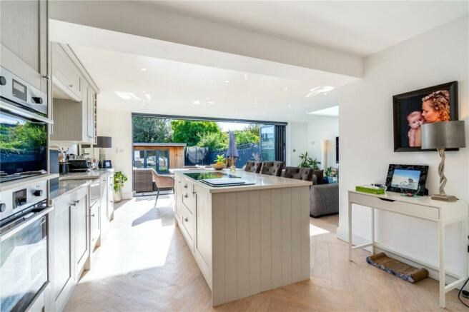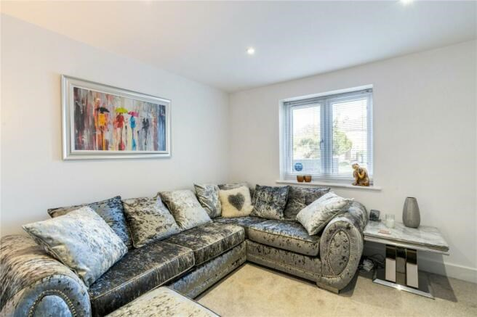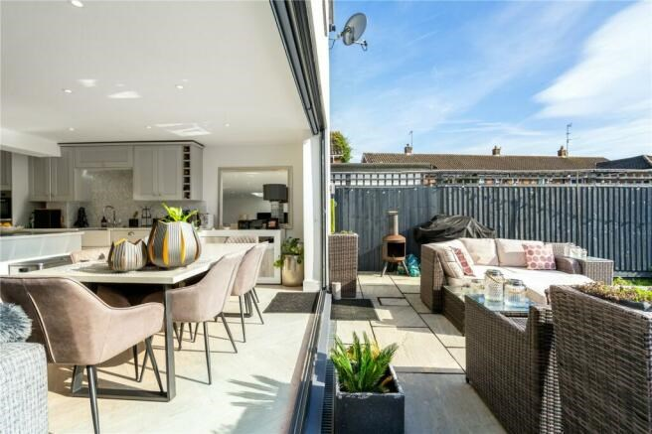

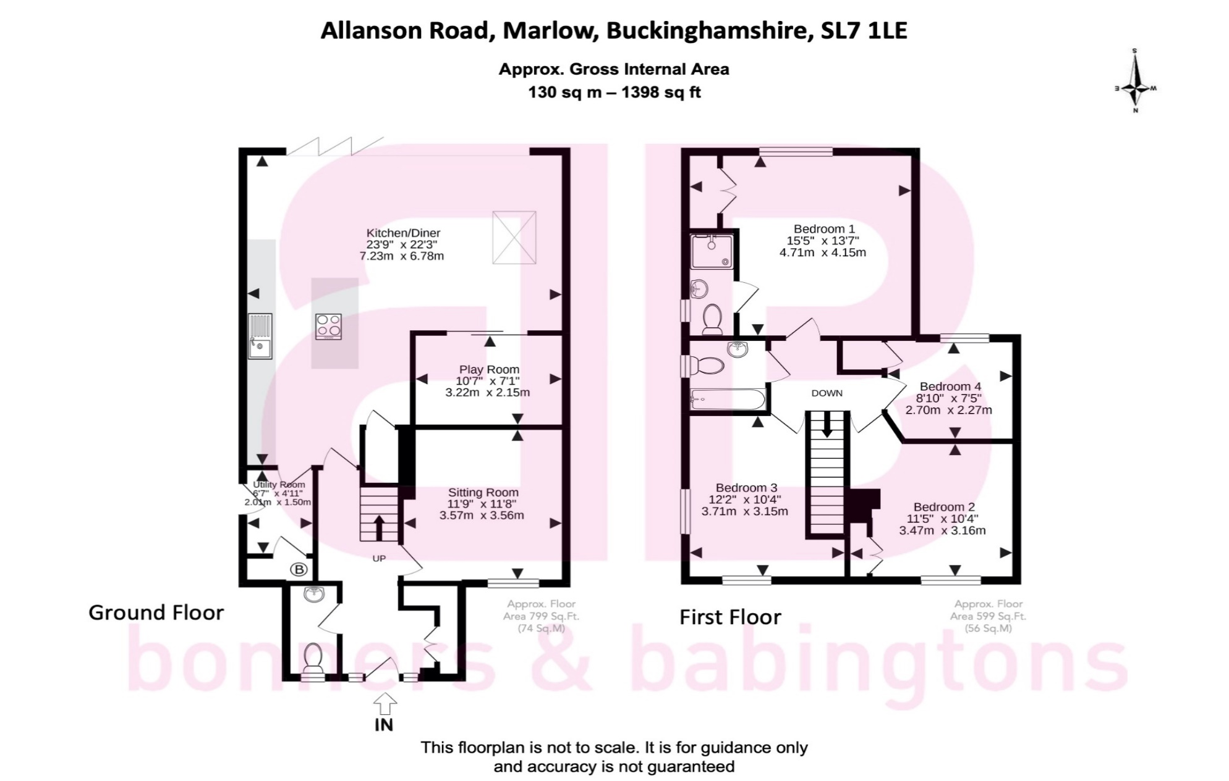

Zoopla LogoNAEA Propertymark Protected CMYKRM_Logo_NoStrap_Colourfacebook logo

**Disclaimer**

We endeavour to make our particulars accurate and reliable. They are for guidance only and are intended to give a fair overall summary of the property. They do not form part of any contract or offer, and should not be relied upon as a statement or representation of fact. Measurements, areas and distances are approximate and photographs provided for guidance only. No undertaking is given as to the structural condition of the property, or any necessary consents, or the operating ability or efficiency of any service, system or appliance. Prospective purchasers must satisfy themselves with regard to each of these points. If there is any particular aspect of the property about which you would like further information, please contact us, especially, before you travel to the property. B2170

3 Anglers Court, Spittal Street, Marlow, Bucks, SL7 3HJ

01628 333800

www.bb-estateagents.co.uk